[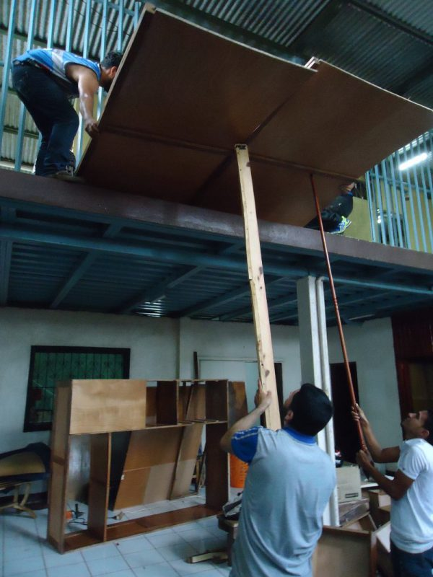](https://www.vivirjuntos.org/wp-content/uploads/2017/07/verhuizing-kast-naar-boven-e1500663162948.jpg)