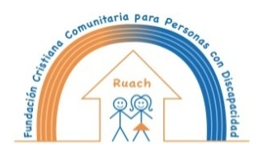
Fundación Cristiana Comunitaria para Personas con Discapacidad Ruach
thanks you for your valuable contribution to our work!

Be the reason people believe in the kindness of humans.

Despite all the obstacles in our way we have made progress in our mission: contribute to the well-being of people with intellectual disabilities over the age of 15 in Nicaragua, promote their rights in a country where they are not taken into account and work for a better world for everyone! Thank you for contributing with a gift, action, prayer or by promoting our work. THANK YOU!

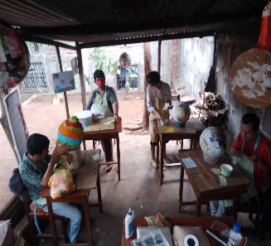
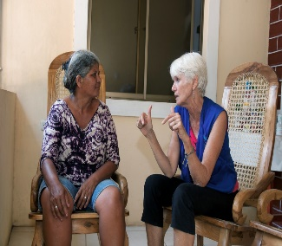
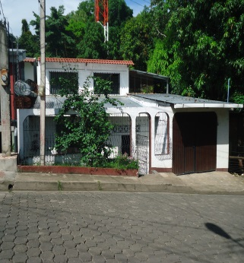
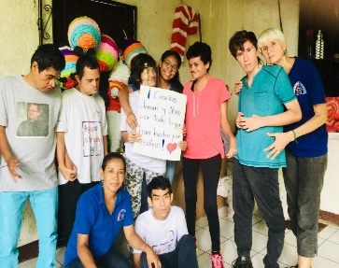

Together we can make a difference in the world!
Together we can make the world a better place.
We send you all our love this Christmas and blessings for the New Yaer!

