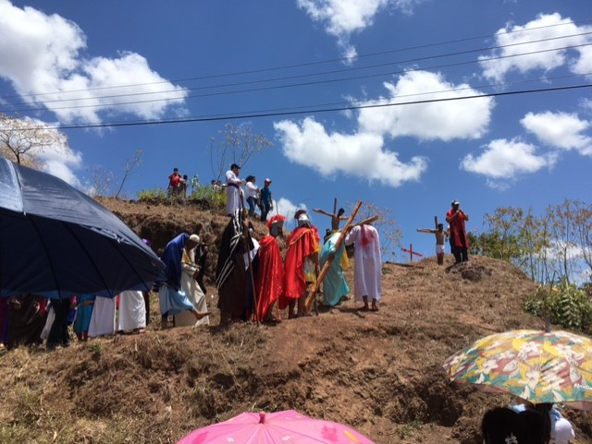
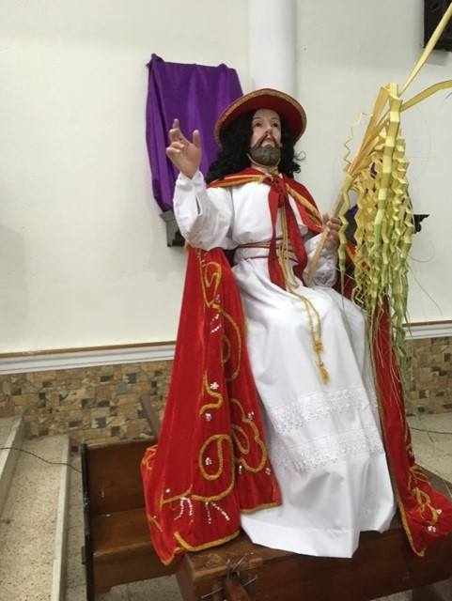
Thanks for your letter. We show you
The trees we have in our garden, especially
the mango tree, which is giving now
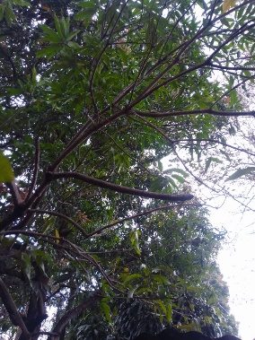
a lot of mango`s! We like them so much!!!
The Holy Week has started. Very important in Nicaragua. Sunday they remembered the entering of Jesus in Jerusalem as a King.There is a procession.
And on Friday they will remember the cruxificion of Jesus-

How do you celebtare the Holy week?

We have one week of holidays now

Happy Eastern!

Every day they fall from the tree…..
