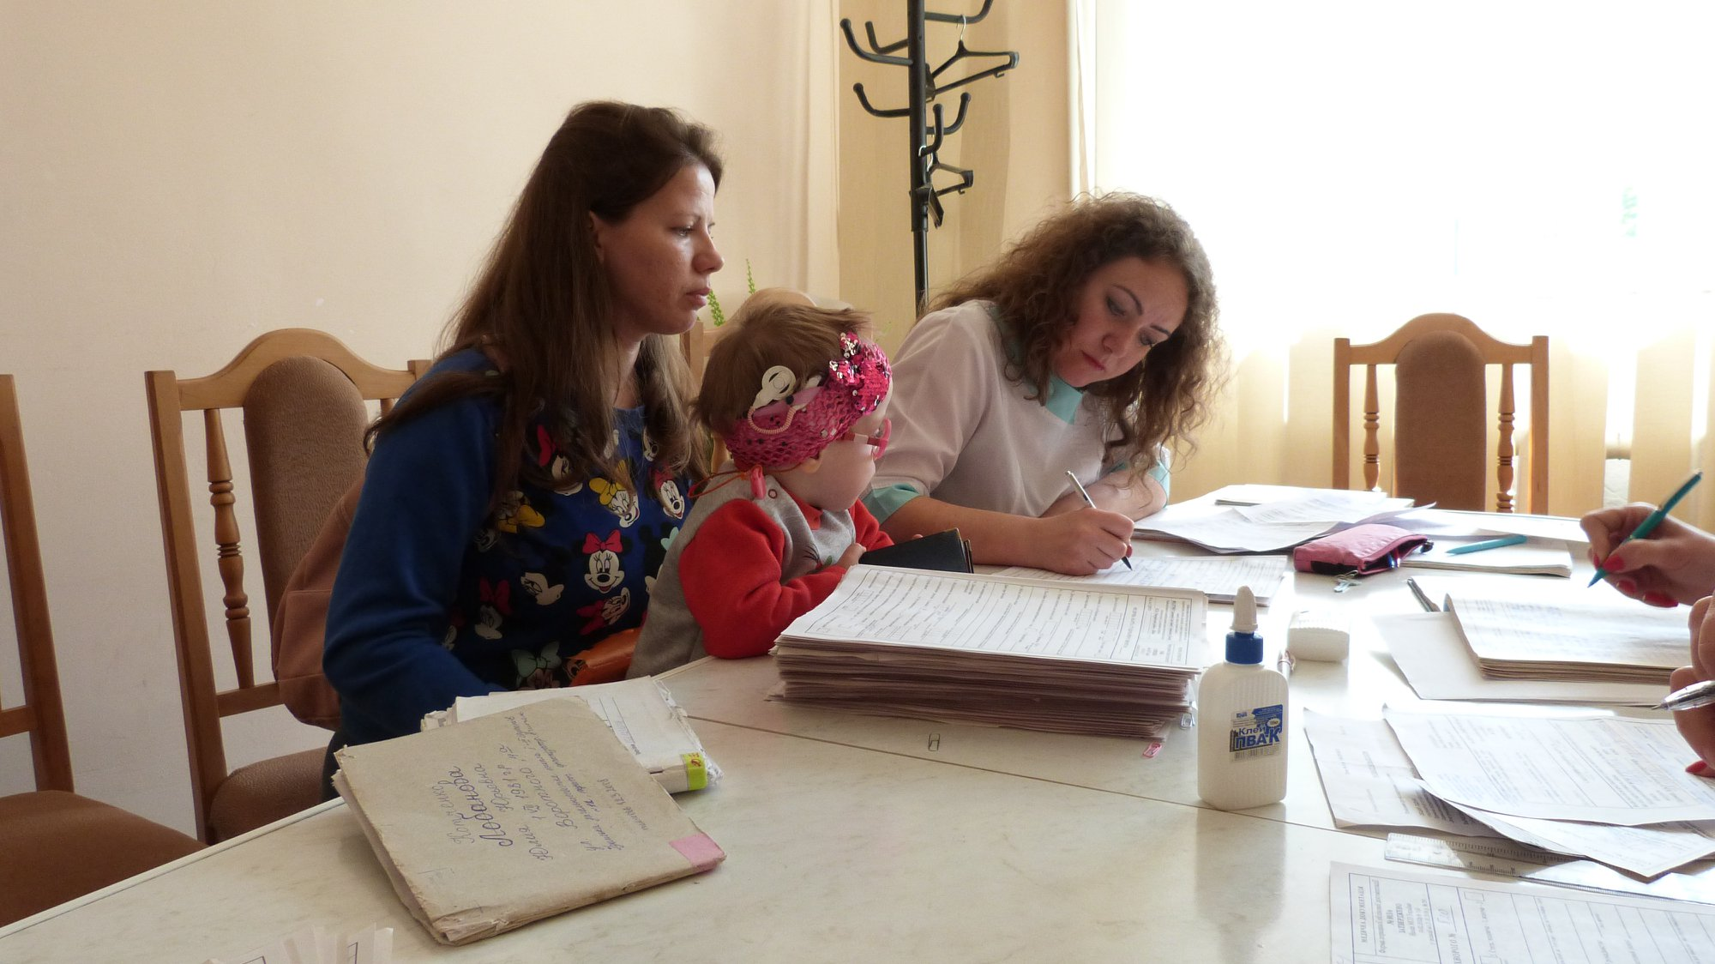
Phono 1. The first lesson for little Olya
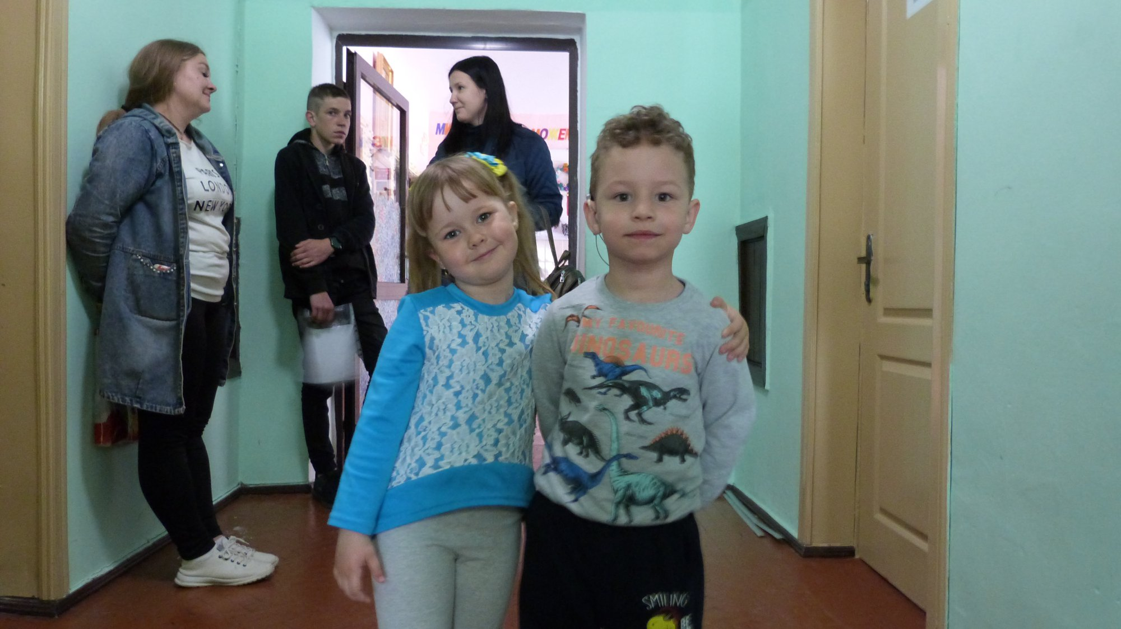
Photo 2. Bogdan and Kate became friends in the camp

