August 2017 Nutrition Report
Prepared for GlobalGiving Donors
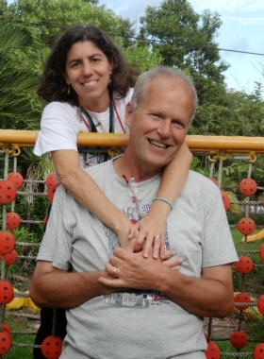
By way of introduction, we’re Paul and Laura, the General Directors of Shoulder to Shoulder. We live in Honduras and love every minute of our lives and our work with this incredible organization. We are inspired by your generosity and welcome you to a team of people committed to working to eliminate inequity that arises from poverty and injustice. Your donation to our nutrition program is making children healthier and giving them the opportunity to realize their potential in life. Every day we witness how this happens and we can’t thank you enough!

Background: Shoulder to Shoulder works with The Mathile Institute and the Municipal Association of the seven towns of Southern, Intibucá to deliver a nutritional supplement, called Chispuditos, to children under 6. Under nutrition (malnutrition related to not receiving adequate nutrition) manifests itself as being underweight (weight for age), wasting (weight for height), and stunting (height for age). These conditions, common in Honduras, are seen at significantly greater percentages in Southern Intibuca (very rural, isolated, and poor) than in the rest of Honduras. Under nutrition is associated with anemia, the development of chronic diseases such as diabetes, diarrhea, and cognitive impairment. Children simply cannot thrive without adequate nutrition and life itself is drained from them.

“Hunger is not a problem. It is an obscenity. How wonderful it is that nobody need
wait a single moment before starting to improve the world.” -- Anne Frank

Chispuditos works! We’ve been working on this since 2008 with the Mathile Institute and we’ve got it right. We won’t bore you with all of the studies here, but you can find them on our website. What we are trying to do now is to get this product to as many children who need it as possible with help from people like you. The people we serve are poor. The under nutrition they suffer is not because they take most of their meals at a fast food joint. They eat what they can grow – beans and corn. In the best of times there is little variety and a substandard level of nutrition. If the harvest fails, well, you might be able to guess at the result.
Data from 2017

The following report summarizes data from July 2016 through May 2017. We have completed a full cycle of distribution, but the data are not yet available. Another report will be generated and sent out in September. There are presently 2,944 children enrolled in the nutrition program.
Municipality | Communities | # Children (October) | # Children (April)
Colomoncagua | 51 | 1,508 | 1,499
San Marcos | 30 | 781 | 860
Camasca | 14 | 522 | 586
Total | 95 | 2,811 | 2,945

3rd Quarter Heights/Weights
- Nutrition indicators show improvements in weight for age (underweight) and weight for height/length (wasting) for both males and females.
- The average height/length for age does not show a clear trend among program participants, although among those who were stunted at baseline there is almost a 25% decrease in stunting by 9 months. This group also showed large decreases in anemia (from 67.6% at baseline to 58.1% at 6 months).

Mid-Point Anemia Results
- In November 2016, hemoglobin samples were taken for a group of randomly selected children under the age of 5. The final measure of hemoglobin levels was completed in June 2017.
- Among program participants anemia decreased from 51.2% at baseline to 39.7% after 6 months. This change is more prominent among girls (17% decrease).
Data are fascinating, and this data show that the program works. But if you’re like me, data can also be pretty boring. I like stories. Here’s one of the great success stories.

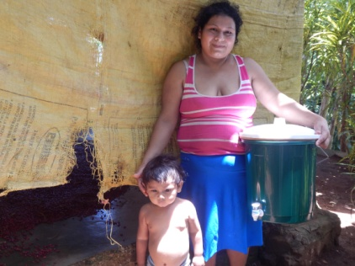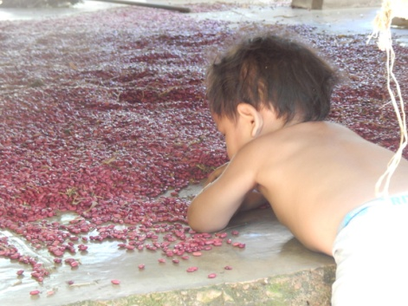
Meet Christian. He’s two. A few days ago, we were delivering water filters to poor families. Nutrition is a serious problem as is clean water. Christian is part of the nutrition program. What an incredible kid! He was engaged with us the whole time we were there, smiling, posing for the camera, and just plain showing off. The family was drying out a fresh harvest of beans, and Christian’s mother had all she could do to keep him out of the beans.

I’ve seen children who are undernourished. They maintain a vacant expression. They remain unengaged. It seems unreal to me, and it usually brings tears to my eyes. Give me a kid that thrashes around in the family’s bean harvest over one that stares absently at a wall any day. That’s what the nutrition program accomplishes. Christian, we’re looking forward to your growing up and engaging this incredible world.

