24th April 2017
Dear Friends of Concerns,
At the end of yet another successful academic year, we take great pleasure in sharing the news of Concerns briefly.
CHILD CARE CENTRES
Around 200 children below five, attended our five Concerns Child Care centers. Nearly 90% of them got admissions in the neighboring schools both in English and Kannada medium.
On 17th April 2017, the children in the centers had their sports day organized by the Community College students.
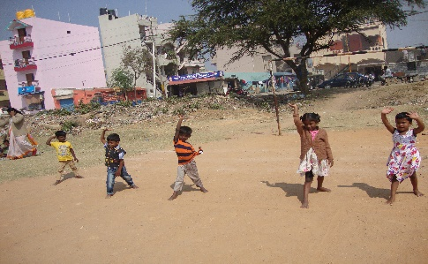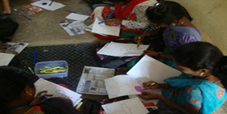
Pre-school teachers underwent three days training. It was from 10th to 12th April 2017.It focussed on curriculum planning. The teachers started preparing course materials and displayed charts for their classes. They are now geared for the next academic year awaiting the new batch of toddlers. The centres are now closed for their summer break.

CONCERNS COMMUNITY COLLEGE
On 11th April 2017, the Teacher Trainees’ showcased their teaching materials at an exhibition. It was a great confidence booster and visual treat for all. Two nursery class teachers from the Priya School visited our college and appreciated their sincere talents and efforts.
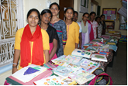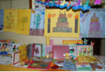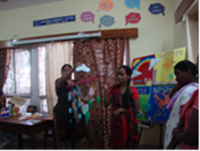

On 18th April Concerns Community College students had their sports day. Every one participated very enthusiastically in the games. They won several prizes and enjoyed the day thoroughly. The married students relived their childhood days! They showed great joy to run and play in the ground once again. They expressed it as an unforgettable day in their life.
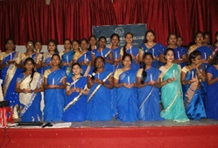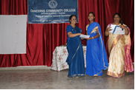
The Graduation function was held on 20th of April 2017. Graduating students took part along with their parents. Totally 56 students graduated this academic year. Among them 28 were from the Early Childhood Care Education course, 23 from Office Management course, 3 from Beauty &Wellness course and 2 from Hotel Management course. The formal occasion was a grand success as the trainers gave a warm farewell to their students. It was graced by an eminent educationist and a well-wisher.

Concerns vocational training centre supported by dell in Baiyappanahalli and SSGA (state street global advisor) in Ulsoor
The following are the recent achievements:
- 15 completed Long Term course on Office Administrative+ tally ERP 9.0
- 13 completed Short Term course on Basic Computing
- 3 completed Advance Course on Basic Computing+ Tally ERP 9.0
- 4 completed Advanced Course on Basic Photoshop
- 4 completed Advanced Course on Basic Tally ERP 9.0
- 4 children of Tuition classes learnt Basic Computing.

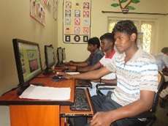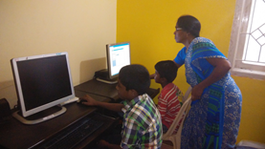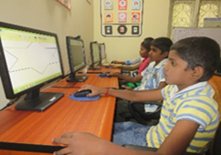
This training unit is closed from 1st April 2017 .Our project tenure got over and the staff is now absorbed in our main office except for Ms. Suganthi and Ms.Rajeswari. Ms.Suganthi is now working for the Community development project in ulsoor . Ms.Rajeswari is keen on finding some other suitable job.

KOLKATTA CONCERNS COMMUNITY COLLEGE (KCCC)

Through our extension centre in Kolkata, we could train few more women this year. Two women have successfully got trained in Early Childhood Care Education, 4 women in Beauty and Wellness, 3 Women in Functional English.

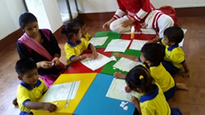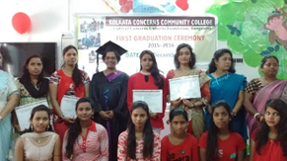

KCCC has also established a Child Care Centre as a laboratory nursery school. 24 children attended and successfully completed their nursery education this academic year. They are ready to join formal school. KCCC runs its program of Child Care and Training unit with staff strength of five full- time workers.

STITCH CRAFT UNIT

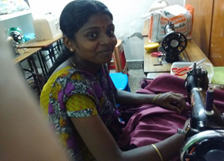 Till March 2017 an average of 53 women of various age groups underwent training for a period of 3- 5 months on basic tailoring and garment making. Five women showed interest to learn “Aari work” and 3 hand embroidery. The unit has shifted to Madurai from 1ST April 2017. Efforts are being made to campaign for the training unit and mobilise women to join the training unit. One trainer was identified to conduct classes in tailoring and embroidery.

CUF Building Progress:
Some initiative has been attempted to get sanction for our construction. We hope to succeed in this venture and commence the construction with God’s grace shortly.
With limited funds, we are continuously making applications for probable funding organization, we would appreciate if you share any information in this regard, which would help us continue our work.
Thank you for your unstinted support and encouragement through all these16 years. Ending this newsletter with a deep sense of gratitude to all our supporters.
Warm wishes from all at Concerns,

Gnana Chitra

Concerns

