Message From The President

Uproot Poverty Newsletter
Never doubt that a small group of thoughtful committed citizens can change the world. Indeed, it is the only thing that ever has. – Margaret Mead
  - Volume 1 | Issue 2
April, 2017

Uproot continues to strive to make a difference in people’s life, by taking away their miseries, into providing hope and strength to one person, one family, and one community. I am extremely thankful to all mediums who are constantly engaged in fundraising for Uproot. I am equally thankful to Ms. Emily Feder, for doing an excellent work, in reaching out with extensive promotion.
Currently, Uproot has:
54 Volunteers
5 International partners
9 Pro bono staff members
Helped 19 Beneficiaries
Saved 6 possible lives
Provided tuition to 4 students in Pakistan, including 2 Master program students.

Uproot hopes to continue helping deserving individuals throughout the world, provided they are genuine and validity is proven. Uproot also plans to hire fully paid staff, upon receiving a promised donation, which could be expected soon.

Regards,

Shakil Tabassum
Founder/President/CEO

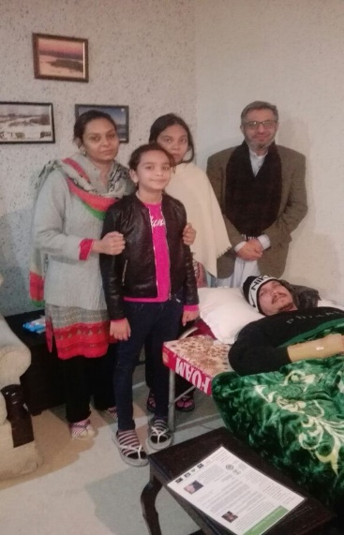
Our Current Mission
The Board
- Shakil M. Tabassum, President
- Chaudhary J. Azam, Treasurer
- Aleem Baig, Secretary
- Tom Fannon, Board Member
- Joshua Cramer, Board Member
Pro-Bono Staff
- Emily Feder
- Omid Rafey
- Soeun Seng
- Firoza Zafar
- Rabia Baig
- Ayub Shah Bukhari
- Amine Belarbi
____________________________

On January 17, 2017, Shakil Tabassum, CEO of Uproot, visited beneficiary #19, Manahil John at her residence in Pakistan, who is awaiting her surgery, which is being promoted by the following mediums:
- Gofundme
- One Today, by Google
- Global Giving
- Facebook
During his visit, Saima John, Mother, requested if Uproot can help her kids resume their studies, as she is unable to pay the monthly tuition, due to recent illness of her husband, who fractured his spine and pelvis, and broke his hand. Upon seeing their misery first hand, Uproot agreed to help her kids with schooling, and postpone Manahil’s surgery for a while.
Contact Us:
1209 E Jefferson Road
Sterling, VA 20164
Shakil@uprootpoverty.org
1-347-721-8186
www.uprootpoverty.org

Uproot is diligently working to raise funds for Manahil’s surgery, and monthly tuition for both kids, for at least six months. Uproot is also thankful to Dr. Imran Mahmud, who is also making efforts to reduce surgery cost from the surgeon.

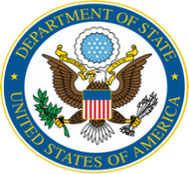
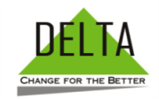

Our Partners:

Dr. Imran Mahmud, a volunteer for Uproot, was sent to their house on March 4, 2017 to disburse first payment of $610 or Rupees 61.784, to cover partial education cost for her two kids, and to examine her father and Manahil. On March 27, additional funds were transferred directly to Mrs. Saima Aneel John, in the amount of $357 or Rupees, 33,573 as a balance payments for school. These funds were transferred from the fundraising from above mediums.

“Congrats, to Uproot, for doing such a marvelous social work. I met with John’s family, and fully endorse uproots’
commitment to help the family”…. “A totally deserving family”- Dr. Imran Mahmud

“I got the money from Dr. Imran on 4th March 2017 almost PKR 61,784”……“Thank you and the uproot team who work hard for my kids to be in school. I am really thankful to you all. Many thanks for the additional expense for the kids, uniform, books, shoes. Actually, due to my husband sickness since last four months he is not able to work, and I am the only source of income and he is still under treatment and will not able to work for more six months due to back bone fracture and he is not able to work from his right hand after his wrist surgery, so this is the reason for the additional charges” - Saima John

Proposal
www.facebook.com/uprootpovertyonebyone/

Uproot submitted its 2nd proposal through DELTA, to the State Department, and was hoping to receive a fruitful response, but a regrettable reply was received on March 21, 2017. “Thank you for your submission to the Bureau of Democracy, Human Rights and Labor’s (DRL) request for proposals for global parliamentary training programs, solicitation DRLA-DRLAQM-17-006. We appreciated the opportunity to review your submission, entitled “Parliamentarians & Civil Society for Minorities (PCSM).” However, we regret that we will not be able to fund the proposal due to other urgent funding priorities.” The State Department

IRS

On February 13, 2017, IRS imposed a fine of $2.298.20 for filing a late 990 for year 2015 on December 31, 2016, though RaviBCPA & Company. An appeal letter was sent on the same day to the IRS, and on March 21, a fine of $2,298.20 was lifted. For year 2016, Uproot has filed its 990N on February 13, 2017, and it was approved by the IRS.

Scholarship

Anacostia High School of DC, has been chosen for seniors to compete for an essay competition. A winner will be provided with $500 scholarship. Deadline to submit two page essay is May 30. Topic: Imagine you are about to change someone's life by taking away their misery, and providing them with hope and strength. How would you bring a smile on their face, and promote peace and support prosperity?

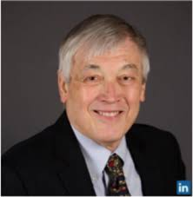
Fundraising Efforts Obituary

http://www.globalgiving.org/projects/thirteenyearold-needs-surgery/ In March, Uproot learned that John Fromm

https://www.gofundme.com/ManahilJohn has passed away, due to heart failure. He

https://onetoday.google.com/p/dj_kmolu?c=6554690991161344 worked for two years as, Pro Bono, and closely
Connect with us!

with the CEO, in setting up Uproot. He will be

truly missed. http://www.cunninghamfuneralhome.net/obituary/John-Fromm/Woodbridge-VA/1709693
https://twitter.com/uproot_poverty1
https://www.facebook.com/uprootpovertyonebyone/

Have an Amazon account? Uproot is part of the AmazonSmile program, where Amazon donates 0.5% of the price of eligible AmazonSmile purchases to the charitable organizations selected by our customers. Use this link to connect your amazon account
https://smile.amazon.com/ch/46-1151686
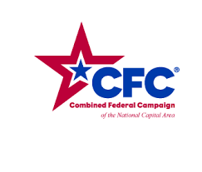

Enrollment with Combined Federal Campaign, coming soon

