Concept Paper:
“The Jamii Leadership Project” - A Family-Based Girls’ Scholarship Initiative

Abstract

At the heart of many of the greatest challenges facing the African continent is the lack of educational opportunities available to young women there, and the absence of the mentorship and training necessary for them to become leaders – leaders who are empowered to identify needs in their own communities and to take action to address them.

To help meet this critical need, AfricAid is implementing The Jamii Leadership Project, a family-based girls’ scholarship initiative in Africa. Through this program, AfricAid will provide school scholarships to some of Africa’s brightest young women – girls who otherwise wouldn’t have the opportunity to continue their education. Believing, however, that students need more than just a classroom education in order to gain the leadership skills necessary to address the challenges faced by their communities, AfricAid will also provide leadership training in the form of workshops, mentorship, and outdoor experiential education to these young women. After completing this two year experience, and upon their graduation from secondary school, the AfricAid scholars will then be prepared to return to their home communities for a six month period and, in partnership with their own mothers, provide mentorship to young girls in the areas of goal-setting, decision-making, communication and the formation of healthy relationships. Ultimately, it is envisioned that these scholars – and the girls they mentor – will become the next generation of leaders in their own communities, and in their nation’s businesses, organizations, and political institutions. In this way, one school scholarship provided through Jamii will have an exponential multiplier effect.

Jamii is the Swahili word for both “family” and “community” – signifying that, when families come together, great things can be achieved. Indeed, through the Jamii Leadership Project, AfricAid will not only provide the means for the AfricAid scholars to partner with their mothers and other community members, but will also give families and individuals around the world the opportunity to engage meaningfully across borders. Through providing scholarship funding, and by way of a dynamic, web-based platform, families and sponsors in the United States will be connected with individuals in Africa, allowing them to learn from one another and to provide the mutual inspiration needed to strengthen community and family ties. Both partners will have the opportunity to share the challenges and joys of their own life stories with one another in video and written format, revealing how their experiences fit in with their larger visions for a better world. Through the experience, the partners will grow closer to one another, and be given the tools to strengthen their ties to their respective families and communities as well.
In this way, the Jamii Leadership Project will represent a break from the traditional mold: the initiative will not portray its partners in Africa as merely a set of numbers or a sea of impersonal faces, but rather will bring the richness of each individual’s story to life, situating it within a broader community of families working and learning together.

Rationale
AfricAid believes, and studies have shown, that when a girl receives an education, she is more likely to marry later, have fewer children, and invest the increased income she earns into her children’s health and education. All too often in African countries, bright young girls who have succeeded in school are unable to continue with their education due to a lack of money to pay for school fees. These are often the very young women who could work to address their communities’ most pressing needs. AfricAid therefore believes it is vitally important to provide scholarships to these young women. However, even when students in Africa are given the chance to go to school, they are all too often taught through rote methods and are rarely, if ever, given the opportunity to exercise leadership skills. Through the Jamii Leadership Project, AfricAid will therefore provide the schooling and training needed to empower Africa’s women to become leaders and to provide critical mentorship to the next generation of young girls.

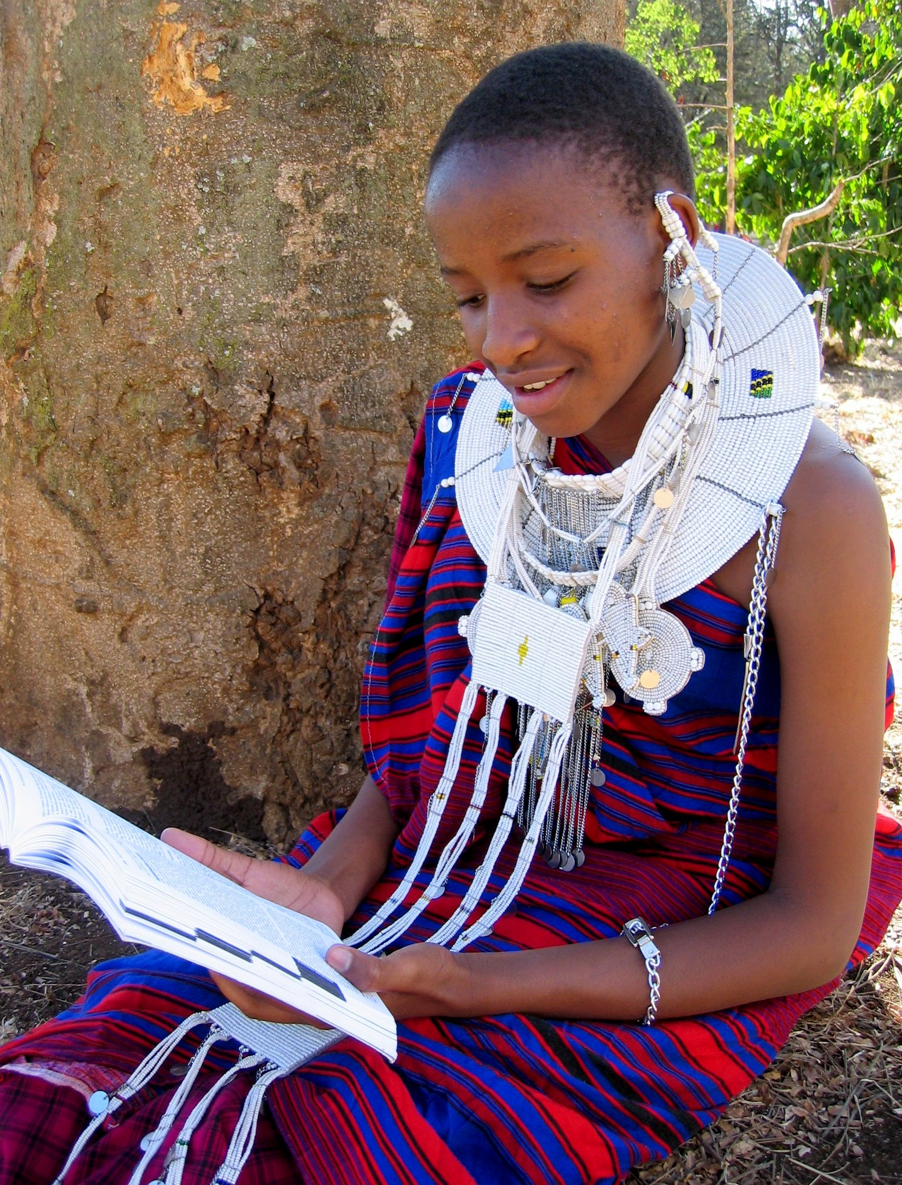
There are certainly many scholarship programs existing in Africa, but they are generally not for students wanting to complete the last, critical phase of their education, nor do most provide leadership training of any sort. These programs are generally impersonal in nature and do not engage students and sponsors to communicate consistently or meaningfully. The Jamii Project provides a unique way of accomplishing its main goals of providing scholarships and leadership training to young African women: it gives sponsors the opportunity to not just provide an educational scholarship, but to be a part of helping to create a new class of women leaders in Africa. It utilizes new technologies to offer and encourage personal communication, building bridges between communities and individuals through the sharing of video and written stories. And, most importantly, it brings families of individuals together as they work to implement their shared vision of a better world.

Impact
In its first pilot year in 2010, The Jamii Leadership Project will be implemented at two schools in Tanzania, empowering 20 young women in Africa to become leaders and mentors in their communities, and giving 40 individuals and families the opportunity to grow closer as they learn from and share with one another. By 2015, it is envisioned that 940 girls in Africa will have gone through school and the leadership training provided under the program, 9,300 young African women will have been mentored in essential skills by a powerful role model, and 1,880 individuals and families around the world will have discovered the power of connecting with members of their global community.

History

AfricAid is a 501(c)(3) organization that supports girls’ education in Africa in order to provide young women with the opportunity to transform their own lives and the futures of their communities.

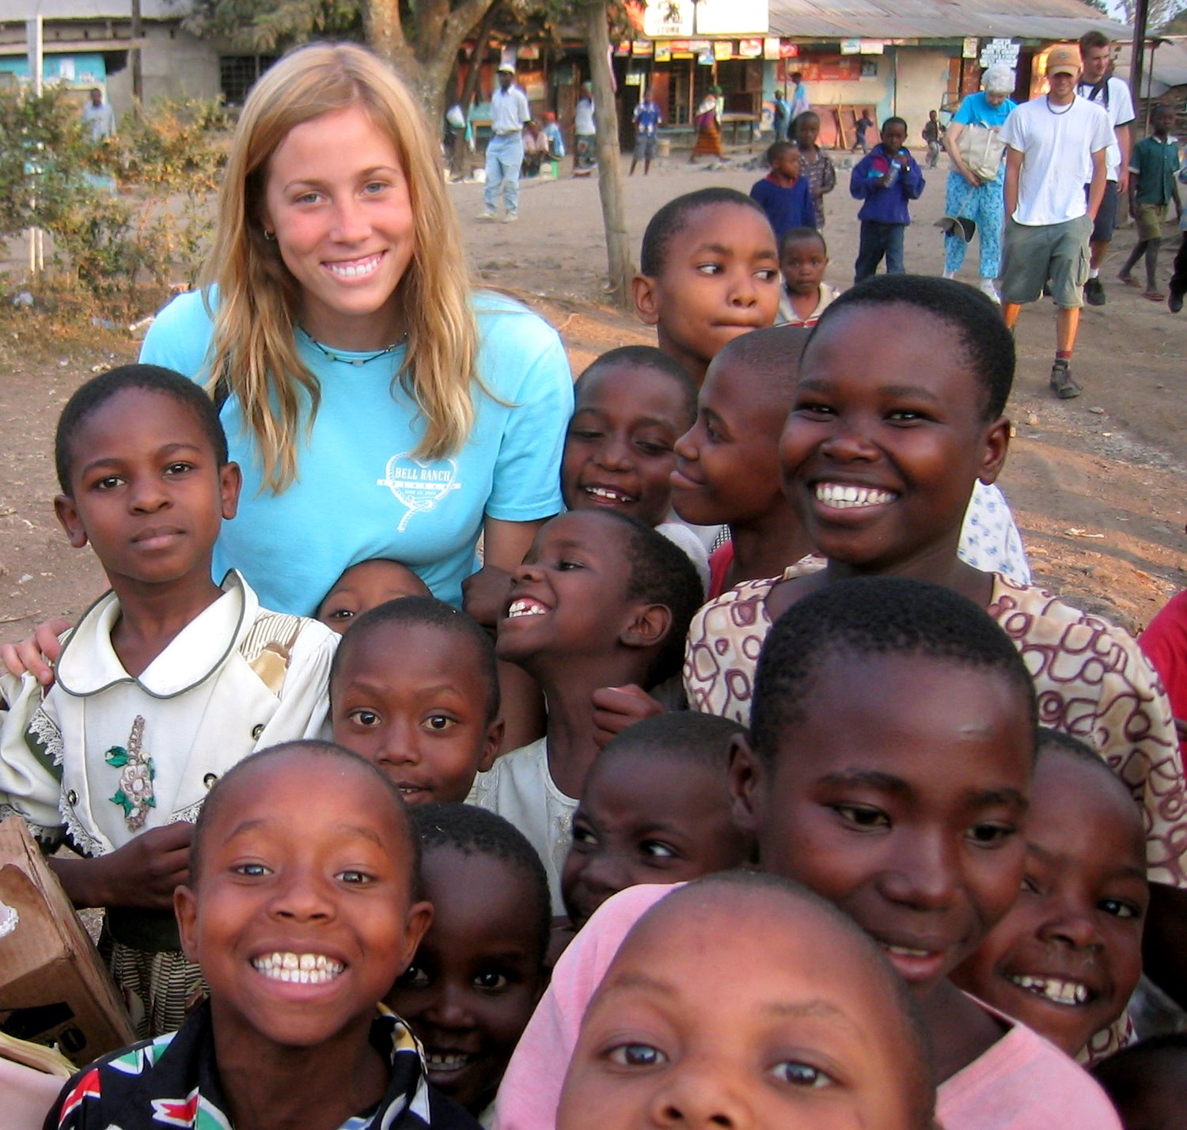
AfricAid’s origins date back to 1996, when its founder, Ashley Shuyler, traveled to Tanzania with her family at the age of 11 and saw first-hand the enormous educational needs that exist there. Determined to find a way to help, she formed AfricAid, which gained its nonprofit status in 2001, and which has since raised over $600,000 in its efforts to help support the educational needs of girls in Africa.

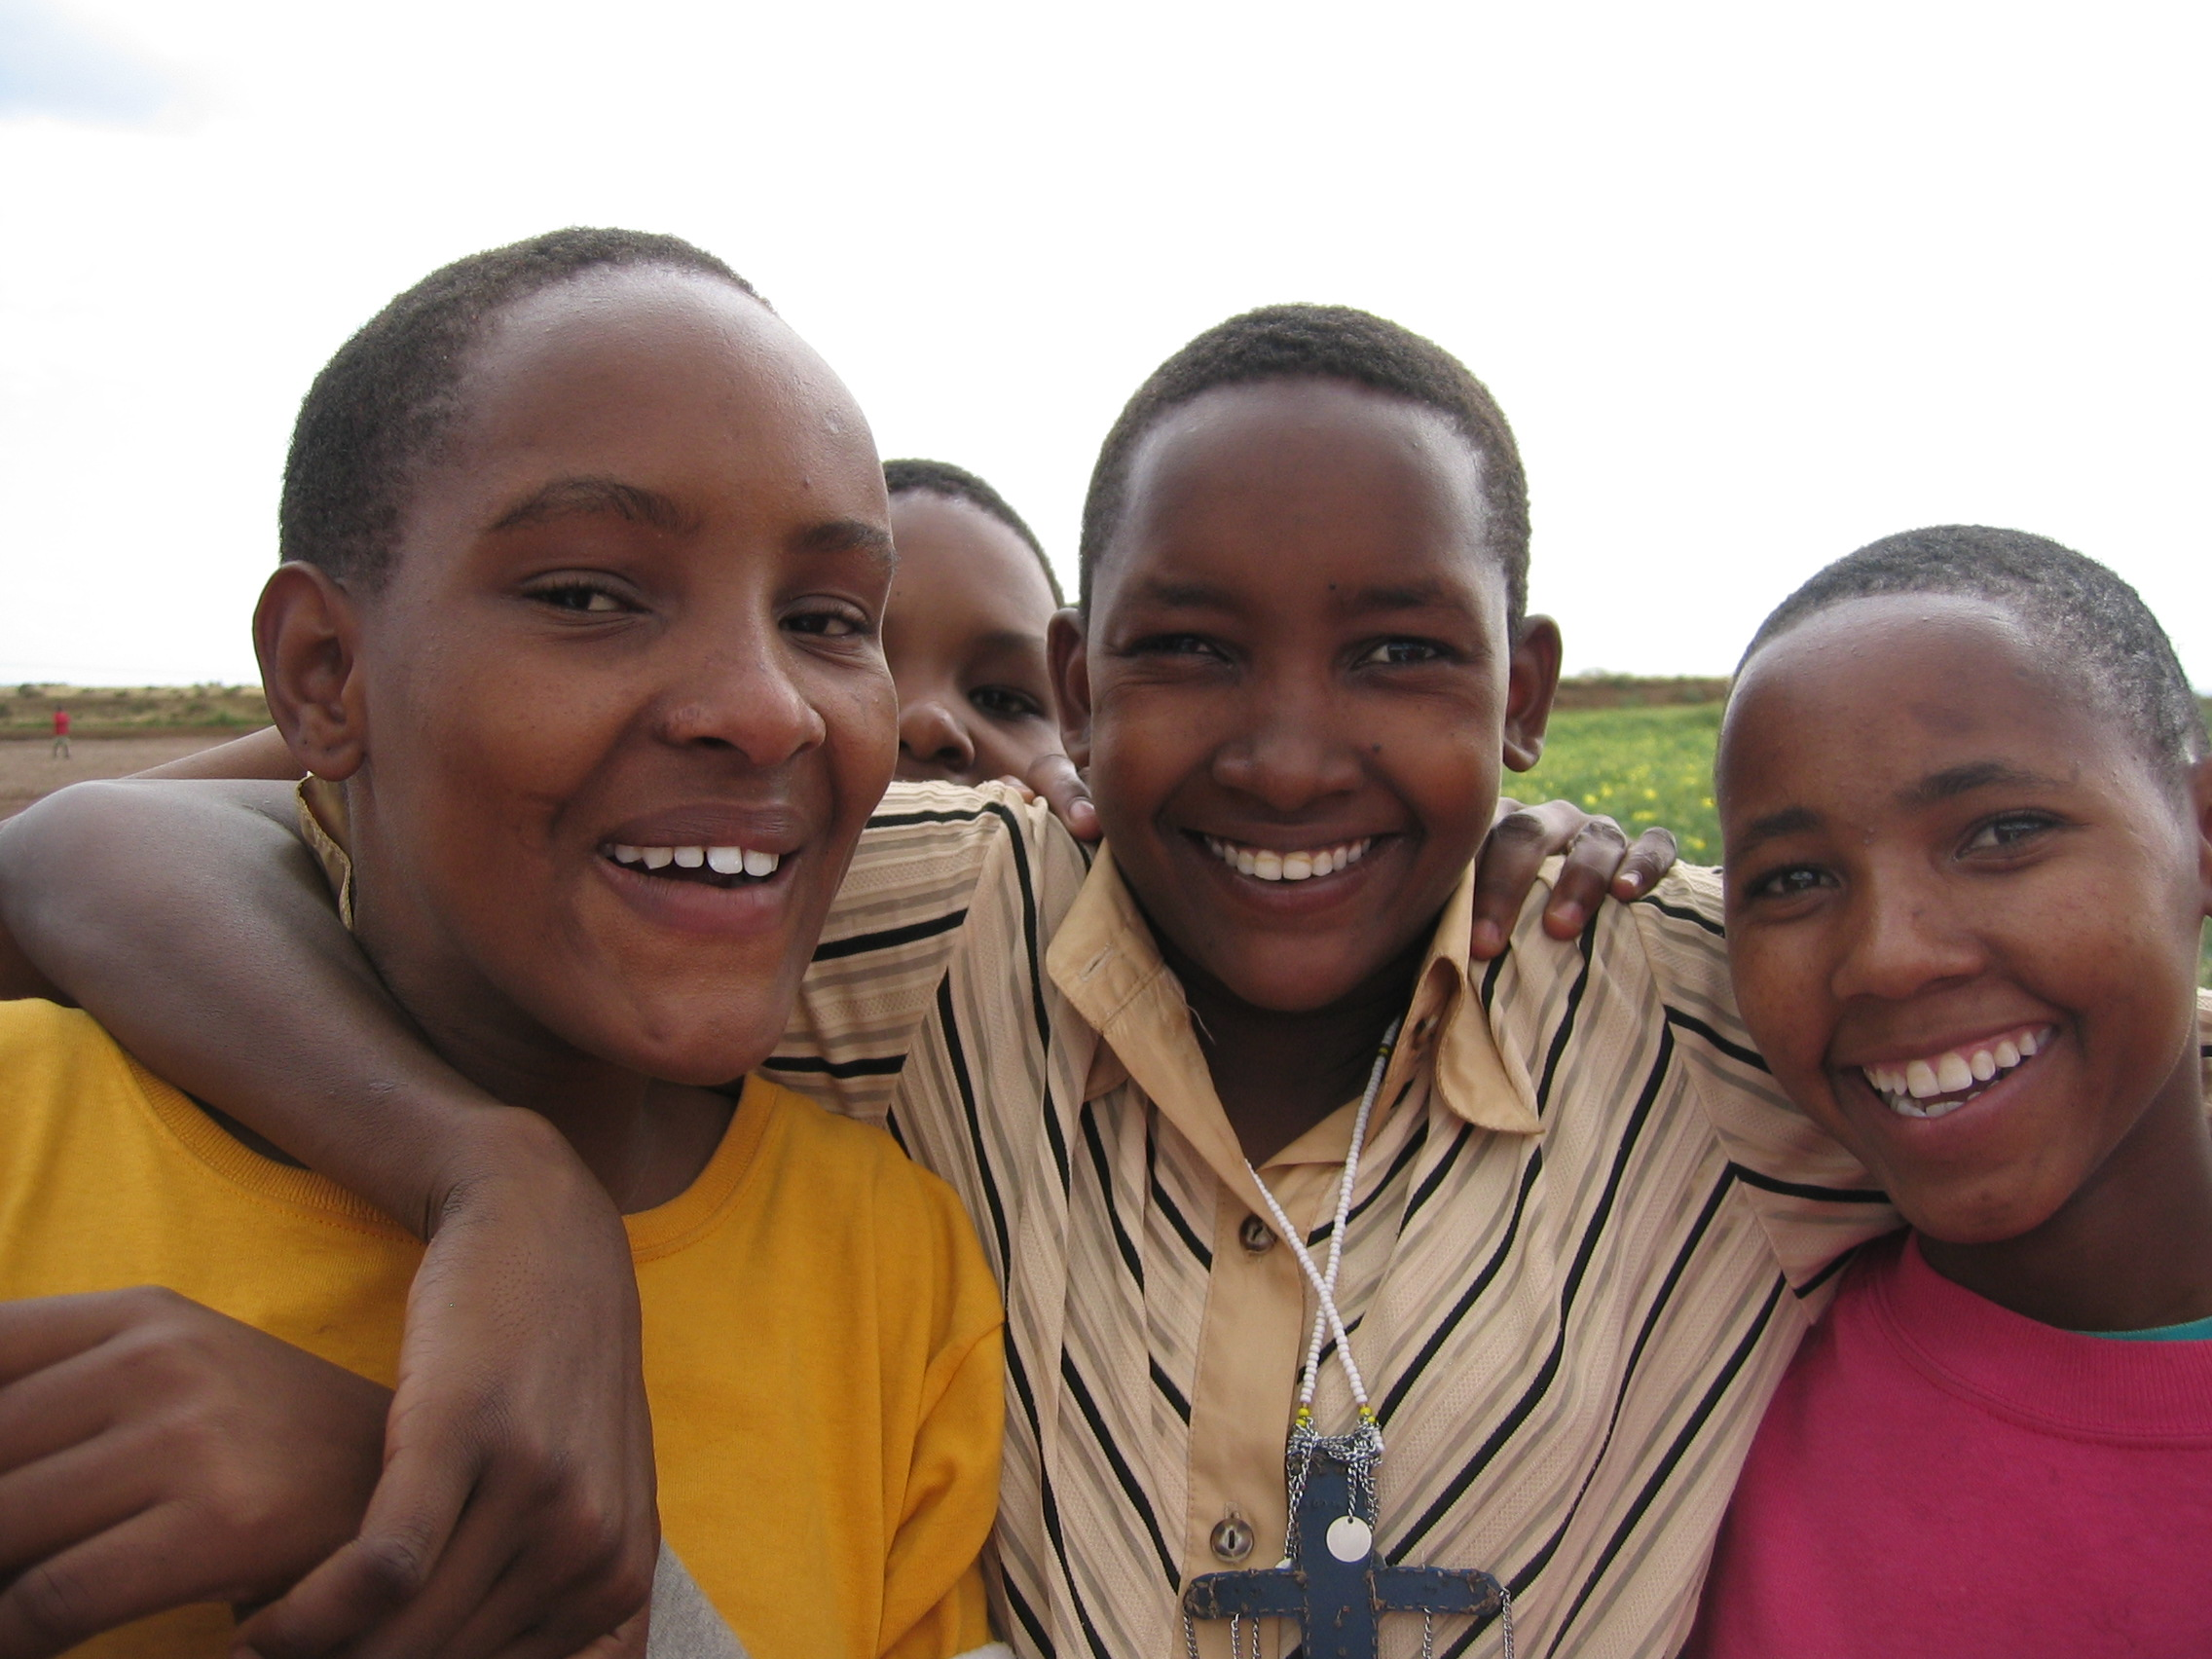
Since 2001, AfricAid has provided educational opportunities for thousands of students in nine schools across northern Tanzania. Specifically, AfricAid has provided over 200 secondary school scholarships, built classrooms at three overcrowded schools, started a school lunch program, provided computers for vocational training, and supplied over $100,000-worth of textbooks, school supplies, and other classroom materials to needy Tanzanian schools. Most recently, AfricAid has expanded its reach to establish an innovative, countrywide teacher training initiative that is working to improve the quality of teaching in hundreds of Tanzanian classrooms.

Since its beginnings, AfricAid has been a family-based organization. As AfricAid grew, Ashley’s parents, Rick and Nina, became more involved in its work, and other families began working together to achieve AfricAid’s aims as well. Each of these families has experienced the meaningful nature of working together on a project that is larger than themselves, and they have grown closer in the process. By offering families both in Tanzania and the United States a similar opportunity, AfricAid’s Jamii Leadership Project will be providing the tools by which family members can grow and learn together, work together to enrich their own communities, and connect to families in other parts of the world.

AfricAid’s Vision

Top of Form
AfricAid envisions a future in which all African girls have access to high-quality educational opportunities that empower them to identify needs in their own communities and take action to address them.
Bottom of Form

This vision can be summarized in four actionable components:
- Provide educational opportunities for girls who might not otherwise be able to attend school
- Enhance both the quality of education offered to girls in the classroom and its applicability to post-educational career and life opportunities
- Create opportunities for personal growth outside the classroom for young women, particularly through community-based service and leadership initiatives
- Encourage young women to continue to engage with their own communities and mentor the next generation of young girls

Moving forward, AfricAid will continue to support and expand its existing programs that meet one of these four core criteria, such as the Teaching in Action (TIA) teacher training seminar. However, as AfricAid’s new initiative, Jamii, grows from a pilot project into a larger program, it will begin to be the primary focal point of AfricAid’s work.

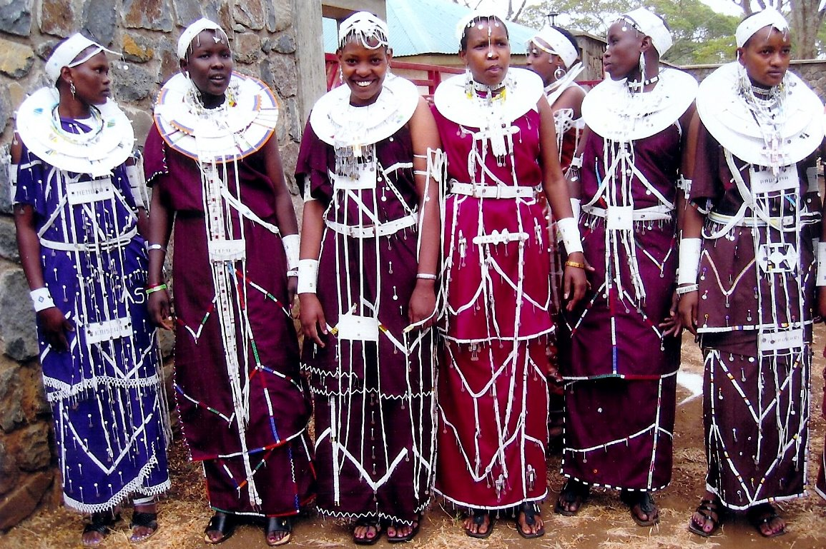

The Jamii Leadership Project

Overview
The Jamii Leadership Project is designed to offer the opportunity for young African women to obtain schooling they might not otherwise be able to receive, and to then empower them to become leaders and mentors in their own communities. Through a dynamic web platform, these scholars will connect with their American scholarship sponsors and, together, share and reflect upon their own life stories, considering how their experiences fit in with their respective larger visions of a better world.

A pilot version of Jamii will be implemented starting in January of 2010 in two Tanzanian schools. Once the program’s success has been established, it will be expanded to additional Tanzanian schools and to other Sub-Saharan African countries.

Student-Leaders
As the program’s starting point, each year AfricAid will select a new set of scholars to participate in Jamii. Students studying at the A-Level – the final two years of secondary school – will be eligible to participate. It is at this level that the greatest need for scholarships exists: approximately 20% of students pass the rigorous national examinations needed to continue on to the last two years of secondary school, but tuition costs dramatically increase during those years, which often forces students to drop out of school. By providing a scholarship at this educational stage, AfricAid will be supporting the schooling of those girls that have demonstrated the greatest potential for educational and professional success – but who might otherwise not be able to finish their schooling.

Students will be selected on the basis of a number of criteria, including demonstrated capacity for leadership, commitment to community, and financial need. The selection process will be conducted in conjunction with partner schools, which will be chosen on the basis of their commitment to providing high-quality education to their students.

Following their selection, profiles of the scholars will be posted on the Jamii website and, as described below, the students will then be paired with an American family, who will raise the funds for the two-year scholarship for their Tanzanian partner.

The Leadership Summit
Each year, the selected scholars will participate in a ten-day leadership summit. During the first unit of the Summit, the girls will learn leadership skills through experience, using an “outdoor education” model that will be adapted to the cultural landscape and natural environment of Tanzania. This experience will give the girls the opportunity to grow closer, to experience and demonstrate leadership skills in a real way, and to expand their “worldview,” helping them to realize that they are capable of achievement in ways that they never even knew were possible.

The “outdoor education” experience will be followed by a second unit comprised of intensive workshops, leadership-building exercises, presentations made by community leaders, and individual counseling sessions.

During the final two-day unit, the parents of the scholars will be invited to join the Summit. These final days will be a celebratory time for parents and daughters, in which parents are given the opportunity to learn about and celebrate the accomplishments of their daughters, through presentations and performances by the scholars. Parents will also participate in a small number of workshops, in which they will be given concrete tools with which to support their daughters and become leaders and role models for others in their home communities. This final unit will be both a celebratory time in which families can grow closer, and a time in which parents and daughters can make plans for the daughter’s community-based mentorship work upon graduation.

American families
American “families” will be a crucial ingredient in the Jamii Leadership Project. Importantly, they will be matched with the program’s scholars, and will undertake the fundraising efforts needed to provide the two-year scholarships for the young women. Through their interaction, they will grow closer as they work together to enrich their global community, and learn from and share stories with young women across the ocean.

American “families” of all types will be invited to participate in the program: families of parents and children, families of students at schools, and families of women in various organizations. Through curriculum materials provided by AfricAid, these families will be given the opportunity to learn about Tanzania, the state of girls’ education around the world, and the possibilities for engagement with their local and global communities. Additionally, the families will be provided with tools that can help them to work together to raise funds for their Tanzanian counterpart’s two-year scholarship.

Through a dynamic online forum, American families will have access to the personal narratives created by the girls in Tanzania (see below), along with periodic updates from them, and they will be able to post stories and letters themselves. Both partners will create profiles, which will include biographic information, “vital statistics,” a description of goals, and a barometer that indicates how much the American “family members” have raised for their Tanzanian counterparts.

Additionally, American “family members” will have the option to travel to Tanzania to meet their Tanzanian counterparts during the annual leadership summit. In all of these ways, American “families” will be able to grow closer as individual units, and also develop a truly meaningful connection with family members on the other side of the world.

Story Sharing
Upon being selected to the program, the Jamii scholars will work in partnership with an AfricAid representative, who will train them in the use of the Jamii website and guide them through the process of sharing their own “stories” in video format. These videos will provide a powerful medium through which each young woman can reflect upon her own life narrative, consider how it connects with her community and larger vision for change, and share it with family members across the world. American families will also be given the tools to create and share their own personal narratives, should they choose to do so.

American families and selected scholars will have the opportunity to communicate informally on an ongoing basis. Once monthly, a designated teacher at the scholars’ school will guide the selected students in the process of answering a question aimed to elicit reflection upon a particular aspect of their own personal narrative and commitment to community, which will be shared with their American family members on the website. The American family members will be encouraged to reflect upon and provide responses to the same questions.

During the Leadership Summit each year, there will also be the possibility for the participating scholars and American family members to “meet” – either in person if the American family attends, or through video conferencing.

Practicing Leadership through Community-Based Mentorship
Upon graduation from the sixth and final year of secondary school, scholars will have the option to return to their homes to become mentors to young girls in their community during the six-month period in which they have to wait for their national examination results. Should they choose to do so, they will receive a small, but meaningful, stipend, and will attend a several-week training workshop immediately following graduation to prepare them for this mentorship.

During the workshop, the participating scholars will be trained to become “life skills” mentors for young girls in their home communities. Through this process, they will be given the tools needed to mentor young girls in goal-setting, decision-making, communication and the formation of healthy relationships.

Once the scholars return home for that six-month period, they will be expected to organize a group of 15 young women (approximately 11-14 in age) with whom to implement the life skills curriculum. Using the leadership skills they have attained over the course of the previous two years, they will be expected to determine how best to organize, incentivize and regularly meet with this group of 15 students during those six-months. They will receive the remainder of their stipend at the end of the six-month period, after having demonstrated that they have effectively mentored at least 15 young girls in these critical life skills, as measured by pre- and post-evaluation surveys.

In this way, the Jamii Leadership Project will effectively equip a corps of young female leaders who will serve as role models and mentors to young girls in their own communities. One scholarship provided by AfricAid will therefore have, at minimum, a 15-fold multiplier effect.

Additionally, the mothers of these scholars will be offered a similar opportunity: they will be invited to participate in the life skills training with their daughters, and will be offered a stipend in order to train a group of other mothers in their community on how to effectively teach their own children these vital skills.

Alumni Network
Upon graduating from secondary school and completing their community-based mentorship, scholars will be welcomed into a powerful network of women leaders. As members of this network, scholars will have access to materials and opportunities to participate in community-based leadership projects, ongoing career counseling, and support from fellow alumni and local participating leaders.

Goals and Impact

AfricAid believes that it will seek to significantly expand the Jamii Leadership Project once the pilot stage has been implemented and evaluated in 2010. By 2015, AfricAid expects to have expanded the Jamii model to all regions of Tanzania, and will be positioned to introduce the initiative to other Sub-Saharan countries.

By 2015, AfricAid expects to have reached a total of 940 young women through its scholarship and leadership training, 9,300 girls through the mentorship provided by the scholars, and 940 additional “family members” through the sharing of stories and cultivation of relationships through the Jamii Leadership Project.

 | Partner Schools | New  Scholars | Total Current Scholarships | Mentored  Girls | American “Family Members”
2010 | 2 | 20 | 20 | -- | 20
2011 | 4 | 40 | 60 | 300 | 40
2012 | 8 | 80 | 120 | 600 | 80
2013 | 16 | 160 | 240 | 1,200 | 160
2014 | 32 | 320 | 480 | 2,400 | 320
2015 | 32 + Schools in new partner countries | 320 + Students in new partner countries | 640 + Students in new partner countries | 4,800 | 320 + Family Members for new country partners
Totals | 32 | 940 | 1,560 | 9,300 | 940

Metrics
AfricAid will measure the success of Jamii using a variety of quantitative and qualitative methods:

- The number of girls provided with scholarships who wouldn’t otherwise have had the opportunity to attend school
- The success of the leadership training curriculum, as measured by pre- and post-program evaluation surveys given to scholars
- The number of young girls who are mentored by scholars and demonstrate mastery of critical “life skills,” as measured by pre- and post-program evaluation surveys
- The number of scholars who continue to engage in community development work or other leadership positions, as tracked by alumni network communications
- The degree of American partner satisfaction with the program, as measured by mid- and post-program surveys
- The number of American families that maintain relationships with their Tanzanian counterparts through the website

Financial Projections (In U.S. Dollars)

 | 2010 | 2011 | 2012
Program Expenses
Scholarships | $6,000 | $18,000 | $36,000
Leadership Summit | $10,980 | $31,640 | $62,630
Life Skills Training Workshop | --- | $8,500 | $16,300
Life Skills Implementation | --- | $9,900 | $19,800
Installation of Internet at Partner Schools | $6,300 | $7,600 | $15,200
Management in Tanzania
Salaries | $3,000 | $5,000 | $7,000
Transportation | $5,800 | $5,800 | $5,800
Operation expenses | $1,000 | $1,500 | $2,000
Management in USA
Salaries | $24,000 | $24,000 | $24,000
Website | $1,000 | $1,000 | $1,000
Miscellaneous | $2,000 | $2,000 | $2,000
TOTAL | $60,080 | $114,940 | $191,730

American family members will be expected to raise $1,000 for each of two years for their Tanzanian counterpart. This $1,000 will cover the costs of the school scholarship, the annual leadership summit, and the stipend given to the student to teach life skills in their community upon graduation.
AfricAid will therefore need to fundraise above and beyond the costs of the scholarship for other ongoing costs of the program. AfricAid expects that it will cover the costs of the life skills training workshops through revenue generated by foundation grants and individual contributions, while partner schools in the United States will be sought out to “sponsor” the leadership summit in order to enrich the basic leadership summit experience budgeted for in the scholarship. AfricAid will either fundraise or partner with an existing organization to cover the costs of internet and computer maintenance at each school. Finally, AfricAid will seek grants and individual contributions for ongoing personnel and management costs in the United States and Tanzania.

Conclusion
Through the Jamii Leadership Project, AfricAid will create vital opportunities for schooling for young African woman and will empower them to become leaders and mentors in their own communities. Additionally, the project will provide a unique opportunity for individuals and families around the world to share and learn together, and to consider how their own life experiences fit in with their larger visions for a better world, while building strong communities in the process.

Truly, when families come together, great things can be achieved.

