Child Sponsorship
This is your chance to change the life of a child!

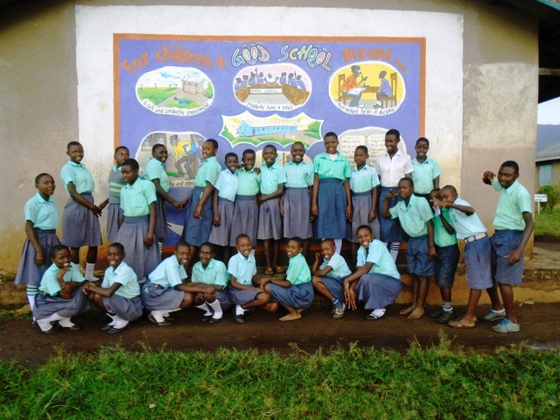
Did You Know?
In Uganda, two-thirds of children drop out of school before completing their primary education? The major cause for this is poverty. Uganda introduced Universal Primary Education (UPE) in 1997and the plan was to provide free primary education for underprivileged children. According to the Uganda Bureau of Statistics report 2016, 8.8 million children enrolled for the UPE program in 2014; however there was a decline in the enrolment by 5.8% i.e. 8.3 million pupils in one year. According to a report Out of school children study in Uganda March 2014 by Prof Christine Mbabazi Mpyangu and Dr Eria Olowo Onyango, while tackling reasons why children have never attended school in Uganda, they outline that children who have never attended school gave high cost of schooling as one reason for missing school. This is attributed to limited resources, funding for schools is inadequate leaving school administrators with no other option than charging school fees. Additionally, parents have to pay for books, school uniform, pens and note books.
Parents who are struggling to survive on less than 1 or 2 US-$ per day, often cannot afford paying for school fees and requirements. Their children drop out of school and are trapped in a vicious cycle of poverty.
__________________________________________________________________________________

Joy for Children’s Sponsorship Program:
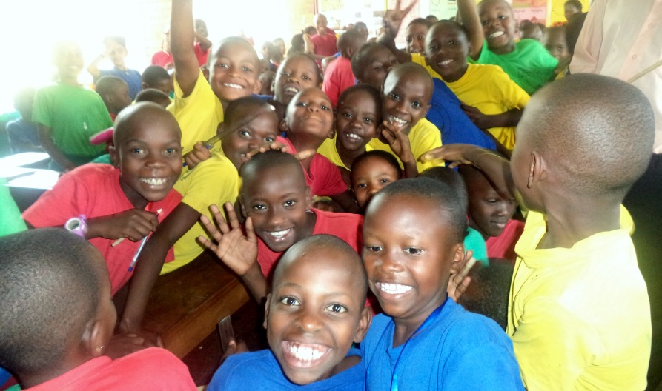
150 children currently benefit from JFCU’s Child Sponsorship Program. Joy for children identifies children these vulnerable children from child headed families, under privileged homes and orphans for sponsorship through its direct engagement with communities and community members of areas of its operation. Each month JFCU receives averagely 30 sponsorship requests.
Sponsorship ensures that children are able to complete their education which open doors to a better paid job and a way out of poverty.

Make a Difference
When you sponsor a child you pay for school fees and (optionally) requirements. Your contribution enables a child to stay in school and complete primary or even secondary education. Education opens doors to a paid job anda brighter future. Your sponsorship helps to break the vicious cycle of poverty!
You can change the life of a child for just:
- 20 US-$/ month for primary school fees only
- 30 US-$/ month for primary school fees and requirements (books, school uniform, pens)
- 30 US-$/ month for secondary school fees
- 40 US-$/ month for secondary school fees and requirements
- 75 US-$/ month for secondary boarding school
- 85 US-$/ month for tertiary (vocational) education school fees.
- 120 US-$/ month for university tuition on average. However, tuition varies with course.

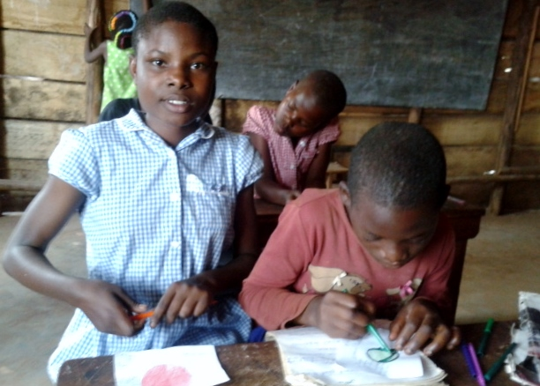
How Sponsorship Works
Our staff knows each of the sponsored children and meets them on a regular basis. She visits their schools to follow up on their performances. You will be the only sponsor this child has. This will make your relationship very personal and unique.
As soon as you sign up for sponsorship, we will send you a welcome package containing a photo of the child, a letter, and her/his story. And this is just the start of your relationship with your sponsored child. Each term you will receive a handwritten letter by your sponsored child and a school report. If you want, you can also write a letter and our project officer will hand it over to the child. Over time you will get a new photo to see how she/he is growing.

Sponsor A Child Now:
If you wish to sponsor a child, Please find the link https://www.globalgiving.org/projects/educate-a-child-sponsorship-programme/ or directly contact us at info@joyforchildren.org/ sponsorship@joyforchildren.org our staff will promptly reply.

We highly appreciate your support!

