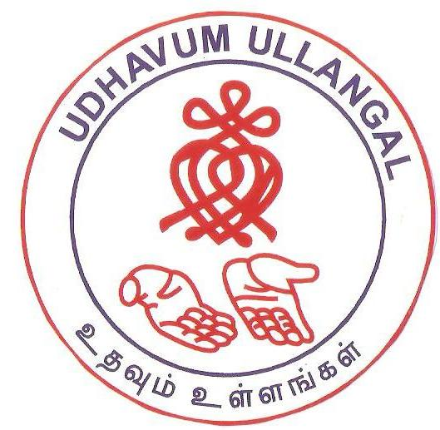

UDHAVUM ULLANGAL PUBLIC CHARITABLE TRUST
A DECADE OF SERVICE TO HUMANITY

ANNUAL REPORT 2015-16

Table of Contents

Our Mission 5
Our Vision 5
Future Plan 5
Founder Trustees Report 6
REPORT OF ACTIVITIES 7
A way to learn 8
A way to Succeed 10
Cancer Awareness and Screening Project 11
Cancer Awareness & Screening beneficiaries details for the period April 2015 – March 216 12
Total no. of beneficiaries Awareness & screening during December 2011 – March 2016 13
Relief & Rehabilitation – Chennai Rain Relief 18
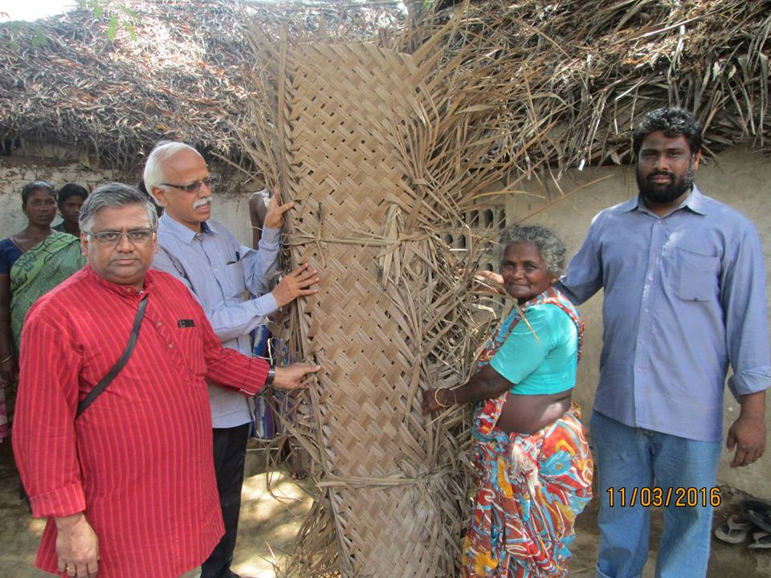 18

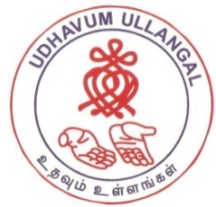
UDHAVUM ULLANGAL PUBLIC CHARITABLE TRUST

No.77, 1st Main Road, CIT Nagar, Nandanam, Chennai – 600 035.
Phone: 044 - 2434 4743 Mobile: 94441 94743.

Email: uu1sankar@gmail.com Visit us at: www.udhavumullangal.org.in

BOARD OF TRUSTEES

Mr. B Sankar Mahadevan : Founder Trustee

Mr. R Santhanam : Trustee

Mr. S V G Subramanian : Trustee

Ms. J Premalatha : Trustee

Mr. S Ramesh Kumar : Trustee

Our Auditor:

R Sivakumar, M/S. Gopikumar Associates

Donations to Udhavum Ullangal qualify for IT exemption under Sec 80G on Income Tax Act.

Registered under Foreign Contributions Regulations Act, 1976.

Our Mission

To provide educational - medical assistance, organise health awareness programmes, celebrate festivals and special days with orphans, destitute and differently - able children, render timely help and relief during disaster / crisis, and mobilize like-minded people to build a socially conscious, selfless society.

Our Vision

To create awareness and build a socialli conscious, selfless society, helping people in distress, poverty and during crisis.

Future Plan

Cancer Hospital

Every day, 1100 people die of cancer in India. Cancer care is expensive and inaccessible in many parts of South Tamil Nadu. Because of this, poor cancer patients in these areas have to be uprooted from their livelihoods and homes to take up treatment. To alleviate the sufferings of poor cancer patients at Tirunelveli we have established cancer prevention Centre (inaugurated by Dr.V.Shanta, Chairman, Cancer Institute, Adyar. The trustees and volunteers of Udhavum Ullangal, a Chennai based NGO, witnessing distressing scenario in the lives of hundreds of poor cancer patients wished to build a modern, 100-bed, cancer care Centre for prevention, early detection and treatment.
By locating the hospital closer to the patients, Udhavum Ullangal believes to bring advanced, affordable treatment.

A Community Service Centre, in which like-minded people join together to achieve our vision, to provide job opportunities for physically impaired.

To create job opportunities for the physically challenged people.

Village adoption.

Founder Trustees Report

Dear Friends,

Another successful year for Udhavum Ullangal with experiences it acquired in overcoming challenges it faced. The spirit of volunteers demonstrated our increased urge in offering relief due to natural calamity Chennai and other parts of TN experienced last year. We could provide timely relief to the thousands of households who had lost their belongings and livelihood with the inclusive support of individuals, traders and corporate. UU was proud to be part of Chennai Volunteers and derived strength of networking in resource mobilization and meeting the demand timely ensuring zero duplication/wastage. Further we had also contributed towards rehabilitation of vendors, families and tribal who were badly affected in floods both in Chennai and outskirts.

Thanks to the sustained and increased supports received from individuals and corporate we could meet increased demand for support on educational requirement of children. We had offered financial assistance to children to the tune of Rs.49 Lacs.

Our 3 skill development centre continue to excel and women got graduated in the current year.

Our Nellai Cancer Centre was inaugurated in July with infrastructure for screening and basic treatment for cancer. Our team has been very active in conducting several awareness programs and screening camps. One philanthropist was kind enough in donating land for cancer hospital project.

Our inclusive strategy of involving every person of society in our charity work reflected in donation we received from large number of small donors.

Support received from Press and TV channel in displaying our various activities helped us to increase our net working capability which is the need of the hour as we grow. Our co-operation with National child Labour Project and Department of Public Health Government of Tamil Nadu was mutual in sharing our experiences and helped mutually to enhance our reach. Brief snapshots of all our activities during the year can be found in this annual report. I am confident with your continued support we can make a remarkable difference in the lives of many under privileged children and create a healthy society.

B SANKAR MAHADEVAN
Founder Trustee.
April 2016

REPORT OF ACTIVITIES

A way to learn
Udhavum Ullangal’s main focus of activity is Education. We believe that educating underprivileged children is the surest way to help them write a new future for themselves.
A way to learn – Making a difference to underprivileged
We at Udhavum Ullangal Public Charitable Trust select the students who show good performance and interest in studies despite their weak economic background. We pay the term fees directly to the respective Institutions and also provide them Note books, Bags etc. We provide them career guidance and also help them to get admission in colleges. The progress of the students is closely monitored by periodic review of their term/semester results during mentoring. We mentor them first Sunday of every month to create interest in studies and to avoid drop out through our volunteers. Chennai students Holistic Development program "Mentorship Program” last program for this academic year was conducted on Sunday 6th Mar 2016 at RKM Saradha Vidyalaya School, Burkit Road, T Nagar.

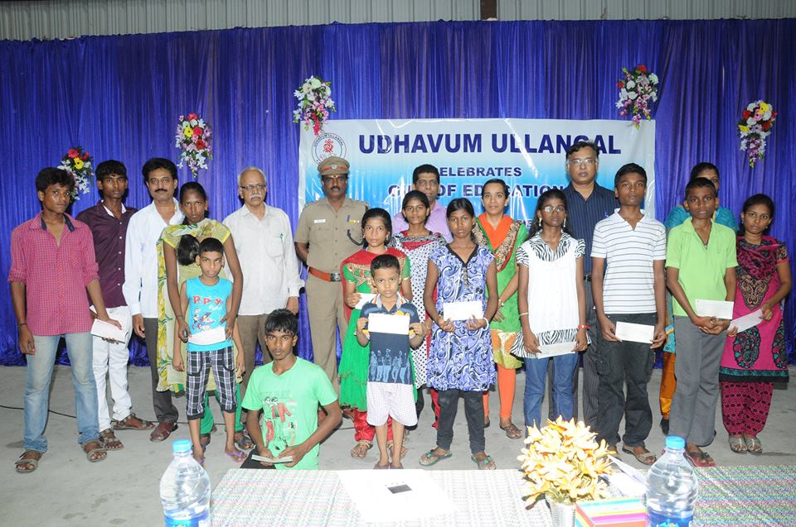
Gift of Education
Description | Beneficiaries | Amount
School Fees | 234 | 2280184
College Fees | 97 | 1519949
Uniform | 480 | 51604
Note Book | 790 | 259783
Total | 1601 | 4111520

.

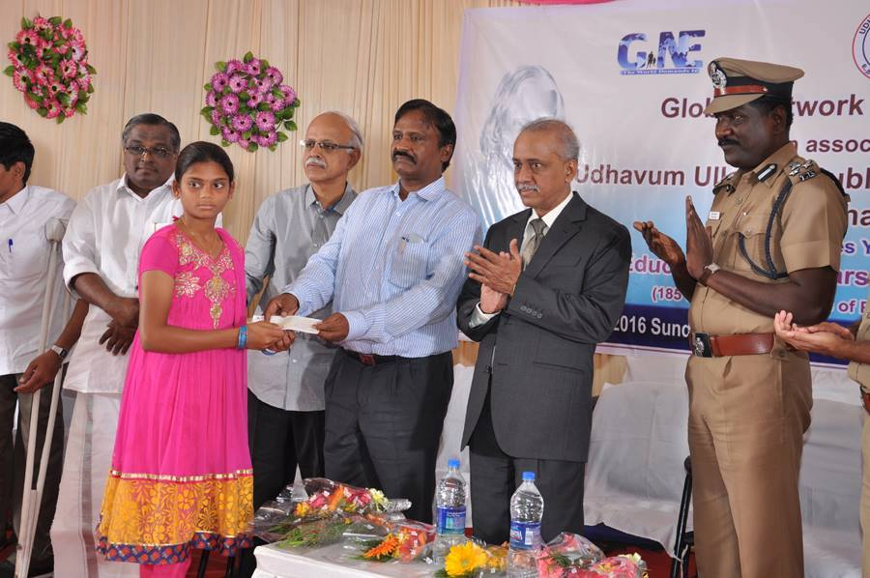

Udhavum Ullangal Public charitable Trust & NGO Global Network for Equality distributed Educational support to 182 children of Palayamkottai Prison inmates on Sunday 10th Jan 2016 at Nellai.

A way to Succeed

Women’s Empowerment educates and empowers under privileged women with the skills and confidence necessary to secure a job, create a healthy lifestyle, and regain a home for themselves and their children.

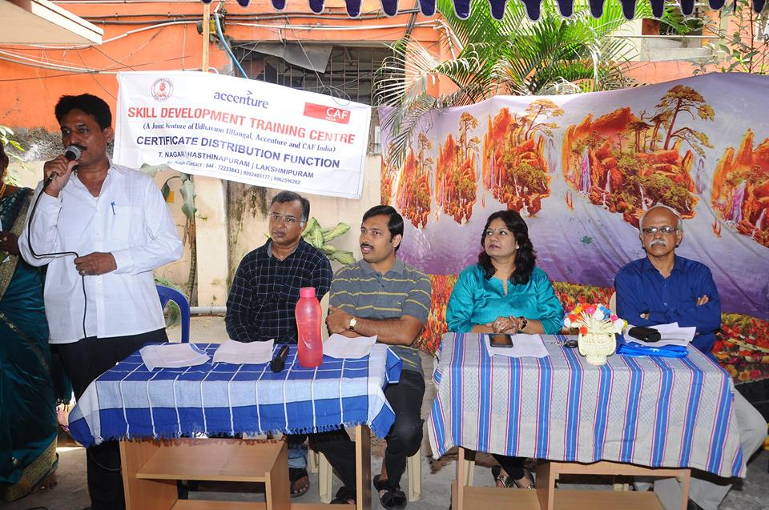

Certificate Distribution Function held on 28th & 29th February 2016 at Hasthinapuram, Lakshmipuram and T. Nagar.
15 of our students from Skill Development Centre (a project supported by Accenture & CAF) displayed their products for sales in Aon Hewitt on 17th & 18th March 2016
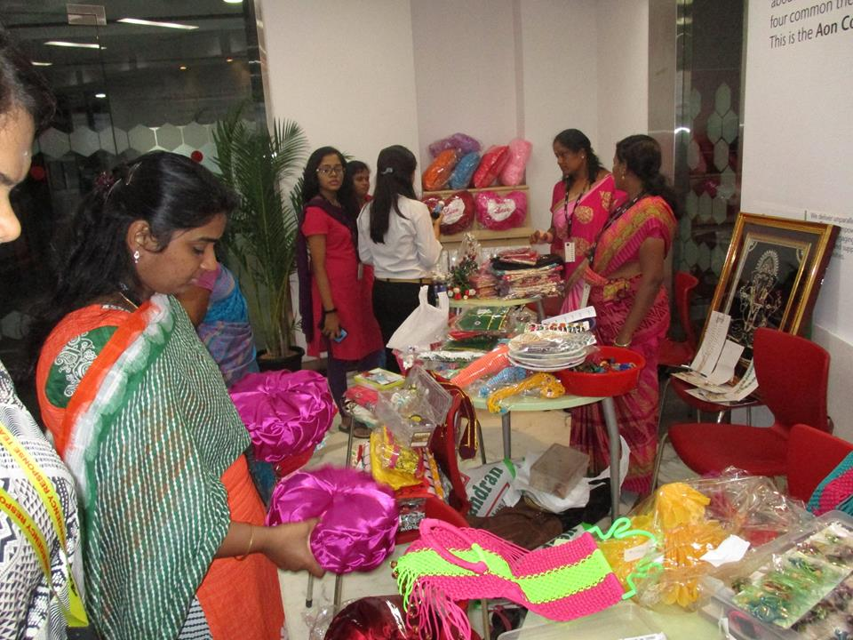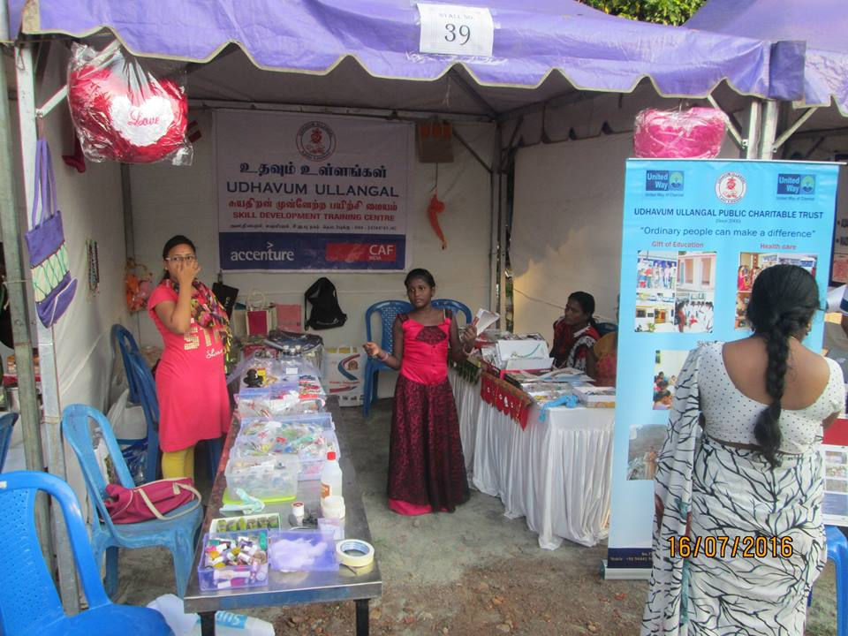

Cancer Awareness and Screening Project
Udhavum Ullangal has recognized the rampant growth of cancer incidence and has been closely working with Cancer Institute (WIA) Adyar towards creating awareness, education, screening and treatment over a decade.
The Cancer Prevention center was inaugurated by Dr. V. Shanta, Chairman, Cancer Institute, Adyar (WIA) on 2nd October 2011 at Tirunelveli.
Under the guidance of Dr. V. Shanta & her team, Udhavum Ullangal established a low cost cancer care program in Tirunelveli.
The main focus is to educate the public on the fact that cancer is curable if detected early, Cancer is preventable and to dispel myths about cancer among the public.

World Cancer Day 2016 by Nellai Cancer Care Centre - "We can I can " work together to reduce the global cancer burden.

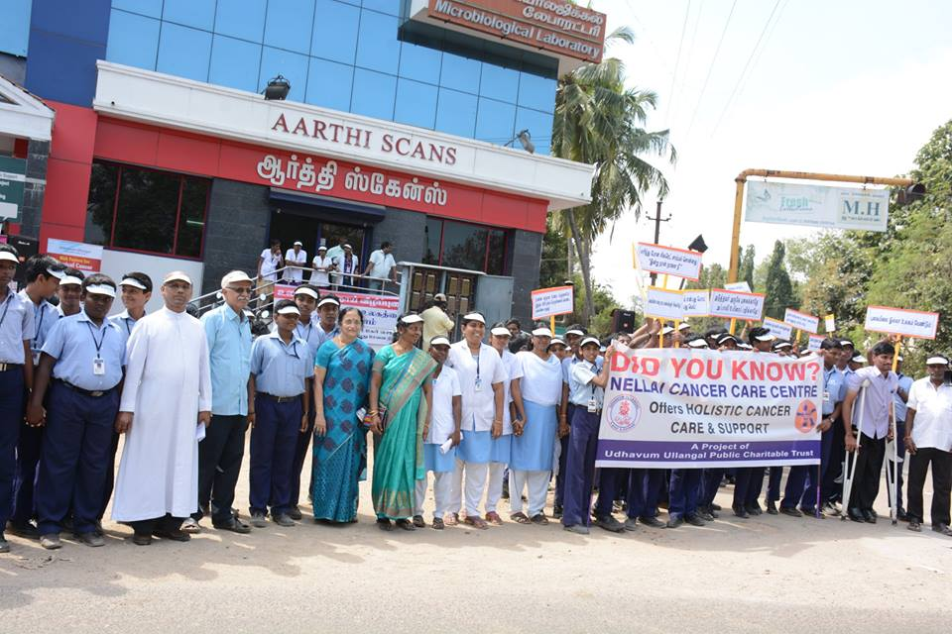

Cancer Awareness & Screening beneficiaries details for the period April 2015 – March 216

Month | No. of Camps | Total  Participants | Cancer Screening |  |  | Pap  Smear | VIA  +ve | Tobacco User
 |  |  | Total | Female | Male |  |  | Total | Female | Male
Apr’15 | 21 | 460 | 206 | 181 | 25 | 157 | 31 | 28 | 3 | 25
May’15 | 26 | 607 | 260 | 212 | 48 | 171 | 36 | 50 | 3 | 47
Jun’15 | 11 | 1807 | 255 | 202 | 53 | 153 | 27 | 51 | 6 | 45
Jul’15 | 11 | 1920 | 246 | 219 | 27 | 180 | 28 | 34 | 7 | 27
Aug’15 | 17 | 1644 | 319 | 283 | 36 | 218 | 38 | 46 | 10 | 36
Sep’15 | 18 | 2163 | 302 | 270 | 32 | 218 | 47 | 36 | 4 | 32
Oct’15 | 16 | 1674 | 298 | 268 | 30 | 216 | 75 | 44 | 14 | 30
Nov’15 | 13 | 926 | 232 | 171 | 61 | 126 | 52 | 67 | 6 | 61
Dec’15 | 14 | 2397 | 318 | 279 | 39 | 189 | 60 | 47 | 8 | 39
Jan’16 | 13 | 1420 | 293 | 260 | 33 | 189 | 83 | 43 | 10 | 33
Feb’16 | 24 | 1447 | 392 | 340 | 52 | 249 | 72 | 57 | 9 | 48
Mar’16 | 6 | 586 | 65 | 64 | 1 | 48 | 8 | 4 | 3 | 1
Total | 190 | 17051 | 3186 | 2749 | 437 | 2114 | 557 | 507 | 83 | 424
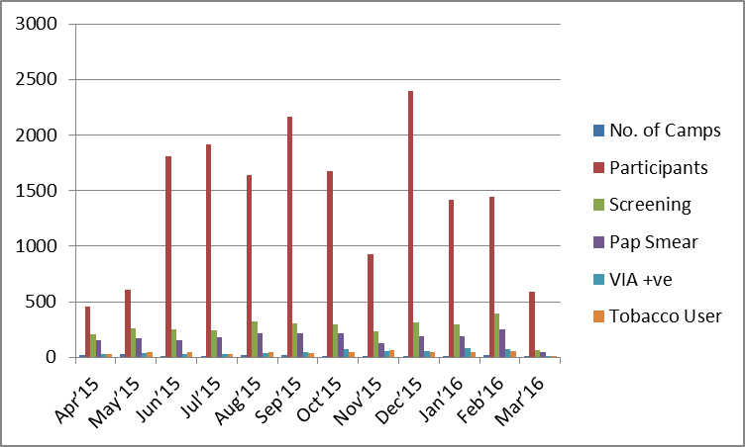

Total no. of beneficiaries Awareness & screening during December 2011 – March 2016

Period | No. of Screening  Camps Conducted | No. of persons  screened | No. of persons attended  awareness programme
Dec 2011 – Mar 2012 | 20 | 760 | 1952
April 2012 – Mar 2013 | 109 | 2606 | 8212
April 2013 – Mar 2014 | 143 | 3563 | 9122
April 2014 – Mar 2015 | 148 | 3197 | 10530
April 2015 – Mar 2016 | 190 | 3186 | 17051
Total | 610 | 13312 | 46867

- Awareness Program to School
- . Awareness program conducted at Singamparai School where the students exhibited excellent interest and attention.
- 2. Awareness given to school students at Tenkasi regarding preventive screening for Breast cancer and Cervical Cancer.
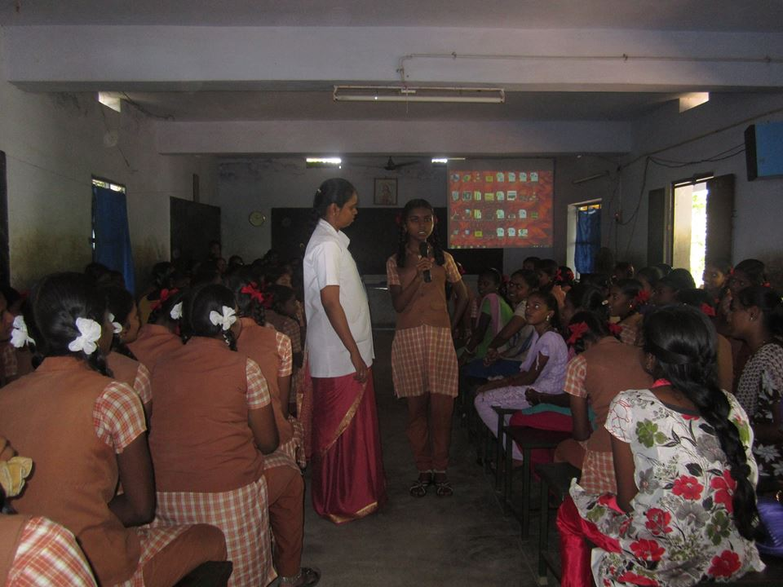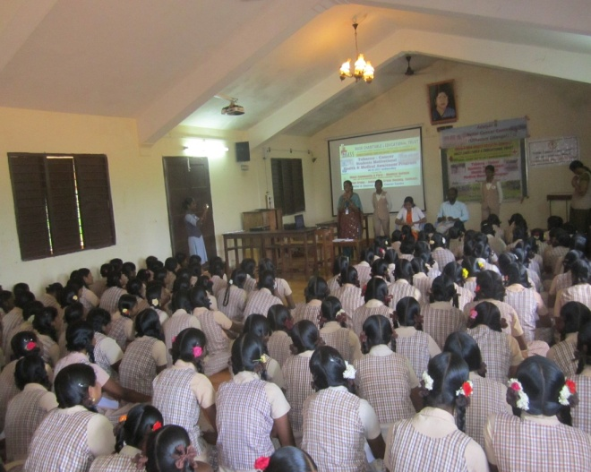

- Awareness Program to College
1. Cancer Awareness program conducted at Tirunelveli Infant Jesus Engineering College, Vallanadu in which 560 students participated on 31st August 2015.
2. JP College of Arts & Science, Ayekudi in which 469 students participated on 26th August 2015.
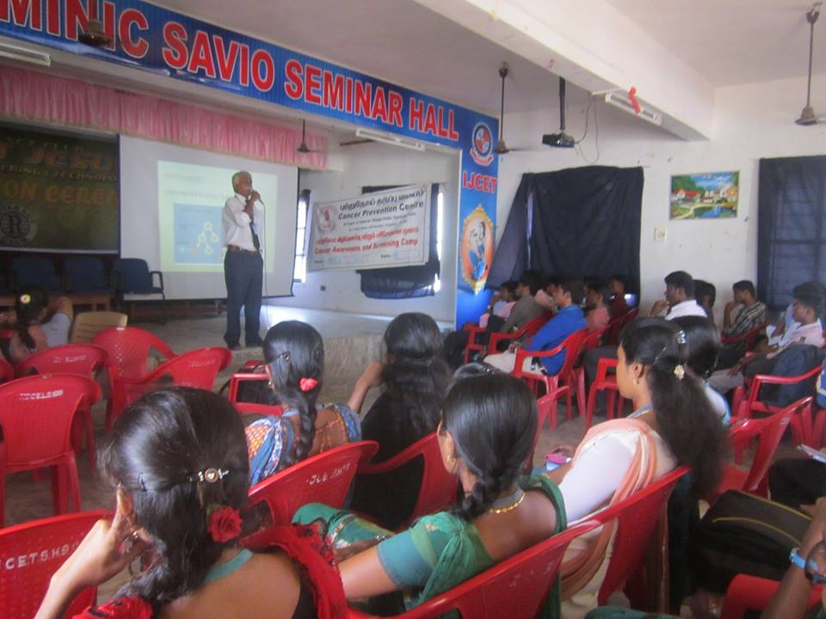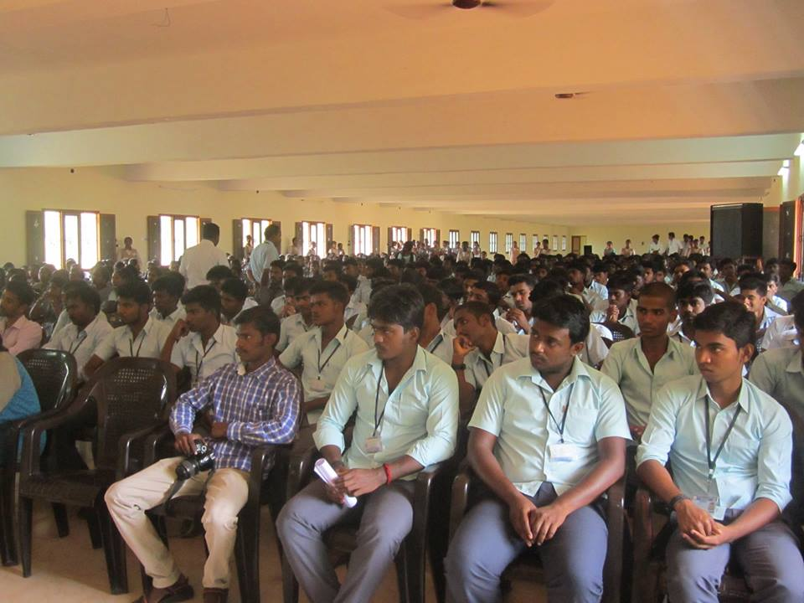

- Awareness & Screening Camp at Rural Area
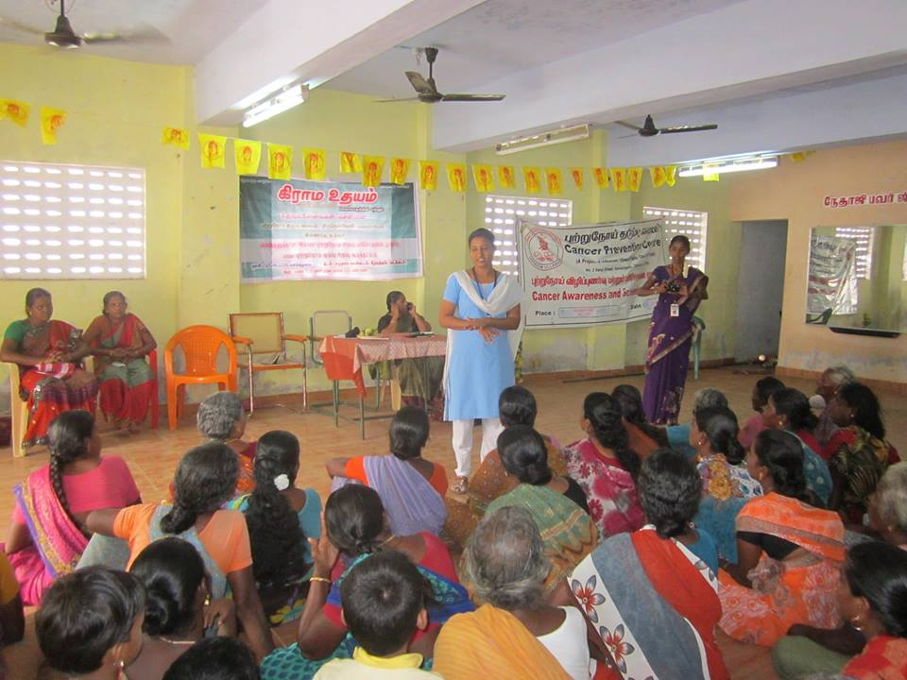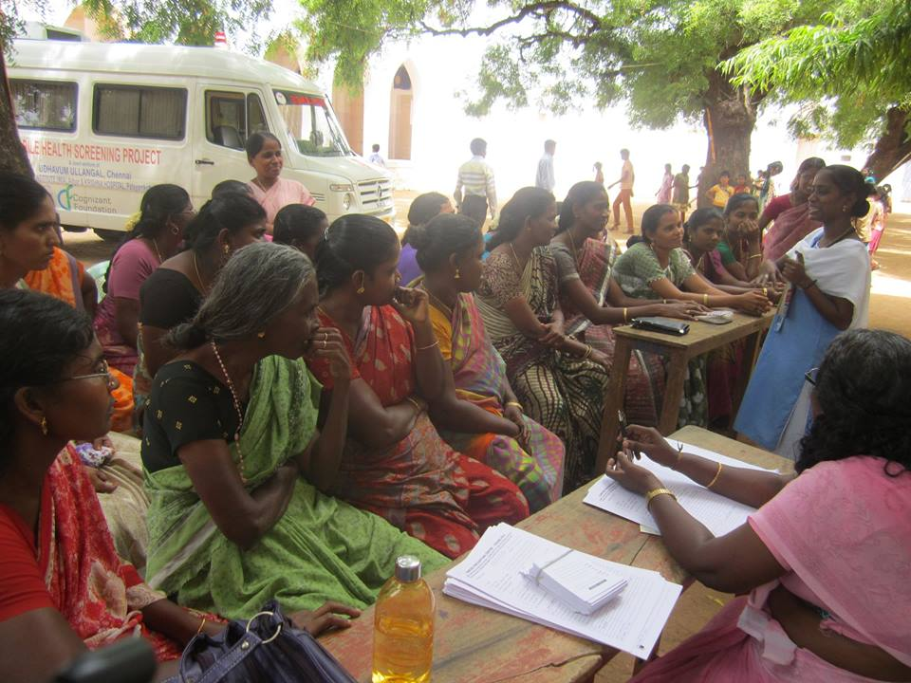
- Pink October – Breast Cancer awareness – Signature campaign – Press meet – CME

Pink October was observed on 31st October 2015 in association with Indian Medical Association, Tirunelveli.
- Starting with signature campaign at Palayamkottai bus stand in the presence of Mayor Mrs. Bhuvaneswari with Rotary Club President, followed by a press meet.
- We had around 15 patients at NCCC who had doubtful breast swelling were examined and advised by Dr. Hymavathy Raje, Breast Onco Surgeon, Apollo Hospital, Bangalore.
- We had a continuing medical education programme for doctors. More than 50 doctors participated. The topic was 'Recent advances in the management of cancer breast.
.
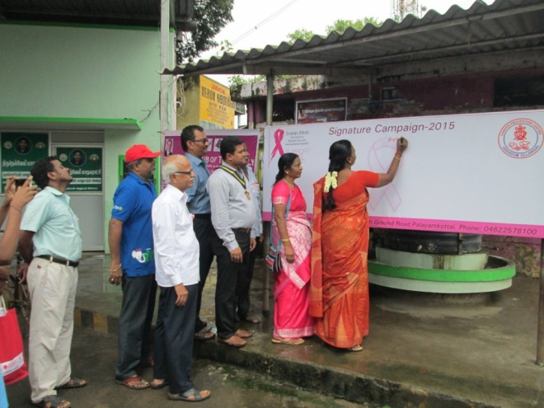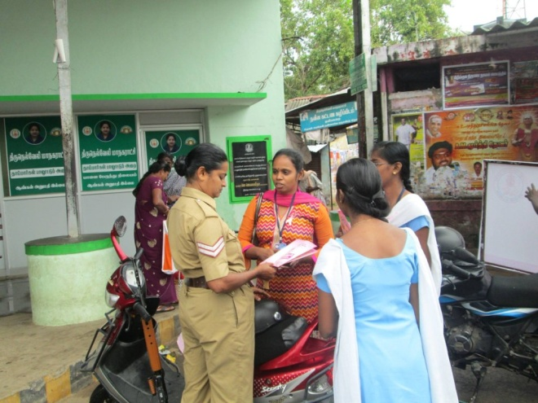

- World Cancer Day

Nellai Cancer Care Centre observed World Cancer Day on 4th Feb 2016 at Palayamkottai with Human Chain by Students of Jayendra School & Christuraja School. Oath against Tobacco usage was taken by Students. Awareness given to Staff of Post office, Axis Bank, Suresh Tutorial College, Teachers Training College & Aravind Eye Hospital.

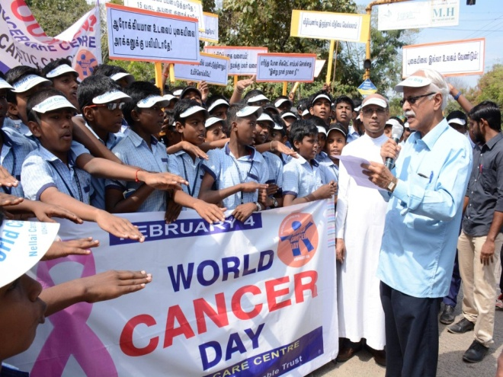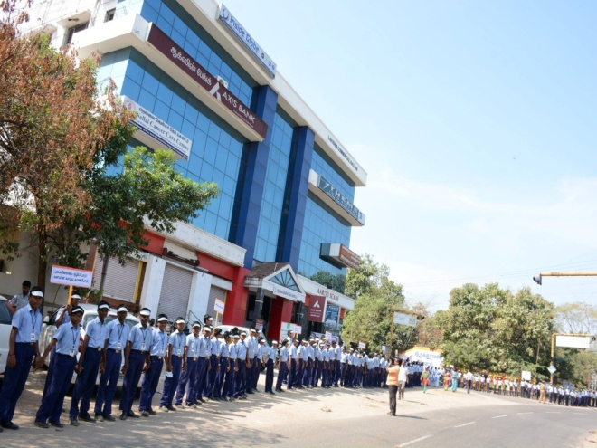

Anandha Deepavali Annual celebrations
Anandha Deepavali has become a unique celebration in which deprived and disadvantaged children are brought together each year on or before Deepavali for one day of festivity, feasting, contests and fun; each child also gets a custom-tailored, new Deepavali dress. How does a hall with 1251 cheerful children of different age groups sound? What if they are all gathered to celebrate Deepavali? Crazy, right?
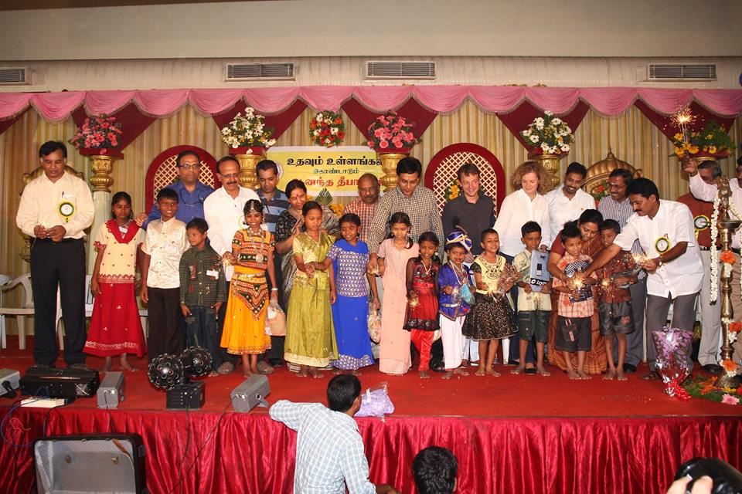

It was on 24th Oct 2015, Sunday when Udhavum Ullangal, a public Charitable Trust celebrated its 15th year of Anandha Deepavali at Krishnaswamy Kalayana Mandapam, T.Nagar. Volunteers from different Corporates spent the whole day performing and dancing with the children. They distributed clothes, helped the little ones to change into their new clothes, took care of their needs and made them enjoy the Deepavali well ahead of the actual festival day.

Relief & Rehabilitation – Chennai Rain Relief

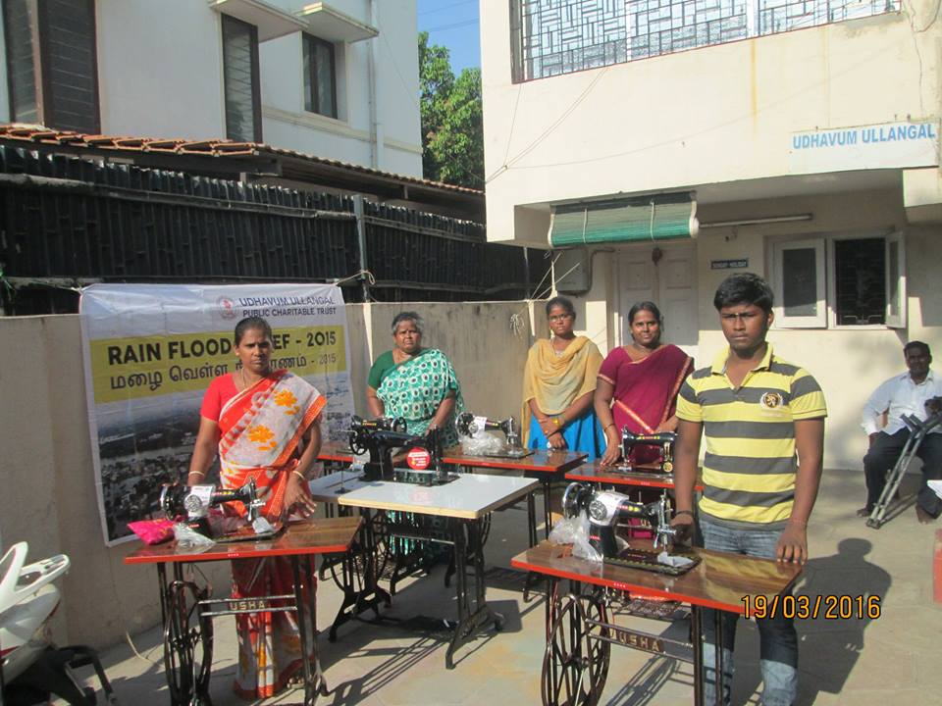
Sewing machine 5 Nos. to rain affected people. Thanks to Reed Elsevier for their support.
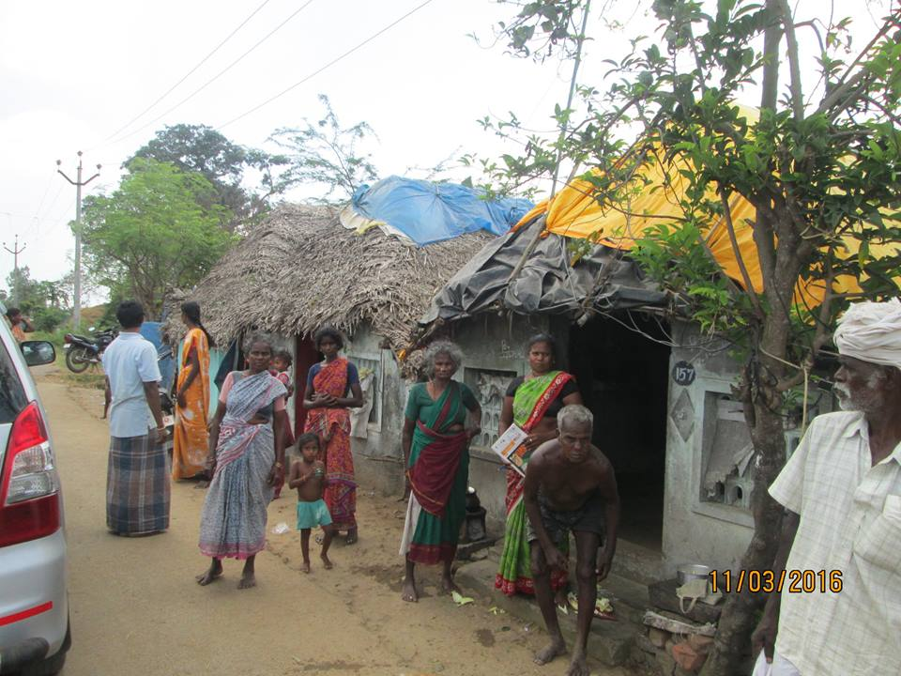
Keeth (Weaved coconut leaves) given to 102 houses of Cuddalore district villages on 11th March2016
