CV and Projects Proposal for Secondary Schools, The less-priviledge elders and Parents In Rural Area of Bende in Abia State And Enugu East LGA, Udi LGA, in Enugu State:

Written by:

Matthew Onyemauwa Kalu.

Your empowerment is our work, Your growth is our desire.

Background
The future in you foundation, (TFF) was established in the year 2010. TFF is registered with Corporate Affairs Commission (CAC) with registration number as CAC/IT/ 69253. The Future in You Foundation was created in responds to the increasing developmental and educational problem in Enugu State and Nigeria at large, using Bende in Abia State, Enugu East LGA and Udi LGA as a point of contact. Resulting issue in the lack of inefficient security, which has caused increase in the personal disposed People (PDP); The Future in you Foundation was one of the First Local organizations to provide sustainability to the less-privileged elders and provide skill acquisition to the youth, which has resulted to given more livelyhood to mankind. The future in you foundation address issues through sensitizations and skill acquisitions.
Mission
The future in You Foundation is an organization created to prove a point for indigenous participation in human Life. Also, to fight against evictions, discrimination and the stress towards education, sustainability and reliability in communities, to provide quality skill to control the affected People from lack of education and sustainability for future generation. Discovering and developing human beings potentials in the aspect of the cordial Focus by providing complete quality assured educational background capable of satisfying the most stringent requirement of human beings wherever it is required, using the most available technical skills.
Vision
Our vision is thus: to be a reference point in changing human's mindset from negative thinking into positive action. Also, turning our NGO"s goals into reality in Enugu State and Nigeria at large. Creating suitable education to avert security problem, sexual harrashment and poverty to large extent.
Championing the Cause
Our experience in controlling educational problem, means of caring for the less-privilege elders led us to the analysis of how we could best work together to create our organizational structure and develop sustainable strategy so that the project will be developed and controlled by community residence. Below are our strategies;
- Contributing greatly to the less-privilege elders sustainability and livelyhood.
- Contributing greatly to improving access to educational material to the youth.
- Partnering with the community "Joint Task Force (JTF)" to combat human harrashment.
- Strengthening the capacity of Community unity to identifying the less-priviledge youth in other for us to effect action or help.
- Networking:- Creating a means of suitable communication between the community residence and the educational stateholders to strengthen educational background and the less-privilege elders sustainability.
- Training: - We will organize a chain of skill acquisition training to the youth, enlightening them on different skill knowledge.
- Campaign:- We will conduct series of campaigning with the masses to fight educational problem and increase human love to helping one another (the less-privilege elders and less-privilege youth).
- We shall celebrate the heroes that has helped Rural Area of Enugu East LGA, Udi LGA in Enugu State to grow. This will drive others to join the helping train.

Project and Communication Plan
What groups do we need to serve most? | What do they need to hear from us? | What is the Best way to find and communicate with them? | When will we communicate with them? How often? | How will we know if they have heard our message?
The country (involved communities) will be divided into groups such as:-  - Educational Stakeholders.  - Youth leaders.  - Less-priviledged Elders.  We will communicate/Lecture the Stakeholders/ Youth leaders/Communities on  - The means of fighting educational problem.  - Creating skill acquisition, and  - Minimising of hunger | The community’s needs to be more united, they need more secured and efficient Education.  We will lecture the youth of the communities on the need to be highly skilled.  We will provide an efficient and effective hunger prevention method. | Our duty is based in the rural areas.  The rural areas does not have efficient means of networking among themselves. So, we shall have a direct communication with the rural area indigenes.  Training to educate them:- We will provide the networking system and create a training section for them, which will give room for communication. | We will communicate with them weekly.  We will send newsletters/educative information every two weeks.  We will create networking and Training system every month. | We will organize seminars with their stakeholders/youth leaders and also give out questionnaire to the public.  We will create a monitoring group that will communicate directly to the masses.  This will ensure the enlightening of the masses by reducing educational problem, increasing unity, strengthen the youth on skill acquisition and provid pess-priviledged sustainability.

Project Need and Motivation.
One of the primary reasons for selecting and embarking on this project is to achieve a community of comfort and to reduce the cause of Poverty among constituencies.
To do this, we use the methodology of frequent education to develop a leadership skill and comfort Zone.
Frequent education helps communities to identify their problems, expectations and needs; facilitate change; and examine unequal power relations in Society.
With frequent education, the expected changes in problem will be achieved as a tool to raise people's consciousness of how their personal experiences are inextricably linked with large social problems. When they are encouraged to unite with each other, trained in skills and work with knowledge they have from their own experience; they can develop strategies together to change oppressive system. This methodology offers the most effective and hopeful system to address and change the root causes of poverty, educational problem and insidious effect it has on those it ensnares.
Capacity Building
- To combat hunger to large extent.
- To focus more on communication.
- To enable everyone know the important of education.
- To create a lasting solutions to security so that at the entire end there will be effective and efficient security and increase in hunger strike in Enugu as per say.
- Creating a networking and training system that will enhance development and educate the masses against ingorance which is currently revamping the society.
Due to the many constant human right violation to low-income people with low-level of education workers, and their families, we have defined educational problem as urbanistic violence. Although giving the hustle daily life characteristics that we confront in our communities, we have established a dialogue of mutual respect that is not only focused in our organization, but as well within communities (Enugu East LGA in Enugu State and Bende LGA in Abia State).
Also; we have defined hunger for food and lack of comfort as a trade in human beings. most commonly for the purpose of poverty and ingorance, forced labour or commercial sexual exploitation or others. We have put plans together to minimize hunger for food, increase comfort and development through education and networking.

Training/Educational Assistant Results/Benefits to the Masses.
We will create a cordial relationship between the masses and the stakeholders of the group to enhance effective communication and networking against educational problem, hunger for food, and health issues.
The benefit of either training or educational assistant will be evidence to the tackling of poverty (hunger for food and comfort), security, educational problem and health issues in the following areas:-
- It will improve unity among the masses.
- It will increase educated youth and enhance security.
- It will increase reliable and sustainable communities.
- It will increase the health of the abuse women (Reproductive health and mental health).
- It will bring development to the area and to the masses.
- It will quench starvation of the abused/human beings.
- It will increase financial management of the area.
- It will contribute towards opportunity for the expansion into main-stream economy.
- It will increase the knowledge and complaints with human resources regulation.
- It will increase the level of understanding among one another and increase the Housing Planning.

PREVIOUS PROJECT
- The future in you foundation, TFF in 2012 trained 30 youths of Birnin kebbi in Kebbi State on Computer application.
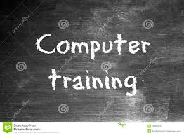

- In 2014, TFF visited the Daughters of divine love motherless baby home in Enugu, Enugu State.
In 2014, TFF visited Daughters of Divine Love motherless baby home located in Abakpa, Enugu East in Enugu State. During this visit various useful materials such as; Cartoon of Indomie, Papers, and other things was given the management of them (DDL). During this visit, the life of 70 to 100 children was helped.
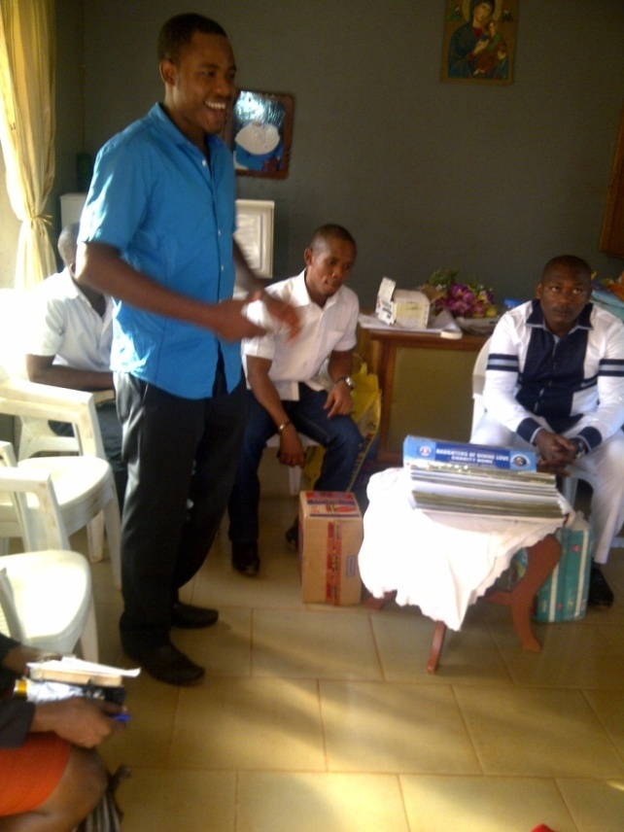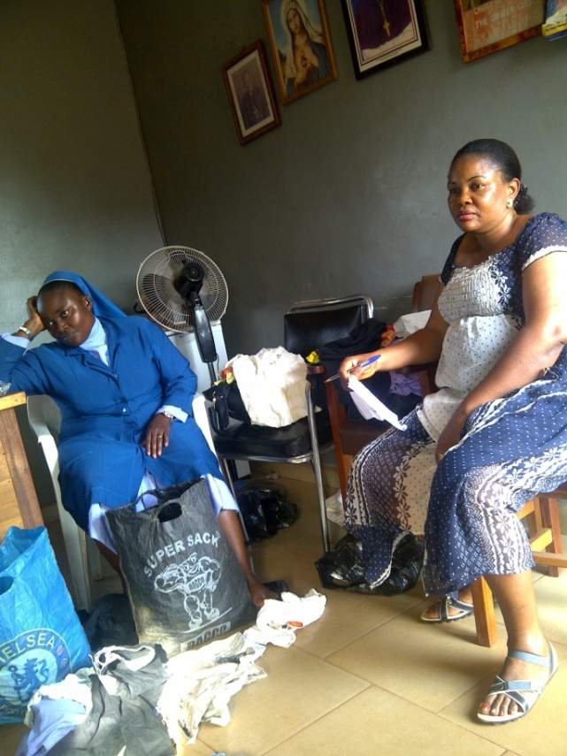
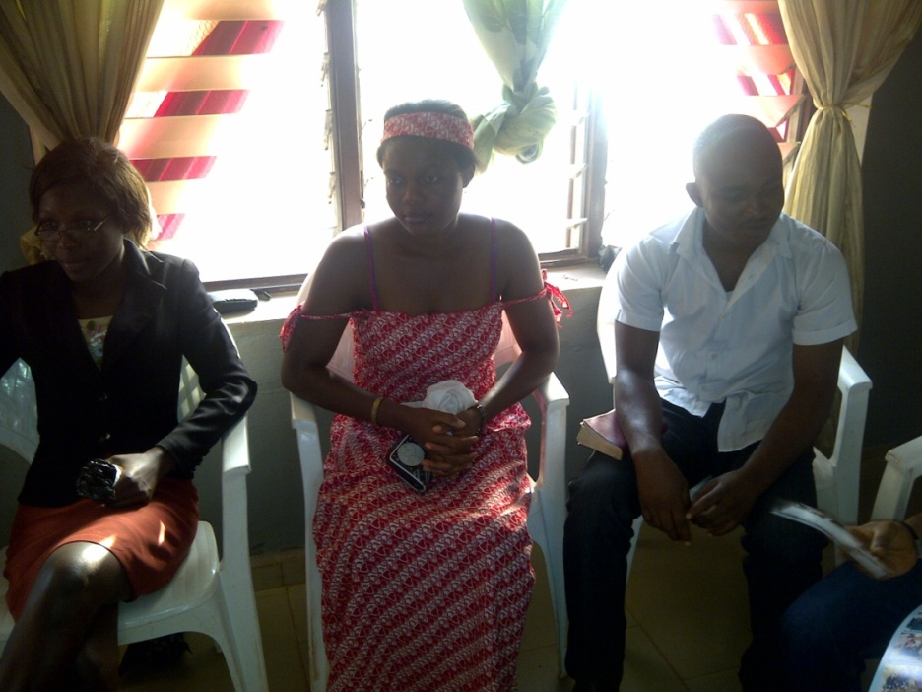

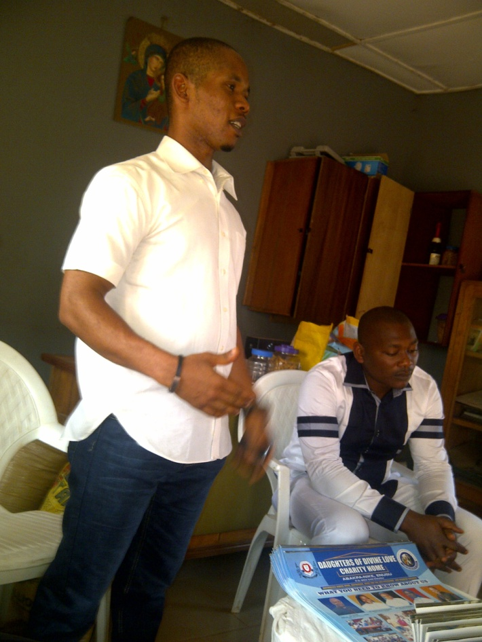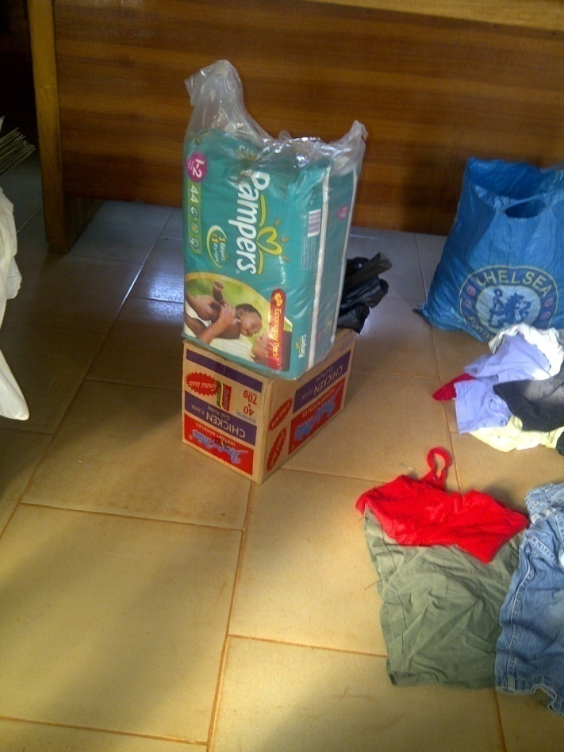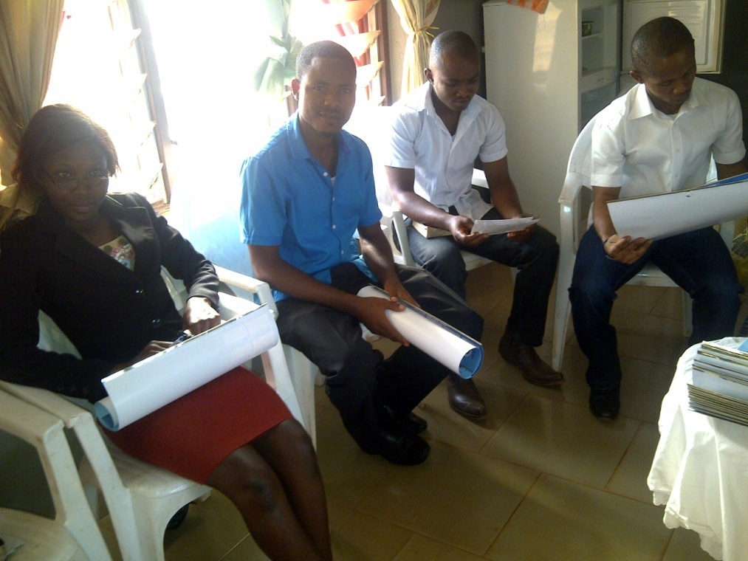

- In 2015 TFF under the shield ODY visited and celebrated nine (9) less previledged elders of nine autonomuos communities in Ozuitem, Abia State.
On the 1st of January 2015, TFF visited Nine less-priviledge (9) elders from Nine autonomous community in Ozuitem, Abia State. During this visit food item such as; Rice, soap, maggi, grandnut and red oil, oinion and some other things was given to them.

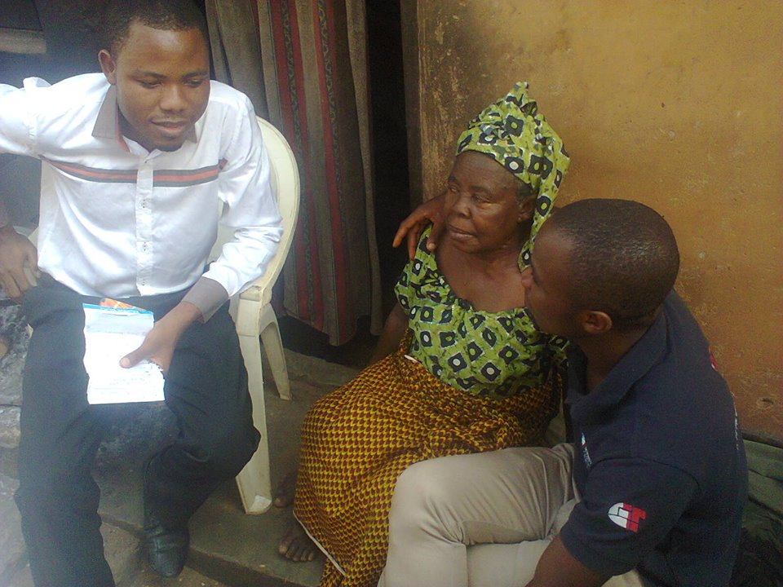
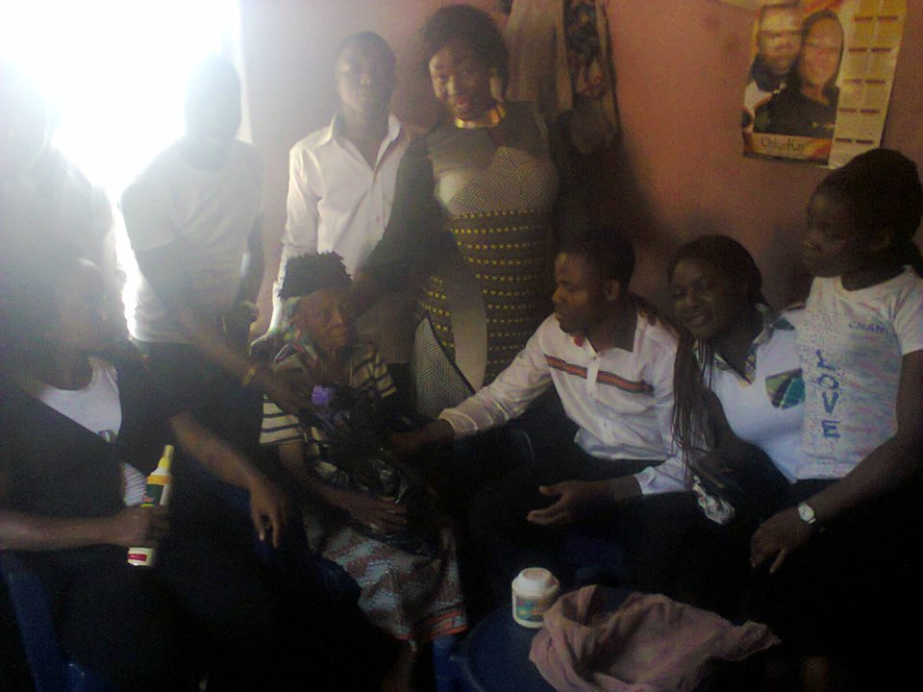
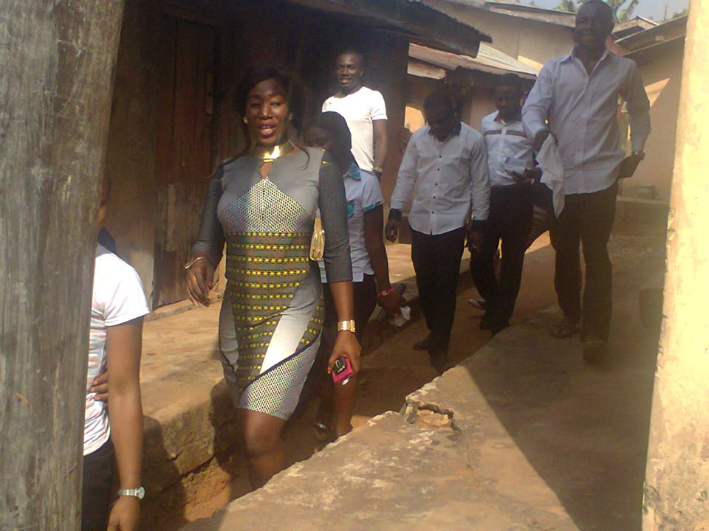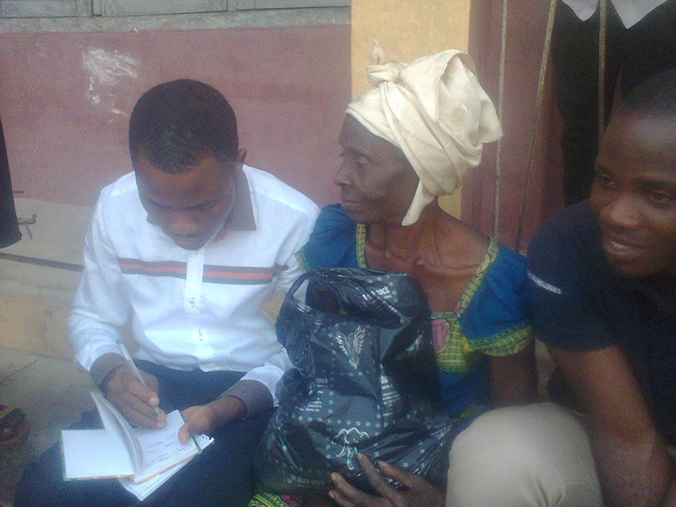
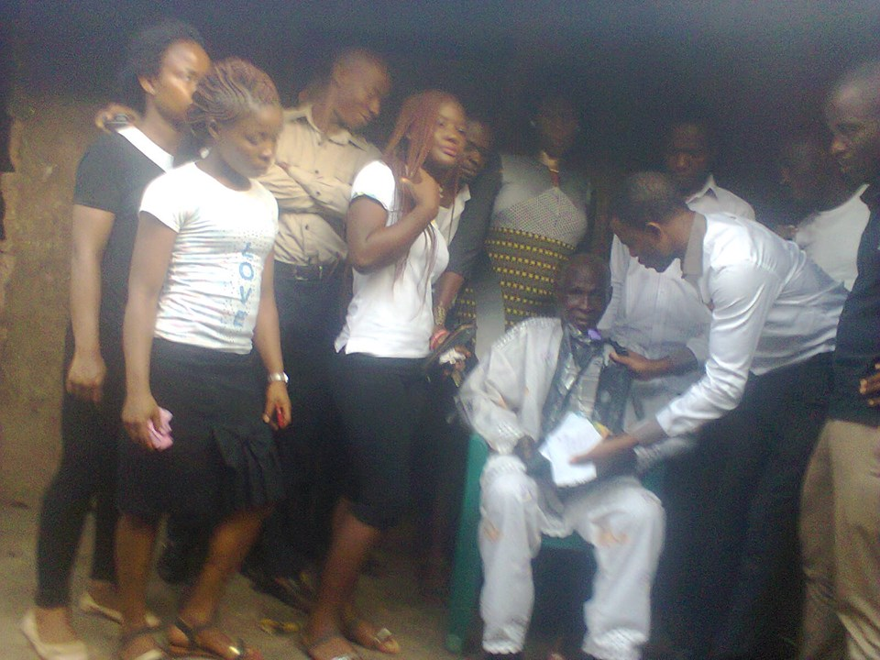
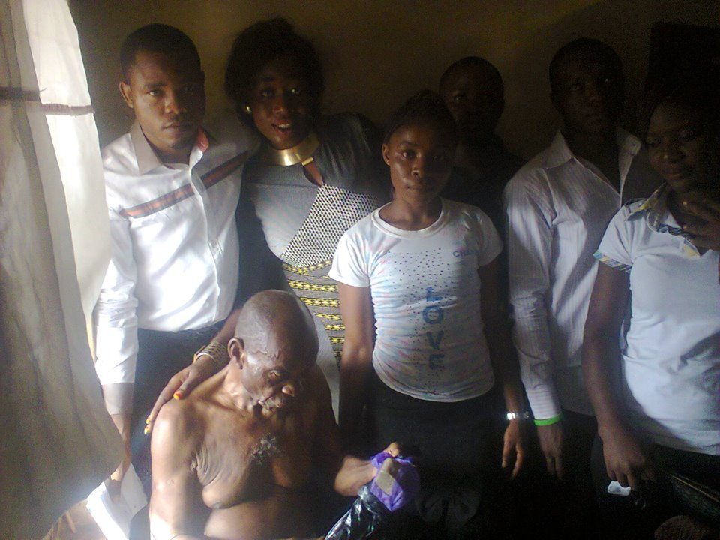
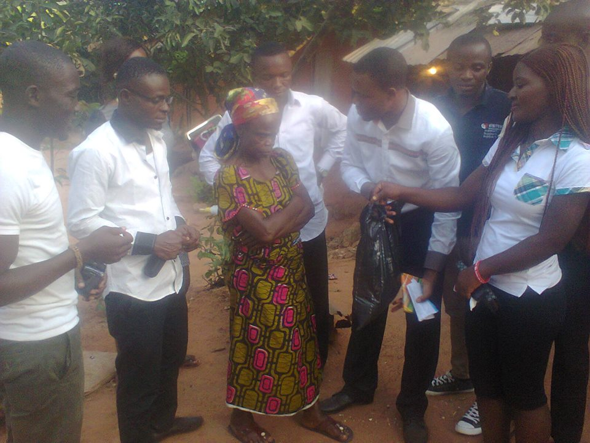

- In 2016, TFF under the shield ODY visited and celebrated with forty two less-priviledged elders of nine autonomous communites in Ozuitem, Abia State.
On the 1st of January 2016, TFF gathered forty three less-priviledge (43) elders from Nine autonomous community in Ozuitem, Bende LGA, Abia State. The elders was celebrated, advised and was given food items. Also, 500 hundrend naira was given to each of them as support.
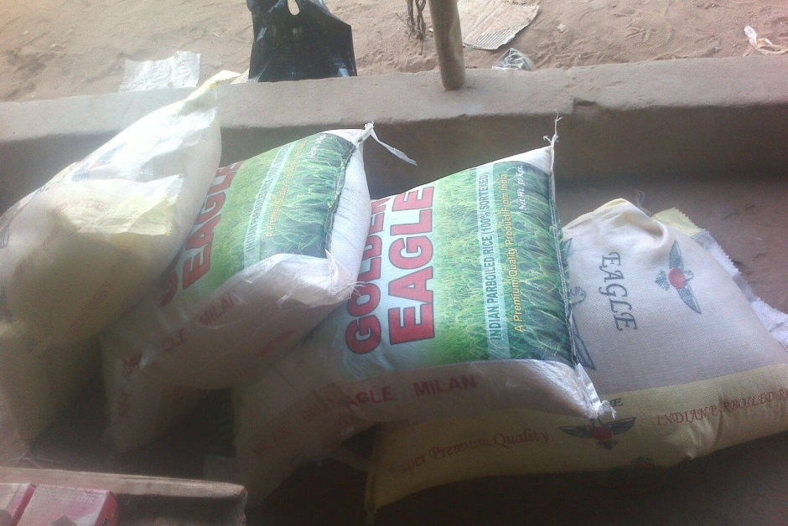
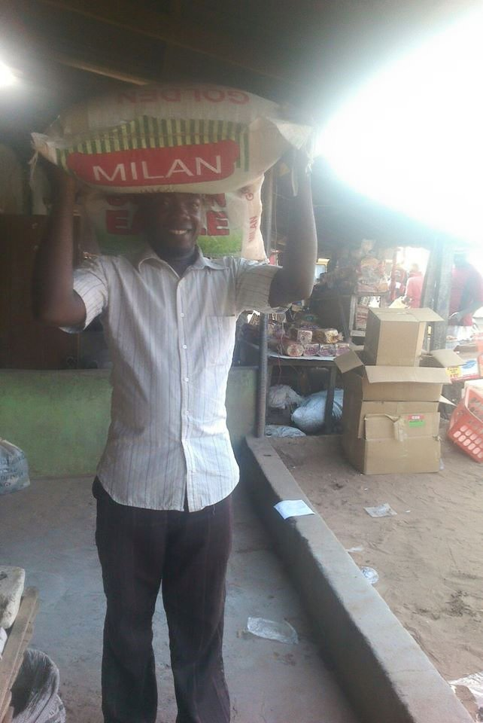
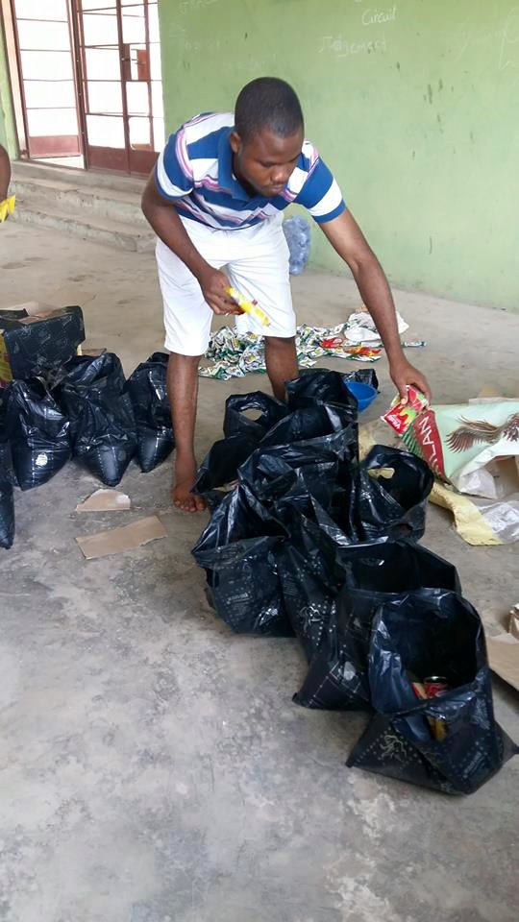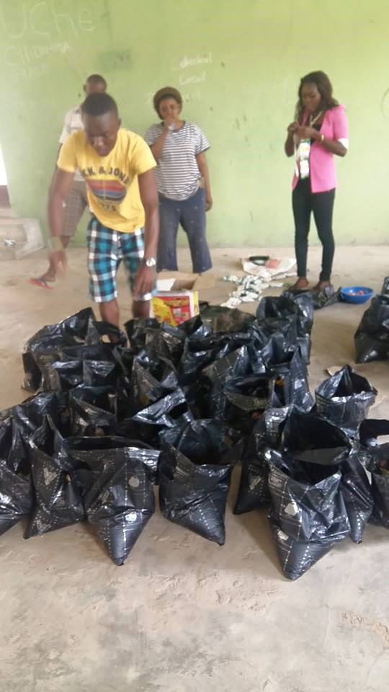
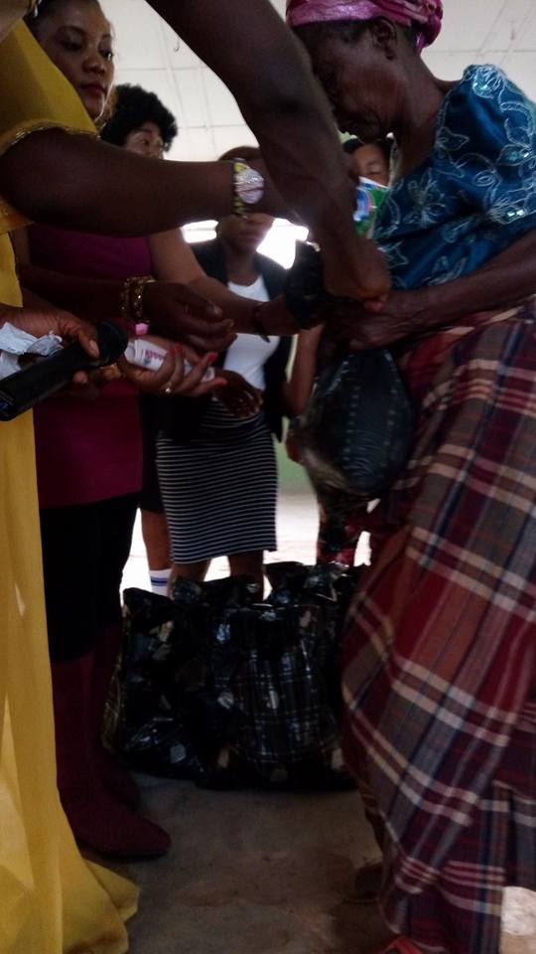
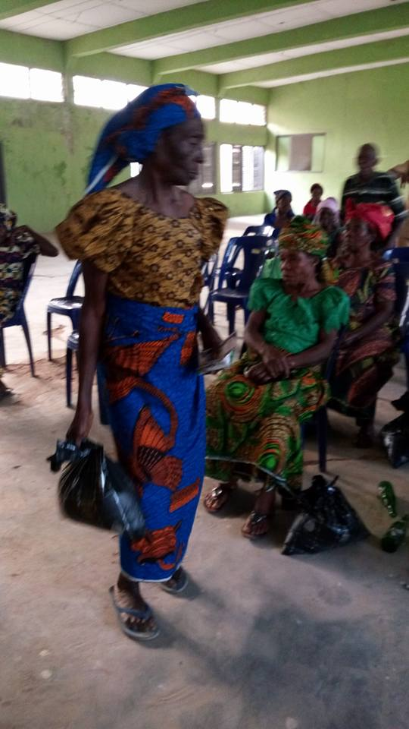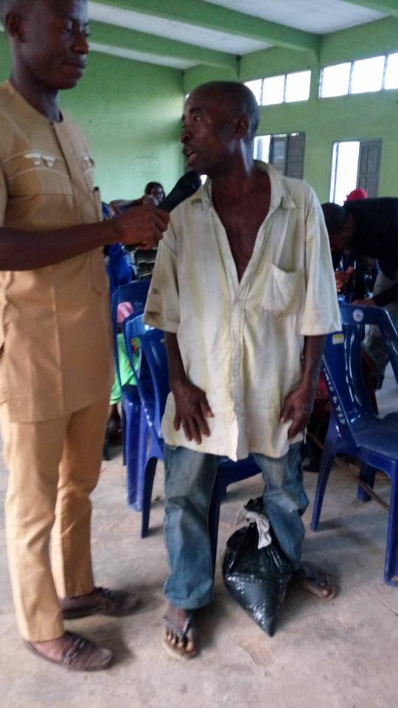
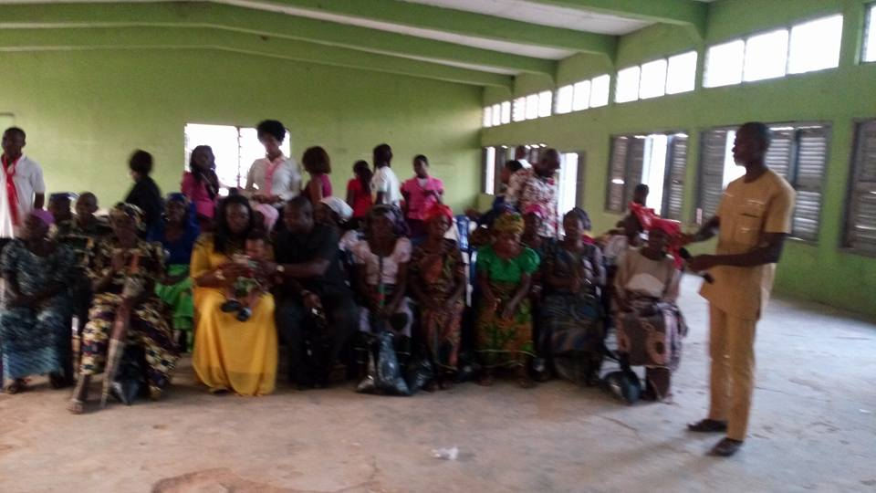

NEXT PROJECT(S) TO BE DONE.
Below are the projects we planned executing in the rural area of Bende LGA in Abia State Enugu East LGA, Udi LGA, and Awgu LGA, Enugu State;
- Orgernizing seminars to Secondary school students on “ Students and procedure for carrier choice making: This is the proccess of guilding students on the procedure to making their profession an accurate and unique one.
- Sustainability to the less-priviledge elders and drungs administration to parents

- Students and Procedure for Carrier Choice Making.
From research TFF found out that many youth of Enugu East LGA, Udi LGA, and Awgu LGA, Enugu State and Nigeria are large are unemployed and stranded. This is as a result of wrong carrier making. When there is passion in carrier there would be a willing mind to establishing such a carrier. The act of wrong carrier making has caused much harm than good. For this reason TFF has planed series of seminars which would address such an issue and give guild to secondary school students on proper procedure in making carrier choice.
This seminars would be carried out in rural area of Bende LGA in Abia State, Enugu East LGA, Udi LGA, and Awgu LGA, in Enugu State. The seminars is to last for six months, beginning from the month of May, 2016 to the month of Oct. 2017.
- 7000 Students are to be tutored/lectured on this.
The material needed for this seminars are;
- Projector.
- Projector stand.
- Refreshment
- Generator for electricity
- Halls.
Sustainability to the Less-Priviledge Elders and Administrating of Drungs to Parents
From the month of January 2017 to the month of April 2017 TFF shall organise , celebrate and share gift item(s) with the less-priviledge elders of Ozuitem in Bende LGA of Abia State, Enugu East LGA, Udi LGA, and Awgu LGA, in Enugu State, all in Nigeria. Below are the gifts items that would be shared;
- Rice
- Maggi
- Red and grandnut oil
- Bathing and watching soap
- Onion and Peper
- Salt and Crawfish
- Rapper
- Etc
In this same project, drungs for Various joint would be administered but to every parent that is available and also to the less-priviledged elders. Advise or service on how to balance and manage Hight Blood Pressure would be lectured or given to the less-priviledged elder and other parents.
We are to reach out to 300 less-priviledge elders for celebration and sharing of gift items. Also, to 200 other parents would be reached out for on drungs and on advise on how to balance and manage Hight Blood Pressure. Making them the total of 500 parents in total.

Project Scope
As a result of Rapid Population in some rural development areas; illiteracy has gradually increased. This has caused much harmed than good.
Illiteracy have displaced people’s potential from its rightful use. In achieving the target of Students and Procedure for Carrier Choice Making and Sustainability to the Less-Priviledge Elders and Administrating of Drungs to the Parents in “Bende LGA in Abia State, Enugu East LGA, Udi LGA, and Awgu LGA, Enugu State”, the following measures would be strictly followed;
- Seminars,
- Campaigning / rally for education,
- Networking Centre,
- Groups/Forums,
- Concelling,
- Sustainability
- Enlightening,
Seminars: - Seminars will be organized for secondary school students on the Procedure for Carrier Choice Making.
Campaign: - We will conduct series of campaigning with the masses for educational improvement
Networking Centre: - A networking system will be placed as a means of linking each group to others for effective communication and to enhance unity to tackle illitracy.
Groups/Forum: - This will be conducted to educate students in groups on PCCM. Students would be given the opportunity of teaching each other but under the supervision of TFF.
Councelling:- Our parents would be councelled on HBP balancing and management. Drungs would also be ministered to them.
Sustainability:- The less-priviledged elders would be assembled in a place, celebrated and given food items for sustainability.
Enlighten: - There shall be enlightening section to inform the masses on education and tailoring work, which its avoidance is currently eating deep in our society, so to combat joblessness to large extent.
Working Environment:- A working environment where most usable things will be made available to prevent the masses from passing or going through the eyes of illitracy which will contribute to the Procedure for Carrier Choice Making (PCCM)
The above will absolutely be achieved considering time frame, measurable desires, realist success, to enable us combat illitracy and promote education and in achieving a lasting sustainability to the less-priviledge elders.
Development Plan
In our organization; we value the Lives of the masses, just as we value our own dear lives (staffs and Volunteers). The staffs and the volunteers are developed to the right skilled and knowledge to work together and deliver our goals towards enhancing Procedure for Carrier Choice Making (PCCM).
.
Area of development needed. | What will be done? | When?
Parents,  Education,  L.P Elders. | Enlightening parents on HBP management.  Sensitizing students.  Create Cordial relationships between students and parents. | Four times in a month to every Sec. School in the area .  From May, 2017 to the month of Oct. 2017  And on the first (1st) of January to April, 2017 for the less-priviledge elders and parent.

Details of the Organization to Your Funding
The members of "The future in you foundation" are people of color, indigenous, women, children, teenagers and immigrants who live below the federal poverty level. Through our work we fight to change and transform the conditions that promote racial, education, human violence, economic injustice and poverty. Each of us come from a different background, and we understand that our fight is against illitracy, poor education, and poverty based on nationality, gender or ethnicity and that we must unite to resolve the impending doom that have been created by illitracy and poverty which we are currently tackling down to zero level.
We promote the efforts of community members to fight for social change and foster unity through participation in commissions, our weekly meetings and community organizing efforts. All members participate in organizational decision making and in-carrying out works, which relies on the model consensus.
By educating, organizing and mobilizing our community, we address inequality, oppression and discrimination within our organization, and by doing so, we can enhance our members’ ability to fight illitracy, poor education, and poverty in larger society. We are teaching managerial skills which students and youth can turn to throughout their life time to continue the struggle to promote carrier choice, reduce unemployment thereby minimising poverty in diversity wherever they confront oppressions and exclusions.
Our Organizing Method.
Our specific methods includes:-
- Outreach to schools.
- Training to youths.
- Parents centers.
- An ant-illitracy/poverty campaigns.
Study circles based on tackling educational problem, through sensitization (seminars) and joblessness issues, through training.
Networking with other organizations: We would collaborate with Joint Task Force (JTF) and Educational centers for workshop, outreach, community actions, sharing experiences, poor education, and fighting illitracy in carrier decision making. Also, we will collaborate with other NGO’s in the community to combat illitracy and enhance skill acquisition (education).
Project Objectives.
As part of our efforts to combat rapid illitracy, poor education and displacement of low-income residents, our plan is to ensure a steady and standard means of living, for the society, holding it is a trust for the long-term, and develop a suitable and secured environment of learning for all and sundry thereby eliminating the act of parents wasting their children’s potential as a result of illitracy and poverty.
"The Future in You Foundation" is the coalition of color and low-income families struggling to promote democratic anticipation, mobilized and trained the Masses affected by the act of not been educated in Enugu East LGA, Udi LGA, and Awgu LGA, Enugu State, so that there would be true respect of cultural diversity to our community. Our strategies are to combat illitracy and achieve the stopping of the personal displaced people (PDP), established the bases for developing affordable skills, stop the wasting of youth life time and sexual harassment of human beings. Promote education as a method of social and political awareness and create coalition with other sectors of the community that are also fighting for social change.
Educating the rural area youth of Ozuitem in Bende LGA of Abia State, Enugu East LGA, Udi LGA, and Awgu LGA, in Enugu State on the issue of sustainability and reliability is an important aspect of this project.
By May 2017, we will develop effective anti- illitracy culture, free illitracy mindset, information tables’, community forums, workshops in schools and social gatherings. Members of the community will work with us in the planning and development of free illitracy and poverty community.
We will provide technical assistant to the community residents. By July, 2017 we will establish and expand number of residents and community leaders on education counseling in the combating of illitracy and poverty.
With this excess, by Oct. 2017, there will be no educational problem and lack of job would be highly minimise in Ozuitem under Bende LGA of Abia State, Enugu East LGA, Udi LGA, and Awgu LGA, in Enugu State. Hence, we will foster a concrete and stable situation to eradicate illitracy (educational problem and lack of job) to zero level.
Educational upliftment and enhancing skill acquisition is our projectional step.
Risks and Opportunities.
One of the core changes we intend achieving in this communities is to confront and reduce the major causes of illitracy and poor education among our constituencies. To do this, we will use the methodology of educating and training the masses to develop leadership skill that drives away fear, promote unity to fight illitracy and poverty, making them have sense of social belonging and drive away the idea of sexual harrassment.
Educating and Training helps communities identify their problems, expectations, and needs; facilitates changes; examined unequal power relation in the society.
Education and Training has been used as a tool to raise people's conscious of how their personal experience are inextramelly linked with large social problem. When they are encouraged to work with the knowledge they have from their own experience, they can develop strategy together to change their own immediate situations. They move from analyzing to encouraging collective actions; to change oppressive systems. This methodology offers the most effective and hopeful system to address and change the route causes of poor education, illitracy and insidious effect it has on those it ensnares.

SWOT Analysis.
Strengths:  "The Future in You Foundation" is an organization builds on strength to carry-out desired work, to fight illitracy (educational problem), to create a standard unity among communities: We rely on our strength which include; Desire to save lives, cause positive change and enhance development in achieving target. | Weaknesses:  Our weakness includes; Finance, lack of sophisticated equipment to approach grounded projects.
Opportunities:  We wish to move beyond our horizons to enable us achieve our aims. Also, to develop a youth empowerment system. | Threats:  Lack of cooperation from the communities, Lack of fund, Government Policy, Life and Death of members or the people involved.

Project Approach and Plan
The Management Plan.
The combating of educational problem and the lack of Sustainability to the Less-Priviledged Elders and Administrating of Drungs to Parents proposal will be reviewed in every one months. Every decision reached by the Management team and Board of Trustees and the community stateholders will be bidding.

