ABOUT THE GOALS LITERACY PROGRAM: LEVELING THE PLAYING FIELD

EXECUTIVE SUMMARY:
In the isolated, subsistence-based villages where GOALS works, there are no schools, no paved roads and no electricity or running water. Nearly all adults are low- or non-literate and just 72% of children attend school. The ‘Leveling the Playing Field’ literacy project uses the power of sport to build locally-led literacy programming in order to create fully literate communities, thereby improving local leadership, health and future earning potential. To date, 64 children and 20 adults have successfully completed the program, each achieving measurable progression in learning. As a group, students have improved from a starting average test score of 13% to a final score of 66%.

For children who cannot attend school and adults who never had the opportunity, the GOALS literacy program provides their first chance to learn to read and write, establishing a more equitable playing field for everyone.

WHAT IS THE GOALS LITERACY PROGRAM? HOW DOES IT INCORPORATE SPORT?
GOALS uses football in Haiti to engage youth, their families and their communities in sport, health, and education projects. By using football as a platform for development, GOALS reaches children who are left behind by conventional educational systems. GOALS empowers soccer coaches and players with leadership and subject-specific trainings to develop local capacity.

It is this network of local coaches and athletes who implement the GOALS literacy program, using a hands-on curriculum which incorporates non-traditional methodologies, including music, art, traditional Haitian games, and of course, soccer! Sample lessons include a soccer ball used to connect vowels and syllables and writing in sand for kinesthetic learning. For children who have never attended school or learned to hold a pencil, incorporating play increases retention, and rejoining their peers for GOALS ongoing soccer activities further helps to socially integrate learners thereby reducing social stigma.

PROGRAM OBJECTIVES:
The GOALS literacy project seeks to teach basic reading, writing and numeracy skills to low- and non-literate youth (ages 8 and up) and/or adults who are financially and geographically cut off from traditional schooling. In the long-term, the project seeks to create fully literate villages in order to improve health, earning potential and well-being.

WHO DOES THE PROGRAM BENEFIT?
In response to community feedback and an assessed need, GOALS integrated a locally-led literacy program into our ongoing sport-for-development activities in two rural villages in the 3eme Dessources region of Leogane.

Amongst participating children (ages 8 -19), none had progressed past grade four in school, and only 25% were able to write their own names at the beginning of the course. Two-thirds of 64 participating boys and girls never attended school past first grade. Amongst adults (ages 19-66), 17 out of 20 students were women, none had formal employment and only three had ever attended school.

HOW IS THE PROGRAM MONITORED?
Testing using the Literacy Screening Device is critical to measuring progress. This tool assigns both a numerical point score and a classification of non-, pre-, semi- or fully literate. Students are assessed both pre- and post-intervention and classroom tests measure additional progress in numeracy.
GOALS also collects a myriad of demographic data (such as family size, income and educational history) to ensure we reach those most in need and to track other indicators, such as school enrollment rates. Individual interviews and focus groups with students, coaches and parents provide supplemental qualitative feedback, and ongoing stakeholder communication ensures the program fulfills a locally identified need and sustains community support throughout the project cycle.

WHAT IS THE PROGRAM’S IMPACT?
To-date, the average pre-intervention test score was 6 out of 24 possible points for children and 2 out of 24 for adults. Post-intervention, both groups tested high enough to be placed in the semi-literate category as a group. Numeracy testing shows that 95% of participants gained the ability to perform basic single digit addition and subtraction after just three months of lessons. In general, illiterate students who successfully complete the course will become semi-literate, and students who begin as low- or semi-literate students will become fully literate.

Beyond improved reading and writing test scores, the ways increased literacy and numeracy permeates daily life can be unpredictable and the program has brought several unexpected impacts such as increased local commerce and new microenterprises founded by newly numerate adults. Increasing the number of literate children and families will continue to have a significant long-term impact for these communities, empowering children and adults alike to reach their full potential and engage more fully in public life.

PERSONAL IMPACT STORY
Frisno is 10 years old and lives in the village of Destra with his mother and four siblings. His father is disabled, and life is challenging. Frisno used to be shy, his soccer coach says. He didn’t talk to the other kids, and though he liked hanging out on the field, he didn’t feel confident enough to play with the team.

But participating in GOALS literacy class has transformed Frisno, providing the opportunity not just to learn and grow intellectually, but also to integrate socially for the first time. This year, he was even selected by his peers to serve as team captain. His coach says he is quickly becoming and excellent leader and has high expectations of his teammates.

Frisno says his favorite part of GOALS’ literacy program was "learning everything he could", but he especially liked the art projects, having never had the opportunity before. “You feel you are learning and becoming someone – a real person.” Frisno’s next goal is to become a policeman, because, just like his role as team captain, he likes donning a uniform and using his leadership skills. Until then, he hopes that GOALS is able to continue the literacy program in his village because, he says, “there are still kids who need it.”

CONCLUSION
GOALS pushes the sport-for-development model further than ever before, using soccer to reach children and adults cut off from traditional education with a locally-led literacy program. Students take pride in walking to class with their books in hand and families and neighbors pitch in when needed, demonstrating the program’s community engagement and support.

With a total of 84 graduated learners to date, each of whom is now able to write their own name and much, much more, GOALS’ literacy program brings new hope to both the students and their extended families, and interest in continuing the program remains high amongst both children and adults.

The ability to read and write is the foundation of all other development objectives – including GOALS’ broader objectives of improving health, reducing poverty, and for long-term community and local leadership development. GOALS therefore remains committed to continuing to provide educational opportunities to those who have been left behind in rural Haiti. As such, GOALS is currently seeking individual and institutional funders to implement an additional 1-2 years of literacy programming to commence in early 2017 to impact 20-60 people, depending on availability of funds.

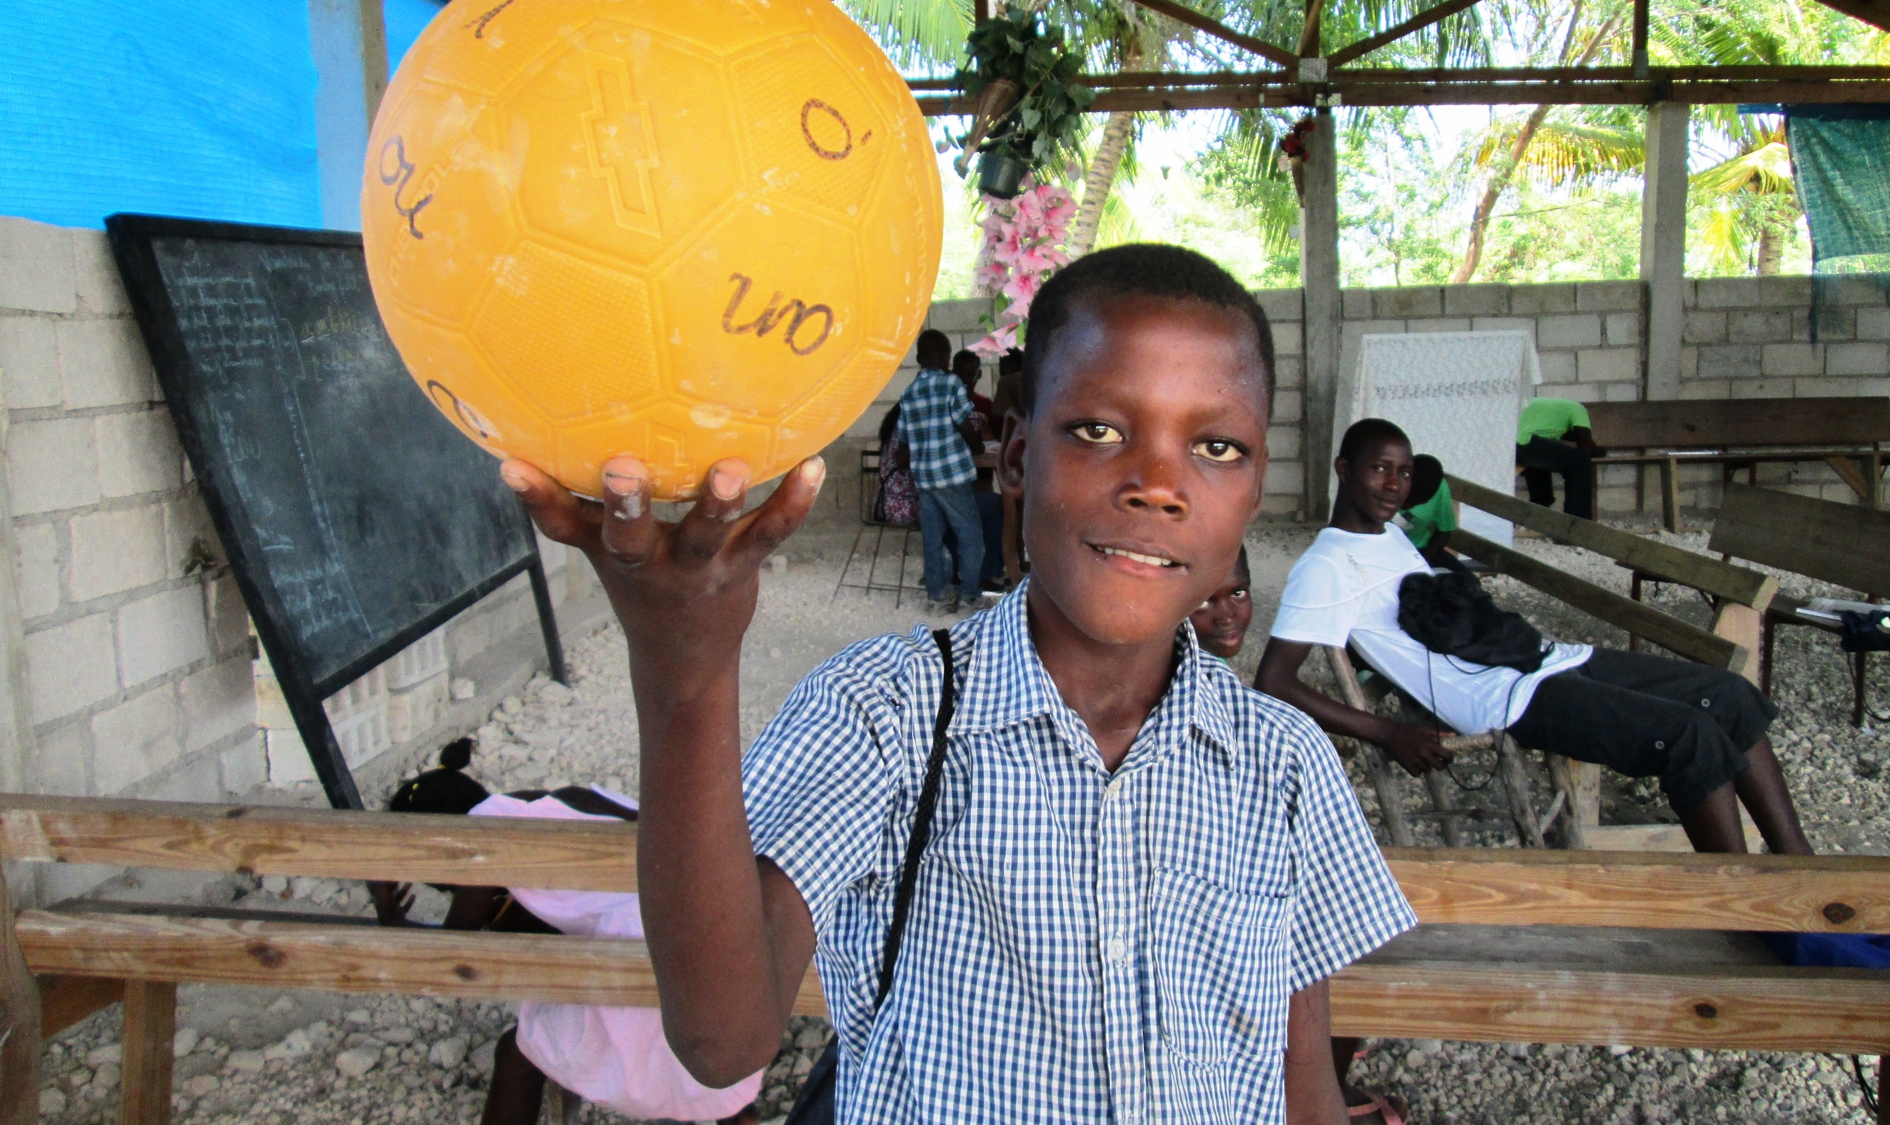
Thank you for your support of GOALS Haiti!
GOALS Literacy Program Budget
To integrate literacy classes and activities into GOALS existing sport for development programming;
All costs in USD
Item | To impact 20 students during one 6-month period | To impact 20 students during one twelve-month period | To impact 40 students during one six-month period | To impact 40 students during one twelve-month period
Direct Program Costs
Books, classroom materials, student supplies | $2,354 | 4,708 | $4,708 | 9416
Chalkboards, benches and classroom furnishings | $651 | 651 | $651 | 651
Local staff salary | $4,964 | 9,928 | 9,928 | 19856
Meals for students | $2,771 | $5,542 | $5,542 | $11,084
Program manager support | $6,000 | 12,000 | $6,000 | 12,000
Soccer materials | $450 | 450 | $900 | 900
Shipping (materials) | $120 | 120 | $240 | 240
Administrative Costs
Printing and reproduction | $120.00 | $240.00 | $120.00 | $240.00
Local transportation / site visits | $265.00 | $530.00 | $265.00 | $530.00
Communications: Phone and internet | $180.00 | $360.00 | $180.00 | $360.00
Rent and office | $575.00 | $1,150.00 | $575.00 | $1,150.00
Printing and reproduction | $120.00 | $240.00 | $120.00 | $240.00
Subtotal: | $18,450 | $35,679 | $29,109 | $56,427
Contingency (5%) | $923 | $1,784 | $1,455 | $2,821
Total: | $19,373 | $37,463 | $30,564 | $59,248

