**Business Plan**

**YANGRI SCHOOL: Educational Center in Nepal**

Rising from the Ashes after the 2015 Earthquake

**(I) STORY**

**ABSTARCT**

HimalayanLife is building a regional school in Yangri, one of the hardest hit areas of Nepal in the 2015 earthquake. After substantial assistance in relief and rebuilding, the key to the future of the area is education. Only if good schooling is available to their children, families will reinvest themselves in the region and truly rise from the ashes, rather than migrating abroad and facing the uncertainties of migrant workers in India or the Gulf countries.

The school will be an educational center for 100 children in the area, providing quality education and preparing the children for further educational pursuit and to be responsible citizens in a country facing so many challenges.

**Challenge**

The 2015 earthquakes have caused unimaginable destruction in areas of Nepal where development had been slow in coming even before the catastrophe. Commencing immediately after the earthquake, HimalayanLife has been assisting with relief and rebuilding in the Yangri Valley, some 70 km northeast of Kathmandu. We have committed to walk with the communities in this hard-hit area for the foreseeable future.

The immediate needs caused by the disaster have been addressed with providing medical care, tents, and food to the survivors who had lost their homes, livelihood and family members. By way of rebuilding houses, bridges, water supply, and hydro power the livelihood is being restored.

However, the future of the area rests on the aspect of solid education for the next generation. Only if good schooling is available for their children, families will truly build their future in the 15 communities comprising the Yangri Valley, rather than migrating to Kathmandu or abroad, facing the uncertainties of foreign laborers.

**Solution**

HimalayanLife is building a primary/secondary school for 100 students in the Yangri Valley. The school has boarding facilities for half of the students, making the school effectively a regional education center. Hence the school’s name: YANGRI ACADEMIC CENTER.

The vision is for a school with outstanding educational standards and current pedagogical methods. A school where teachers are excited about education, where the potentials of both the academically talented and challenged students are developed to their fullest. A place where children will discover the sheer joy and excitement of learning. An educational center with model character that will inspire other schools. Students will be equipped for further educational pursuit, be it vocational or academic. Moreover, students will be prepared for being responsible citizens, willing and able to contribute to society and have transformative impact on the nation.

The land for the school has been purchased at a central location in the valley. The school buildings have been planned by an experienced architect from Canada, with the limited availability of local resources and the need for earthquake resistance in mind. The design foresees bright spacious classrooms, pleasant dorms, a sports field, and adequate sanitary installations. The local population will be involved in the construction, which provides them both income and the opportunity to develop a sense of ownership for the school.

The first phase of the school will include the construction of 7 classrooms in 2 buildings, as well as a dorm building and a bathhouse with showers and washrooms/toilets. Construction of the first wing with 3 classrooms has commenced. During the construction period, teachers and administrators are being trained and prepared for their challenging job.

The cost breakdown for phase one of the project is the following:

1. Construction of classroom pod #1 (3 classrooms): $28,000
2. Construction of classroom pod #2 (4 classrooms): $33,000
3. Construction of bathhouse (showers/washrooms/toilets: $ 8,000
4. Construction of dorm building #1 (housing for 40 children): $34,000
5. Furniture and equipment: $16,000
6. Material transportation cost: $4,000
7. Staff development and training: $4,000

TOTAL: $127,000

**Long-Term Impact**

Even before the earthquake, communities in rural Nepal have been challenged greatly to re-invent themselves in light of the changing socio-economic landscape. The traditional livelihood of subsistence farming can no longer sustain families in rural communities, as they require money to pay for services such as health care and schooling for their children. Villagers need to make the transition form subsistence farming to commercial agriculture.

The earthquake in Nepal has accelerated this change. However, the people in Nepal and even the country’s leadership find themselves ill equipped to drive the necessary transition. Lack of education hampers progress and development.

The Yangri school will equip the next generation of locals for having positive transformative impact on their society. Moreover, the school will reinvigorate the Yangri Valley and play a vital role in the local development. In tandem with an array of small local enterprises and vocational training, the school will in fact by a catalyst for socio-economic growth in the region.

**(II) COnstruction plan**

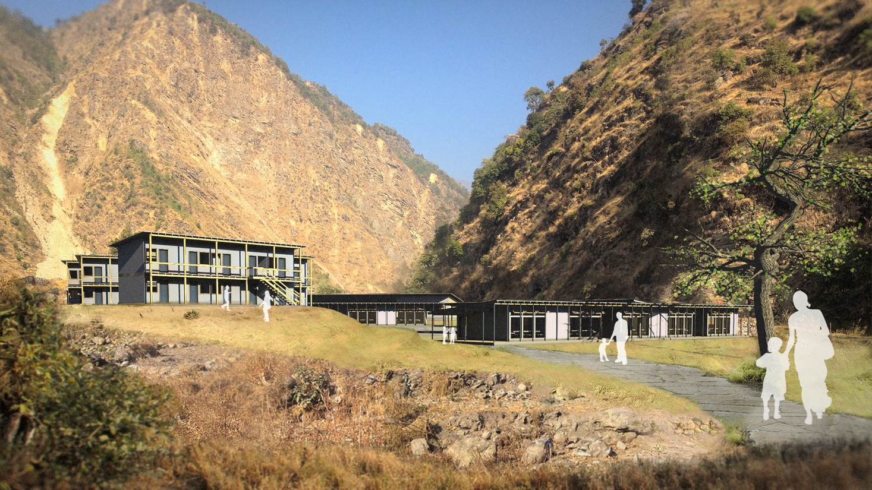

../../../.Trash/Master%20Plan%20Full%20Build.pdf