SOVA …. A Profile

Registered Office |  | Head Office
At: Bhojadeipur,  P.O.; Sadashivpur,  Dist.: Dhenkanal,  Odisha 759025  Cell: 09437361026 | 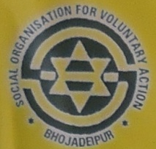 | At: Ranapasi, via: Dhenkanal RS  P.O.: Gengutia, Dist.: Dhenkanal, Odisha  PIN: 759013 Tel: 06762 211856  E-Mail: sova_dkl@rediffmail.com  URL: www.sovaodisha.org

Genesis

Social Organization for Voluntary Action (SOVA) is a product of a social order, which envisages to ensure social justice & empowerment of under privileged and the underserved rural population of Dhenkanal district, Odisha, a typical example of process induced poverty and under development and somewhere below in the HDI list of the state witnessed us to formation of a Society in the year 1989 by a group of like-minded dedicated youths of the locality and this organization was legalized under the Societies Registration Act XXI of 1860 on dated 19.09.1992.

Legal Status
Society Regn. No. | 2846/210 of 1992-93 dated 19.09.92 (SR Act)
FC(R) A Regn. No. | 104890070 dated 27.11.1996
Exemption u/s 12 A of IT Act | Memo No. Judi/84/12A/94-95/30542-43
Exemption u/s 80 G of IT Act | ITO (Tech)80G-215/11-12/2012-13 of 06.09.2012
PAN with IT Dept.: | AADTS7986C
TAN No.: | BBNS04228A

Vision
A self sustained & equitable society free from exploitation and Injustice of all type as well as making people empowered economically, socially and culturally to attain highest degree of self esteem & dignity with moral values.

Mission
To strengthen communities, community based organizations and people’s institutions on the issues related to education, health care, Gender equity, Natural Resource Management and make them empowered to attain sustainable development.

Objectives
  - To provide Primary Health Care Services for rural people.
  - To take up welfare activities for women and children
  - To conduct training, survey & research programme on Health and sanitation
  - To take up Natural Resource Management activities (land & water management/ agriculture and other means of livelihoods)
  - To take steps to eradicate child labor
  - To undertake awareness generation project for the underserved people of the society.
  - To enhance quality of life of tribal living in remote areas and also migrated to urban settlements
  - To promote handicraft programmes and artisan welfare programmes
  - To encourage thrift and credit activities, especially among women
  - To encourage rural sports, drama and other cultural aspects in the village level
  - To manage Crèche centers, Agro Service Centers

Financial Aspect (in INR)
2013-14 61,21,853.08
2012-13 47,04,896.04
2011-12 40,58,192.44

Thrust Areas
- Basic Health Care services like Reproductive Child Health, ARSH, HIV/AIDS, IYCF, Malaria Prevention and Control of communicable diseases in rural communities.
- Eradication of Child Laborer and contributing towards promotion of Juvenile Justice.
- Promotion of education for children belongs to marginalized sections of the society.
- Promotion of creativeness, competitiveness through organizing sports & games, quiz, cultural and literary events.
- Women empowerment through SHG formation, capacity building, promotion of micro-entrepreneurship and income generation activities.
- Sustainable livelihood promotion for poor vulnerable communities through implementation of income generating programs and proper natural resource management with focus of land and water management, agriculture and horticulture promotion.
- Conducting Vocational Skill up-gradation trainings target at unemployed rural youth & women SHGs.
- Preservation and Protection of Environment & Bio-diversity conservation through organizing Environment Awareness Campaign, Plantation
- Promotion of standard health & hygiene practices through implementation of activities such as construction of household sanitary latrines, distribution of IEC materials and organizing awareness raising programs.
- Promotion handicrafts for rural traditional artisan groups through skill up-gradation, utilization of S & T methods, value addition and providing support.

Strategies
We involve village development committees (Health and sanitation Committee, education committee etc.) including SHGs in Planning, implementing and monitoring of any development project. All the policy level decisions are taken by the General Body and Executive Committee and the Director takes a proactive role in order to execute the decisions taken in the meetings. The physical progress achievements and future action plans are placed before the Executive Committee and General Body in a participatory approach. The organization prioritizes to maintain transparency in implementation of works, their processes and a systematic monitoring mechanism adhered to all the rules and regulations of the organization as mentioned in its bye-laws.

Our Donors
- Ministry of Health & Family Welfare, Govt. of India
- Ministry of Tourism & Culture, Govt. of India
- Ministry of Labor, Govt. of India
- Ministry of Youth affairs and sports, Govt. of India
- Ministry of Women & Child Development, Govt. of India
- Department of Agriculture, Govt. of Odisha
- NCRI (National Council of Rural Institutes), Hyderabad
- Ministry of Textile, Govt. of India
- UNICEF, Bhubaneswar
- WFP, New Delhi
- ZSS (Zilla Swasthy Samiti), Dhenkanal
- RD Department, Dhenkanal Division
- ACTIONAID India, Bhubaneswar
- NABARD (National Agriculture Bank for Rural Development), Bhubaneswar
- Nehru Yuba Kendra Sangathan, Dhenkanal
- Department of SC & ST development, Govt. of Odisha
- RUSHA, Vellore, Chennai
- Odisha Voluntary Health Association (OVHA), Bhubaneswar
- Children Film Society of India, Mumbai
- APICOL, Govt. of Odisha
- International Agencies based at USA, UK, Switzerland

Our Associations
- Orissa Voluntary Health Association (OVHA), a State level Federation of health NGOs.
- Nehru Yuva Kendra, Dhenkanal, under Ministry of YA&S, Govt. of India.
- Dist. Representative, Right to Food Campaign-Orissa, Dhenkanal
- Member, Voice for Child Right, Orissa
- Member, District Rapid Response Group, Dhenkanal
- Life Member of Breast Feeding Promotion Network of India, New Delhi
- Member Rogi Kalyan Samiti, Muktapasi PHC(N) and Srimula PHC (N), Dhenkanal
- Member, District Blood Bank (Under Indian Red Cross Society)
- Member, Gender and Water Alliance, The Netherlands
- Member, Public Hearing Committee, MGNREGS, Sadar Block, Dhenkanal
- Member, Youth Council, Govt. of India
- Member, Zilla Swasthya Samiti Dhenkanal
- Executive Committee Member, Society for Welfare of Child Labour, Dhenkanal
- Advisory Committee Member, PC & PNDT, DHH, Dhenkanal
- Member, Consumer Protection Council, Govt. of Odisha
- Member District Quality Assurance Committee, DHH, Dhenkanal

A Brief on Sectoral Approach
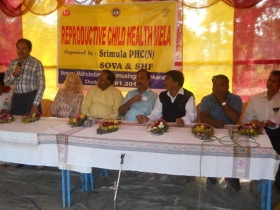
SOVA’s approach to community sector is multi sectoral, multi disciplinary in pursuance of its objectives for inclusive growth, attempts to address issues relating to a diverse spectrum of population which includes farmers, women, children, scheduled caste, scheduled tribe and other un-served and underserved vulnerable sections.
Primarily, SOVA relates itself to the unmet needs of the rural population. Out of its total target population, approximately 85% constitute of rural people. Women and children have taken a prime space in the developmental agenda of SOVA. Issues relating to health, mainly of women and children; creating opportunities for the adolescents, the youth, issues relating to children have been mandatory with SOVA.
This is evident from looking at the activities of SOVA since its inception.
Health issues are addressed through organizing various events. SOVA manages one Primary Health Center under Public Private Partnership (PPP) mode in Dhenkanal. It is mandated to deliver indoor health services as well as outreach services which mainly focus on women and child health issues. Reduction of IMR, prevalent child health issues such as de-worming, Vitamin A Supplement etc. Malnutrition and stunting child issues are addressed with priority. SOVA has reached out to almost all families in its operational area with messages on Infant and young Child Feeding (IYCF) and promoting breast feeding. First two thousand days of the child’s life is important to SOVA and is attended to with various means.
Addressing livelihoods issues, SOVA is a continual partner with the Development Commissioner (Handicrafts) for imparting training and rehabilitating artisans of different art/crafts.
SOVA has been promoting advanced methods of agriculture. In pursuance of this objective, it has covered Sadar and Odapada blocks of Dhenkanal district, with support from Govt. of Odisha. It also has established one Agro-Service Center at its headquarters to improve far mechanization in the vicinity.
SOVA is running ten (10) Crèches in its operational area which is targeted to take heath care including nutritional aspects of children of working mothers within 0-6 years of age group. Presently 250 such children are being taken care of in these centers.
Addressing issues relating to Child labors, it is operating 2 Special National Child Labour Schools, which creates opportunities for the child labors for a decent life in their future. Strength of the schools is 100; within age group of 9-14 years, who are imparted vocational training along with normal education. The children are provided with Midday Meals (MDM) keeping the nutritional aspect of the children in view.
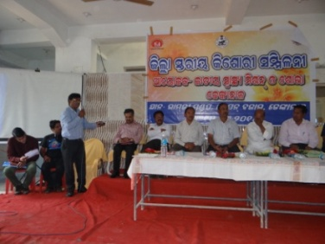
Involving school children in many of its programmes open a wide window for children living in its operational area and creates an enabling environment for the children to have a better understanding of the community living, the desirable practices and be able to shape their future.
Adolescence is a critical phase of life. Continually SOVA organizes different programmes which target to shape their thinking, attitude and practices. The programmes are thematically approved and accepted by national mainstream programmes for adolescents.
Awards and Recognitions
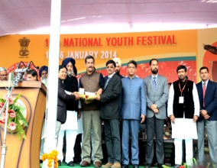

SOVA receives the prestigious National Youth Award for 2012-13 from the Ministry of Youth Affairs and Sports, Govt. Of India

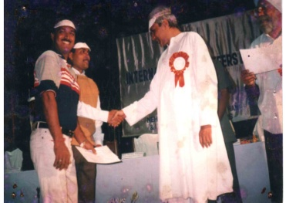
SOVA receives the prestigious State Level Humanitarian Service Award from the Chief Minister, Odisha
ORGANOGRAM

General Body

Executive Committee

Director

Administrative Staff

Project Staff

Accounts
Support
PC
Other Staff

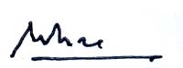

[Mr. Udayendu Mishra]
Director, SOVA

