**Project Completion Report on Education Support for Child Laborers in Nepal**

**(Project # 27536)**

**Report Prepared by:**

**Backward Society education (BASE), Central Project Office**

**Tulsipur Sub Metropolitan City, Dang District, Nepal**

**Tele: +977-82520055**

**Email:** [**info@nepalbase.org**](mailto:info@nepalbase.org) **AND** [**churna@gmail.com**](mailto:churna@gmail.com)

**Website: http://nepalbase.org**

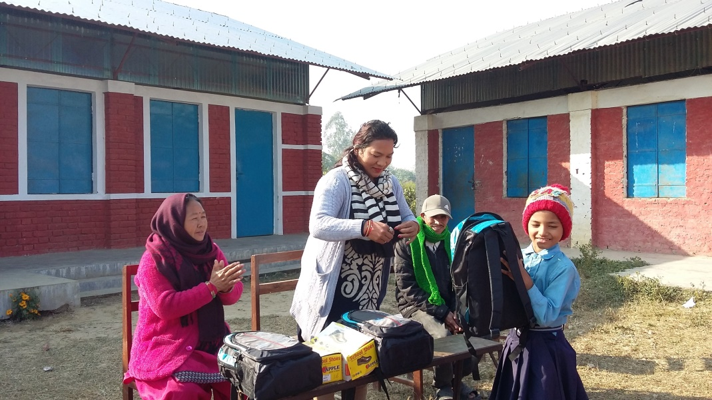

**Report Submitted to:**

**Global Giving Foundation (EIN: 30-0108263)**

**Global Giving UK (Charity # 1122823)**

**1110 Vermont Avenue NW, Suite 550  
Washington, DC 20005**

1. **Background:**

Nepal is a landlocked country in South Asia. It is bordered by two larger countries - India and China. Nepal is an agrarian economy with the majority of the population engaging in subsistence farming. Nepal is an under developed country and the poverty rate is 25.2% according to the population census of 2011. Each year, millions of people including children are victims of human trafficking. These innocent people and children become enslaved through the fake promises and commitments made to them. The children are coerced into forced labor, forced begging, sexual exploitation and domestic servitude.

The incidence of child labor in Nepal is higher in comparison to other countries in South Asia. The majority of children who work in the agricultural fields are aged 6 – 15. The agricultural sector is very dangerous for children. While working in the fields, they are exposed to harmful chemicals and dangerous weather conditions. The children are also involved in domestic labor. They cook, clean, fetch water and take care of other children in the homestead. Poverty is the main reason why child labor exists. The cost of attending school is very high. Unable to afford school often leads parents to find employment for their children.  Children who are enrolled in school often have to work in order to afford the costs of attending school.

Thus, large numbers of the children drop out of school due to the scarcity of economic opportunities at home and the lack of social and educational awareness. These children work for 17-18 hours a day and do not even get wages from their employers. In Nepal, poor families are unable to afford the cost of education for their children and out of desperation and /or custom, they are often compelled to send their children to work.Nepal has an open border with India. Most of the women and children are therefore sent to India. BASE is exploring for funding and grants to support education for child laborers.

**In July 2018, the Nepal Federal Government passed master plans that prohibit child labor in all work sectors.** As per the master plan, the employment of children as domestic helpers, porters, farm workers, in collection and trafficking of narcotic drugs, in carpet weaving, embroidery and hosiery, in brick kilns, in the mining sector, in the entertainment business (including sexual abuse), and in the transport sector has been prohibited. All these forms of child labor have been declared as serious crimes and draw maximum penalty in any case of non- compliance. The main goal of the master plan is to put an end to all forms of child labor by 2025. However, there is a lot skepticism about whether the laws will be implemented at the grassroot level.

1. **Introduction:**

**This is the project completion report of Education Support for Child Laborers in Nepal** **(Project # 27536).** Backward Society Education (BASE) has received two grants on behalf of this project (on May 31, 2017 and July 31, 2017). BASE has been advocating for child rights and advocacy in the west regions of Nepal since the organization was established. BASE has been carrying out several interventions to address the issues and needs of child laborers.

BASE has successfully implemented the project titled *Education Support for Child Laborers in Nepal* through the financial support of Global Giving. Under the project, 37 child laborers (16 boys and 21 girls) have received school supplies support and 10 parents across in Dang, Kailali and Banke districts received tools and business support. The major aim of the program is to end child labor, reduce school dropout rates by enabling children access education. At the same time, the program aims to make parents financially responsible through parent's awareness sessions, vocational training support and income generation activities (IGA). Skill development training will contribute to eliminating child labor from communities in a sustainable way and contribute to achieving *SDG 1-end poverty in all its forms everywhere, SDG 4- ensure inclusive and equitable quality education and promote lifelong learning opportunity for all, SDG 5- achieve gender equality and empower all women and girls and SDG 8- promote sustainable, inclusive and sustainable economic growth, full and productive employment and decent work for all.*

BASE has coordinated with local government institutions for educational material support since they are responsible for ensuring quality education for all children in their constituencies. In the project areas, the local governments are committed to ensuring that their constituencies are child labor free. BASE has provided support to those children who were working as child laborers. Although, some children are enrolled in schools, they lack school supplies, attend school irregularly and as a result their education levels are low. As a result of this, they develop low self-esteem and end up dropping out of school. BASE has decided to provide educational material support to those children who are in vulnerable. The educational material support to children and livelihood support to their parents helps to break the practice of child labor.

1. **Summary of the project achievement:**

* 37 children (16 boys and 21 girls) received educational material support. 2 girls were rescued from the landlord’s home in Kailali district
* 10 parents across in Dang, Kailali and Banke districts received tools and business support 7 staff members including 2 board members received training on project modality
* 15 parents enrolled in parenting education session

1. **Brief summary about activities carried out under the Education Support for Child Laborers in Nepal (Project # 27536):** The following are the activities carried out by BASE in the project proposed districts.
   1. **Program orientation meeting**

BASE formed a team to ensure effective implementation of the project activities related to this project. Two board members were assigned to this project and received training on project modality from a senior staff member of BASE. The full day orientation meeting was held on Aug. 20, 2017 at the central project office in Tulsipur, Dang District, Nepal. The objective of the meeting was to create a common understanding of the program implementation modality. The Executive Director of BASE, Mr. Churna Bahadur and Project Leader Mr. Mahabir facilitated the meeting. The first priority was to conduct a small survey to identify child laborers who were the most affected or out of school. The data gathered from this survey has helped to keep a record of child laborers and has also helped to organize for support for education materials and vocational support for their parents.

* 1. **Coordination and linkages**

In order to maximize the number of rescued child laborers, BASE has coordinated with state and non-state actors in project districts. Rescuing a child from a landlord’s home is very risky. BASE continues to coordinate with local government authorities, law enforcement authorities, journalists, human rights and civil society networks members. The coordination meeting helped to make clear objectives of the project initiative that was formulated during the implementation of project activities.

* 1. **Educational material and school uniform support to child labor:**

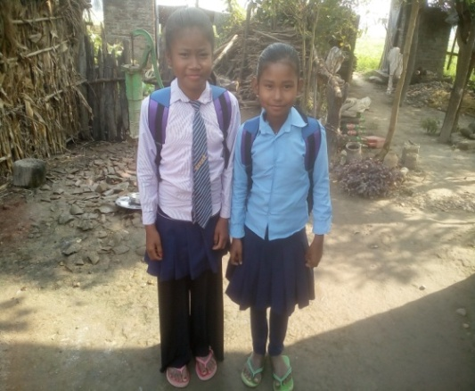The major aim of the program is to end child labor, reduce school dropout by ensuring access to education. BASE has provided educational materials to those who were working as child laborers. Each child received 2 **dozen copies, 2 pens, one set of a geometric box, 1 English- Nepali dictionary, 1 school bag, 1 sweater -1, 1 shirt,1 meddy, 1 pair of shoes and socks.** These school supplies will help children continue their studies in government schools and ultimately contribute to the end of the child labor practice. The support will also address the problem of child labor through improving educational standards.

Sarita and Anisha - Freed Child Laborers benefiting from the project

***The following is the details of grade wise educational material support received by child labor;***

|  |  |  |  |  |
| --- | --- | --- | --- | --- |
| ***Grade*** | ***Girls*** | ***Boys*** | ***Total*** | ***Category*** |
| *Early childhood development* | *0* | *1* | *1* | ***1*** |
| *Grade 1* | *1* | *2* | *3* | ***9*** |
| *Grade 2* | *0* | *0* | *0* |
| *Grade 3* | *4* | *2* | *6* |
| *Grade 4* | *5* | *0* | *5* | ***16*** |
| *Grade 5* | *2* | *3* | *5* |
| *Grade 6* | *1* | *1* | *2* |
| *Grade 7* | *1* | *3* | *4* |
| *Grade 8* | *3* | *2* | *5* | ***11*** |
| *Grade 9* | *2* | *2* | *4* |
| *Grade 10* | *1* | *0* | *1* |
| *Grade 11* | *1* | *0* | *1* |
| ***Total*** | ***19*** | ***16*** | ***37*** | ***37*** |

* 1. **Parenting education:**

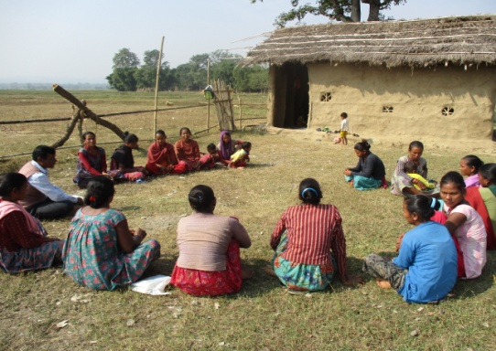In some rural areas of Nepal, parents are still not fully aware of the importance of education. Many parents believe that female children should be at home doing domestic work instead of going to school. The main reason is that they believe that there would not be enough people supporting the household and that girls would eventually be given away in marriage which is not beneficial to them. Girls who do go to school are still expected to do the same amount of work at home compared to their male counterparts. Gender discrimination begins at home. BASE organized a parenting education session where the parents received awareness and enhanced knowledge on importance of gender equality and education to all children. **In total 15 parents received** parenting education training under this project. The parents are also encouraged to ensure a child labor free village.

Parenting education session

* 1. **Support to parents for business entrepreneurship tools:**

To create a prosperous society and a better quality of life for the people, there should be sustainable economic development opportunities for the parents so that they can afford their children's education. Parents feel that by enrolling their children in school they are missing out on the income that they could earn while working. BASE has provided support to the parents of child laborers by providing them with vocational skills and tools for small business enterprises. Under this project in 7 parents received tools and business support. BASE has also encouraged them to make strong networks with locally available micro finance institutions to enable them access small loans to expand their businesses. It is expected that they will afford the education cost for their children in the coming years. During a field follow up, these parents continue to run their businesses.

**4.6.** **Rescued child labor and support educational material:**

Under this project two children have been rescued from their landlord's home. BASE continues to coordinate with local government authorities, law enforcement authorities, journalists, human rights and civil society networks members. These coordinated efforts continue to help rescue child laborers. BASE has provided educational materials to those who were rescued from child labor. Shobha was rescued from landlord Mahendra’s home in Kailali district and Santoshi was rescued from landlord Jalal's home in Kailali district. They are back home with their parents. Each child received 2 dozen copies, 2 pens, one set of a geometric box, 1 English- Nepali dictionary, 1 school bag, 1 sweater -1, 1 shirt,1 meddy, 1 pair of shoes and socks. These school supplies will help children continue their studies in government schools and ultimately contribute to the end of the child labor practice.