Photos
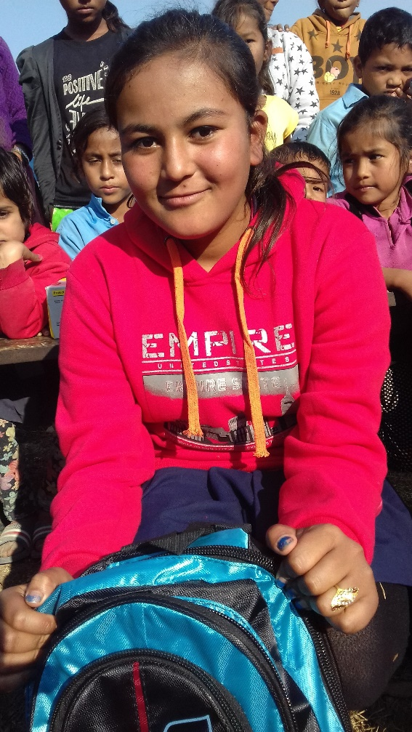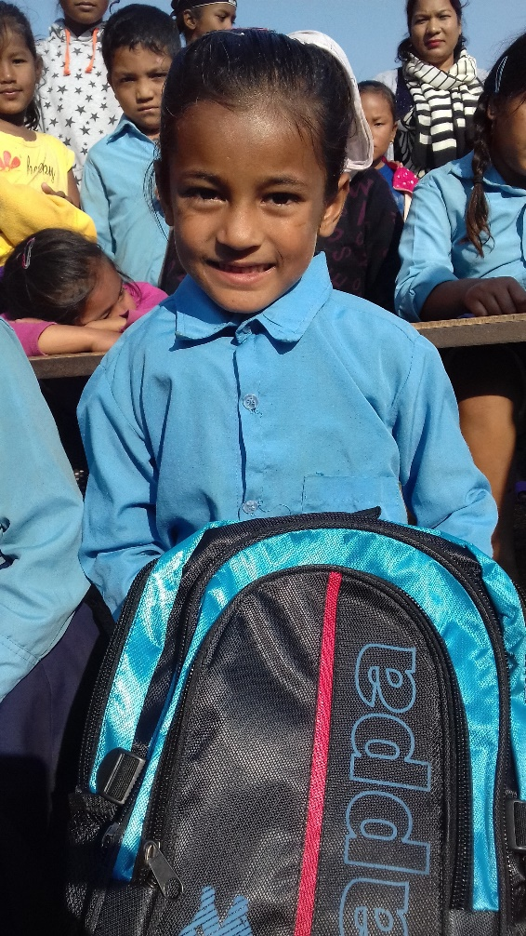
Former Child Laborers receiving school supplies in Dang District
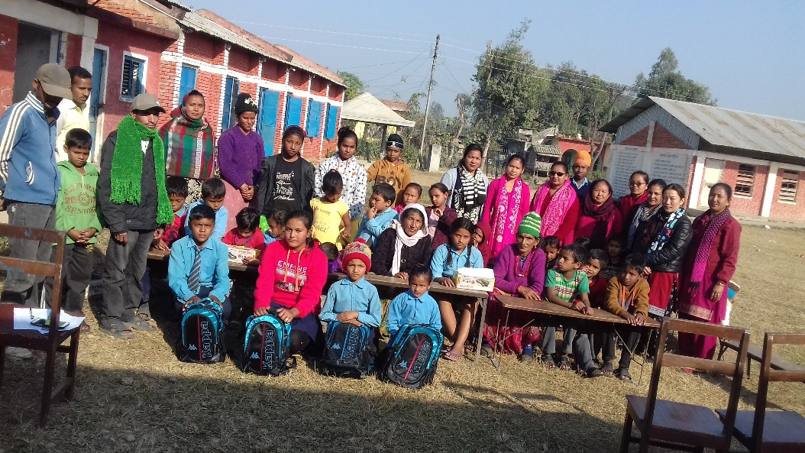
School Supplies Distribution Ceremony in Dang District
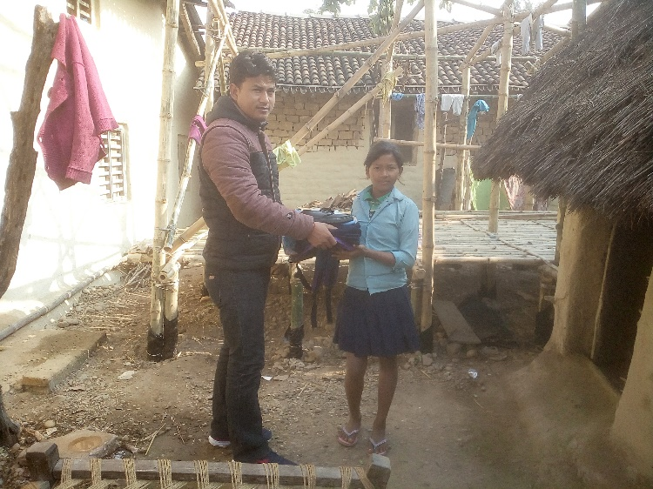
Sima Receiving School Supplies In Bardiya District

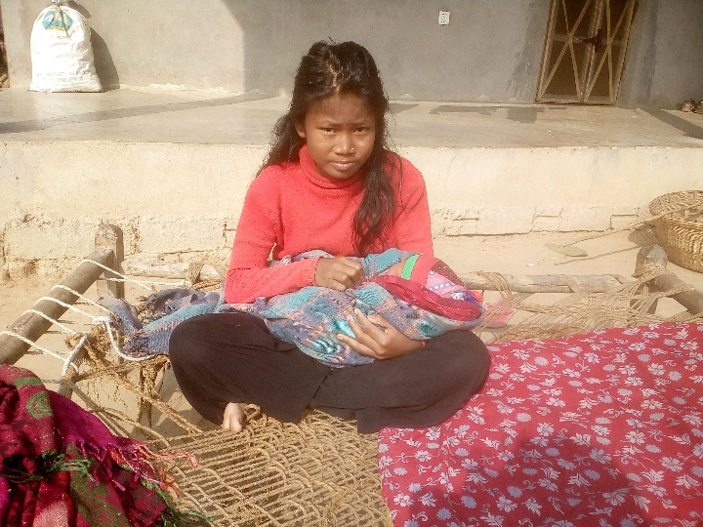
Sanita Taking Care Of A Child In A Neighbor’s Home

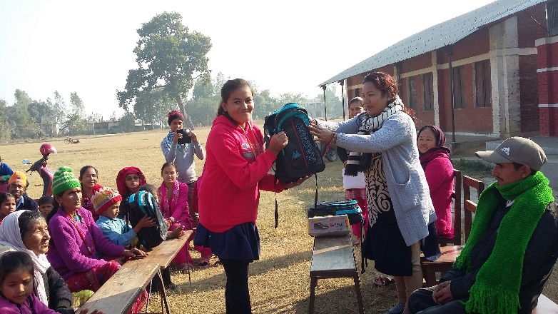
School Supplies Distribution Ceremony in Banke District by A BASE Board Member

