We two sister become orphans- Due to Covid-19 Pandemic"
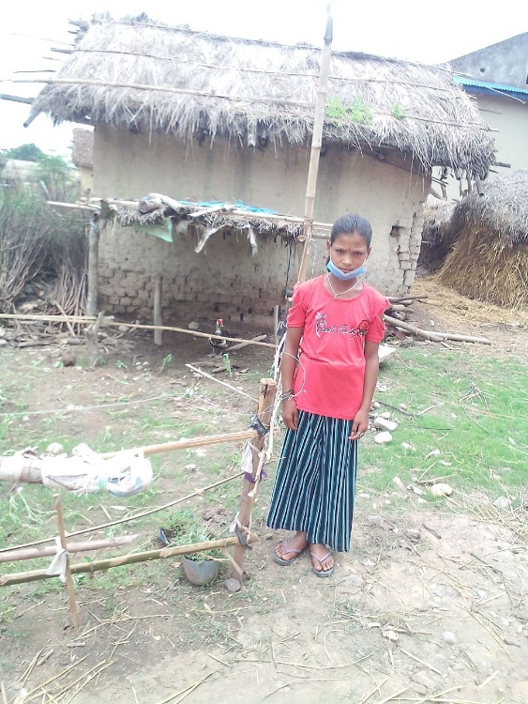
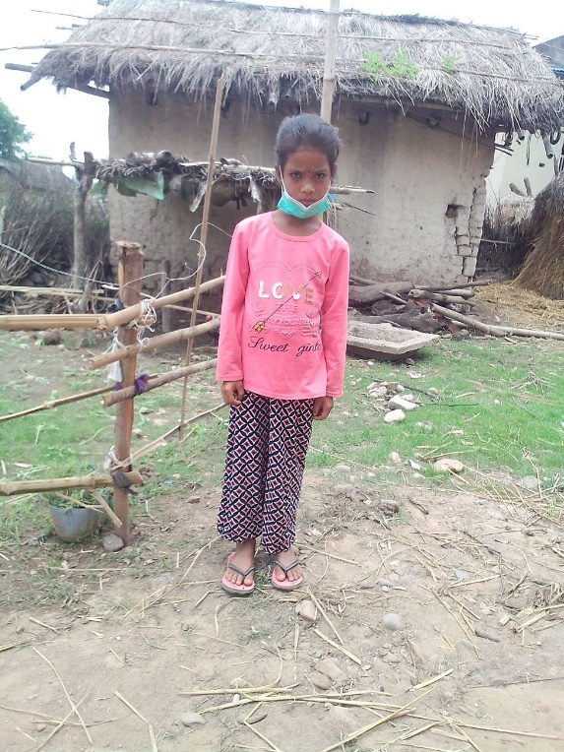
Mr. Mahesh , 35 years is living in Tulsipur Sub Metro City, Nepal. Only he has to take care of his 2 daughter. Elder daughter is Sapana who is 12 years and now studying in grade-5.Younger daughter is Sharada who is 7 years old and schooling in grade-2. There used to be a happy family before his wife Sarmila death. His wife Sarmila had tested COVID-19 PCR on 20 May 2021 (2078/2/6 BS). Her COVID result was positive. After being in process of treatment for 4 days she died on 24 May 2021 (2078/2/10 BS). After her death her 2 daughter became orphans. In the name of Mahesh's property there is a small piece of land 2 Katha (675 square meters). He has not got any support even after his wife's death by the COVID-19 pandemic. Education is one of the fundamental rights. There is provision of free basic education in government of Nepal. But school education material (stationeries, uniforms, course books, bags and sandal) are required. It is hard to afford school material and uniform for his 2 daughter to the Mahesh.
Elder daughter Sapana
Younger daughter Sharada
BASE organization has provided to education cost to continue education for Ms. Sapana and Ms. Sharada as they are studying at government school. After their mother's death they feel alone at home and are worried for their continuation of education.. Their father used to go to outside home for labor work but due to lock down imposed by Nepal government he is unable to get daily labor work. Sometime their father did not earn daily wage and return at home with empty hand. In this situation BASE organization has decided to support them for at least their education cost.

