"It's challenging for me to continue education of my tiny child"- Prakash, Said.
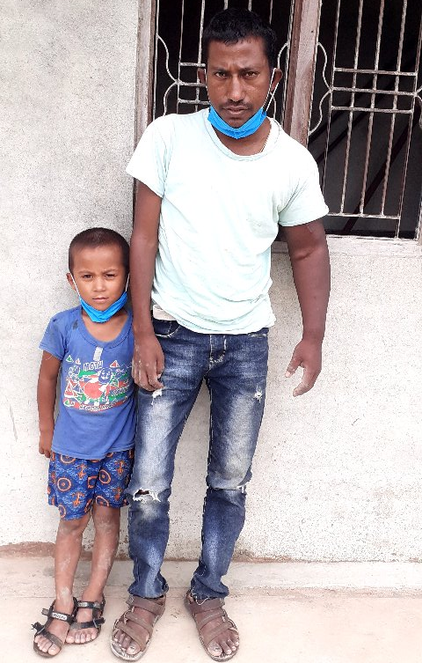
Mr. Prakash family is most affected by COVID-19 pandemic. Mr. Prakash is now running in 26 years old. There are 4 members in his family. One is mother, his wife, 5 years son and himself Prakash. There was a common living style before his father died. Because of the COVID-19 pandemic his father Krishna died in 22 May 2021 (2078/2/8 BS). After his father's death Prakash has to run his household. But unfortunately he himself has been suffering from Kidney disease. His left hand is swelling as well. Since last 2 years he has been dialysis twice in a week. His resident home lies in Tulsipur sub-Metro City and dialysis place is in Lamahi Municipality which is approximately 50 Kilometer far from his house. He has to pay NPR. 4000 (four thousand OR USD $ 34) for one week of travel. It cost NPR. 16000.00 in a month. His wife has been working as daily wage labor. Her daily wage is NPR. 600.00 (USD $ 5).
Mr. Prakash is worried about his child's education as his son Mr. Krish has enrolled at nursery grade. But cause of very poor in economy he is thinking to stop his children's education. In the name of his property there is a very piece of land 2 Katha (675 meter square). There is scarcity of daily required food from their regular income. In spite of his poorness, he has not received any support from the government and other humanitarian support. It is essential to provide him for any kind of support for his household work, his kid's schooling and for his health treatment. In this situation BASE organization has provided education cost for Mr. Prakash child.

