"It is being impossible to continue my children's education"- said Mr. Narayan, 32 Years
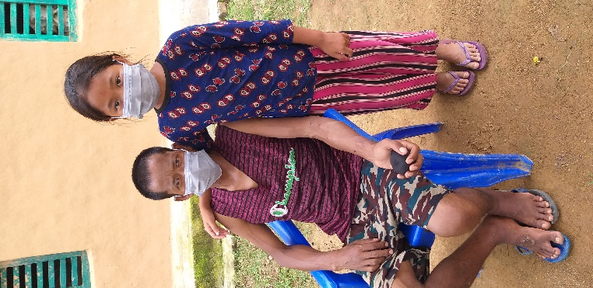
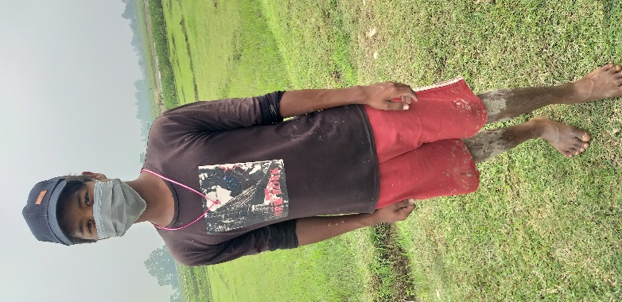
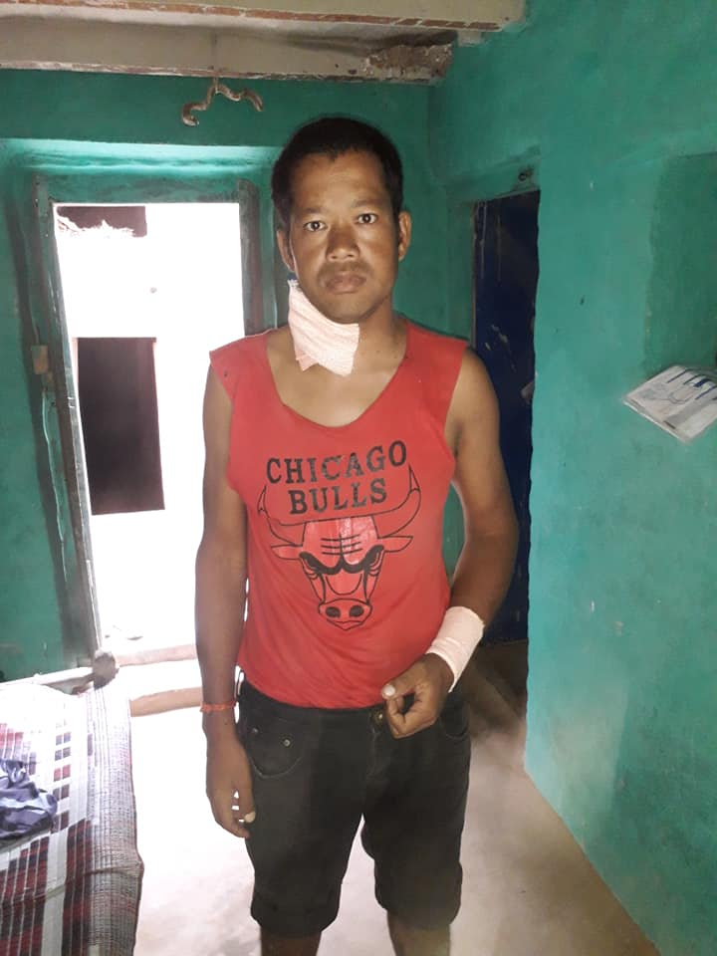
Mr. Nayaran caught a sudden stomachache before the last 2 years. After the diagnostic it is found that his both kidneys were failing. The family suffered limitlessly after knowing that his kidneys were damaged. It is required nearly 20 Lakh rupees (NPR2 million OR USD $ 1740) for transform of the kidney. But Narayan has not any coins for his treatment. His house is in the land which has not land ownership certificate. Narayan is household leader for his house. There are 6 members in his family. His older parent's father and mother, his lovely wife and 2 children named Mr. Puskar (studying at grade 10 and Ms. Reshu studying at grade 5). Narayan and his wife were able to do work and run household. Their parents are very old. Now because of damaging kidney, Narayan cannot do any physical work. Neither he is able to transform the kidneys due to heavy cost. There is no any option except waiting and see the blessing of god. Some of the relative and villager have collected money. But there is no way to get treatment from collected few money.
Mr. Narayan's son and daughter
Mr. Narayan
By cause of the chronic kidney disease not only his health is weak but also his children's education is in the stage of stop. His wife is worried thinking of her husband's disease and expensive treatment. In such a condition all of the villagers and relative are requested for supporting his treatment and education of his children.
In this situation BASE organization has provided education cost to Mr. Narayan's son and daughters for their continuation of school education.

