**Case story-3 Prabhat Rejoin his study**

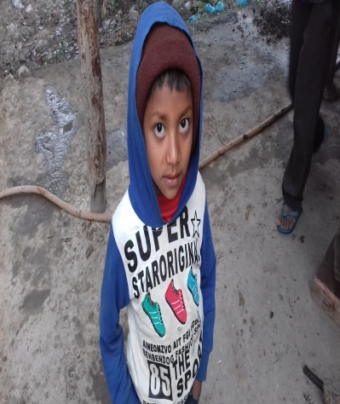Mr. Prabhat of Shantinagar Rural Municipality ward no 6 Sundabri village, Dang (previous Dhanauri VDC) district the younger son of Mr. Bhagwat rejoined his study in class one at Saraswati Primary School in Dangisaran Rural Municipality. He is 6 years little boy. He has now one elder brother Mr. Hari age of 12 and a sister age of 9 who are studying in Saraswati Higher Secondary School Charakmatiya in grade 6 and 3 respectively at Babai Rural Municipality. He also has 73 years grandmother and his father. They have only one and a half Kattha of land (2733.25 square feet) where their small home is stand. There is not enough field for the agriculture of their own so, his father claimant (lease) another person's land. His mother use to work in Hotel at Kohalpur Banke. Though Mrs. Prabhat's parents are low capital income generating person. From their income 6 members of family lives were running normally, before his mother eloped to another person.

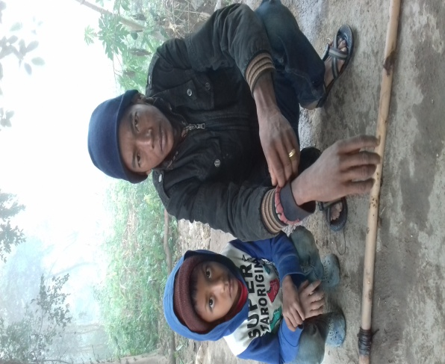When his mother eloped to another person leaving them alone their father has the double responsibility to bare the family and continue his three children's study. Father has no time to do extra work for income generating and agriculture and had to look after his 73 years grandmother and children, feed them and send them in school. They have to stop their study and went for labor work. Then his father has to face very hardness in life.

During the time his father come to contact with a health person Mrs. Chetana who committed to support Mr. Prabhat's elder brother's study till his high school level and provide him NPR 500 rupees (USD 5) for his pocket money per month and other two younger son remain without continuation of school. In case of this Mr. Rabhat's brother has to support them in their daily household work during the vacant time and from this Mr. Prabhat's brother became the child labor. Now BASE has provided to Mr. Prabhat's school education such as two dozen copies, 2 pens, one set geometric box, English Nepali dictionary-1, school bag-1, sweeter -1, shirt-1, Meddy-1, choose- 1pair and suck- 1 pair and now he is happy with his schooling. Mr.Prabhat's father received support for income generation activity and doing vegetable farming. Now he is happy with this support.

Mr. Prabhat with his father Mr. Bhagwat

**Thanks.**