Case story -1:
Ms. Sarita- "I will go my school daily for study with hard worked and one day I will show everyone that child labor also can do something good in future."
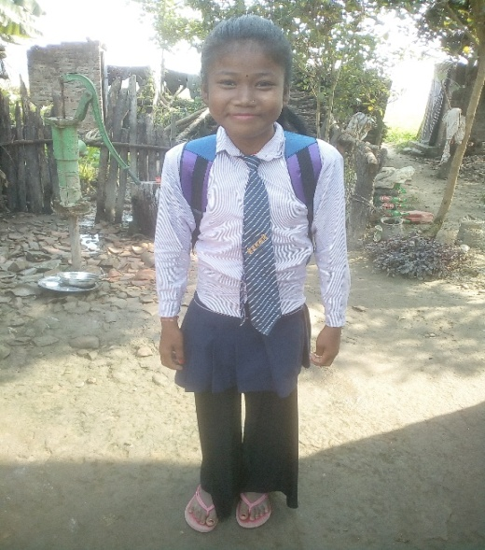
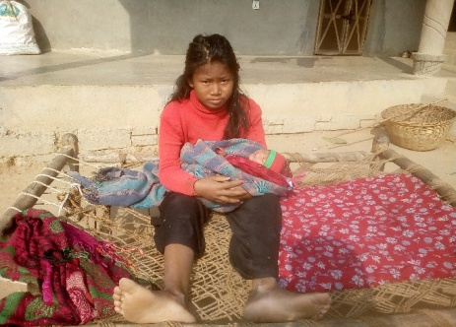
Ms. Sarita's the daughter of Chet Ram is one of the ex-child labor who is staying with her parents in Rapti Sonari Rural Municipality ward no. 5, Suntepari Village Banke district. Her parents are low capital income generating person. They have to run and subsistence the 5 members of family, caring and upbringing three children including their education, customs, and basic need through their hard labor works. They have only 5 Katha (3.75 hectare) of land to build the small hut and stay. There is not enough field for the agriculture, so, they have to do labor worked. Due to the poverty or low income family, Mr. Chet Ram and his wife have to put their second daughter in other's child caretaker as the child labor in Lalahi Village near by their own village in the age of eleven. Then Sarita becomes the child labor. She has to work for one year as the child caretaker. Suddenly the little girl had to stop her study from grade 5 final exam. She could not continue her study in grade 6 in cased being the child labor. There is not daily wage conformed of her labor, she got only one pair of cloths and food to eat from her worked in a year.
Ms. Sarita Freed Child Labor, after the support continues her further Education
Ms. Sarita- Child labor as the child caretaker

After knowingly the case in the coordination of her parents BASE program field facilitator Mr. Ganesh Kumar convinced her parents to free the child from the child labor. He counseled to the parents about child labor is the crime and also the importance of education and time. Then Sarita was freed again and joined her education in grade 6 in Shree Samaya Bhawani Adharbhut Bidhalaya Alinagar Village. In the lead of Ganesh Kumar one of the child labor was freed and now she is continue her study further. The parents are being positive to provide her education.
In support to continue the Sarita's education Backward Society Education (BASE) had provided the stationary materials and school dress dedicating to her parents.

After getting the support the little girl is very cheering and encouraged to continue her school study. She said, "I will go my school daily, study with hard worked and one day I will show everyone that- I, child labor also can do something good in future." Sarita did commitment to continue her study and also her parents made conformed to support and continue her study and willing to see her better and bright future. They thanks to the supporting organization and program who provided support to continue their child's school education.
Thanks.

