Case story-2 Pride of Little girls –Akrity to be enlighten

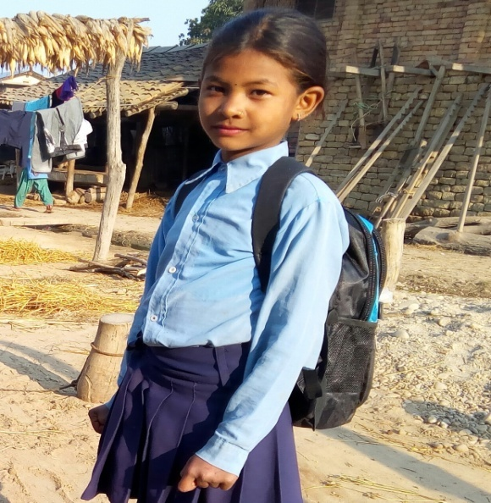
Ms. Nisha and Ms. Akrity are both two sibling, little sister age of 11 and 9 respectively staying alone in their own home in care of their uncle and Aunt at Rapti Sonari Rural Municipality ward no 5 Chacharpharka village, Banke, district. Ms. Nisha is reading in class 4 and Akrity in class 3 in Balak Shanti Adharbhut School Chacharpharka Banke. They are facing drastic problem after their father's death. Before their father death their schooling and lives style was normal. But their mother eloped to another person after a month of their father's death. The children became without parents (orphanage) just like the chicken without mother hen. The children have to manage their reading materials and stationary themselves to continue their education wearing customs, and basic need through their hard labor works. The children sometimes go to their Mother's fathers home (maternal uncle's home), sometimes in nearby neighbor's home as the child caretaker and during the rainy season both children (Nisha and Ms. Akrity) use to go paddy farming for daily wages, labors and managed some money for their further study, customs and fulfill their daily need.

Though, the children were staying nearby care with their uncle and aunt. Whole family are depending in agriculture, they could not fulfill all the need base materials because of low income in the family. There are no enough fields for the agriculture. So, the little girls themselves have to go other's home for daily works as the labor. This is the pride of the children that though they are facing drastic slavishness in their life they never stops and discourage for their further education. They never compromised for education.

After knowingly, BASE field staff Mr. Ganesh Kumar convinced the children's uncle that the practice of child labor is the crime and also the importance of education. Now the children's uncle is being positive to provide her education. In support to continue the children's education BASE had provided the stationary materials and school dress dedicating to their parents. After getting the support, the little girls are very cheering and encouraged to continue their school study. The family and the girls did commitment to continue their study for bright future. They gave thankful to the organization- BASE and program that supported to continue their school education.

Thanks.

