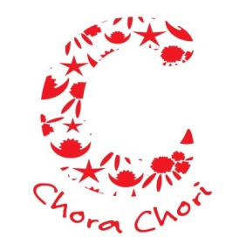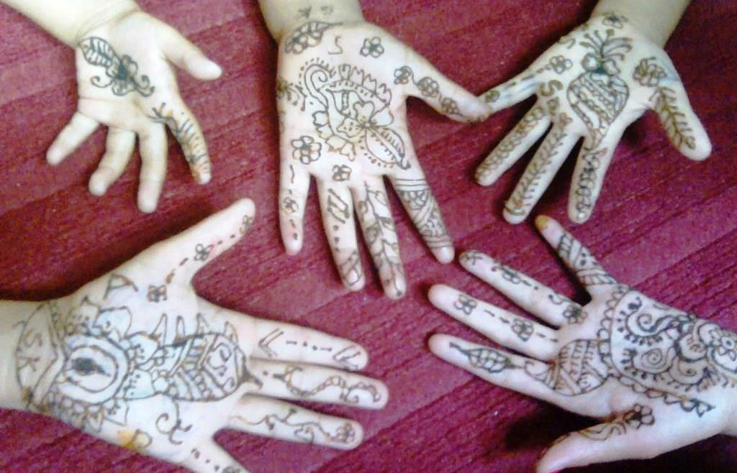

**ChoraChori Girls’ Trauma Management Centre**

**Introduction**

This is the outline and budget for a three-year programme that we will launch on 1st June 2017 through which we will provide trauma support services to Nepalese boys and girls. Central to the programme will be a new centre at Godawari, southeast of Kathmandu, will also offer residential care to girls who are suffering from acute trauma.

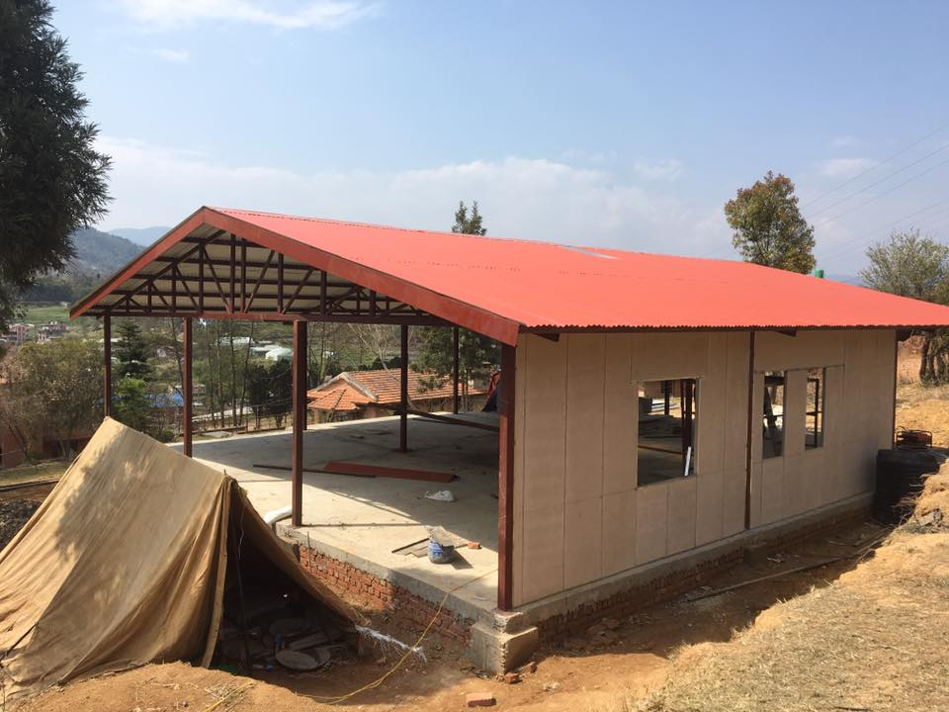**Background**

Building in progress

Over the years the staff members of ChoraChori both in the UK and Nepal have developed a wealth of experience in managing child trauma. This has ranged from managing child trafficking survivors rescued from India to supporting children who suffered more than others through the 2015 earthquakes. We have achieved remarkable results using conventional counselling in combination with the use of art and the performing arts, drawing upon both local and foreign expertise. The latter has included an input from our German partner, [Hatemalo](http://www.hatemalo.de).

In 2016 we decided to enhance our childcare capacity by building a girls’ trauma management centre at Godawari. This has been funded by sponsorship raised by Sam Day, Philip Hunter and Rory Buckworth, three British men who took up the challenge of an unsupported cycle ride from Shanghai to Kathmandu. Their “[Taking the High Road](http://www.takingthehighroad.co.uk)” challenge saw them covering 7,500km as they passed through seven countries in four months, arriving in Kathmandu in June 2016. Building of the centre started in February 2017 and when complete the earthquake-resistant facility will have a 12 bed capacity and incorporate an art therapy room, counselling rooms and a sensory room. We believe this Centre will be the first of its kind in Nepal.

**Project Vision**

Our Vision is to see child trauma support services in Nepal that are on a par with the best available internationally.

**Project Aim**

Our Aim is to establish a sustainable child trauma management service at Godawari, on the outskirts of Kathmandu.

**Project Objectives**

1. To furnish and set up the facility after building is completed in mid-April

2. To provide residential trauma support

3. To offer a referral service to the child welfare authorities and to other NGOs in Nepal

4. To develop staff capacity

5. To ensure that the Centre is sustainable after three years

**Funding needs**

1. *Furnishing and set up*: Aside from the need for providing furniture, furnishings, kitchen equipment and other items necessary for 15 residents (12 beneficiaries plus three carers) we require the funds needed for therapeutic activities. The latter include the setting up of an art therapy room and sensory room.

2. *Providing residential trauma support:* There are a range of monthly costs such as utilities, food, clothes, medical, educational and carer salaries.

3. *Providing a referral service:* There is only a requirement for a modest budget to cover miscellaneous expenditures. The administration of the service will be covered by the Centre’s core staff.

4. *Developing staff capacity:* We have a budget to cover local consultancy support, a professional input that will be augmented from time to time by overseas visitors to the project.

5. *Sustainability:* Finding long term support to the project will be a task for ChoraChori in the UK and this is covered in part by the UK support cost element of the budget. We believe the secret of sustainability lies in sharing the funding challenge with other charities, including Hatemalo. We will also seek long term support from a corporate, which can be based in Nepal or internationally.

**Budget summary**

