Help Ellsworth Bands, Help the World
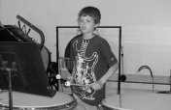
This year the Ellsworth Bands have decided to try something different to reach our fundraising goals. Instead of selling products, we are going to do a local-global project. We are teaming up with Creating Hope International, a GlobalGiving Partner, and GlobalGiving to help others as we help ourselves. As we raise money for the bands this summer, we also have an opportunity to raise funds to provide an education to children in Afghanistan through Creating Hope’s partner, the Afghan Institute of Learning and to provide food for the needy at The Good Samaritan Food Pantry.
Did you know that Ellsworth is the smallest community school in Lower Michigan with an instrumental music program for students in 5th – 12th grade? 96 students participate which is 69% of the student body. Isn’t that amazing!!!!! The national average for band program participation in any given school is 10% of the student body. Recently, our high school band took a First Division Rating (the highest possible rating) at State Band Festival. We also had middle school band students participate in the Solo and Ensemble Festival, and all received First or Second Division ratings!
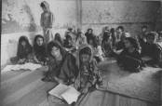
Creating Hope International (CHI) is a Michigan non-profit that partners with the Afghan Institute of Learning (AIL), an Afghan NGO providing education and health services to 350,000 Afghan women and children every year. After decades of war and the Taliban regime, most Afghan women and children are not literate. AIL offered underground schooling to thousands of girls during the Taliban regime and now offers classes in the open to 22,000 women and children annually through Educational Learning Centers (ELC’s). Students are eager to learn as much and as quickly as possible after years of having no opportunity to learn. ELC’s offer women and children culturally sensitive education at safe locations close to their homes.
GlobalGiving is an on-line organization whose aim is to link people online with small charitable organizations around the world. GlobalGiving is going to provide matching funds for up to $7,000 raised by us. GlobalGiving is also going to provide our project with a website where you can go to make a donation online as well as check the Band and Creating Hope’s progress as we work towards our goal. The address for this website is:
www.globalgiving.com/2748
This is how it works. Once we raise $2000, GlobalGiving will provide dollar for dollar matching funds for every dollar raised up to $4000, including the first $2000 raised. After we’ve reached our initial goal of $4000, GlobalGiving will provide $.50 for every $1 we raise above $4000. Creating Hope and the Ellsworth bands will split the first $8,000 evenly. Anything over $8,000 will be divided between the Ellsworth Bands, Creating Hope and the Good Sam. You can donate by credit card online or by mailing a personal check written to GlobalGiving to Ellsworth High School, Band Fundraiser, 9467 Park St. Ellsworth, MI 49729 or by supporting a band fundraiser. The band will be hosting fundraising events during the summer, so keep your eyes peeled!
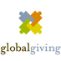

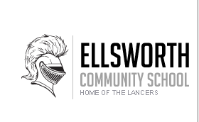
The hope of our fundraiser is that not only can we provide for the needs of the growing band program in Ellsworth, but that we can help those less fortunate along the way. We are also excited about getting to learn more about a culture very different from our own. We are hoping that you will be wiling to help us reach our goals.

