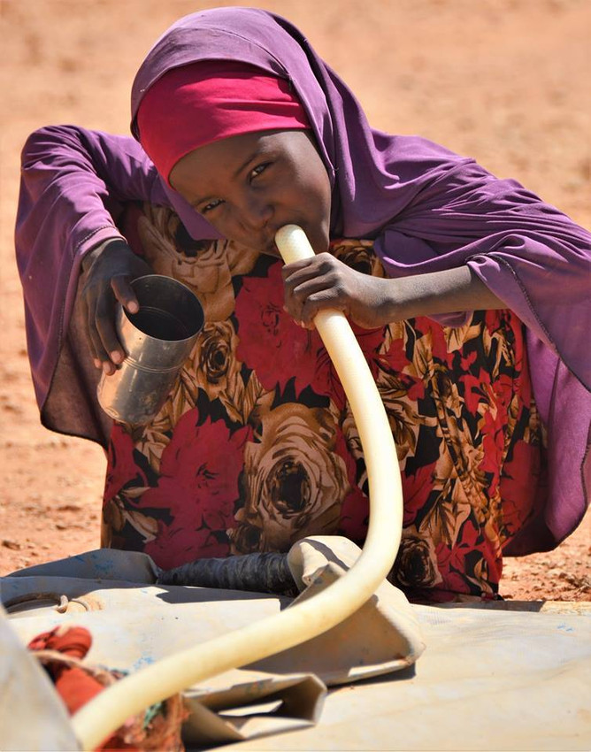**“*Saving these lives and rebuilding livelihoods will require concerted action by the international community – and that action needs to start now.”***

**Save the Children Scales up its Response to Famine in South Sudan and Hunger Crises in East Africa**

**March 17, 2017**

* Hassan Noor, Save the Children’s Country Director in Somalia

**The Emergency**

The humanitarian situation in South Sudan and East Africa is rapidly deteriorating – children are dying today from starvation, cholera and associated diseases. Millions more people are reported to be on the brink of famine. According to the United Nations (UN), an unprecedented number of simultaneous, severe hunger and nutrition crises are placing an estimated 19.4 million people at risk of starvation across this region.

The situation in South Sudan is catastrophic; the government and the UN have declared a famine in conflict-ravaged Unity State. This means people have already started dying of hunger. There are legitimate fears that the crisis could spread to 5.5 million households by July, due to a lethal combination of civil war, mass displacement and little to no food production. An estimated 742,000 South Sudanese refugees have already fled to Uganda in search of food and water and to escape conflict.

A thirsty girl in Puntland tries to drink from a dry water container. With severe shortages, the price of water is soaring and beyond the reach of most families.

*Photo: Hassan Noor/Save the Children*

Somalia is also close to experiencing another famine, prompting the government to declare a national disaster. Almost half the country’s population is suffering from a lack of food and water. Exacerbating the situation is the rapid spread of cholera in drought-affected areas. Since the beginning of January 2017 alone, there has been more than 9,500 cases and 237 deaths – numbers that are likely to be significantly higher given the remote locations of the cholera outbreak. Of these known cases, over one-third were children under age 5, and 110 cases occurred recently over 48 hours in the Bay region alone. The cholera outbreak poses an immediate risk to an estimated 363,000 children who are already suffering from malnutrition and could rise to 944,000 cases this year unless urgent aid is provided.

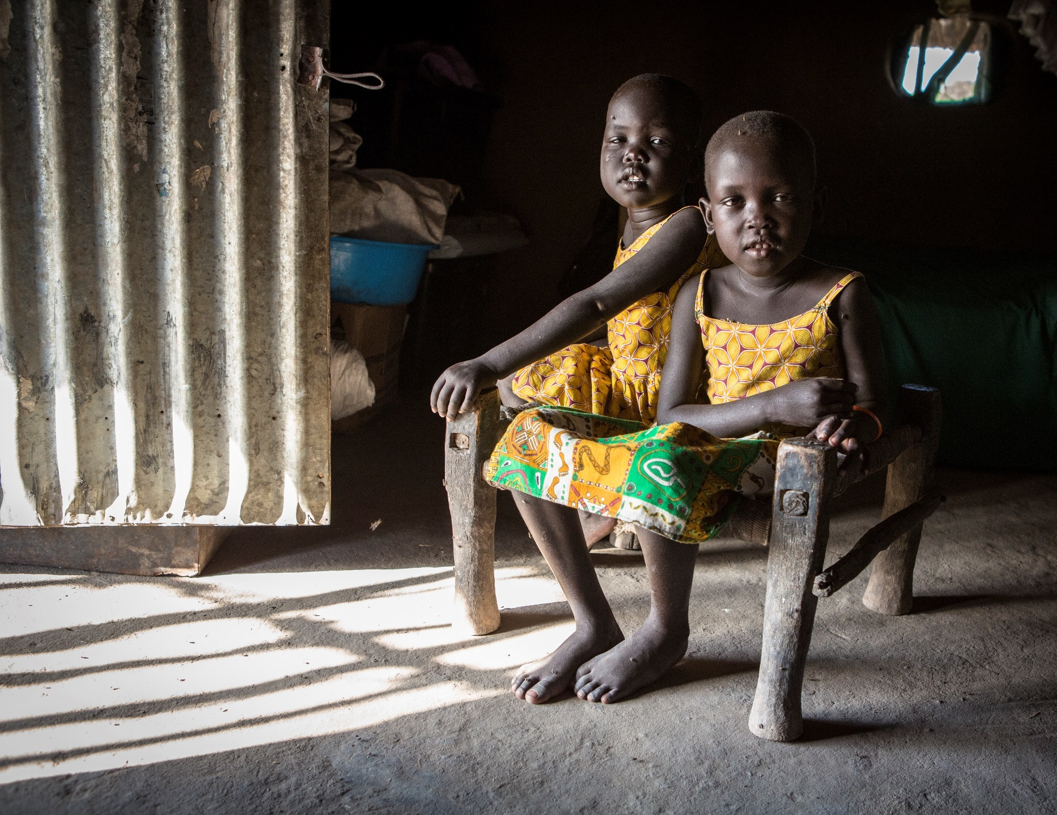Ethiopia and Kenya are dealing with similar impacts of the drought on children’s and families’ nutrition, health, education and livelihoods. In early March, an outbreak of acute watery diarrhea in southeast Ethiopia affected hundreds of children. Similarly, in Kenya, nutrition screenings found that over half of children in some hotspots of Turkana County were acutely malnourished. These developments are extremely alarming and could lead to the imminent risk of children dying in the next few weeks if immediate action is not taken to provide supplementary feeding.

Save the Children knows that action now will prevent unnecessary deaths later. As the 2011 crisis in the Horn of Africa – the most severe emergency of its kind in this century – has shown us, the response to that drought was too little too late, resulting in more than 250,000 lives needlessly lost – half of them children.

Two young girl sit in their grandmother’s home in the Jonglei State, South Sudan. The state is among those in which we are scaling up emergency food and nutrition programs in response to extreme hunger.

*Photo: Jonathan Hyams/Save the Children*

Our Response

Save the Children is on the ground in each of the countries experiencing grave hunger emergencies, providing lifesaving support to children who are most at risk of dying. Our priority is to reach children under age 5, who are less able to withstand acute malnutrition and are more susceptible to diseases such as measles, malaria and cholera. Our teams are working hard **screening tens of thousands of children** for malnutrition, running **feeding programs** and treating malnourished children in **specialized health centers**. We are also providing water, sanitation and hygiene to prevent diseases from spreading.

South Sudan

Save the Children worked in South Sudan for years prior to its independence in 2011, and we have continued to conduct large-scale humanitarian programs there ever since. We are the largest international aid agency and the lead health and nutrition provider in the Eastern Equatoria State and also work in the Jonglei, Upper Nile and Lakes states. Our objectives are to ensure famine-affected households, and those at risk, have access to food, lifesaving nutrition services, safe drinking water and improved hygiene. We also aim to protect children and their families against communicable diseases and increase access to essential lifesaving drugs, child protection assistance and education. Our Emergency Health Unit has prepositioned medical supplies, water and sanitation equipment and shelter materials in Juba, and has carried out health and nutrition training to help prepare for a scale up. As we scale-up our response, we aim to reach 598,000 drought and famine affected children and adults in South Sudan over the next six months as well as 148,400 South Sudanese refugees in Uganda through these expanded programs.

Somalia

Save the Children is the aid agency responding to the drought across the country. We are trucking water to parched areas, providing cash transfers to vulnerable families and running nutrition programs. To respond to the cholera outbreak, we established a cholera task force and have deployed our Emergency Health Unit to Baidoa to scale up our response and distribute pre-positioned supplies in Kismayo and Garowe. This is critical, given our recent assessments indicating that more than 7,000 new cases of cholera are expected to occur over the next six months. In addition, there is an acute need for ready-to-eat therapeutic food. Our goal is to reach 2.5 million children and adults through these multi-sectoral and expanded programs. In 2017, we have already reached over 156,600 people, including 83,700 children.

Ethiopia

With tens of thousands of families affected by the drought, we have deployed mobile health and nutrition teams to treat children suffering from malnutrition. Our teams are also trucking water and installing water tanks at sites where internally displaced people have settled. We are supporting nutrition measures in rehabilitation centers, providing medical supplies to treat malnourished children and enrolling pregnant and lactating women in supplementary feeding programs. We are providing child protection services for refugees at the border in Dollo Ado as well as school feeding programs in the camp. We have also worked closely with communities, training them on disease surveillance and providing households with alternative income-generation skills, crucial for those whose livestock has died. Our goal is to reach 1.1 million children and adults through this work.

Kenya

Across three of the worst-affected counties in the north, we are conducting nutritional screenings and treatment in 142 sites. To date, we have reached over 19,000 children under age 5 and over 10,000 pregnant women. We are helping keep schools and health facilities open by providing water and sanitary services. Our Emergency Health Unit has been deployed to scale up our health and nutrition response in Turkana. We aim to reach 540,000 drought affected children and adults.

Deploying the Emergency Health Unit

We are at a critical moment in this unprecedented hunger crisis. Never before have speed, reach and expertise been more vital to save lives. Our Emergency Health Unit is fully equipped to deliver quicker, more effective frontline emergency healthcare and is helping us rapidly scale up our health responses in Somalia, Kenya, South Sudan and Uganda.

In Somalia, the unit is helping to curb a deadly cholera outbreak in some of the hardest-to-reach areas. In Kenya, it is providing primary mobile health care that works closely with nutrition, water, and sanitation. In South Sudan, we are planning to deploy a unit to bring lifesaving treatment for malnutrition to children in Unity State where famine has been declared. Meanwhile, our rapid response health teams are already in Uganda, where we are running two clinics to bring primary health care to an average of 2,500 exhausted and weakened refugees who arrive from South Sudan daily.

Why Save the Children?

Save the Children is the world’s leading child-focused humanitarian organization. We have nearly 100 years’ experience responding to children and their families during and after crises. We are exceptional among aid agencies because we provide comprehensive emergency preparedness, relief and recovery programs that are specifically designed to meet the unique needs of children and their families. We have well-trained national staff ready to respond at a moment’s notice. Our international experts in health, nutrition, food security, shelter, water and sanitation, education and child protection can join our local staff if needed. We also have pre-positioned relief supplies and medicines.

Because we work directly with children and families in the heart of the crisis, we know immediately when conditions change and can adapt our programs to meet children’s most urgent needs. Save the Children also stays as long as it takes to help children, families and communities recover from their losses, rebuild their lives and become more resilient to future shocks.

*Nobody knows when the next crisis will strike. That's why 10 percent of your generous gift goes to helping our emergency teams prepare for and provide critical assistance when and where children need us the most.*