Summary
Le Tonle training guesthouse and restaurant is a social enterprise project of Cambodian Rural Development Team (CRDT), a non-profit NGO in Cambodia). Le Tonle Training Guesthouse and Restaurant aims to provide free theoretical and practical training to young disadvantaged Cambodians in the area of tourism and hospitality such as front office, housekeeping, cooking and hospitality. By providing these skills in short term, vulnerable youths are able to obtain varied and worthwhile careers, and are able to live by themselves independently and support their family by sending some of their earnings back home. In the long term, the training is providing an opportunity for youth to develop themselves further in tourism professions and giving them general knowledge, which will enable them to take careers as one of the country's human resource. This will help solve the human development program of Cambodia and lift the poverty rate in the future. According to the global Multidimensional Poverty Index (MPI) from 2018, thirty-five per cent of Cambodians are living in poverty, especially in the countryside.

Our 8-month training program
Le Tonle training program is recognize by the Ministry of Tourism of Cambodia under the National Committees of Tourism Professional as vocational certificate. Trainees are trained by our experienced trainers, many of whom were our graduates from 2008. Most of the training periods are focused on practicing and interacting with the tourism industry by supporting trainees to develop generic competencies such as computer skills and English proficiency.

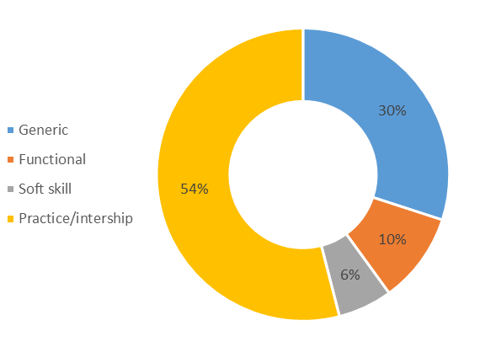

Progress report
Since the project was established in 2008 till present, there have been 276 trainees from marginalized communities around the Northeast of Cambodia and around 53% of trainees are female. Based on our records, 85% of these graduates obtained a job in tourism industry in North-Eastern regions and some have obtained careers in the big tourism hub in Cambodia such as Phnom Penh and Siem Reap. Most trainees send 60% of their monthly earnings back home to support their families.
February 2020 saw the onset of the Corona pandemic in Cambodia. Le Tonle was fortunate to be able to still safely carry out the training for our 25 students and conduct skills tests. We conducted theoretical and practical classes based on our practical learning approach. Students completed two months of classes that were focused on housekeeping, food & beverage preparation and service as well as an English course. Students were then introduced to the real job world with traineeships in tourism industries of the Kratié province. For all of them, this provided a great chance to experiment with what they had learnt at Le Tonlé training center, challenged them in a protected environment as well as enabling them to build networks with their potential employers.
Once they came back from one-month traineeship, they had time to review the skills they acquired in their work experience and get ready for the final skill test. The skill test is divided into written and practical exams conducted by the team of Le Tonle trainers and expert staff from Provincial Tourism Department of Kratie. As a result, twenty-four of the trainees were graded as competent by the staff from DoT. Successful trainees were issued with a certificate by the ministry. After the test, they were supposed to go back home to celebrate Khmer new year before actively looking a job, but unfortunately, the COVID-19 crisis and government restrictions trainees, trainees were unable to return home for Khmer New Year and the greatly diminished tourism industry prevented any graduates from being able to secure job opportunities.
The management of Le Tonle decided to temporarily closed the whole operation of Le Tonle to prevent the spread of COVID-19 in our community and to keep everyone safe from it. Trainees, trainers and the rest of the operation team had to take an unpaid leave. The management decided to keep only a few standby team members just to work on communication and prepare for the re-opening as soon as COVID-19 is defeated.

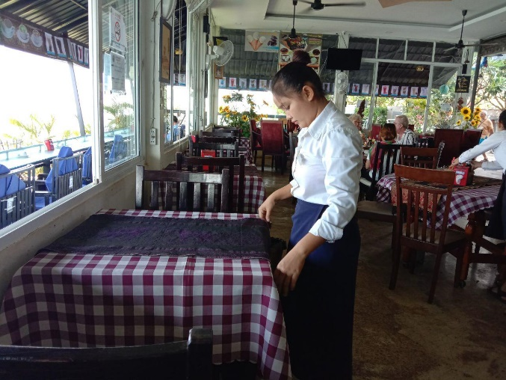
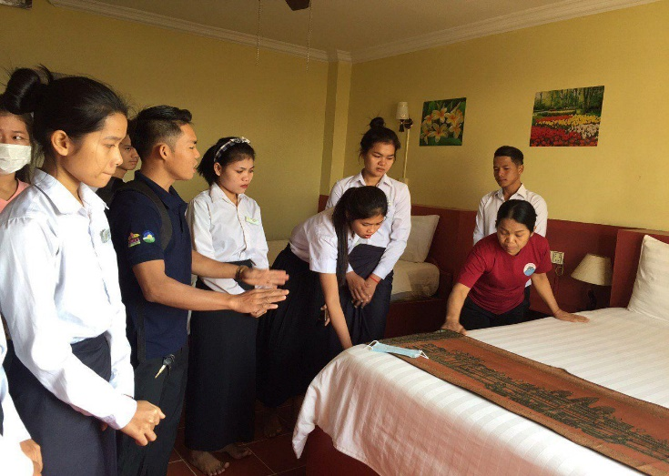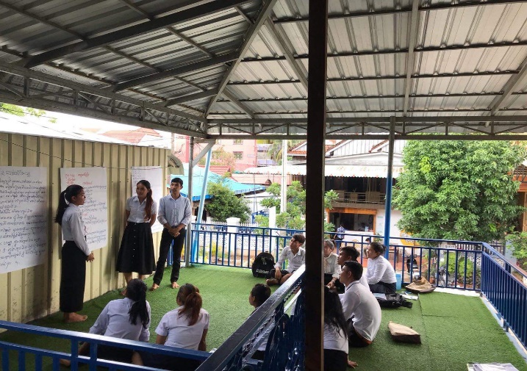
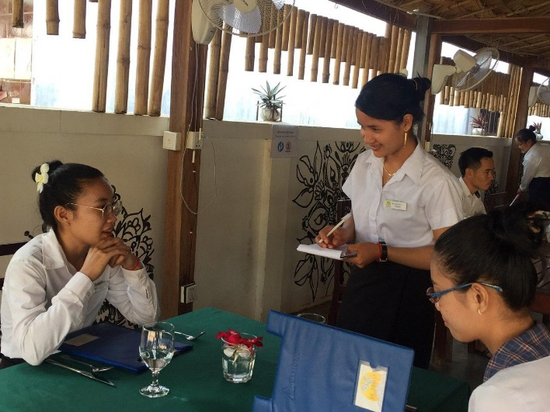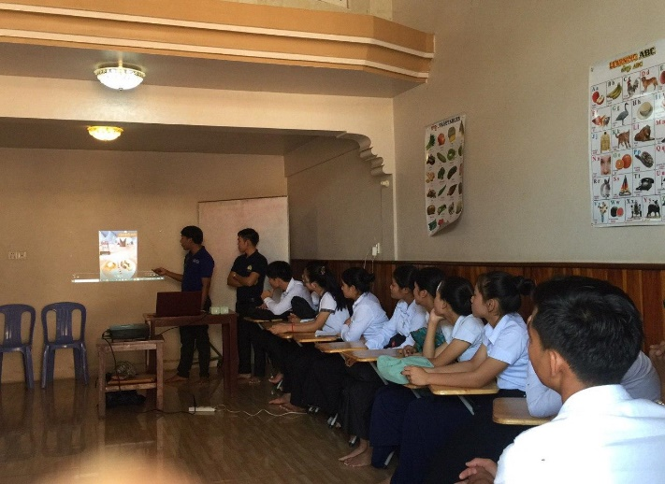

Response to COVID-19
Past three months of our training program was one of the most challenging in history due to the pandemic of COVID-19 and we assumed that it is occurring almost everywhere in the world. Below were our responses to the pandemic of COVID-19.
  - Changing training content to raise the awareness of COVID-19.
  - Conduct on going meetings and update on personal hygiene to trainee and working team.
  - Continue communicating with the parents of trainees, supporting their concerns during the pandemic, providing information regarding hygeine, our response as an organisation and information we have regarding the development of the pandemic.
  - Apply working from home to prevent the spread.
  - Double the hygiene management regarding Le Tonle.
  - Temporarily close the operation of Le Tonle.

Our current biggest challenges
Le Tonle is a non-profit project which aims to equip vulnerable youth with skills in tourism, create opportunities for them to generate income providing support to the CRDT community through income generated through the tourism community. Currently it is temporarily closed because tourism is directly affected by pandemic of COVID-19. The team is struggling to pay for the property leasing and its standby team who working on networking, updating job opportunity and developing the training program. The total cost this is USD 3,540.00 monthly or USD24,780.00 until the end of 2020 as we assumed that the situation is getting better which we can resume our training to more vulnerable youth who are still waiting. So far 20% of the above total cost had been raised. Le Tonle is sincerely grateful to those who supported and continue to support us during this difficult period.
Job seeking for our graduated trainees is difficult as the whole tourism sector in Cambodia is directly affected from COVID-19. Many of our recently graduated trainees who were employed before, now face unemployment and lack sources of income to sustain themselves and their families. Our standby team is currently maintaining the facilities to hopefully enable operations to return to normal as soon as the crisis ends and it is safe to do so.
