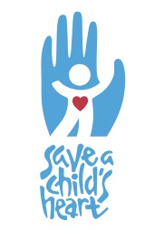
In 1995 Save a Child’s Heart (SACH) was founded by the late Dr. Ami Cohen to save as many children as possible with heart disease from developing countries, regardless of nationality, religion, race, gender or financial situation.
SACH is an international humanitarian organization based in Israel whose mission is to improve the quality of pediatric care for children from developing countries. It treats children suffering from heart disease and creates centers of competence in these countries.
For the vast majority of children, from the moment they comes into our care until they are fully recovered, costs are covered by SACH and its partners, including medical, travel, and accommodation, even if the child requires a life-time of cardiac care.
Congenital heart defects are responsible for more deaths in the first year of life than any other birth defect. Rheumatic heart disease, the most common acquired heart disease, has been all but eradicated in developed countries, yet still kills children and young adults in developing countries.
To date, SACH has provided care to over 4,000 children from 51 countries in Africa, the Middle East, Asia, Europe and South America.

What SACH Does
- Provides free life-saving cardiac surgery and other critical procedures to children from developing countries at the Wolfson Medical Center in Holon, Israel.
- Provides a comprehensive training program in Israel for doctors and nurses from these countries
- Leads surgical and teaching missions to partner countries in the developing world
- Holds pre-operative and follow-up cardiology clinics in Israel and abroad

Follow us on:
Facebook: Save a Child’s Heart
Twitter: @SACHTweets
Instagram: saveachildsheart
www.saveachildsheart.org

How to Get Involved!

For volunteer Opportunities in Israel:
Daniela Bitton
Mob: +972-54-6547888
Tel: +972-3-558-9656 ext. 6
Email: ylcoordinator@saveachildsheart.org
16 Haviva Reik St., Holon, 5849538, Israel

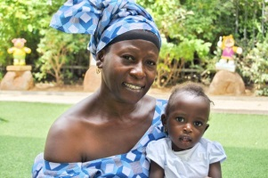
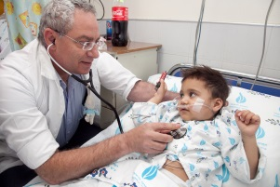
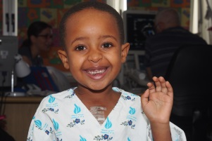
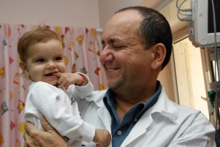
Getting Involved Abroad:
Brianna Fowler
Mob: +972-58-4644168
Tel: +972-3-558-9656 ext. 7
Email: leadership@saveachildsheart.org
16 Haviva Reik St., Holon, 5849538, Israel

