PRESS RELEASE

A Tale of Two Libraries: Prison inmates raise funds for a slum library for girls in Kolkata (Calcutta), India, with a sponsored 700 km static row

15 prisoners at HMP The Mount, Bovingdon, will attempt to row for 12 hours straight from 7 am onwards on Monday 24th April this year to raise funds for a small library dedicated to girls in a Calcutta slum. They aim to cover 700km, which is more than twice the length of the Thames. Teams of three prisoners along with some of the officers will be rowing non-stop on five machines. They are already training hard and are well supported by prison staff and prisoners.

Sean, the prisoner who has organised the row, says:
“The girls in the slums in Kolkata only want the opportunity to educate themselves so they can better their lives. It made me think that it is a shame that the place you are born can dictate how your life will be. Having been in jail a long time myself I have had the benefit of educating myself and gaining skills which will help me on release. So I thought it would be good to raise some money to help the girls better themselves. These small but worthwhile charities need support as they really make a difference to people’s lives.”

Sean and the other prisoners and staff have been inspired by local resident Helen Bratchell, the prison librarian. Helen has worked at The Mount for 18 years, providing educational support to prisoners and guiding them through Open University degrees as well as encouraging recreational reading. Helen went to India on holiday in January this year and visited the library run by NGO, Tiljala SHED. She met some of the 700 girls who use the library and was invited into some of their homes in the slum afterwards.

Helen says, “In January this year I was privileged to visit a pretty amazing library. The Gyan Azhar library was set up in 2008 in one of the poorest slums in Kolkata by a local charity, Tiljala SHED, to provide a safe place for girls to go to study, borrow books, use computers, take part in activities such as health education and crafts and to meet their friends. One of the charity's main aims is to help girls to stay in education to give themselves the best chance of avoiding a life of extreme poverty and early marriage. With a good education girls can gain financial independence and support themselves and their families and the library plays a big part in this.

The girls I met at Gyan Azhar were so proud of their library and really enjoyed showing me around. It's not big by any means - the library is in a room measuring about 12 feet square - but it has 700 members from the ages of five to twenty! The library is desperately short of books, computers and craft materials and I came back from my trip determined to raise some money to buy some more.

The girls in the slum are trapped in poverty, living in rooms no bigger than a typical prison cell, often with five or six family members. Like the prisoners at The Mount, the girls know that education and skills are their best hope of a better life. I was amazed when Sean said he wanted to organise this fundraiser: I was only telling them about my holiday. As manager of the library at the Mount I know what a difference libraries can make. As well as being vital for learning, books can offer a real release from the problems of everyday life. We can all escape with a book!”

The funds the prisoners raise will be used to supply books, computers and craft materials for girls to use when they visit the library.

Donations are being collected here www. justgiving.com/crowdfunding/helen-bratchell

Notes for Editors:

About the NGO
Tiljala SHED is a small charitable organisation established 30 years ago to provide support for some of most vulnerable slum and squatter communities in urban Kolkata (Calcutta). Most of the residents work in the informal economy: rag picking (collecting and sorting the city’s waste), rickshaw driving, vegetable selling or exploitative piecework. There are very low levels of literacy; many have no ID and therefore cannot access their statutory entitlements; malnutrition, infectious diseases and especially TB are endemic; boys as young as 10 drop out of school and end up in child labour; girls are at risk of early marriage and a life of drudgery, domestic abuse and extreme poverty. Tiljala SHED empowers these young people by providing educational support by way of sponsorship.

The Gyan Azhar library is a refuge for the girls in these deprived communities. The traditional, mostly Muslim, culture dictates that girls should remain “indoors” and away from mixed company. In reality this means they spend a lot of time at home, which is a single room shared with the rest of the extended family. It is hard for them to do school work at home where the light can be poor, the noise distracting and with no table, chair or desk – let alone electricity or internet. As a girls-only facility the library offers a space where they can be safe and where their parents are happy for them to spend time.

Jane Manson who lives locally in Bourne End is the international fundraiser for Tiljala SHED and hopes to join the prisoners for their sponsored row on 24th.

Contact details:

Tiljala SHED and Gyan Azhar Library:
Jane Manson 07743 955665
Janemanson27@gmail.com
www.tished.com
www.facebook.com/tiljalashed/

About HMP The Mount Library
http://www.justice.gov.uk/contacts/prison-finder/the-mount

The library service at HMP The Mount is provided by Hertfordshire Libraries.
The Mount Prison was designed as a Category C Training prison built on the site of the former Bovingdon RAF station. However, when the establishment opened in 1987, it was used as a Young Offenders Institution for males aged 18 to 21. This has changed over the years however, and today the prison is used to hold Category C adult male prisoners.
The regime at the prison includes full- and part-time education, workshops, training courses, farms and gardens, and a works department. Other features include listener groups (community based project to keep juveniles out of prison), a job skills course, and prisoner driven drug-free meetings.

Contact details:
Helen Bratchell (Librarian) 07762 784796
Email: helbratch@hotmail.com

Please note that permission to take photographs of the event has been applied for, but no guarantees.

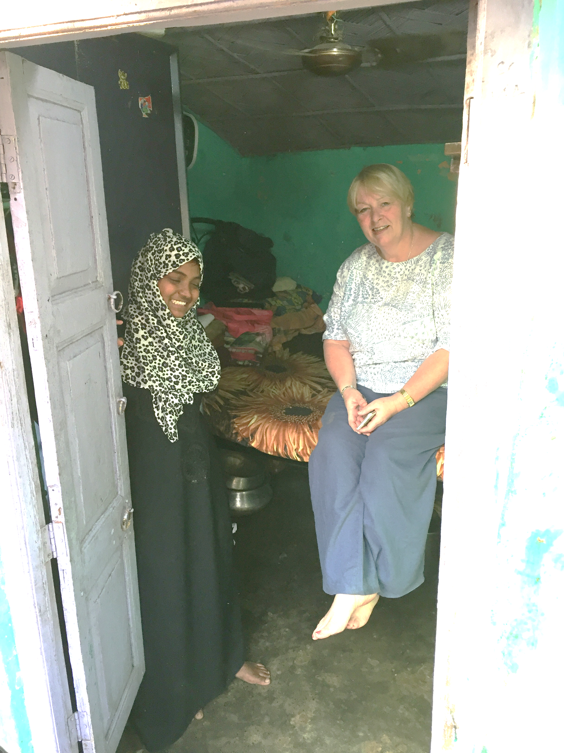

Helen visits Tabassum in her single-room dwelling in the slum. Tabassum and her two sisters sleep under the bed.

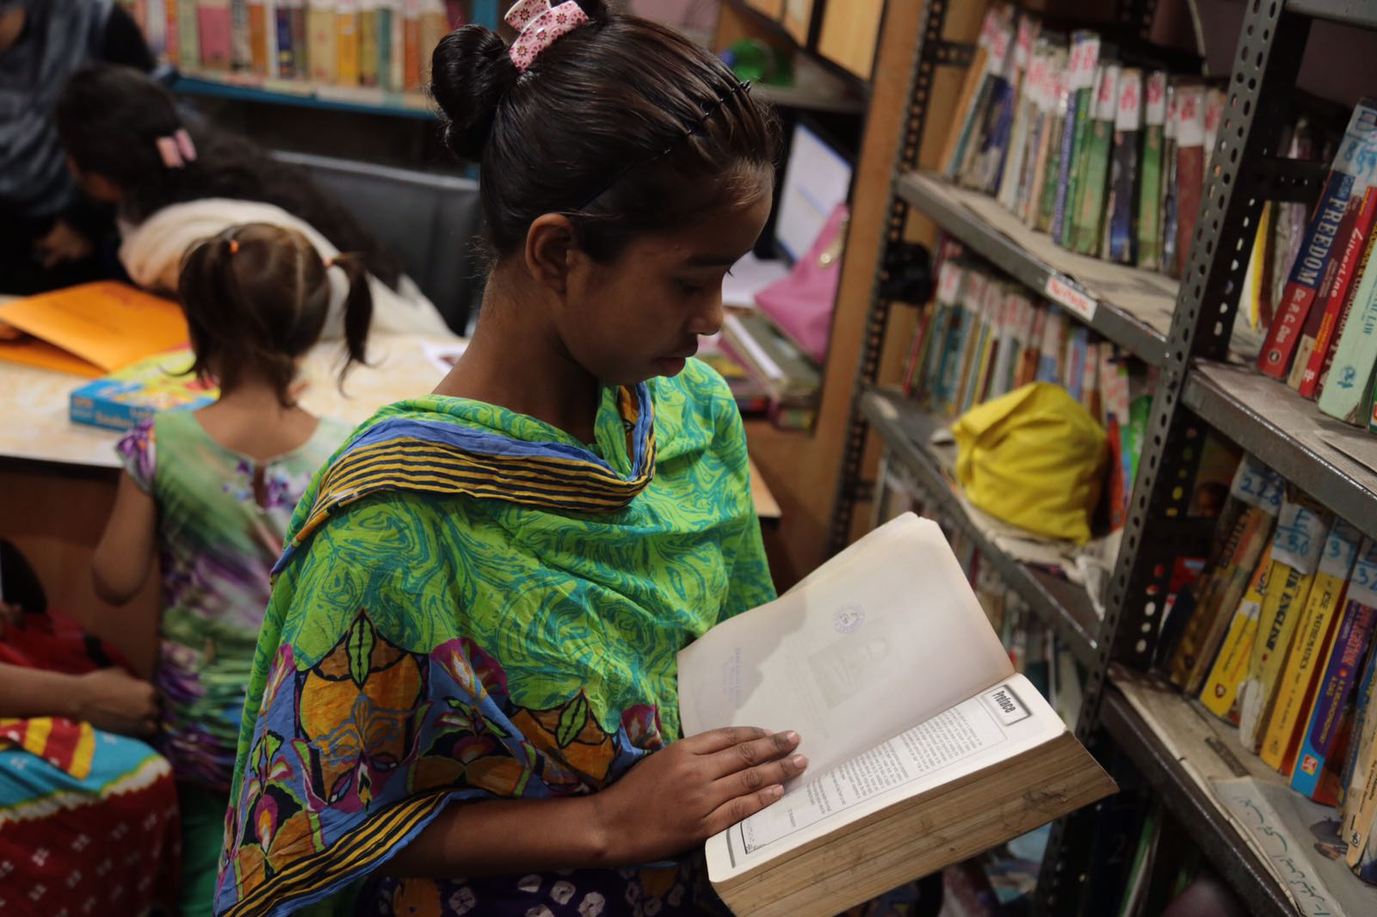

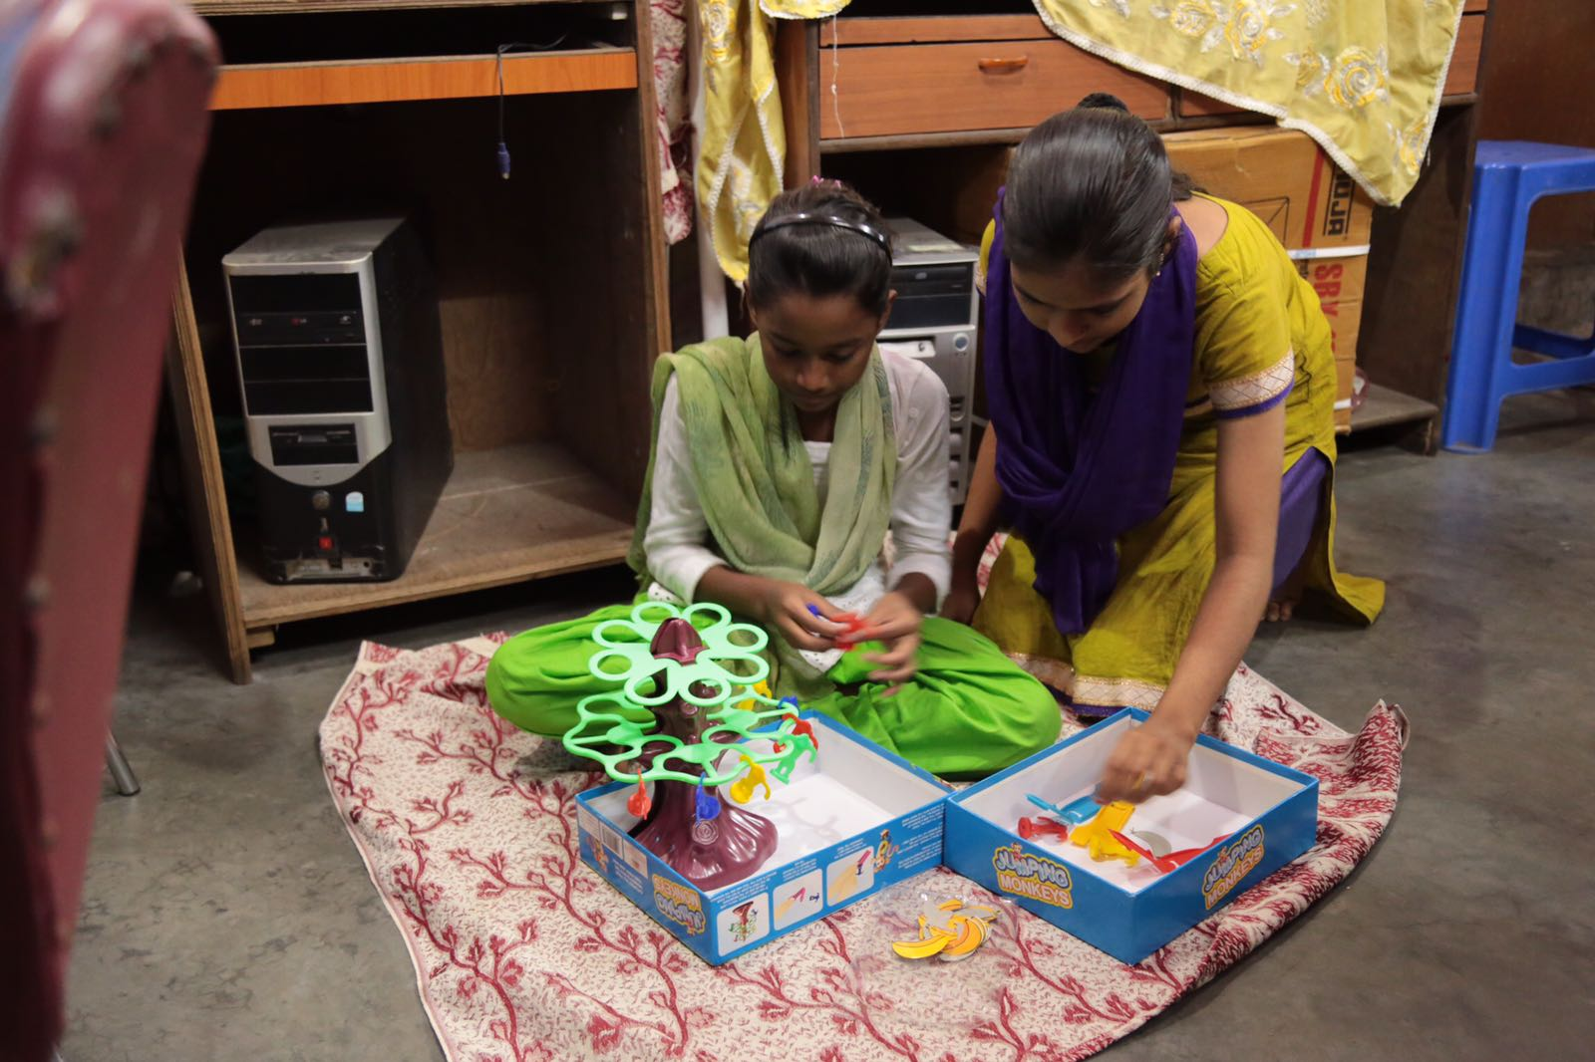
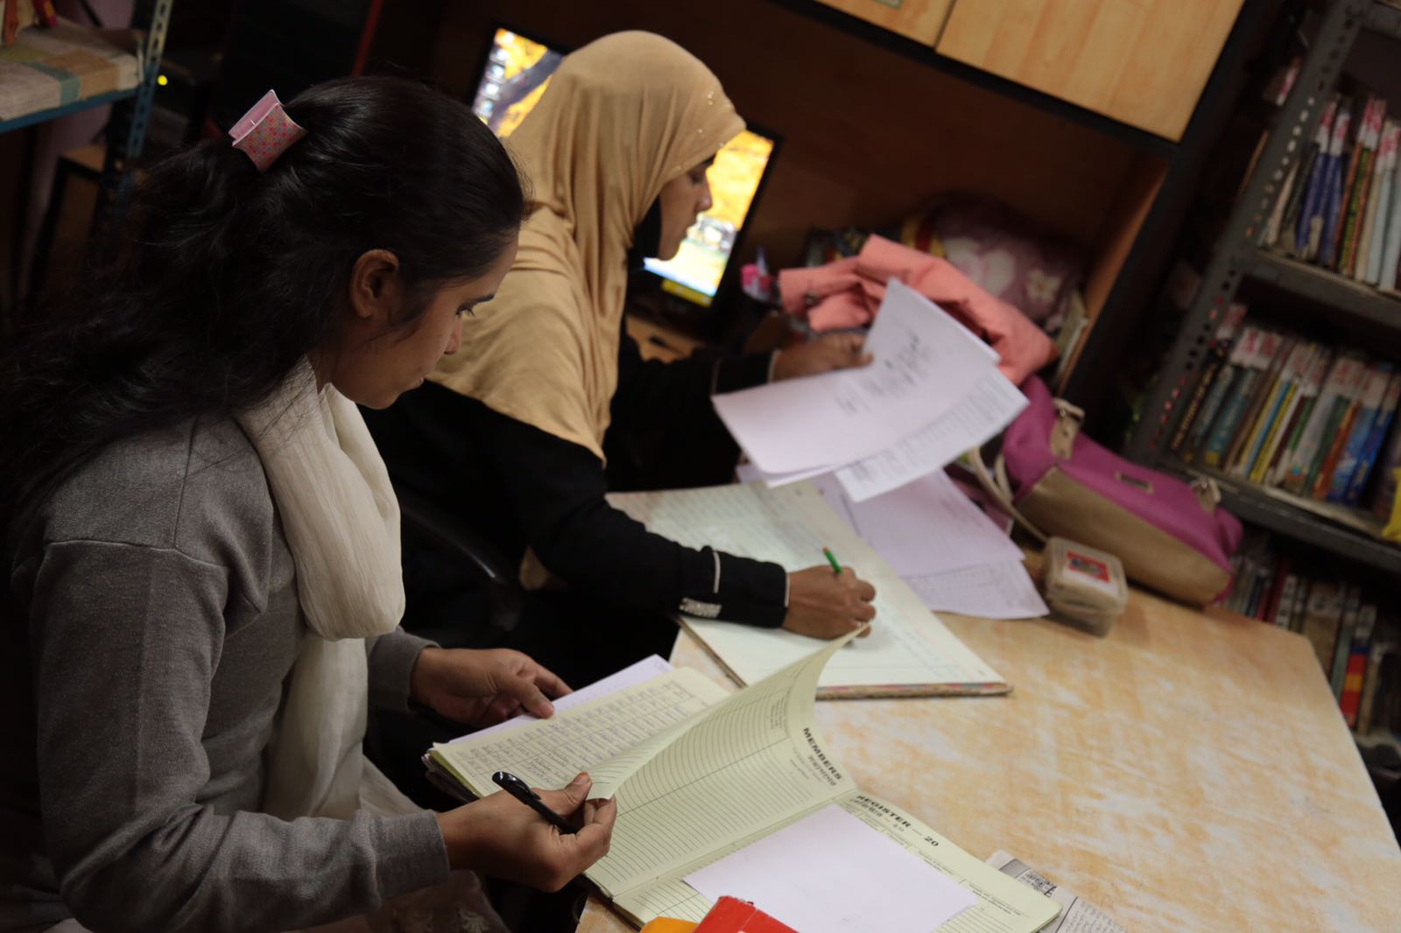

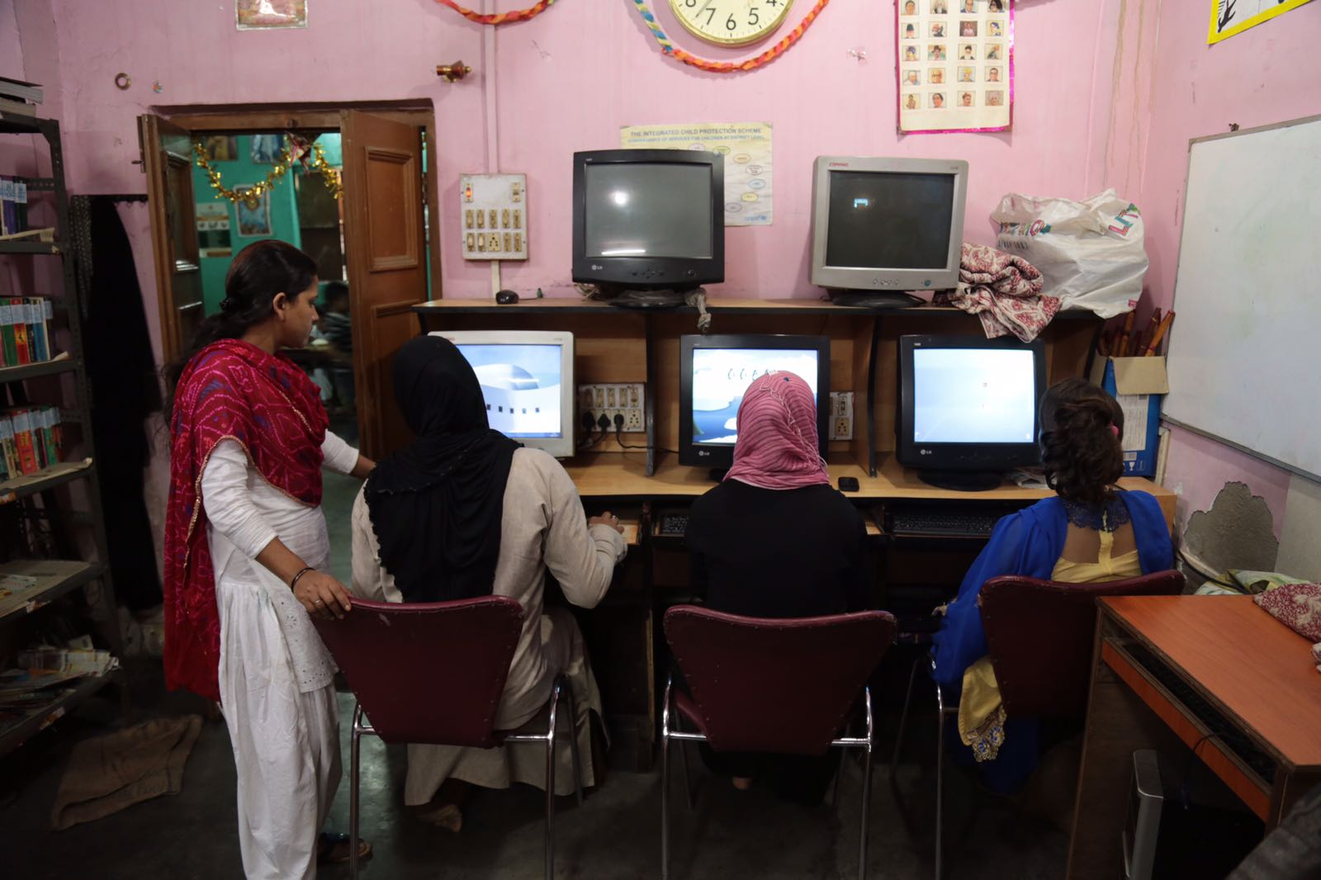

=ENDS=

