Highlights of Design Squad Global 2017
Association of Science- Technology Centers DSG Pilot
The participants had the opportunity to be part of a pilot project with the Association of Science Technology Center s, having sessions that focused on addressing one of the UN Sustainable Development goals (SDGs)
The sessions directed participants towards a more integrated approach in the co-design of projects. The goal was to encourage participants to design projects that are applicable to their communities while still allowing the final projects to be adjusted depending on the nuances of one’s local resources and environment.

The pilot will consisted of 7 DSG clubs from around the world each paired with a ASTC affiliated science centre.

The Partner Project
The participants were partnered with a science house in Belgium called Technopolis.
The purpose of the partner project is for participants to explore the Sustainable Development Goals and the following six key issues / areas suggested by DSG:
- Help people stay healthy
- Help people stay safe
- Protect the environment
- Improve our school
- Make older people’s lives better
- Make children’s lives better
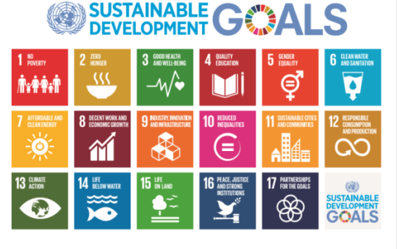
Participants brainstormed the key issues; they were tasked with ranking the top 3 priorities and suggesting possible solutions. They selected people stay safe from SDG number fifteen which is about life on land (designing a Land fill model to help keep the environment clean and fan Cap to protect from the heat).The participants worked on building prototypes for a landfill model and fan cap using various materials and the engineering and invention skills and knowledge they have gained during the previous sessions.

The Pop Fly! Challenge
The primary focus of this session was to engage participants in an open-ended activity which encourages them to see engineering as a creative problem solving technique or approach that the ‘every day’ person is able to use.  Participants were tasked with designing a device that can launch a ping-pong, a light weight ball, and hit a target. | 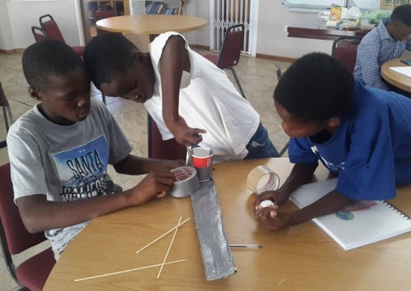  “We must make sure that it is a strong arm. So we are using more tape to make it  stronger.”  One of the Pop Fly designs  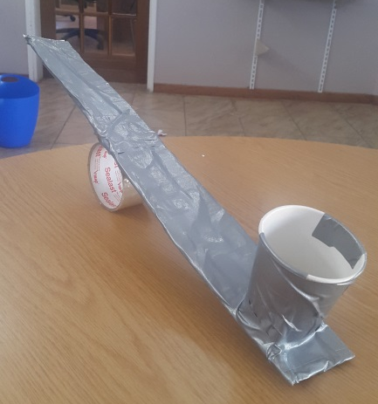  constructed by one of the groups  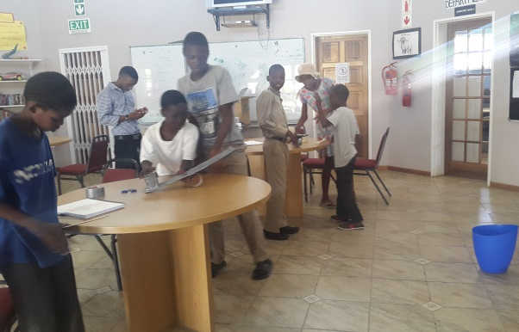  “I think we have the right design because we have redesigned it and made it perfect. We just need to aim better.”
Helping Hand Challenge
The session focused on the following concept: In order to grab something, a device needs two arts or arms that can go on each side of the item being grabbed.  It also focused on exploring how a lever functions and learns to identify its various parts. As participants became more familiar with the design process, they discovered the importance of testing, evaluating and redesigning their solutions.  Participants have begun to realize that if their first solution is not successful, it does not mean they have failed their task. Rather, they have an opportunity to learn from their error and redesign their solution. |  | 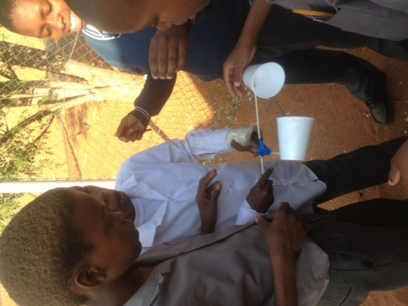  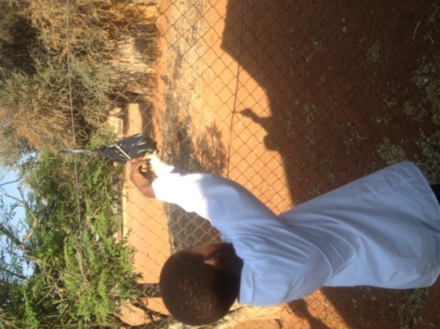  “Yhis will not work, we need to add something that can grab this package without falling.”  “Let us redesign the helping hand.”  “This looks perfect! Let’s test.”
Emergency Shelter
The purpose of this session was to design an emergency shelter prototype.  During this session, the participants focused on strengthening their understanding of the design process by focusing on the brainstorming and design steps. The participants discover which architectural shapes (triangles, squares etc.) make the strongest building blocks.  Participants were tasked with designing an Emergency Shelter prototype. A prototype is a quick and simple model that lets engineers and inventors test whether their ideas work. |  |  | 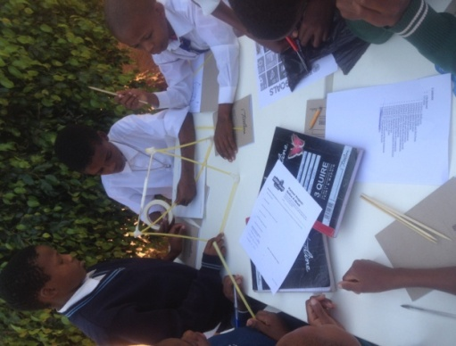  “We think this will be a strong shelter because we have used a triangle shape and added a base.”
Fan Cap Challenge
Using the Design Process, the participants designed a fan cap to help people walking in the sun get shade. They made a normal cap and little paper fan which they stuck at the front of the cap. As the person walks the fan will start to work like a windmill and blow a breeze on that person’s face, at the same time the cap giving them shade. |  |  | 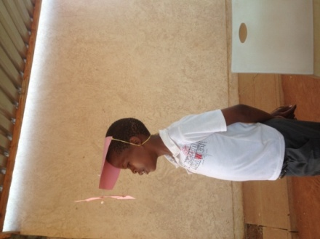  “ This gives a cool breeze, we could actually use it for income generation during summer.”
The Landfill Model
This design is a land fill model. They collected all the trash that was scattered around; layer by layer they put them into a container adding soil and water to each layer. After some days the trash decomposed and to be used as composed manure |  |  | 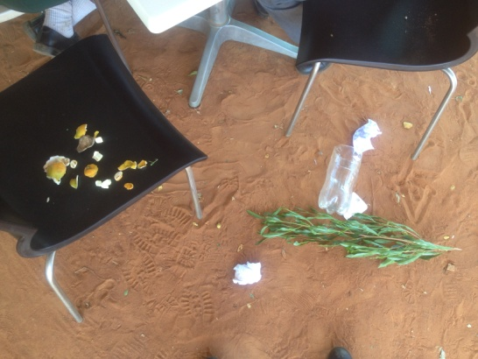  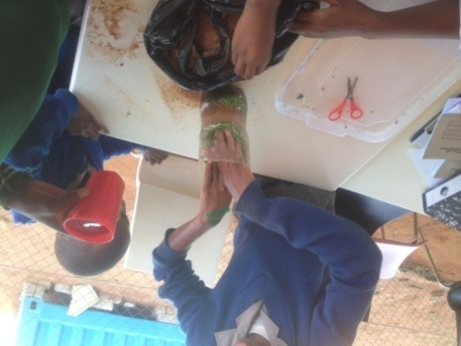  “we need to add more water to make it decompose faster”

