Find The Missing Millions

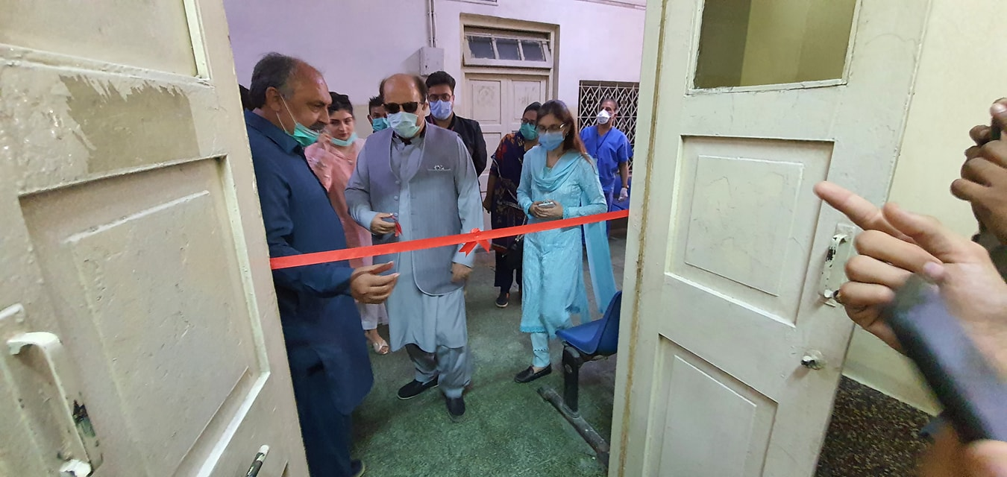

The Health Foundation, despite of challenges faced during the lockdown, continued to provide medicine for the treatment of Hepatitis B and C to each and every adopted patient.

We have recently inaugurated Hepatitis Free Kemari Project in collaboration with Gilead.
An American biotechnology company Gilead Sciences, Inc. joined hands with The Health Foundation and M.M Group Pvt. Ltd. for Viral Hepatitis Elimination in Pakistan.
The first of its kind partnership for Viral Hepatitis Elimination aims to improve awareness, screening, and linkage-to-care for viral hepatitis and ensure a work environment that is free from any discrimination for those with the disease. Screening is carried out in the community camps and identified patients will be treated at KPT Hospital Free of Cost.

The clinic was inaugurated by Mr. Shah Nawaz Judoon (Member Provincial Assembly Sindh), Firdios Shamim Naqvi (Member Provincial Assembly Sindh) and Mr. Mahmood Moulvi (Advisor of Minintry of Maritime Affairs.)

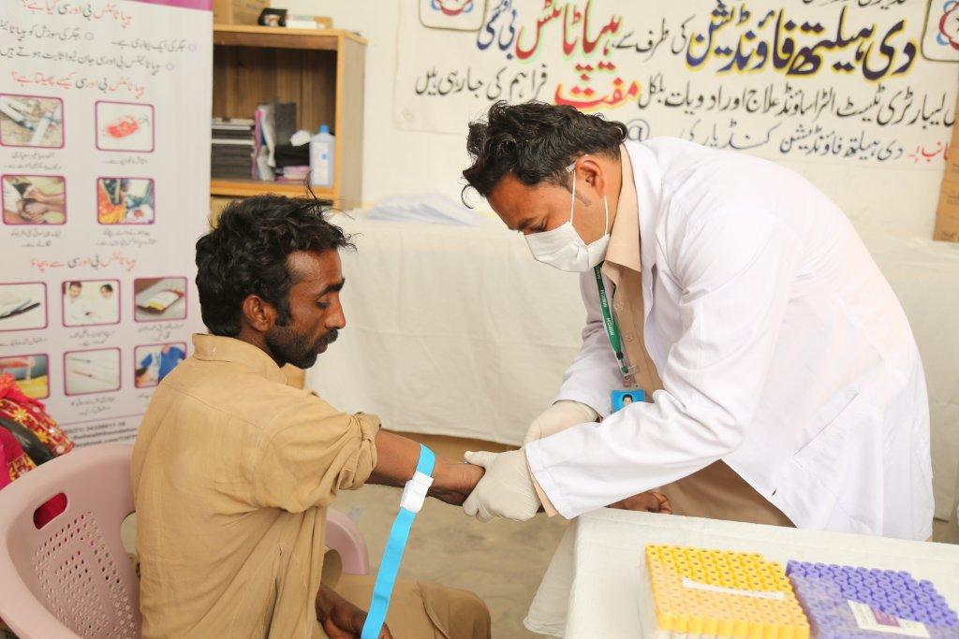
Talking at the launch, Mr. Firdous Shamim Naqvi said that we hope to eliminate viral hepatitis in Pakistan by promoting public private collaborations. It is important area for us to focus on, as this disease disproportionately inflicts the poor and marginalized who usually suffer at the hands of bad health systems and practices. For all these reasons, the public health goal of viral hepatitis elimination and the launch of this coalition to support this cause is extremely opportune. It is indeed, a very pragmatic step by the industry and stakeholders, he said.

He added that there is a need and we understand that elimination of viral Hepatitis on a national scale requires public awareness and appropriate prevention strategies to tackle the epidemic.

Pakistan has the second highest burden of viral hepatitis in the world, with an estimated 20 million people suffering from Hepatitis B or C. According to a recent estimate, over 200,000 new patients develop Hepatitis every year, and 10% to 40% of people with chronic infection may develop cirrhosis and potentially liver cancer. Many people contract the infection unknowingly, because of reuse of syringes, dental equipment and barber shop equipment.

Highly effective treatments for hepatitis C can cure the infection in over 95% of people. Hepatitis B can be prevented through vaccination. Those with chronic hepatitis B infection can manage the disease with lifelong treatment.

The inauguration of the clinic was followed up by a visit to the field where the team interacted with the lady health workers and praised their efforts for their hard work and dedication in the community.

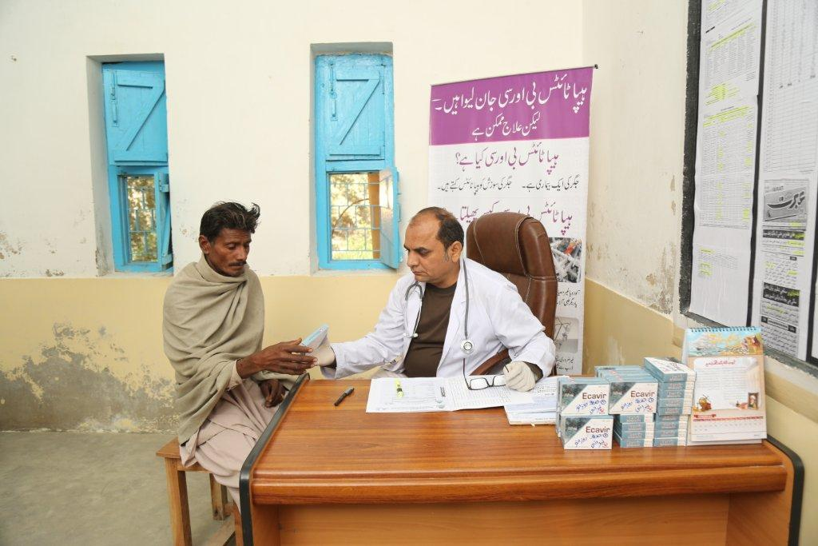

Currently there are over 12 million reported Hepatitis cases in Pakistan. Till date THF has sensitized more than 1 million target population, treated 15,251 patients and has immunized 977,103 high risk population against Hepatitis. However, a lot more work has to be done. Let’s reach the 12 million together!

