RURAL YOUTH VOCATIONAL SKILLS TRAINING CENTRE PROJECT
Project summary
The project aims to empower rural youths with vocational skills in carpentry and joinery, baking and tailoring. It is purported at poverty alleviation by addressing unemployment through imparting the aforementioned vocational skills in the youths so that the youths become active players in income generating activities hence improving their economic standards in the long run. The project realizes that youth empowerment as the basis for economic development of the community and of the whole nation at large.
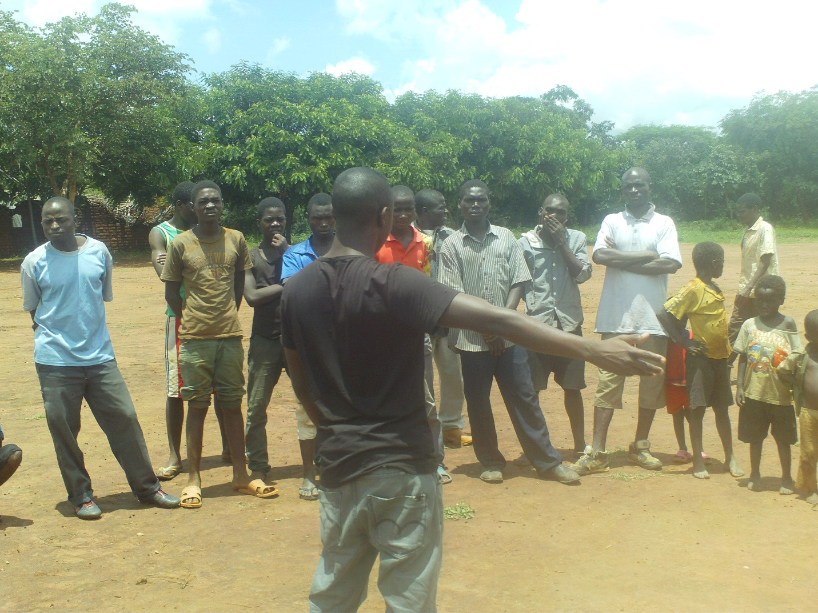
Youth in Malawi in need of vocational skills

Compassion
I am a member of the community in which the project is operating in. Being a member of the community has made me to be a percipient of the necessitous conditions in which the youths are living in. Having been motivated by a sense of duty and respect for the dignity and intrinsic nature and value of every human being, the youth in this case, I instituted the project so that it acts as springboard for poverty alleviation among the youths from the community. The project therefore works with the targeted youths irrespective of their religious and political affiliations, physical abilities or their sex.
Why is the project needed?
The project addresses poverty among the youths from the community. In this sense, the project addresses poverty emanating from unemployment by equipping the youths with skills in carpentry and joinery, baking and tailoring so that the youths do not rely on getting employed as a lone way to an improved economic living standard. Unemployment is one of the prevalent factors that leads to impoverished living conditions among Malawian youths. Imparting the youths with aforementioned skills is therefore a solution to unemployment because once they are equipped with such acquirements, they are able to be self-employed and make money for purchasing their daily needs.
The need for the project really exists and this need is reflected by looking at the living conditions of the youths. Many youths are living in conditions of poverty because of unemployment and this is resulting into the emergence of social issues such as theft, robbery and social instability in general, in their efforts to curb poverty. Outfitting the youths with vocational skills shall address poverty by dealing with unemployment through reliable and acceptable sources of income.
What does our project involve?
The project involves the establishment of a vocational training center where the youths shall be learning the vocational skills. It shall be instituted in Msokoneza Village, Traditional Authority Kalolo in Lilongwe district. Upon being successful with this application, the project shall start in July, 2017. The grant shall be used for buying the necessary materials to make the project meet its ends. It shall target a minimum of 50 youths with first priority being given to those youths living in the poorest conditions.
Currently, there has been an identification of people with a goodwill who have skills in carpentry and joinery, baking and tailoring to teach the targeted youths. It has been observed that the identified people are more than willing to be involved in the activities of the project. This has been the case because, being from the same community they are also concerned with the necessitous living conditions of the youths and they share a similar disposition intended at bettering the living standards of the youths in the community.
This plan addresses the issue of poverty among the youths because their poverty mostly emanates from unemployment resulting from the lack of skills for income generation. Dealing with unemployment in this regard addresses poverty because the youths shall be able to earn their living through the skills learnt. The project will work because upon being imparted with the skills, the youths shall be responsible for producing products for sale and this shall enable them to have money for buying their basic needs. As a result, they shall be able to live in improved living conditions and break the cycle of poverty.
Who else is working with me on this project?
Currently, the project has 13 volunteers. These are responsible for carrying out day to day activities of the project such as offering training and guidance to the targeted youths. The main challenge that we have at the moment is the issue of funding to ensure that all operations are conducted in an efficacious manner. Presently, we have partnership with Mwayiwathu Youth Organisation. This is a Community Based Organisation works at addressing issues such as HIV/AIDS, family planning and poverty alleviation by targeting in and out of school youths. However, our project is unique because it exclusively targets the youths through the provision of vocational skills.
Research has been conducted on other groups working on the same. It has been revealed that within our community as well as in the neighbouring communities, there are no such groups that have youths as a special group that needs to be empowered with vocational skills. There also exists no groups that offer vocational training to the youths in the aforementioned disciplines. These have been the principle reasons that have prompted me to come up with the institution of the project.
Who will be served by this project?
The primary target for the project are exclusively the youths. It places a special emphasis on those youths who have completed their secondary education and they are living jobless as well as those youths who have dropped out of school so that the skills enable them to perform generative activities.
I am a native of the community in which the project is being undertaken. However, putting aside the issue of origination, the living conditions of the youths in the area are really destitute and this enabled me to establish the project with a deontological motivation at heart. I wholeheartedly believe that I have the obligation to bring change wherever necessary for the melioration of the community.
The project targets the youth because they are the most active age group of the society and they are also a special age group that determines the future of the community and of the whole nation at large. Once they are imparted with skills, they shall be able to live a better life and eradicate poverty. This shall have a strong bearing to the socio-economic status of their communities.
What goals do we have for our project?
In the next year, the project intends at increasing the active involvement of the youths in economic activities through the provision of the vocational skills that shall enable them to produce products for sale. It also intends at creating a conducive living environment for the youths, free from unemployment. These skills shall aid in removing the mindset of relying on employment as a sole source of a better life. In addition, in the next year, the project aims at working with interested stakeholders working on promoting the provision of vocational skills to the youths to ensure working together for a common cause. This shall ensure a joint action in tackling the issue of unemployment. It also aims at increasing the number of females taking part in vocational skills.
On the other hand, in the next two years, the project intends at increasing the targeted number of the beneficiaries because the aforesaid number is very little. It also intends at developing the spirit of sharing the skills to others. Those who have learnt the skills shall be encouraged to teach their fellows so that many youths shall be able to have sources of income.
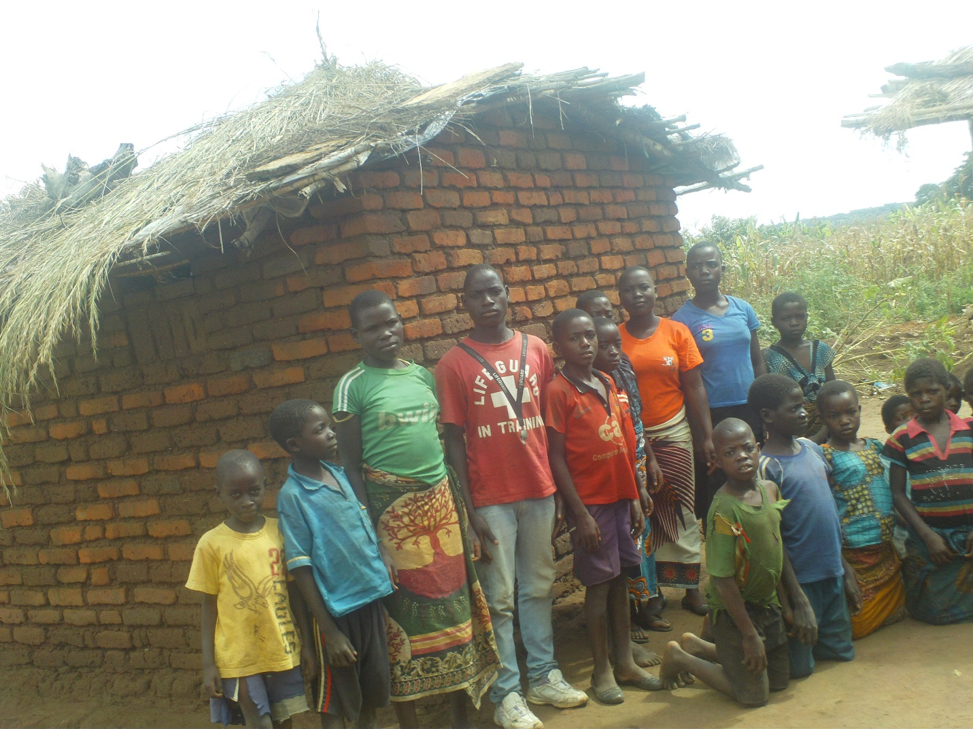
Malawian Youths ready for developmental work

How will we know if our project is successful?
The project shall be monitored through my active involvement as well as the active involvement of other responsible people in the project activities. This shall aid us to measure its progress and then identify appropriate strategies in order to produce the best outcome. It shall also be monitored through a system of veritable reports. When an observation is made, it shall be reported to ensure that the project does not lose its track. Checklists are yet another methods that shall be used in monitoring the project. These shall be advantageous because they shall ensure that all the relevant facts of the project are undertaken.
Success of the project shall be measured by looking at the products being produced by the youths. This shall comprise of looking at the quality and quantity of the products as well as their competitiveness on the market. It shall also be measured by looking at the utilization of the skills by the learners. Working on their own to produce products of their own shall signify success with respect to the skills being imparted in them.
Sustainability of the project
Once the seed grant is used up, if awarded, the project shall continue its operations through the use of money from some sales of some of its products. It has to be made clear that the sales shall not be intended at making personal gains but to ensure a continued functionality of the project. Proper mechanisms of checks and balances shall be employed to ensure that money from these sales are used for their designated purposes and avoid any cases of abuse by any member. This shall keep the project moving foward.
As already pointed out, the project involves people with an endowed obligation to better the living standards of their youths, people who do not expect any financial gains from their effort. These people shall be encouraged to retain their spirit of duty towards their society as well as emphasizing on the significance of such actions to the transformation of the society. This shall result into working hard to ensure the sustainability of the project.

