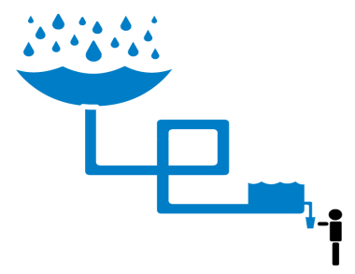
http://www.rainwaterforhumanity.org /

Rainwater For Humanity
Story of Suma from Achinakom Village:
Suma is a mother of two children. Though she has a Masters degree from a local college, she lacks the financial capability to solve the water scarcity problem. When her two children grow older, they will have to help her carry water. The water that they spend hours collecting is still polluted.

Clean water access is a basic human right. However, in India, 1 person dies from water-related disease every minute.

Such an overwhelming number seems impossible to overcome, yet by starting on a local level we can implement simple, sustainable, and eco-friendly rainwater harvesting systems that will both improve the health conditions of Kuttanad and empower its women.

Harvesting rain to boost community health and empower women.

Support Rainwater Harvesting
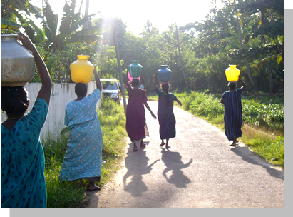

What is Rainwater for Humanity?

What can we do?
Rainwater for Humanity consists of students and graduates trained in engineering, environmental science, economics, and international studies. We are optimizing the design of subsurface rainwater harvesting systems that will stand adjacent to houses. The tank capacity and the built-in filter systems will ensure each family a year-round supply of fresh water, as well as save them hours each day of physical labor. All components of the systems are made from locally-available materials, and will stand for twenty years.

In addition, Rainwater for Humanity is partnering with the Asparawa Screwpine Society, a local women’s self-help group that provides micro-loans to its members. Together, we have surveyed 165 families, educating them about water safety and gathering data on water consumption patterns. As part of implementing the storage reservoirs, we will train women in maintaining and distributing the systems, ensuring that the Kuttanad community stays as active as possible throughout the process.

What will this cost?
We need to raise $70,000 to implement the pilot model, set up women masonry training program, fund the first phase of microloans and support ongoing redesign of rainwater harvesting structure in the next two years. We value any feedback or technical advice you will have for us too!

Want more information?
Visit our website: http://www.rainwaterforhumanity.org/
Email us: info@rainwaterforhumanity.org

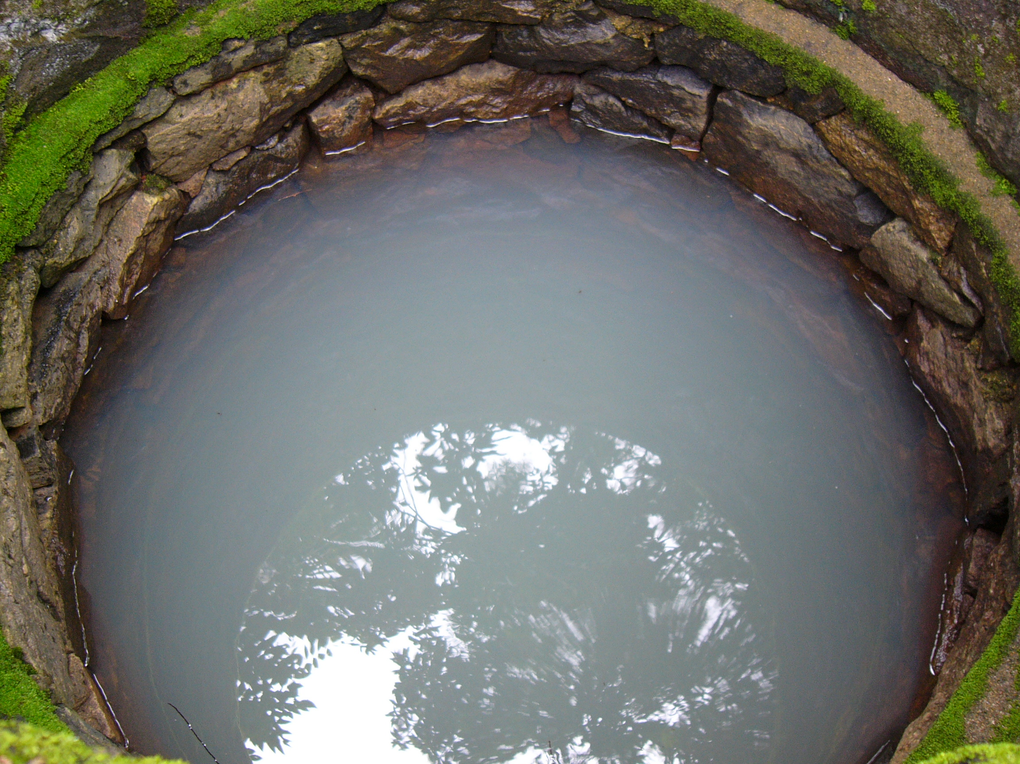
Water from a typical well in Kuttanad

Rainwater for Humanity’s missions are to improve community health and empower women via harvesting rainwater. We are working in the Kuttanad region of Kerala, India. Rainwater for Humanity is a collaborative effort of Mahatma Gandhi University School of Environmental Sciences and Brown/RISD students & graduates.

Kuttanad’s water
Picture the supermarket near your house. Without doubt, there is at least one aisle dedicated just to different types of water. Now imagine that you live in Kuttanad, where 80% of the population relies on a distant water source contaminated with agricultural run-off and fecal matter. Women and children have to spend hours a day to collect 20-30 liters of water for their families. In that same day, the average American individual will use 150 liters of water without a second thought. The 700,000 men, women, and children in Kuttanad deserve a clean water source.

