Annual report

2015/2016

July 15, 2015  -  July 14, 2016 | Society for Positive Atmosphere and Related Support to HIV and AIDS (SPARSHA Nepal)

At a glance
SOCIETY FOR POSTTIVE ATMOSPHERE AND RELATED SUPPORT TO HIV AND AIDS (SPARSHA Nepal)

SPARSHA Nepal started its journey as support group for PLHIV in 2002, by valiant individuals who were diagnosed HIV positive in due course of treatment in drug treatment rehabilitation centre, Richmond Fellowship Nepal. The rationale of the group was to provide psychosocial support and the confidential environment for disclosing status for sharing concern. The period was most challenging in itself for the group to sustain in the environment where the pervasiveness of HIV related stigma and discrimination was very high, and the idea of getting exposed with positive status and to seek treatment was perceived as threat by the society. Realizing the extent, the group approached with the concept of people living with HIV and their friends (PLHAF) as the working strategy to reduce stigma and discrimination associated with HIV. Overtime the increasing network with other PLHIV and the individual membership of community revitalized the group, which led vital policy changes within SPARSHA Nepal, establishing institutional framework which finally took the shape of community based organization in 2004.
The level of stigma was very high in the society, we had a fear of getting exposed and discriminated. Support group provided us the moral support and the confidential environment to share our problems with each other
SPARSHA Nepal since its inception has been working with Most at Risk Group (MARP) like drug users (DUs), injecting drug users, and female sex workers (FSWs) with the particular focus to PLHIV and their children. The service domain starts from VCT as an entry point and up to ART including short term residential care for PLHIV and Drug Users, Palliative Care including Home Based and Hospital Care.

Vision
Creating responsible society that promotes healthy and dignified life of Human.

Mission:
Enhance HIV care, increase public awareness that leads to informed understanding, caring and involvement, results in hope for the future and to promote of justice that seeks to change unjust structures affecting the people among whom we work with.

Goal
- Reduce new HIV and blood borne transmission
- Improve health status of PLHIV
- Reduce stigma and discrimination among PLIHIV
- Improve livelihood status of PLHIV
- Increase meaningful participation of PLHIV in social and political sectors

Objectives
- Reduce the risk behaviors of people on acquiring and transmitting of HIV and other blood borne diseases.
- Increase the accessibility of PLHIV in health services.
- Reduce fear associated with HIV by increasing awareness among PLHIV and community, at large
- Increase skills and employment opportunities for PLHIV.
- Enhance the leadership and advocacy skill of PLHIV.
- Strengthen networking and collaboration with different stakeholders.
SPARSHA’s Milestone

SPARSHA Nepal has played a proactive role in the field of HIV. Within the span of 11 years, SPARSHA Nepal has not only grown institutionally but has been able to garner its expertise in developing and improvising treatment, care and support for PLHIV in Nepal.

At its initial phase, SPARSHA Nepal as a support group have put their relentless effort in reducing stigma and discrimination related to HIV in the Nepalese Society which was one of the challenging memoirs for the institution. The gusto of the institution was further augmented through community support which led to the concept of people living with HIV and Friends (PLHAF).
Providing proper and positive information on HIV to the local community has played one of the vital roles in the prevention of HIV. Educating, and providing training on the HIV to local volunteers and social workers has helped them to advocate against stigma and discrimination associated to HIV and AIDS in the community. Disseminating positive information on HIV through volunteers and students resulted in wider acceptability of PLHIV in the community.
In 2005, SPARSHA Nepal was the first CBO to initiate Community Based ART Program in Nepal with the support of National Centre for AIDS and STD Control (NCASC) and probably in South Asia as well. The Community Based ART program has been very instrumental in enhancing access to treatment and care for PLHIV in Nepal. The PLHIV enrolled in ART program of SPARSHA Nepal has been provided with essential information and tracked on time to monitor their health status and to check their adherence. It has revealed that adherence of 97% of PLIHV is more than 95% where as the national average adherence of PLHIV on ART is still unknown. Likewise, retention of PLHIV in national ART program is one of the biggest challenges but retention of PLIHV in ART program of SPARSHA Nepal is almost 100%. The country first initiated ART program in 2005 with the enrollment of 25 PLHIV in the program and as a result of constant and effective advocacy of organizations like SPARSHA Nepal currently 6,000 PLHIV are enrolled in ART program throughout the country and 62 centers including sub-centers are catering treatment of Opportunistic Infections and ART program, SPARSHA Nepal is one of the centers.
Moreover, SPARSHA Nepal is one of the pioneer organizations to initiate Community and Home Based Care for PLHIV in Nepal. SPARSHA Nepal was one of the contributors in developing CHBC national guideline. Short term residential care to PLHIV and drug users was the unique strategy adopted by SPARSHA Nepal to prepare them for a better and dignified life.
Additionally, the vibrant leadership of the organization along with other like minded organizations put tremendous pressure to the CCM to discard its policy of status quo and to democratize its criteria for membership of civil society. SPARSHA Nepal, for the first time in the country, facilitated developing district AIDS plan and psychosocial care and support plan in Nepal. Both the district plans have been illustrations for other districts and based on the plans districts have started allocating resources for prevention and care of PLHIV. Gradually, the advocacy shifted on decentralization and scale up of the treatment and care initiative and the government started realizing the strength of CBOs like SPARSHA Nepal and adopted new strategy to adopt Greater Involvement of PLHIV (GIPA). However, the adaptation of GIPA principle during the initial stage was only tokenistic. Again, massive advocacy was carried out to recognize PLHIV as one of the core group for developing and implementing strategies and programs related to HIV in the country.
In due course of time, SPARSHA Nepal has not only been recognized nationally as one of the leading organizations working in the area of treatment and care for PLHIV and reducing HIV related stigma and discrimination but has also been accepted regionally, i.e., South and South Asian level for promoting universal access to prevention and treatment and care. The institution has been invited to join regional network of organizations working in the area of HIV and AIDS. Head quarter of the regional network is based in Bangkok of Thailand and the member countries of the network are Nepal, Thailand, Myanmar, Laos, Vietnam and China. The network has been established with the objectives of sharing international experiences in reducing or halting the spread of HIV and providing universal access to prevention and treatment and care and support
Moreover, SPARSHA Nepal is one of the very few organizations providing continuum of care for PLHIV in the country. SPARSHA has utilized HIV testing as an entry point and is providing various services including ART. SPARSHA believes in universal access to testing and treatment and care for PLHIV and is adopting strategies to translate its belief in practice.

The continuum of Care
From the very beginning SPARSHA Nepal has put tremendous effort on the development of an epitome of treatment, care and support for PLHIV and to foster the environment for PLHIV to live qualitative life. With the philosophy of need based treatment, SPARSHA Nepal has prioritized the range of services focusing on the immediate need of PLHIV and has been constantly serving PLHIV for easy accessibility and availability of the treatment options for PLHIV.

Mobile Clinic and Mobile/Static VCT
The prevalence of HIV is relatively high among drug users than other Most at Risk Group (MARP). The reluctance of this group in utilizing VCT services are comparatively low due to the presence of stigma and discrimination associated with HIV in general and VCT testing in particular. In order to reduce the stigma associated with VCT and encourage HIV testing among drug users, in 2006, SPARSHA Nepal in partnership with UNDP Nepal initiated mobile clinic and mobile VCT as the strategy of providing Primary Health Care service coupled with Voluntary Counseling and Testing (VCT) services to DUs. During the reporting period 4483 of people have received VCT services, whereas 3194 of IDUs have received PHC services. Till date SPARSHA Nepal has provided VCT services to 18799 of people and PHC service to 6000 of IDUs.

Components of Mobile Clinic and Static VCT
Providing clinical services to IDUs
Providing essential medicines as per the need of the client
Voluntary Counseling and Testing at Site
Referral to EPC or other site as per the diagnosis and the case of client
DOTs
HCV Counseling and referral

Essential Package of Care to PLHA:
The lifespan of PLHIV is often determined by progression of disease juxtaposed with the availability of treatment option for PLHIV. The crucial factors like clinical assessment and staging; diagnosis and treatment of opportunistic infections; Cotrimoxazole prophylaxis; diagnosis of TB and referral to DOTS for TB treatment; initiation of ART; psychosocial services are the crucial components in the treatment strategy to improve health status and to prolong the life of PLHIV.
In 2005, SPARSHA Nepal started to provide some of the treatment facilities through clinic with its internal recourses. From April 2005, with the support of Family Health International (FHI), SPARSHA Nepal initiated Essential package of Care integrating necessary treatment attributes essential for PLHIV. The service is run by Health Assistant 6 days a week including provision of 3 specialist doctors visiting the clinic three times a week. Till now, SPARHSA Nepal has provided 1900 PLHIV with EPC service. Since the initiation of Health Care Clinic total 728 of PLHA have been served.
Components of EPC
General Health Checkup
Clinical Assessment and Staging
Cotrimoxazole Prophylaxis
OI Diagnosis and Treatment
TB screening
Positive Prevention Services
Nutritional Education and Management of
Symptoms
Adherence counseling (ART, Cotrimoxazole)
Referral for diagnosis and treatment

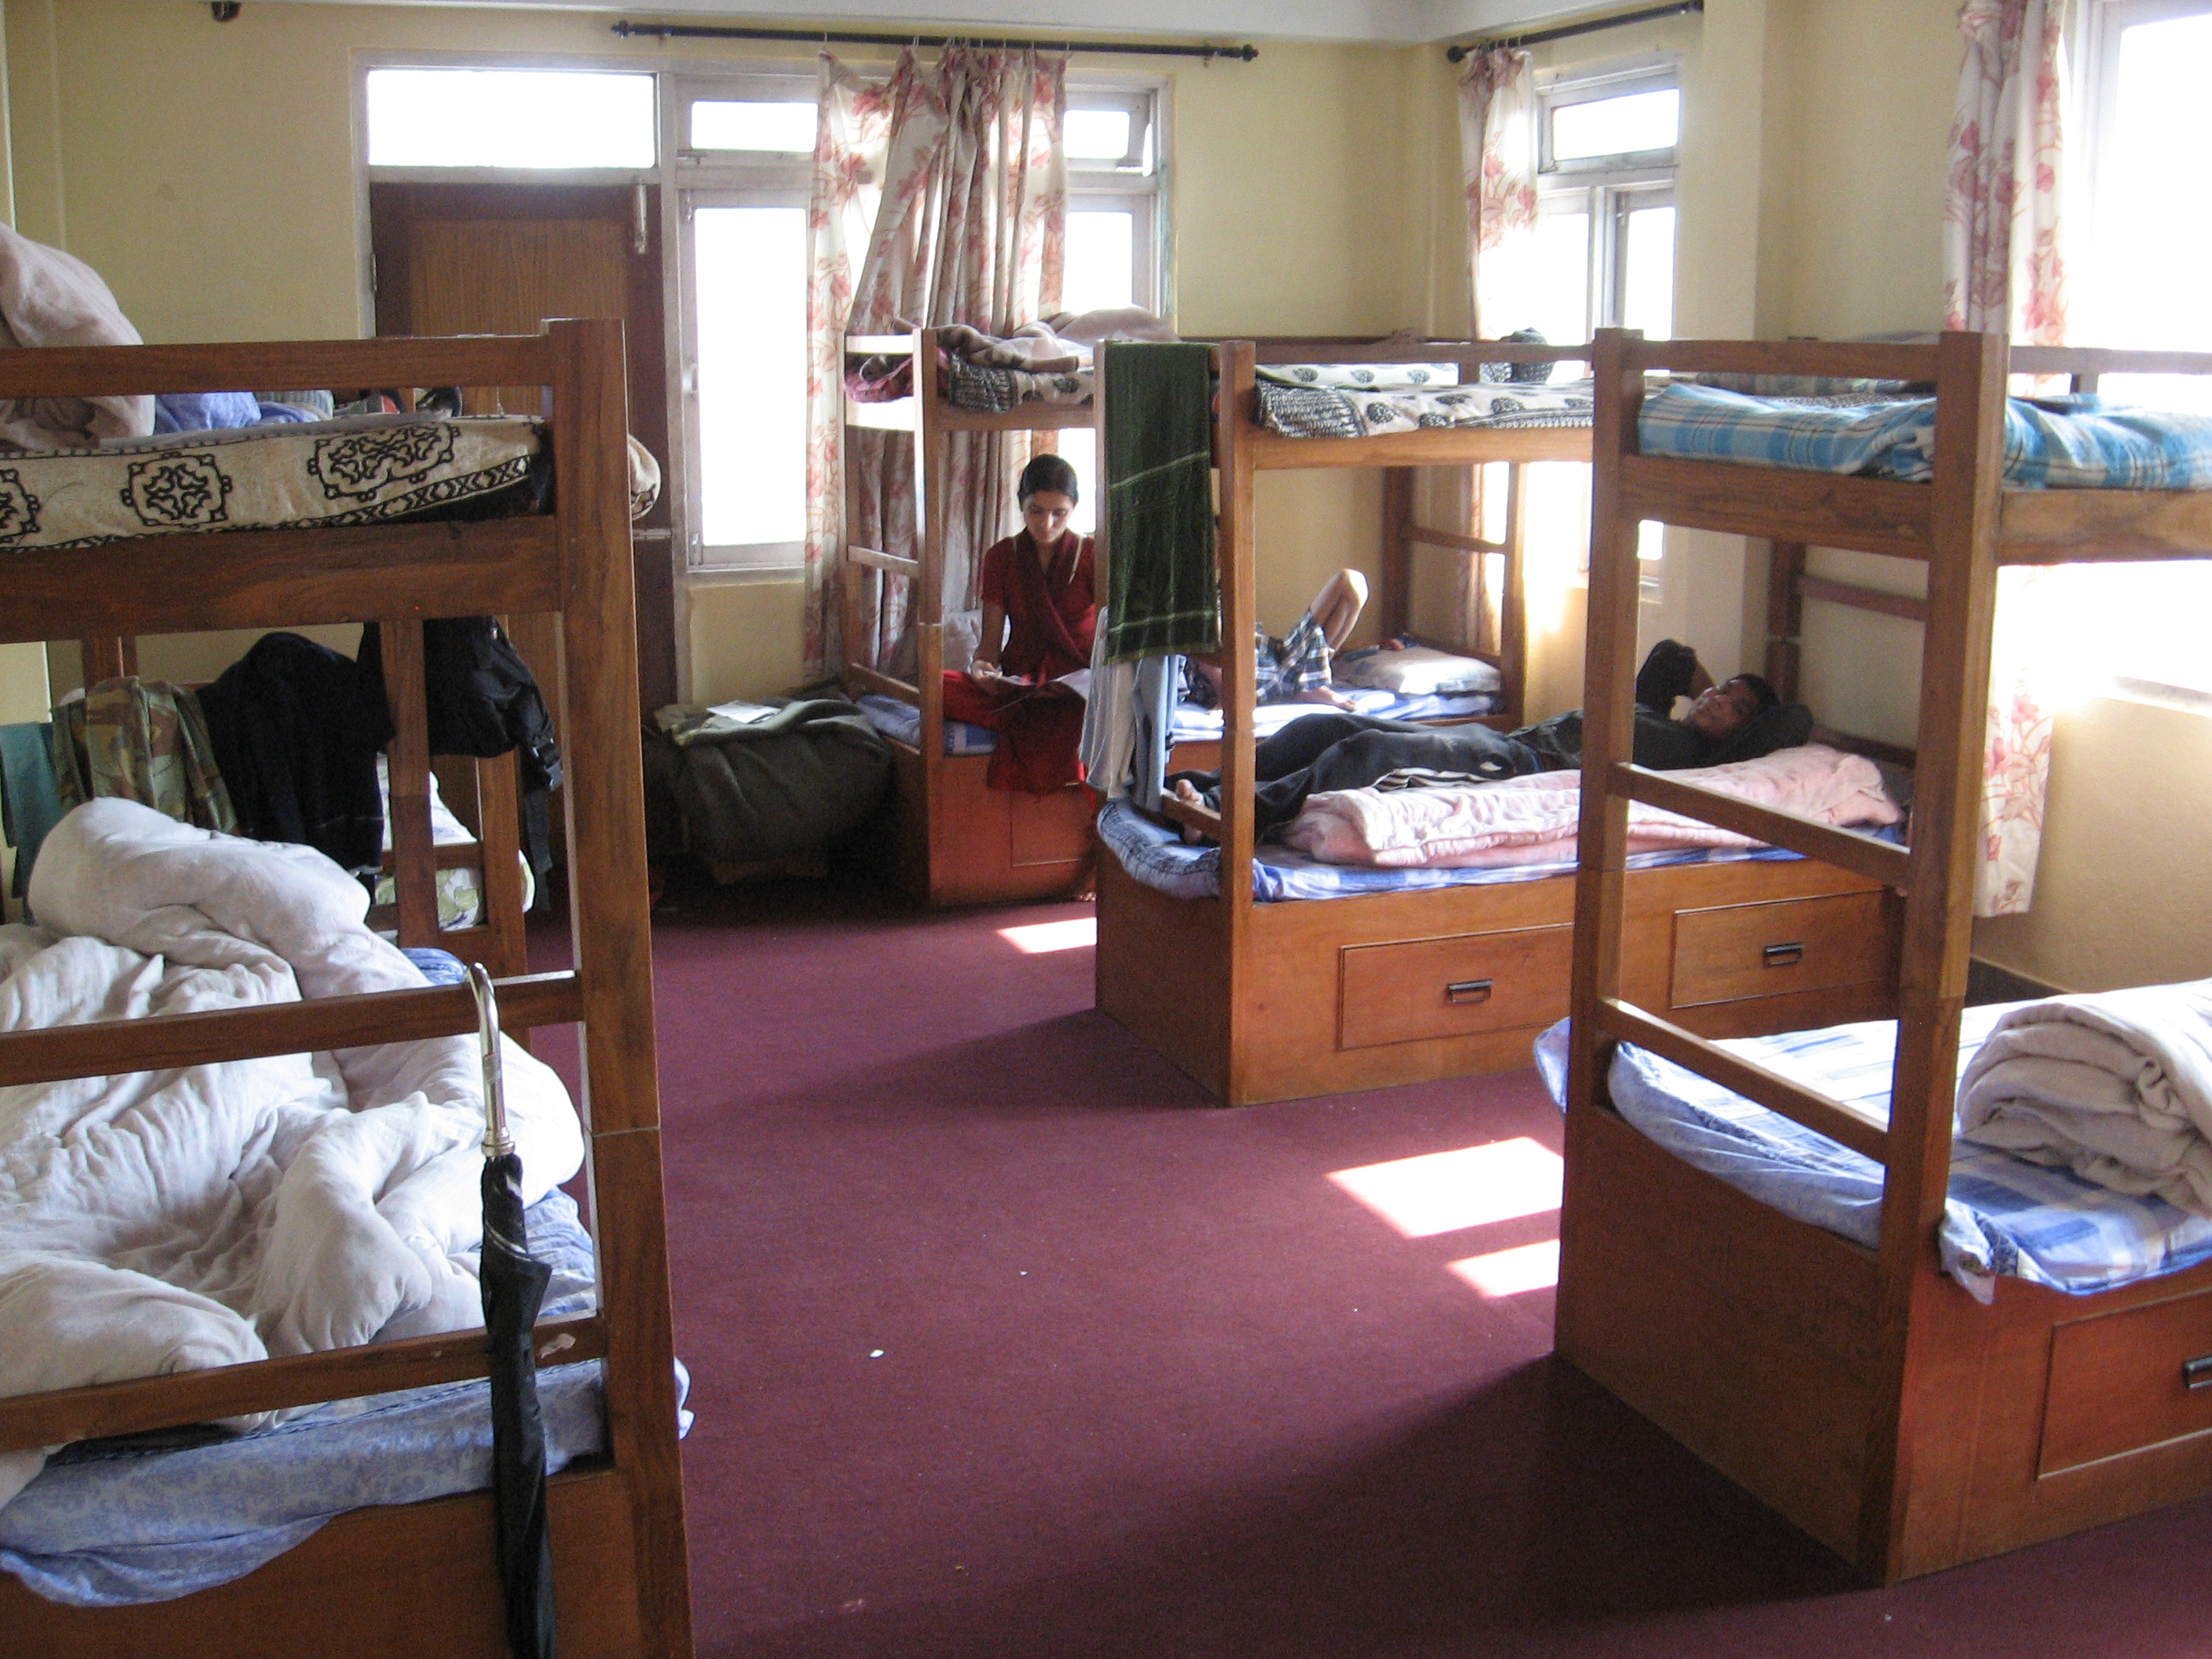
Residential crisis care (Care Home):
The institution is providing residential crisis care with the capacity of accommodating 15 members at a time. SPARSHA Nepal has developed a standard protocol for the eligibility for PLHA to receive the crisis care. The duration for crisis care is 15 days (this can exceed as per individual client’s need). Provisions of the crisis care include providing care to the PLHA in psychosocial distress, observation of PLHA under ARV during initial days of ARV treatment, PLHA in need of health care and PLHA facing stigma and discrimination within their families and communities. During the reporting period 473 of PLHA have received crisis care service from SPARSHA Nepal and the number covers both of Kathmandu and Damak and cumulatively SPARSHA has provided crisis care services to 1282 of PLHA.

Hospital based care to PLHA:
SPARSHA Nepal has been providing PLHA with hospital based aid and attendance service. It has been mobilizing volunteers for providing essential aid and attendance services.
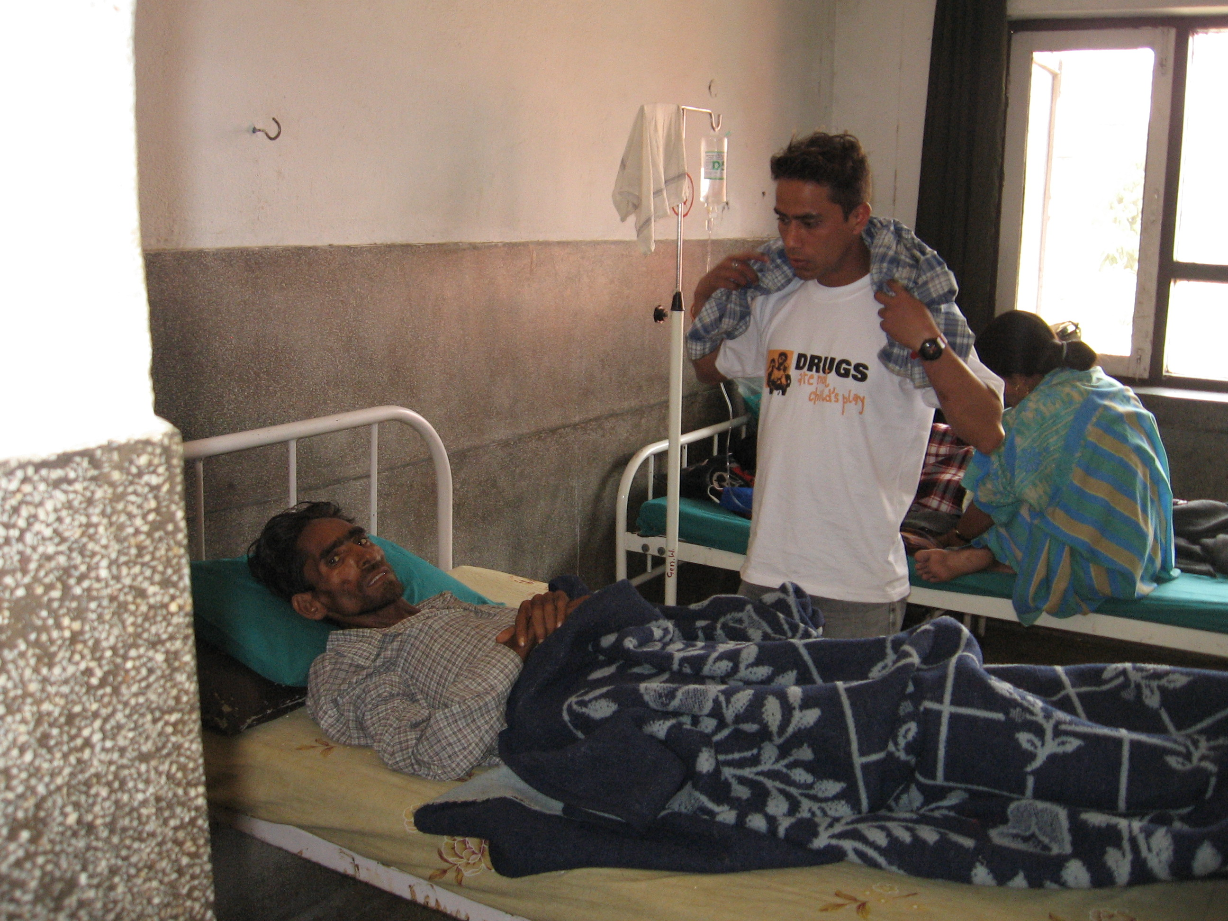
Components of Hospital Based Care
Motivational Interviewing
Attending patient
Counseling
Bridging the gap between service provider and patient
Referral

Community and Home Based Care (CHBC):
SPARSHA Nepal in its every endeavor has been trying to garner community support and involvement in treatment and care and support of PLHA. To translate community involvement into practice, the institution initiated Community and Home Based Care (CHBC) services utilizing its health personnel, field workers and peer outreach workers. Primary objective of this program is to prepare a safety net within the community to provide care and support services to PLHA in their own settings. During the reporting period 45 of new PLHA received CHBC Service and till the date the organization has provided CHBC services to 432 of PLHA.
CHBC aims to:
Addresses the physical, emotional, social and spiritual needs of PLHA and their families.
reduce stigma and discrimination
promote client and family HIV care
knowledge , skills and self-reliance,
provide vital links to needed health and other services and
improve overall quality of life of clients

From October 2011 to June 2016, 210 new PLHIV were enrolled in CHBC services and 218 PLHIV were served for follow up services. 191 households were reached by CHBC team members. Among total clients of CHBC service, there were 112 Asymptomatic, 94 Symptomatic, 164 PLHIV on ART, 17 lost to follow up and 20 deaths till June 2016.
The team has been providing basic health care services including symptomatic treatment, self-care education, psychosocial support, adherence support and other support such as drug counseling and positive living counseling to PLHIV. The CHBC team members are also playing crucial role to refer the clients for different essential services such as OIs management, laboratory tests, etc. to different health institutions including EPC Clinic.

Community Care Centre:
CCC service in SPARSHA was started since May 2012 and running till date. We have been provided different services to clients such as ART start & observation, TB treatment support, side effects managements, CD4 Count, viral load count, OI management, health care management, psychological support. Till date, 275 clients have used CCC service, among which 204 are male and 71 are female. During the reporting period of Fiscal year 2072, 173 clients used the service, out of which 110 were male and 63 were female.

Community Based ART Service
Anti Retro-viral Therapy is one of the major components in the spectrum of treatment and care to PLHA. Realizing this fact, since November 2005, SPARSHA Nepal, with the approval of National Center for AIDS and STD Control (NCASC), initiated a Community Based ART Program, first of its kind in the country. Goal of the program is to improve quality of life of PLHA. Major strategy of the program is to ensure community involvement and ownership in the treatment and care of PLHA for securing optimum adherence to treatment of PLHA.
Highlight of the program
Psycho-social assessment of each PLHA (a standard form has been developed) to ART preparedness
If found not prepared intensive measures applied to prepare them
Treatment Supporter; any one from the family
Training to treatment supporter along with the PLHA (Standard curriculum have been adopted)
ARV drugs are dropped to the residential settings of the PLHA by CHBC workers
Different tools including pill counts have been adopted to monitor adherence
Once in every month PLHA under ART are encouraged to consult doctors
In every certain intervals (preferably in every six months or as per the need) PLHA are encouraged to get their CD-4 count and other routine tests done

The ARV drugs for the program has been provided by NCASC while other costs such as providing ARV drugs to PLHA in their own settings, clinical monitoring of PLHA, regular health checkups and nutritional support to PLHA are provided by SPARSHA Nepal. Until the reporting period 312 of PLHA are receiving ART service from SPARSHA Nepal.

Social Protection and Cash Transfer Program for Children Living with HIV (CLHIV):
CLHIV program was started in April 2014 and continuing till now. Since then we have provided service to 109 children’s out of which 7 of them have crossed the age of eligibility and their service has been interrupted. The support provided each month to children’s is used for different proposes like education, nutrition, health problems, regular checkup, ART related services etc.
 | Male | Female | Total
CLHIV (Cumulative) | 52 | 57 | 109
CLHIV (P15M1) | 47 | 55 | 102
Single Orphan | 9 | 16 | 25
Double Orphan | 17 | 21 | 38
On ARV | 40 | 34 | 74
Community Opioid Substitution Therapy (OST):
OST Service in SPARSHA started since February 2015 and running till date. OST service not only means dispensing Methadone to clients, we perform different programs like input sessions to clients as well as their family members, co-ordination meeting is also performed with stakeholders and police personnel regarding achievements, learning, and difficulties being faced. Along with that we also help clients to get vocational training and income generation skills time and again.
The regular clients for different months during the reporting period of fiscal year 2072 are as follows:
 | Months | Male | Female | Total
P13M1 (Srawan) | 16 July – 15 August | 60 | 2 | 62
P13M2 (Bhadra) | 16 August – 15 September | 93 | 3 | 96
P13M3 (Asoj) | 16 September – 15 October | 66 | 2 | 68
P13M4 (Kartik) | 16 October – 15 November | 64 | 1 | 65
P14M1 (Mangsir) | 16 November – 15 December | 53 | 1 | 54
P14M2 (Paush) | 16 December – 15 January | 60 | 0 | 60
P14M3 (Magh) | 16 January – 15 February | 71 | 1 | 75
P14M4 (Falgun) | 16 February – 15 March | 78 | 1 | 79
P15M1 (Chaitra) | 16 March – 15 April | 131 | 1 | 132
P15M2 (Baisakh) | 16 April – 15 May | 119 | 1 | 120
P15M3 (Jestha) | 16 May – 15 June | 88 | 1 | 89
P15M4 (Asar) | 16 June – 15 July | 79 | 1 | 80

Emergency Response Program:
The program was supported by GFATM-Save the Children, International. The program period was from 16th July, 2015 - 15th November, 2015. The ER program was implemented through Sub-Recipient in their respective district to respond to post earthquake crisis for PLHIV and Key Affected Population (PWID, FSW, MSM and Migrant).
The main objective of the program was to provide immediate relief support to PLHIV and Key Affected Population. The main activities of emergency program were:
- Mobile Health Clinic- (medical camp focused to cater medical services to PLHIV & Key Affected Population as well as general population)
- Referral to local health clinics and hospitals were made as per the need. Patient who couldn’t support the cost of treatment were supported partially.
- Awareness on prevention and promotion of positive living (behavioral change) including safe sex practice/health care management
- Onsite adherence counseling and follow-up

Distribution of relief materials
- Health & Hygiene Materials: Water purifier, ORS, sanitation set
- Immediate provision Raincoat, bed nets, waterproof sleeping bags, mattress for lactating Key Affected Population

Nutrition Support for Children Living with HIV and other vulnerable children
- Micronutrients power and high energy biscuits

Status of Emergency Response Program:
S.N | Program | Target | Achievement
1. | Mobile Health Clinic | 12 Episodes | 12 Episodes
2. | Nutrition Support for Children living with HIV and other vulnerable children | 150 Children/per month | 150 Children/ Per Month
3. | Income Generation Program for ultra poor client | 15 ultra-poor | 45 applicants screened, 15 were selected and provided with IG support
4. | Food for PLHIV, their families and key population | 60/per month | 60/per month

Working with Partners
From the very beginning, SPARSHA Nepal has been aware of the intensity of the issue of HIV and AIDS. Networking and close coordination with support groups working for PLHIV, Governmental Organizations (GOs), Non-Governmental Organizations (NGOs) and human rights organizations is the main working strategy of SPARSHA for effective intervention and to cater the immediate needs of PLHIV and Most at Risk Group (MRPS).
Currently, SPARSHA Nepal has been implementing programs in partnership with National Center for AIDS and STD Control (NCASC), an apex body for HIV in Nepal, FHI 360 and UNODC Nepal.

• National Centre for AIDS and STD Control (NCASC):
The partnership started in 2004 and still ongoing. SPARSHA Nepal is implementing Community Based Anti-retroviral Therapy Program in partnership with NCASC. Besides, SPARSHA in partnership with NCASC has time and again contributed in enhancing knowledge and skill of HIV clinicians of Nepal and in advancing the issue of access to treatment and care of PLHIV in Nepal.

• WHO Nepal and WHO SEARO:
SPARSHA Nepal in partnership with WHO Nepal and WHO SEARO coordinated an international training program on treatment preparedness on HIV to PLHIV and mid-level health workers in Bangkok in 2006. Moreover, the partnership with WHO Nepal was again instrumental in organizing capacity building training and workshop for HIV clinicians of Nepal.

• Project Management Unit (PMU) UNDP:
Partnership with PMU started on Jan 2006 and lasted till Sept 2011. Major objective of the partnership was to provide continuum of care for PLHIV of Nepal. The partnership came to an end because PMU ceased to receive funding from funding agency to support HIV program in Nepal.
• Save the Children International/ Global Fund:
Save the Children International / Global Fund has been in partnership with SPARSHA Nepal since 2015. They have been supporting harm reduction program and Community Care Center in Lalitpur and Dhanusha districts. There are many components of the program which includes Opioid Substitution Therapy (OST) and cash transfer program for Children Living with HIV (CLHIV) as well.

• Care Nepal:
Care Nepal was one of the pioneers to have partnership with SPARSHA Nepal in the early phase of 2005. The partnership was instrumental in developing District AIDS plan in 3 districts and psychosocial care and support plan in 5 Districts of Nepal under GFATM Round 2. Besides, time and again SPARSHA Nepal implemented various sporadic advocacy activities with Care Nepal to enhance access to treatment and care of PLHIV of Nepal.

• Family Health International Nepal:
The partnership with FHI Nepal started on April 2005 and still ongoing. Major thrust of the partnership FHI is to provide treatment and care for PLHIV of Nepal.

• UNODC Nepal:
SPARSHA Nepal entered in partnership with UNODC Nepal on June 2011 and is still continuing. Major objective of the partnership is to provide health care services to Female Drug Users (FDUs) in Nepal to prevent them from BBI including HIV and to create enabling environment for FDUs to access available services.

• Recovering Nepal:
SPARSHA Nepal is one of the partner organizations of Recovering Nepal, a national network of Drug Users and HIV organizations. SPARSHA Nepal contributed in institutional development of Recovering Nepal.

- AIDS ACCESS Foundation, Thailand:
SPARSAHA Nepal was invited to join a regional forum of South and South East Asian Countries in 2007. Major objective of the forum was to promote universal access to prevention and treatment and care and support in the south and South East Asian Region.

- AIDS Health Care Foundation Nepal:
SPARSHA Nepal contributed in establishing AHF in Nepal in 2007. SPARSHA Nepal is one of the core partners of AHF in Nepal and SPARSHA has implemented various programs in partnership with AHF Nepal. Sole objective of the partnership is to enhance access to testing and treatment and care of PLHIV of Nepal.

S.N. | Program Name | Component | Working area | Funding source | Program Period  MM/YY-MM/YY
1. | Community Care Centre | Treatment. Care and support | Lalitpur | GFATM-SSF/Save the Children | ongoing
2. | IDUs-Harm Reduction | Harm Reduction | Dhanusha Branch | GFATM-SSF/Save the Children | ongoing
3. | Mobile Health Clinic | Harm Reduction | Kathmandu Valley | GIZ | ongoing
4. | Community Testing and Treatment Program | Testing and Prevention | Kathmandu Valley | AIDS Health Foundation | ongoing
5. | Basic Care and Support Project | Care and Support | Kathmandu Valley | FHI 360/USAID | 05/2005 ongoing
6. | Enhancing access on Health Care Service of Female Drug Users | Health Care services | Kathmandu Valley | UNODC Nepal | 06/2011 ongoing
7. | Community Based ART | Treatment and Care | Kathmandu valley | NCASC | 12/2005-ongoing
9. | Comprehensive Package for PLHIV | Continuum of care | Kathmandu valley and Jhapa | PMU, UNDP | 01/2006-09/2011
10. | Case conference for HIV clinicians | Capacity development and advocacy | Whole country | WHO SEARO and NCASC | 2008
11. | Training on Treatment Preparedness | Capacity development and advocacy | Whole country | WHO SEARO | 05/2006-09/2011
12. | Orientation and sensitization workshop for district level and community leaders | Prevention, reduction of stigma and discrimination and formation of district level plan | Chitwan, Jhapa, Banke, Doti and Aachham | Care Nepal/GFATM | 06/2005-09/2005
13. | Gain In power Fight Against AIDS | Stigma and discrimination reduction and capacity development | Doti | Care Nepal | 04/2005-07/2005

