MUTARE SPCA, AN ESSENTIAL SERVICE PROVIDED
REGISTERED CHARITY IN ZIMBABWE. W.O.98/68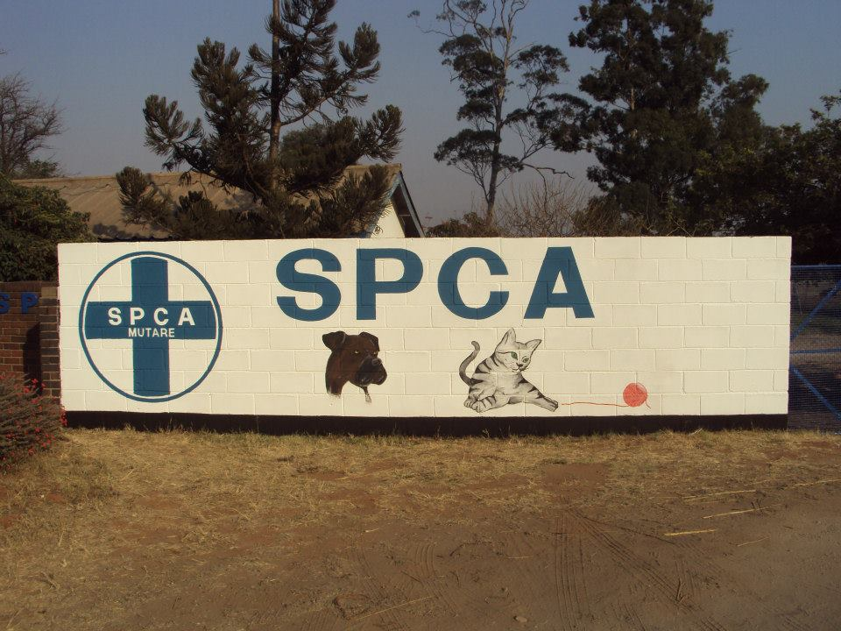

Zimbabwe. Feb 2017

The Mutare SPCA is an animal protection charity, desperate to uphold the laws our society in terms of animal cruelty and welfare. Based on the UK RSPCA model, but modified for local Central African conditions, we were established at its current headquarters in the mid 1900's, when fundraising was easier, and Zimbabwe had a well functioning economy and higher employment statistics. The SPCA in Mutare apparently began volunteer work in the 1930’s but we do not have any written details about this. We do know for sure that the charity was established in its current premises in Nyakamete suburb of Mutare in the mid 1960’s.
But presently, it is hugely difficult to operate an animal welfare charity in Zimbabwe that is completely locally funded.
It would be almost unethical for us to request or expect any donations from the majority of the Zimbabwean population, when they can hardly afford more than a single meal per day per family. The extreme wealth accessed by the political elite does not percolate down, not even to government establishments like hospitals. We are currently a nation in crisis, and in such a crisis, animal welfare can become a casualty at the same time as its very incidence is exponentially on the increase.
The prevailing situation, sadly, does not allow for animal anti-cruelty and abuse concerns, as perhaps many first world citizens might reasonably expect, but that doesn’t mean that we should fold up the fine work that has been done historically and that we are desperately trying to continue. The man on the street, in fact, relies on us. Many people will tell us when we are in the field about the SPCA. I was recently out rescuing a tiny mongrel puppy from a hectically busy road, as it was looking for insects that had been squashed on the asphalt, when two men came to tell me to call the SPCA to help me out. So it’s important to say that this is still a very special country, full of courageous and hardworking people, who smile readily, at the best of times, at the worst of times. And no matter how poor, they do want animals in their lives... even if perhaps the reasons are often different from our own. Some of us are ‘pet lovers’ in the traditional sense, whilst most Zimbabweans are very practical about ‘owning’ animals. They must serve a function, be it a source of food, transport (donkeys and oxen), security or hunting wildlife. These animals are not ‘pets’ and often live on the very fringe. We know that some of us differ hugely in this way, and it is something that we talk about together, both sides not really comprehending the modus operandi of the other, even finding it strange to ‘pet’ animals or alternatively cruel to work them to extremes, be dependent on their work and yet not care for them. Our role is critical in changing perceptions. Life is hard.
AT present our town is almost overwhelmed with dogs and cats, some feral, some roaming in search of food not provided at home, and we at the SPCA could be doing so much to help if we had the resources.
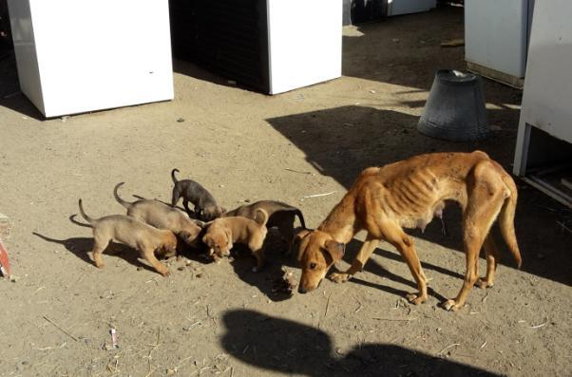
Right now it’s a constant struggle to cover our basic monthly expenses, (salaries, pet food, medicines and vet bills, utilities, and maintenance costs). We are desperate for one more permanent staff member who could man the office, handle day to day issues, fundraising, educational outreach etc, etc...the list is long.
Our volunteers, a small band of 8 people, endeavour to cover these bases, but it is far from ideal. It means no one person is singularly responsible for admin, fundraising and communications and helping the permanent staff with their daily problems. The SPCA paid staff consists of three good men, who work full time and tirelessly at our overflowing kennels. Mr Noel Usore, our Inspector, has been with us over 40 years, and would like to retire, but we can’t afford to pay his retirement package. We would be lost without this strong stalwart, who is the perfect representative for us. The other two men have no formal qualifications that would allow them to fill Mr Usore's Inspector’s shoes. His years of experience are invaluable. We need to train as inspector another man who has the appropriate social standing and background to do this difficult job. Apart from the education project, a real ambition of ours would be to do regular neutering and basic treatment programs for the people living in our high density areas. We have a neat little clinic on our premises, and we could be neutering dogs and cats brought to us and nurse them for a few hours safely post-operatively before releasing them.
Our volunteers mostly work fulltime themselves to survive in Zimbabwe’s harsh economic climate, and whilst we commit time when we can and energy and enthusiasm, we simply do not have the resources to donate funds to sustain our SPCA. Much of our time and effort is spent simply fund raising and whilst we have a wonderful community who are 100% behind us, we are now very vulnerable to donor fatigue from our ever shrinking section of able and willing contributors.

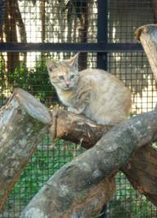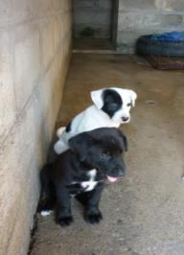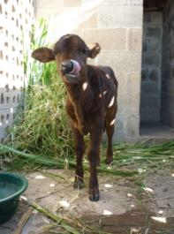

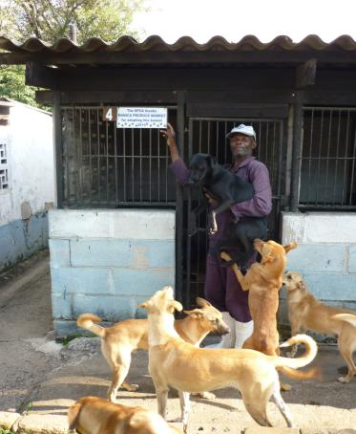

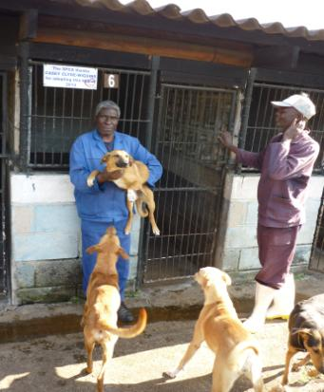

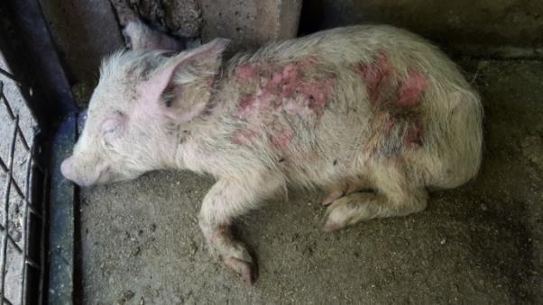
FROM A JACK TO A KING, helping Petal Pig and her siblings to survive cruel abuse. She was treated at the SPCA and then finally retired to a small hotel where she could meet children. Her siblings were not as lucky.
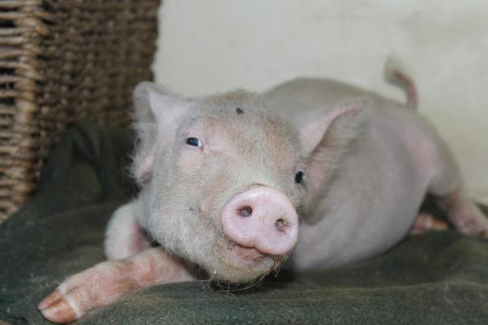

I am not sure if you are aware of the recent politics in Zimbabwe, but we have gone from one of the most successful African countries to one of the most shattered, soul destroyed, broken places. It’s not there are not the resources, it’s just that the population sees none of it. Our unemployment rate is quoted as being 80%, perhaps more, and as a result we are a nation of street vendors. Even our graduates are reduced to this. Yet we have some driving around Humvees and the latest BMWs. It’s a tragic oxymoron. But our charity speaks of the very basic rights, of first lessons in caring for something more vulnerable than oneself, of kindness as an inherent and instinctive quality. It speaks of not giving up.

In other African countries, domestic animals often live parallel lives to people, not integrated lives, where the dog has lost his historical relationship with Man. We haven’t reached that point, but we will, if we lose the SPCA in Zimbabwe. In days past, the SPCA in the capital city Harare undertook some responsibility for providing funds for the rural and outlying SPCA’s, but they themselves are now overwhelmed, because they cannot distribute any funds to us. We are trying to be independent and inventive and energetic about keeping our charity alive, but the writing is on the wall for constructed, legal animal welfare. It would be extremely sad to lose this little part of the outside world, because once gone, we will never have the legal standing to re introduce it.
Some of our annual EDUCATION AND FUNDRAISING INITIATIVES
THE ANNUAL DOG WALK
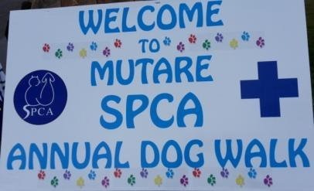

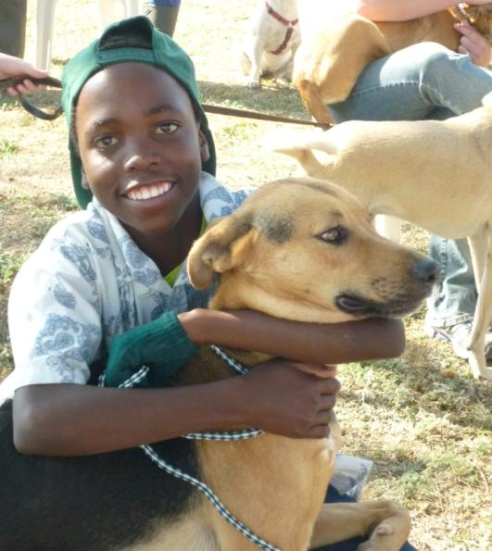
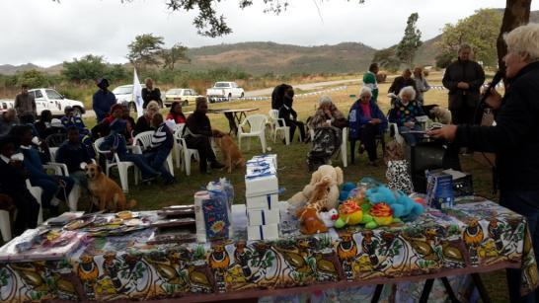
At the Annual Dog Walk, we collect and bus in children from peripheral schools to participate in this event. They each take a dog from the SPCA kennels and do a short walk in the cool, early morning. They are taught to make, from cheap rope, a safe leash, and use it with kindness on the allocated dog. They get a little talk about caring for dogs and cats, in the language most commonly used in Mutare, and each child leaves with gift packs, an animal toy, a book, and they are given a hot dog and a soft drink. All though this is out of our budget, we feel we have to try and persist as a social, and critical, responsibility.

The BLUE CROSS ULTRA DISTANCE EVENT
We ask all citizens in Zimbabwe to self fund this long distance walk, run or cycle. They travel down to the lowest point in the country, in the far South as the Save River exits the country to make its way to the Indian Ocean. The participants make their way through beautiful back country to the highest point, Mount Inyangani, in the Eastern mountain range. This remote adventure is unique in Zimbabwe. Participants raise their own sponsors, and use their annual leave to do this. The participants elect which SPCA countrywide that they would like to support. Mutare SPCA organizes the entire event, and endeavours to make it very special, to show our gratitude. Last year it raised about $2828.00 for our branch. Other branches received varying amounts, at the participants’ bequest.
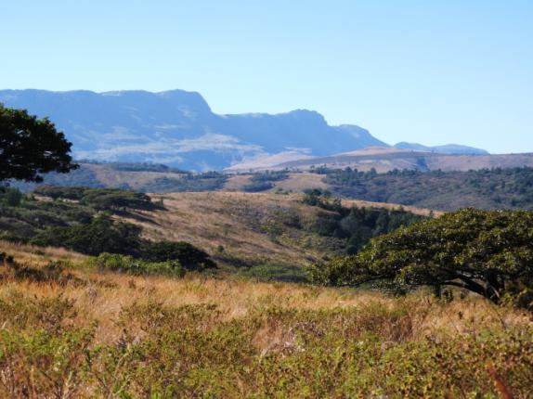

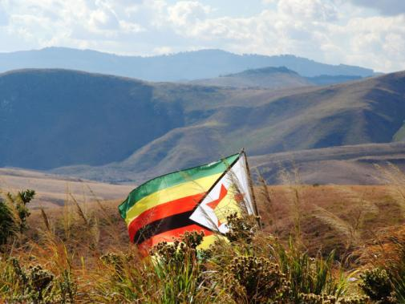
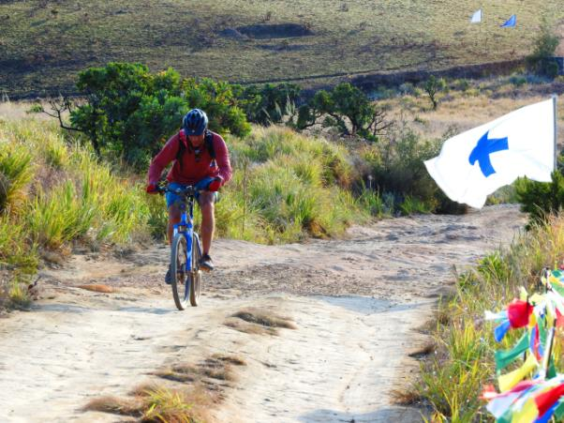

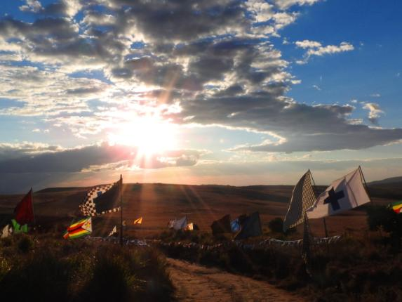
Apart from annual events, we organize interest talks and request a donation to attend. We prevail on everyone we possibly can to speak to the public. The subject matter ranges from health matters, to gardening for Nature, to any exciting and adventurous safaris, to research science and art. We also hold Open Gardens Days twice a year. Attendees are welcomed to beautiful chosen gardens, and are given a high tea, with wonderful teas, cakes, and later light lunch. We attend every fete and fair we can, even if we raise only $40, we are out there. We really try everything we possibly can to keep going, but we cannot meet our costs with the economy as it is.
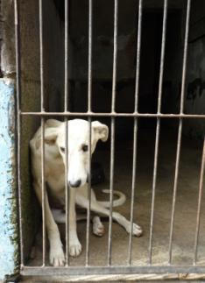
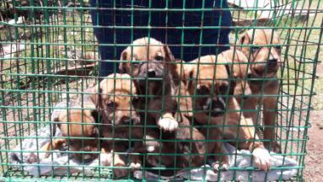
We are not requesting this help lightly. We have simply reached a tipping point. It would be easy to close the doors, put the dogs, cats and one magical goat to sleep. (Euphemistically PTS.) It would be easier to give up than to continue trying to organize novel fundraisers from a beleaguered community. But then we will be entering a time of great cruelty and hardship for the beautiful domestic pets of this country. We have at any time around 30 to 40 dogs in the kennels, and 10 to 15 cats and kittens in the cattery. We do not automatically remove animals in difficult circumstances from their homes, but rather, we try to educate and re-visit to make change rather than cause bad feelings. If we get in a pet in devastated condition, we try to give that animal love, food, comfortable sanctuary before they get put down, so they know what love felt like before they die, and that their whole existence wasn’t a cruel one. We cannot hope to home all the animals we get in, and this is the hardest part of our work. There are just too many dogs out there. When we really have huge difficulty is when farm animals are abused. The costs involved are too much for us, but how very difficult it is to turn our back on them. Recently, we responded to a case where a herd of cattle were left corralled in a pen, throughout the November heatwave with no food and water. But that does not stop us from trying to provide a service, a last resort, legal advice and at least an option. (See the SPCA-Mutare facebook page for details.)

If you can see your way to helping us, in any way, we would be able to give detailed feedback and would love to show any interested parties what we do. We have photos of our premises and some past work, and will engage with anyone who wants to know more about our Mutare SPCA. As we said before, we are at our tipping point, but not ready yet to give up. If we could just get some funding for our basic costs, we will do whatever we can to keep doing fundraising projects locally to meet the donors’ expectations and show them we work very hard to pay the bills, but we don’t know how long we have till the day comes when we can’t afford to feed the animals we are endeavouring to home or provide sanctuary for. Till we have exhausted every chance of keeping going, we will NOT give up.

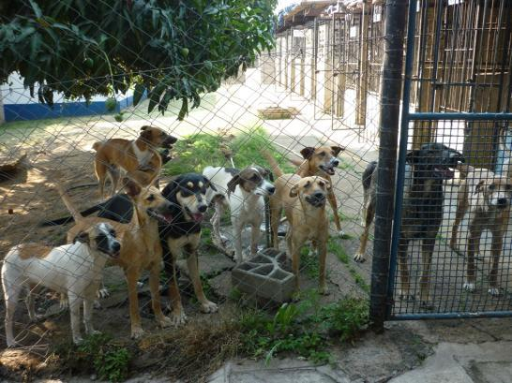
We may not have perfect pedigrees, but we are a wonderful band of brothers, and we need help.

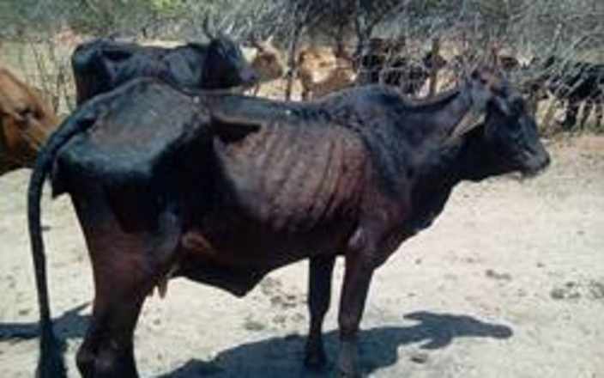
A recent case of cruelty, where a herd of cattle were corralled in a boma or pen, with no access to food or water. November was a blistering hot month, and how some of these animals survived is unimaginable. Although we did not have the funds, we just had to get involved, and although the outcome has not yet been resolved, at least the animals have got access to the basics, and we are watching the case. The absentee land claimant holds a doctorate (unknown which discipline, and unconfirmed) and apparently resides in the United Kingdom.

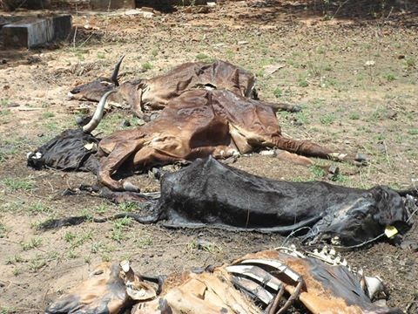

Yesterday Mutare SPCA were contacted by the ZRP about an urgent and extreme cruelty case involving approximately 40 head of cattle in Nyazura. The pictures we are about to post are graphic so please bear this in mind.
These animals belong to a new farmer who is currently 'out of the country' and is quite evidently completely out of touch with the state of his cattle herd.
These poor animals have been left penned and unable to access food or water to the point of starvation. As we write this, 3 animals are about to be euthanised, one of which fell into a pit and has been stuck in it for days. No one has been tending these animals as we are told that their wages have not been paid.
The cattle shown here have literally died of starvation and thirst. It is hard to imagine them going through all this over the past weeks as we have all gone about our business completely unaware. The early November heat wave must have been horrific for them - and then the rains came but still they could not drink what fell within their prison. One animal can clearly be seen to be tangled in the barbed wire fence, no doubt doing her best to get out of her hell hole.
We have opened a docket on this case and are in the process of trying to move these animals to a safe haven for their immediate veterinary needs and recovery.
.
ACCOUNT NAME: SPCA - MUTARE
NMB BANK, MUTARE
Account Number: 290 060 893
MUTARE BRANCH - code: 11521
IBAN:
SWIFT CODE: NMBLZWHX

mutarespca@gmail.com

