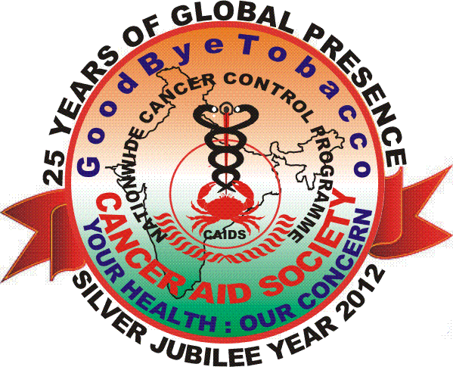 IMPORTANT MILESTONES

Our vision and action since 1987 has now been visualized by global leaders like International Union Against Cancer, World Health Organisation and United Nations.
Appreciations& Recognitions
- Top rated NGO at Great Non Profits 2016.
- “Global Woman of U.P.” Award received by our Director from Honorable CM of Uttar Pradesh on 30th April 2016.
- “Best NGO in Healthcare” at Giving Back 2015 CSR & NGO Awards by UBM on 22nd December 2015.
- Top rated NGO at Great Non Profits 2014.
- Finalist in AmeriCares Spirit of Humanity Awards 2014.
- Won the Award for “Best Cancer Awareness Program” out of 165 NGOs in Can India Conclave Award 2013 held at Tata Memorial Mumbai on 19th December 2013.
- Top rated NGO at Great Non Profits 2013.
- Finalist in AmeriCares Spirit of Humanity Awards 2013.
- Top rated NGO at Great Non Profits 2012.
- Awarded best NGO in Health Care at SAMAAGAM – IIM Lucknow in 2011.
- Cancer Aid Society received appreciation from American Cancer Society USA in 2007.
- Appreciation for presentation at World Conference on Tobacco or Health, U.S.A. in 2006.
- Cancer Aid Society received an appreciation letter from World Health Organisation in 2000.

Participation in National / International Events

- Participation in COP7 at Greater Noida in November 2016.
- Participation in World Cancer Congress at Paris in November 2016.
- Participation in the Conference on HPV at Chicago in October 2016.
- Participation in the WHO Dialogue of GCM NCD at Mauritius in October 2016.
- Participation in 11th Asia Pacific Conference on Tobacco at Chine in September 2016.
- Active participation in 69thWorld Health Assembly 2016 at Geneva in May.
- Participation in National NGO Consultation 25th to 27th May 2016 by WHO Country Office, NCD Alliance & Healthy India Alliance.
- Participation in International Workshop on NCD Prevention at Delhi in March 2016.
- Participation in AORTIC 2015 at Morocco.
- Selection of our representative as “World Cancer Young Leader” globally at World Cancer Leader’s Summit 2015.
- One day workshop on NDPS Rules organized by Dept. of Revenue, Ministry of Finance in July 2015.
- Participation in Summer Institute on Spirituality in Health Care at Washington DC in July 2015.
- Participation in Dialogue on NCDs at WHO Headquarter Geneva in April & November 2015.
- Represented the Country in the Review meeting for the Control of Non Communicable Diseases at United Nations in July 2014.
- Represented the Country in the High Level meeting for the control of Non communicable Diseases at United Nations General Assembly Headquarters New York in September 2011.
- Participation in Global Advocacy Training Program as Global Scholar at Boston.
- Participation at WCTOH as Youth Participant.
- Participation in World Cancer Congress 2014 where our representative selected as “World Cancer Young Leader” globally.
- End Game of Tobacco 2013 Delhi.
- APACT 2013, in Japan.Nominated Leader of Youth Conference 2016 in China.
- World Cancer Congress at Geneva in 2008.
- World Cancer Congress at Washington D.C. U.S.A. in 2006.
- World Conference on Tobacco or Health, U.S.A. in 2006.
- Several events of national repute viz. Health Mela 2001 inaugurated by The Then Honorable Prime Minister Sri. Atal Bihari Vajpayee &Organised by the Health Ministry - Govt. of India.

National/ International: Membership/ Empanelment
- Registered Participant of World Health Organisations Geneva under Global Coordination Mechanism on Non Communicable Diseases in 2015.
- We are having Special Consultative Status with the Economic and Social Council of
United Nations New York since 2012.
- Empanelled with Indian Institute of Corporate AffairsHUB Code: A000098.
- Registered in DESA's Civil Society database & CSO Net - the Civil Society Network of the UNITED NATIONS Headquarters, New York, USA.
- International Association of Hospice and Palliative Care, Houston, USA
- Global Cancer Control Community, UICC, Geneva, Switzerland
- GLOBALink, UICC, Geneva, Switzerland
- Framework Convention Alliance, Geneva, Switzerland
- NCD Alliance CIG Group, Geneva, Switzerland
- Cancer Service Group (ICISG), Toronto, Canada
- Indian Association of Palliative Care - India
- Action Council against Tobacco, Tata Memorial, Mumbai
- Cancer Control Committee, Govt. of Delhi
- Delhi Smoke free Civil Society coalition, Govt. of Delhi
- Tobacco Control Committee, Govt. of U.P.
- Government of India, Planning Commission’s NGO Partnership System UID No. UP/2009/0009446
- National CSR Hub code A/1/12/08/029 at Tata Institute of Social Sciences.
- Action Forum on Tobacco Control India.

Significant dent in the existing problems related with Cancer:
Tobacco Control:
- Representation to the Parliamentary Committee on COTPA Amendment Act and 85% Pictorial Warning.
- Announced Award of Rs. One Lac INR for Leadership in Tobacco Control for the SAARC Countries 2015.
- Wrote letters to the Prime Minister and Finance Minister for increasing Tobacco Taxes in 2014.
- We had Organized several rallies and campaigns demanding ban of Smoking and Sale of Tobacco products near educational Institutions before 2004 which were one of the contributory factors towards the promulgation of COTPA 2004 by Govt. of India.
Control of Cancer and NCDs:
- In 2013 we Declared December 8th as NCD Awareness Day.
- Our comments on Draft Zero published in the website of World Health Organisation in 2013.
- Joint Project of Telemedicine Bus for Organising Camps near Lucknow with SGPGIMS & Dr. KL Garg Memorial Trust.
- Announced Award of Rs. One Lac INR for Leadership in Cancer & NCD Control for the SAARC Countries.
- Improved Life Style and Dietary Habits of young India reflected in an independent survey report of National Sample Survey Organization published in the Times of India dated May 1st 2007 Titled @ Highway to health: India eating better.
- We got stamp released on Cancer Awareness by Dept. of Post Govt. of India on 7th of November 2001, since then it is celebrated as National Cancer Awareness Day.
- International Union against Cancer - UICC (www.uicc.org) the International Apex Body on Cancer Control has advocated in 2007 the above activities under World Cancer Campaign (www.worldcancercampaign.org); which we had pioneered in 1987 having a vision 20 years prior to that of World leaders.
Palliative Care:
- Organized 24 workshops on Palliative Care since 2007-2014 in the States of U.P., M.P., Bihar, Jharkhand, Chhattisgarh, Punjab, Assam and Tamil Nadu.
- Member of the Govt. of India Committee for considering the amendment of Narcotic Drugs and Psychotropic Substances Act in 2012 which was possible due to our active advocacy.
- Amendment for Narcotic Drugs and Psychotropic Substances Act initiated by the Government in 2011 & finally passed in February 2013 through our effective Advocacy.
- Honorable Supreme Court on August 24th 2012 has directed the Chief Secretaries of State Governments to make Morphine preparations available for treating the pain of terminally ill Cancer Patients. The issue is being actively followed by us ever since.
- Announced Annual Award for the Leadership & Excellence in Palliative Care within the SAARC Countries for Rs. One Lac. INR in 2011.
- We drafted Palliative Care Declaration 2011 – the first ever of National and International Level.
- Organised 18th International Conference of Indian Association of Palliative Care 2011 at Sanjay Gandhi Post Graduate Institute of Medical SciencesLucknow:
Our two years of hard work of sensitization, advocacy and correspondence with Governmental and other agencies yielded dramatic results which effected the entire Country. The Conference was a great success having 10% Foreign Delegates and encouraging outcomes:
- Introduction of Palliative Care in Medical Curriculum was a long pending demand, on eve of the Conference Medical Council of India announced MD in Palliative Care. Chairman MCI in his message for the Conference suggested us “to come out with practicable strategies, which could be affected by the Council in coming times, so that optimal results are generated and used to train Graduates and Post Graduates in Palliative Care in a much better way”.
- The Topic of Debate held on 12th February 2011 during the Conference was Pro – “Euthanasia is humane care in face of suffering” Con – “Euthanasia is ethically unacceptable in a Civilized Society”. In March Honorable Supreme Court of India through its Judgment, Legalizes Passive Euthanasia – Times of India dated 8th March, 2011.

