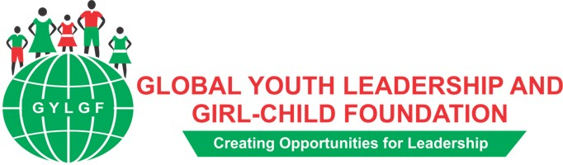 (GYLGF)

About us
Global Youth leadership and Girl-Child foundation is saddled with the mandate to alleviate challenges faced by youth and girl-child in Oyo State and Nigeria. Our vision is ensuring that every girl has quality education and reaches her optimum potential; we envision that every youth is gainfully employed or able to create employment. This is with the view of eradicating the circle of poverty, ignorance illiteracy and other vices that pervades societies where majority of youths are unemployed and their girls don’t attend school or drop out.

Preamble
The youth in Nigeria have long history of neglect, unemployment, under-employment and therefore not positioned to effectively participate in community development. Moreover, social vices such as drug and substance abuse, violence and other criminal activities to mention a few are more prevalent among youths,. By so doing, some of them have turned out to become problems to the society including youth restiveness and insurgency. Worse heat is the female gender who has a long history of deprivations, discrimination and exclusion from social, economic, political, educational and professional spheres. Some of them have grown with low self-esteem and truncated ambitions. Others who are in school are not equally motivated as the male counterparts and some have become victims of various forms of violence in the hands of people they trust. Though government at all levels had made several efforts to address some of these challenges including development of various policy documents that provide guidelines to various actors to meaningfully contribute their quotas to addressing the problems. The Civil Society is also reputed as an organ that has significantly driven the process of translating these policies to actions.
The Global Youth Leadership and Girl-Child Foundation was founded by Dr. Adepeju Aderogba-Oti in 2014 after over two decades of working in the three tiers of Education sector, Faith Based and the Non Governmental Organisations. The burden to do something about the situation of the youth and the girl-child was layed in 1997 after the rigorous training she received at the prestigious Pan African Institute for Development (PAIDWA) Cameroon, as a Development Agent. Field research and community based activities had been carried out in Ibadan, Oyo State, Nigeria under the aegis of Action Research Training and Development Centre 2001 and Leading Edge Global Resources 2007.
This vision is being narrowed down to focus on contributing to addressing some of the above mentioned challenges. GYLGF hopes to create viable opportunities for the youth, women and the girl-child to overcome challenges and attain the utmost potentials without neglecting the men

Our Vision
GYLGF envisioned a society where the potentials of youth and girl-child are fully developed and supported to become socially responsible, responsive, able to lead self and contribute meaningfully to healthy society.
Our Mission
To ensure that every girl attains highest level of education and reaches her optimum potential.
To ensure that the girl of today grows to become an informed, educated and economically empowered woman of tomorrow.
To ensure that every youth is gainfully employed and/or able to create employment.
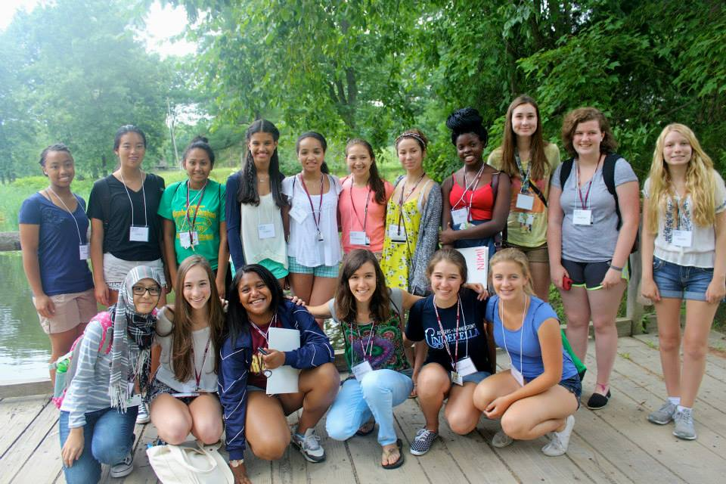
8th from left: TioOluwanimi Ayeni sent by GYLGF to Girls Leadership Workshop-Eleanor Roosevelt Center Val-Kill, Hyde Park, New York, USA July 2014

Objectives
- To build the self-esteem, can do spirit and knowledge base of the girl-child through capacity building programmes: reproductive health; education and career talks in schools.
- To empower, inform, educate and train the minds of young people with skills that will position them for self-reliance, economic independence and self- management.
- To assist the youth/women identify and build the skills that will make them become employable and also become employers of labour.
- To assist the youth and the girl-child develop powerful leadership skills through effective mentorship.
- To use the foundation as a platform to assist the government in formulating essential curricula, education and social policies that would link gown to town.
- To imbue in young girls the necessary skills that will help them make informed decision about their sexual and reproductive health.
- To enhance the ability of young girls develop career path towards becoming successful leaders tomorrow through various career counselling
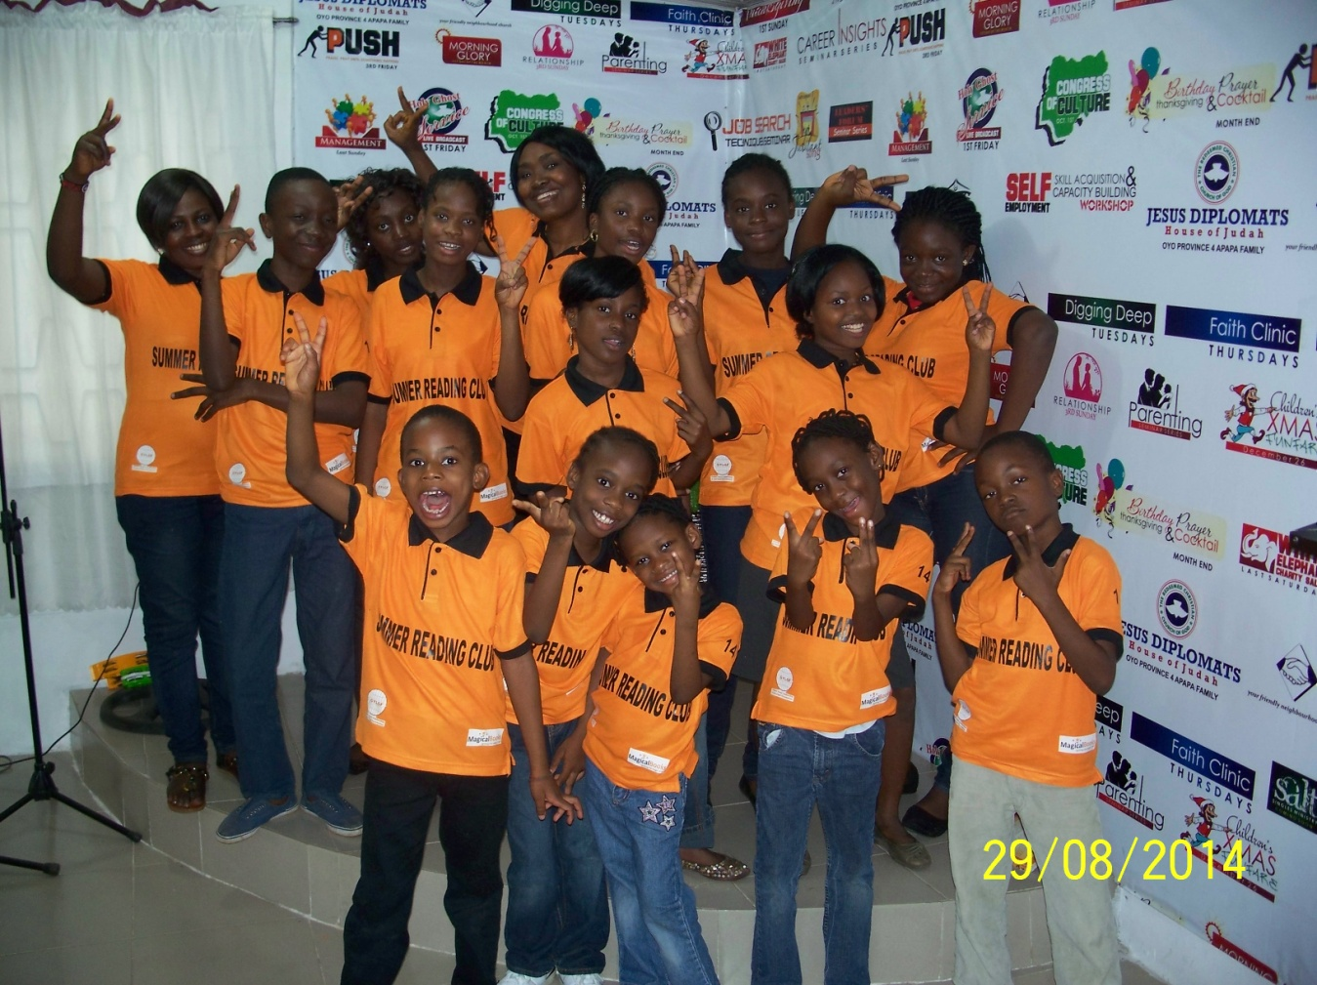Some of the Participants at the closing ceremony of the 2014 Summer Reading Club

Our programmes and strategies
- In-house and School Based Reading Clubs
- Gender Sensitization Workshops
- Gender, Education & Leadership Program For Girls
- Girls Education Advocacy In The Grassroots
- Adopt A Girl Project-AAGP
- Economic/Political Empowerment Of Grassroots Women
- Employability, Leadership And Job Skills Training For Youths/Women
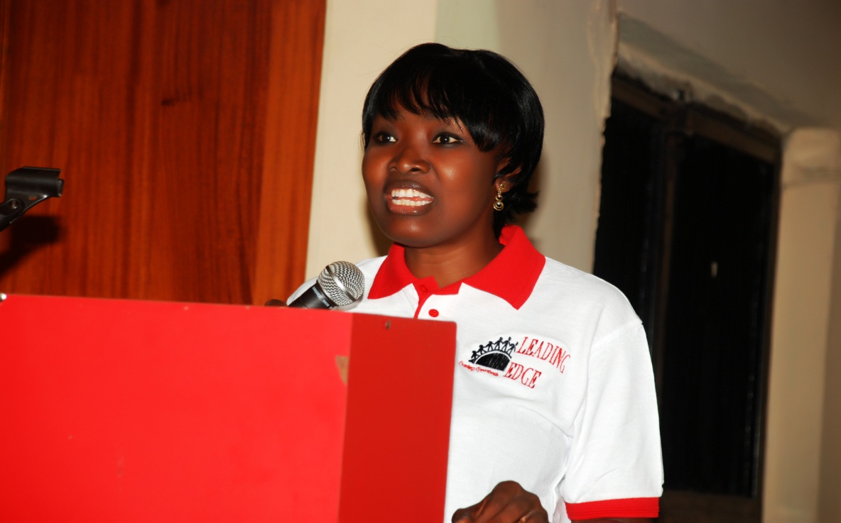
Dr. AdePeju Oti delivering a lecture

Our Core Values
- Education of The Girl-Child to the highest level.
- Equality Of Opportunity
- Zero Tolerance for Violence against Women and The Girl-Child.
- Economic, Empowerment For Women And Youths
- Political Empowerment For Women & Girls
- Safe guarding the rights of women and girls

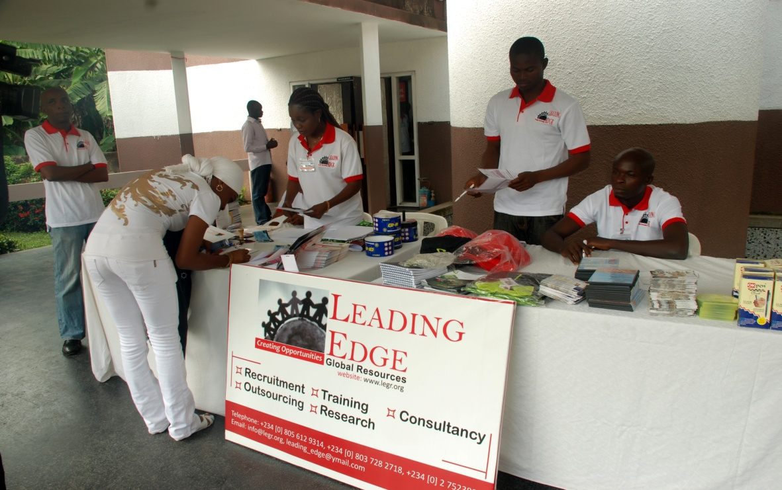
Self-employment Skills Acquisition Workshop- University of Ibadan Conference Centre, Registration Desk

Our activities
- Gender Sensitisation And Leadership Workshop
- Career and Leadership Talks in Schools
- Girls Leadership Workshop
- Self-Employment Skills Acquisition & Capacity Building Workshop
- Nonviolence Conflict Reconciliation Workshop
- Employability and Soft skills Training for Job Seekers/Newly employed
- Research
- Advocacy

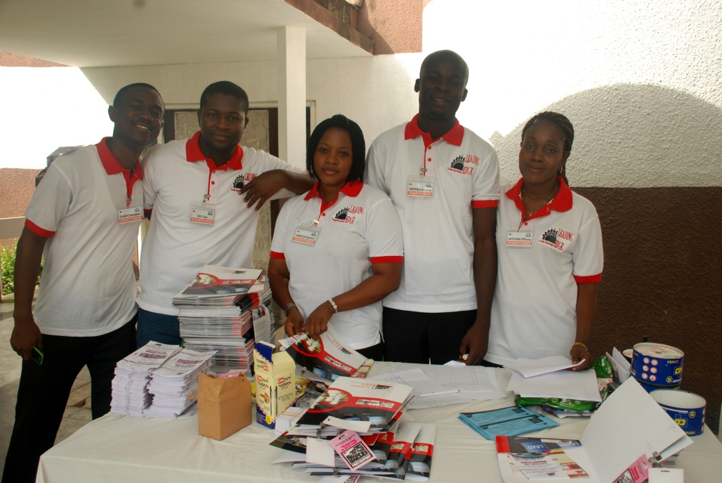
Self-employment Skills Acquisition Workshop- University of Ibadan Conference Centre, Volunteers

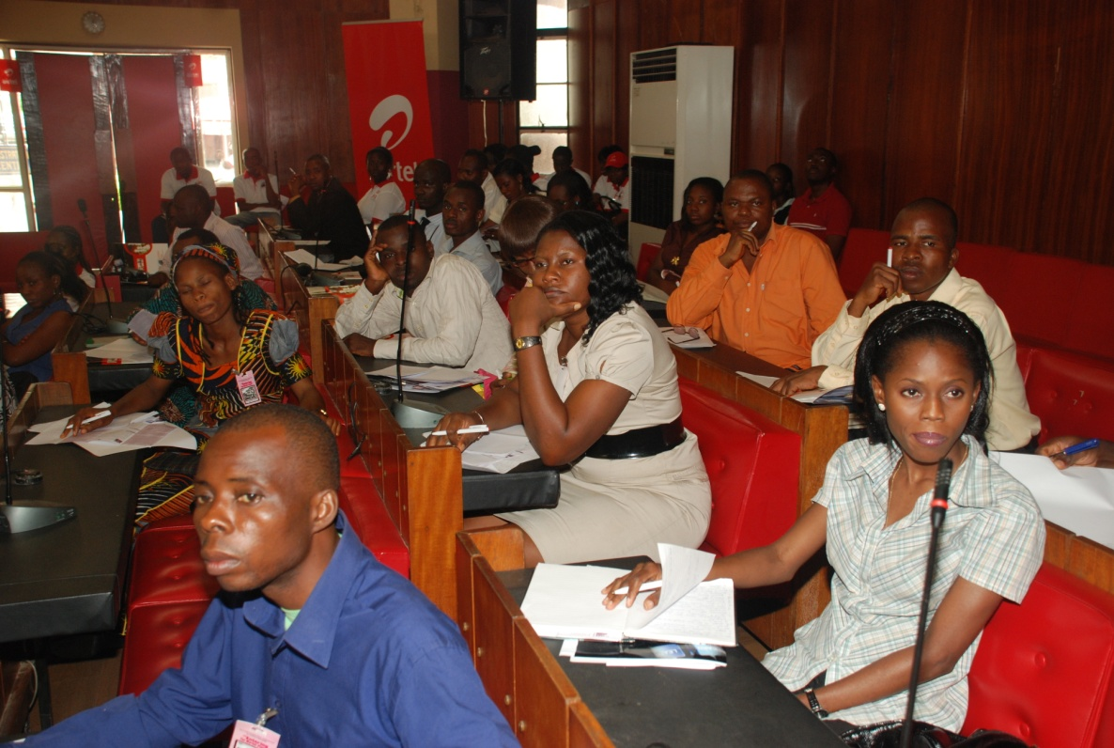
Self-employment Skills Acquisition Workshop- University of Ibadan Conference Centre, some of the participants listening with rapt attention.

Our Community
- Educational Institutions
  - Primary
  - Secondary Staffs & Students
  - Tertiary
- Parents
- Grassroots
- Government: to influence and /or change policy

Support Us

Book Drive
We want every child between the of four (4) to twelve (12) and every teenager and young adult to read at least 2 books in one month through our Reading Club and library project. We want to stock our library with 2000 titles of children storybooks, fictions, non-fictions, documentaries, adventures, adult literature and text books. Donate your excess books, old and new books to us today.

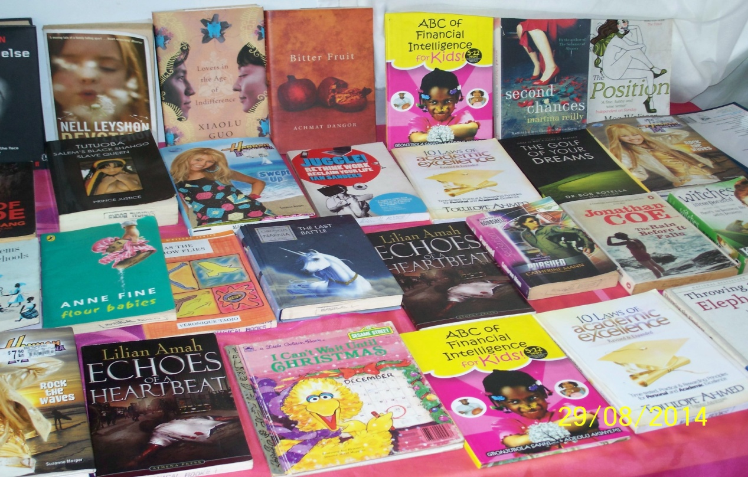

Adopt a School Project

Be a part of adopt a school project to improve teaching and learning process in our schools. One class per time will go a long way.

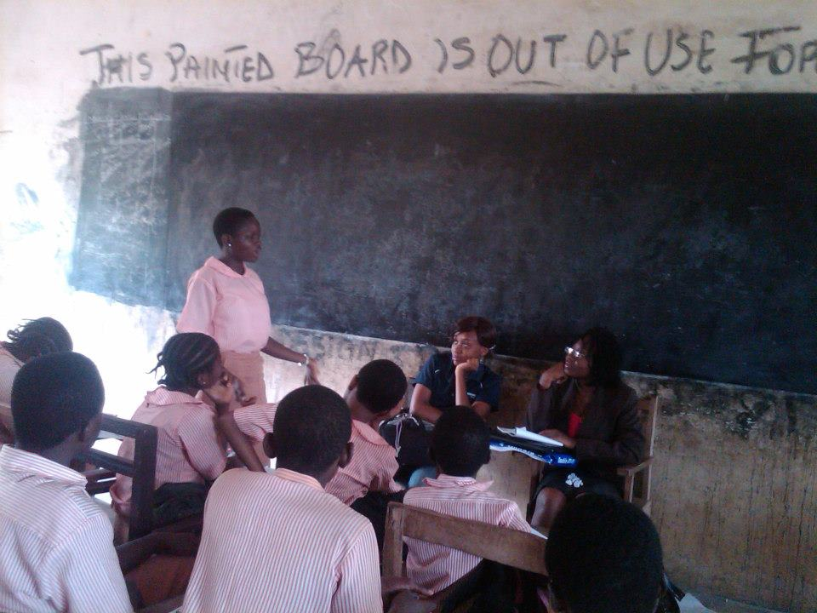

Adopt A Girl (AAGP)
Help an indigent, but brilliant girl in the rural community complete Basic, Secondary Education and transit to Higher Institution of Learning by donating to her scholarship. You will be ending the circle of poverty and other social vices thereby making such young individuals socially responsible.

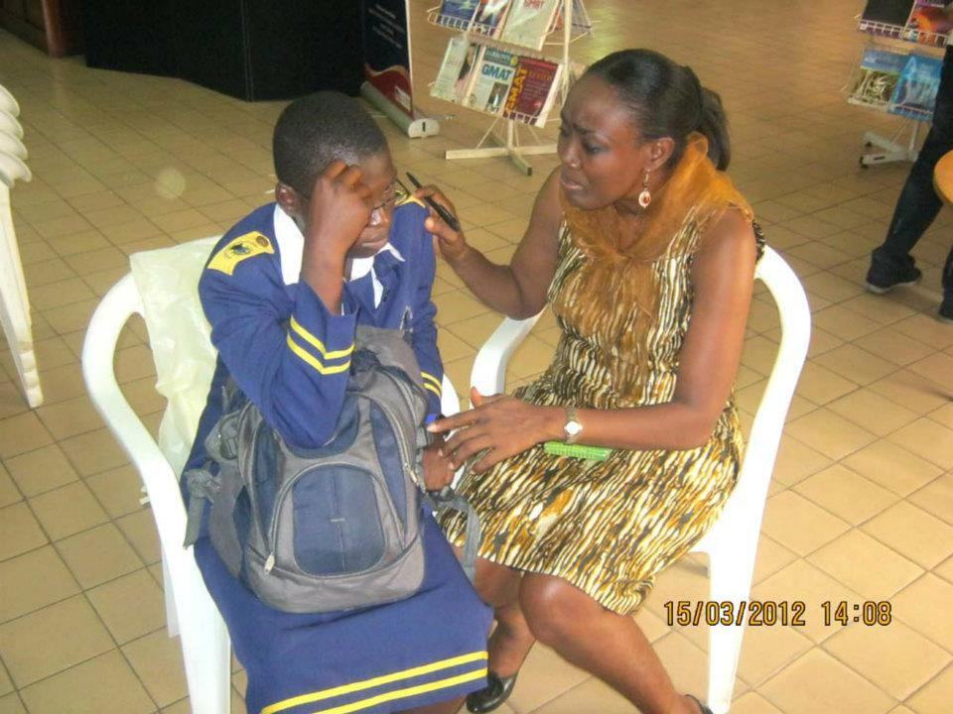
Dr, Oti counseling a school girl after a programme

Volunteer
We provide you with most fulfilling experience and work opportunities in our project and causes. We invite you to contribute your talent, skills, experience and education for helping others through volunteerism. With our programmes, you will find innovative ways to combat illiteracy, poor health, inequality, violence, etc. Eligibility: Secondary school students, Professionals in various fields, female in professions and business. Please log on to www.gylgfoundation to fill our volunteer form.

Donate
To give to any of our activities, project and causes, please do so via our website, or send enquiry to our email, or call.

Trustees: Adepeju Olaide Oti, Ph.D, Distinguished Senator Dr. Bukar Abba Ibrahim, FNIQS, Dr. Olusegun Sunday Adeleye JP, General Dr. John Nanzip Shagaya, OFR, Gen. Dr. Abdullahi Bagudu Mamman, Dr. John Adebisi Arewa, Chief Mrs. Oluremi Adiukwu-Bakare, Princess Dr. Ebunoluwatofunmi Bosede Oladunni Ilugbusi, JP,
Mr. Yinka Fasuyi

Board of Directors: Professor Stella Odebode –Chairperson. Omolara Comfort Adedoyin, Ph.D- Vice- Chairperson. Adepeju Oti, Ph.D- Executive Director. Dr. (Mrs.) Wumi Femi-Akinlosotu- Treasurer. Oluwaseun Aina-Communications/Publicity Director. Oluyemi Atibioke, Ph.D- Organisational Development. Rasak. Olajide, Ph.D. – Member. Omolara Olatubosun- Member

Advisory Board: Oyebola Ayeni-Nigeria. Ryan Nicole Martin-USA. Phanida phivilay-USA. Karen Shaw UK. Mr Rowdy Duncan-USA. Michael Oti-Nigeria. Eric Sumo-Liberia. Toluwalashe shanu-Nigeria. Olumide Adeyemi-Nigeria.

Our Address
Off Road 19, Plot 10, PDCOS Bashorun Housing Estate, Akobo, Ibadan, Oyo State, Nigeria.

Website: www.gylgfoundation.org
Email: info@gylgfoundation.org
www.facebook.com/global youth leadership and girl-child foundation
WhatsApp: 07080360240
Twitter: @gylgfoundation
Tel:+234 805 612 9314
BB Channel PIN: C00246AB0

Sexual Violence Prevention Training Skills for 500 Nursery and Primary school girls in Ibadan City (ages 4-10), this is because sexual molestation of female children have been on the increase, in the face of weak Nigerian laws. Leadership and Entrepreneurial Workshop for 50 Secondary School girls, (to boost their self-esteem and prepare them for leadership roles in the community).

