Project Living classrooms in the community of Atánquez, Colombia

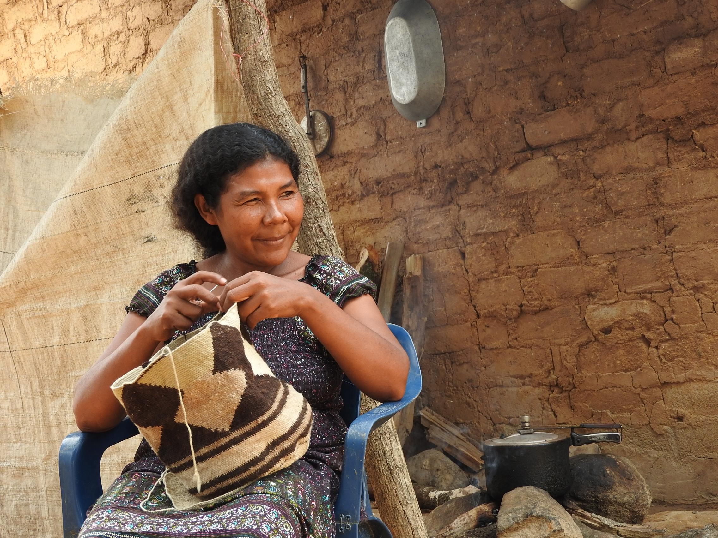

Produced by:

Sofía Villa Barajas
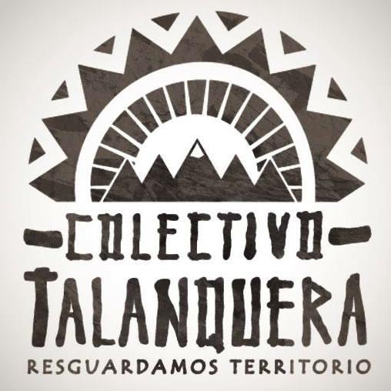
Andrés Maku Pardo Carmona
Thomas Macintyre

Introduction
This document will provide an overview of the Living classrooms project which involves the construction of an ecological demonstration farm in the community of Atanquez. The document will begin with an introduction to the region of La Sierra Nevada, and will continue with the challenges facing the community of Atanquez and the living classroom project which will address these challenges.

Atánquez – Sierra Nevada de Santa Marta

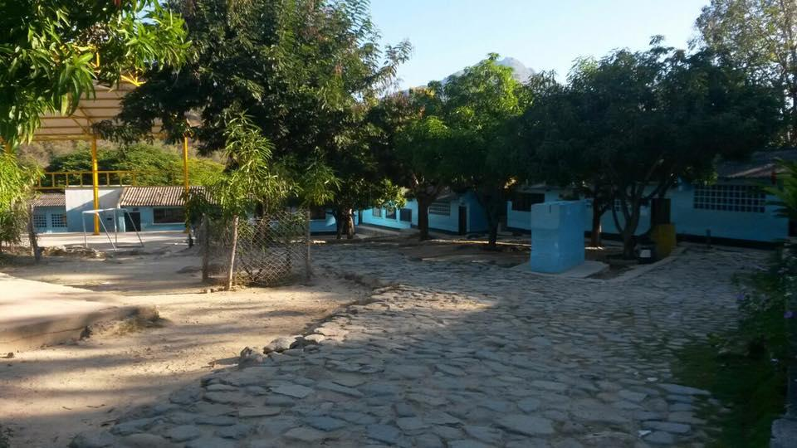

"Atanquez, a town of cobbled streets embroidered with adobe houses. Built on uneven terrain, with hills and ravines that condition the layout of the streets, the location of the houses and the course of several streams. This side of the Sierra mountains is not a mountain range of exuberant jungles or steep hills. It is a broken mountain range, wounded by erosion, dry for long summers that never finish, sown with cactus and caressed by winds born in La Guajira."

By: Florence Thomas. October 10, 2001 (personal translation)

Introduction to La Sierra Nevada and the community Atanques

The Sierra Nevada de Santa Marta (SNSM) is a vast territory comprising approximately 2,115,800 hectares. This territory has been recognized by UNESCO as a world heritage site due to its unique richness in biodiversity. It comprises the three departments of Cesar, Guajira and Magdalena, and has a total of 26 municipalities that have jurisdiction in this territory.

The SNSM includes the four Indigenous peoples of the Kankuamos, Koguis, Arhuacos and Wiwas. These groups have developed different productive activities under a self-sustaining ecological economic model directly related to their territory.

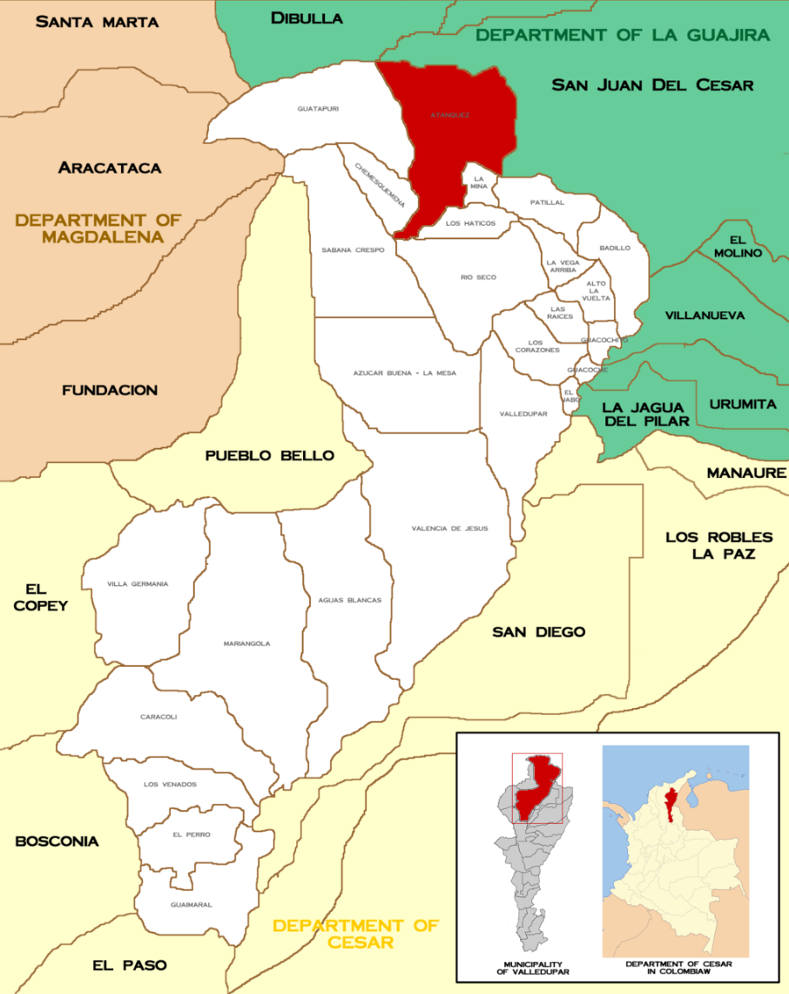

Atánquez, center of the Indigenous reserve of Kankuamo, is one of the 26 municipalities of the province Cesar, located 1 hour from the capital of Valledupar, and is located to an hour of the capital of the Cesar. It has approximately 7000 inhabitants, and is an important hub for the the different reserves of the Indigenous communities Wiwa, Kogi and Arhuaca.
In the Indigenous Reserve of the Kankuamos, coffee production is one of the main lines of its economy. It makes significant contributions to the livelihood of families distributed throughout the territory in the range between 900 and 2,000 meters above sea level. There are also many other crops in the territory cultivated through organic practices, Examples of this is pancoger (banana, guineo, maize, beans, cassava), under shady timber trees such as Guamo, Roble, Nogal, Guayabo, Avocado Macho, and Fruit trees such as avocado, citrus, mango, amongst others.

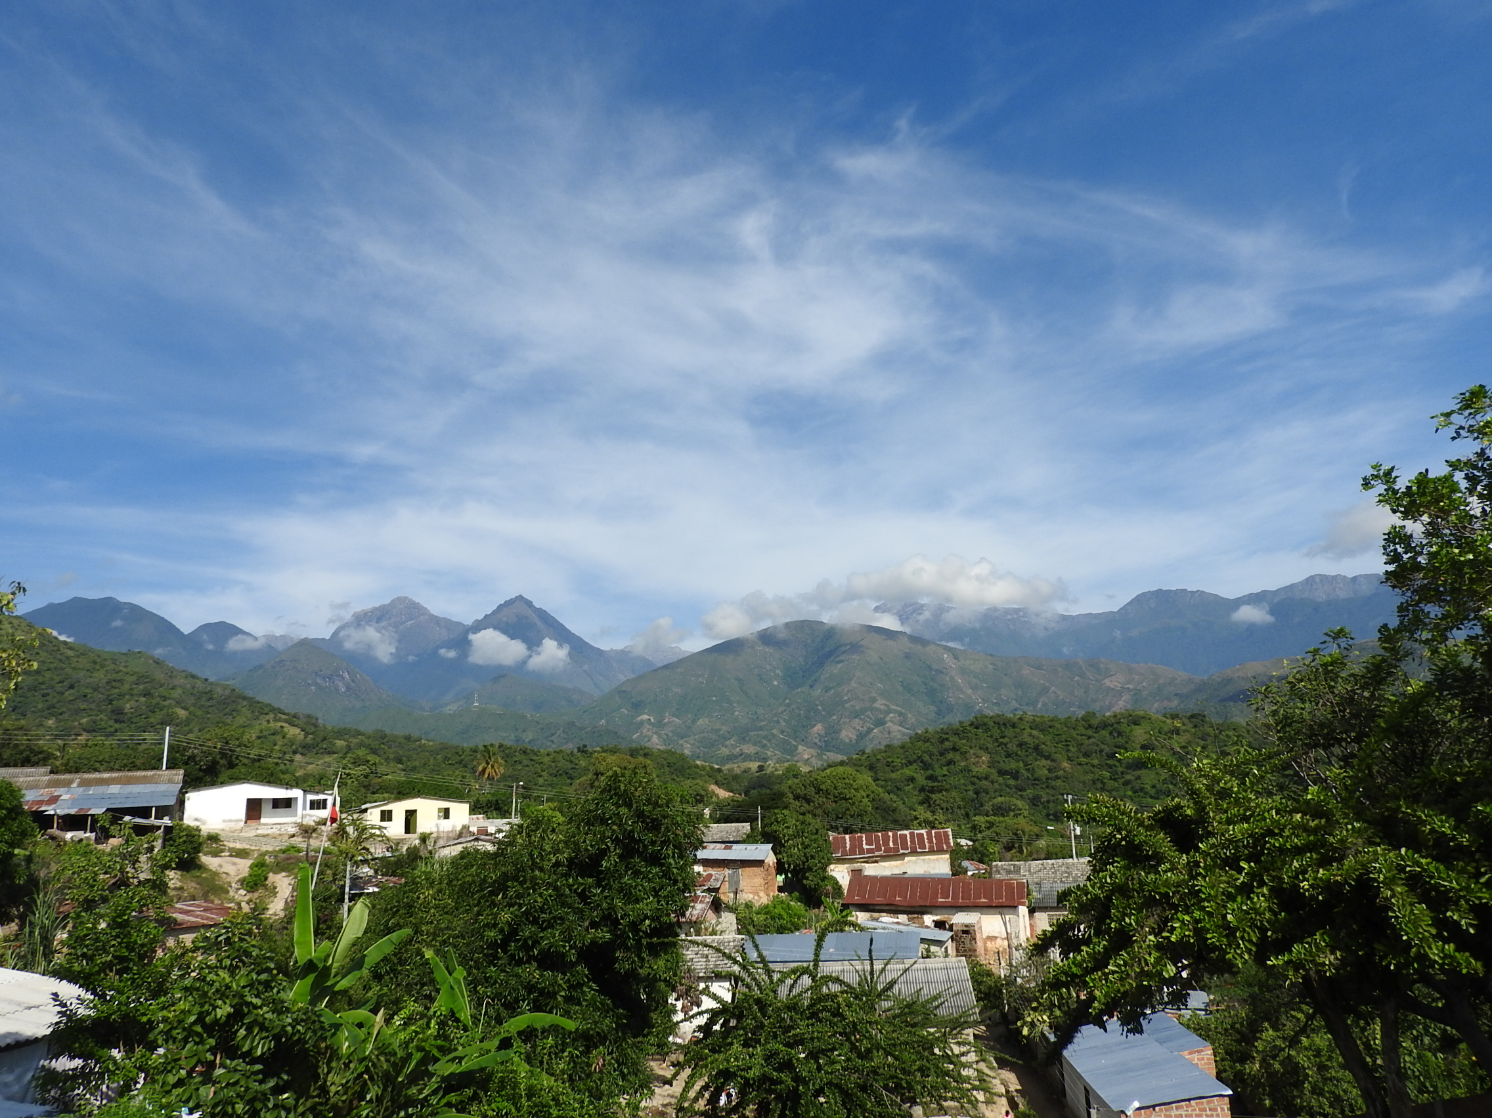

Challenges facing the Community

After a long history of violence that has marked the region, Atánquez is being rebuilt through a focus on its his cultural identity - integrating knowledge from different perspectives of sustainability. At the same time, the Indigenous identity of its inhabitants is being strengthened and protected, binding them to the principle of compliance with the natural law-of-origin which is based on the care of life. The community pioneering the path in Colombia towards rebuilding human and territorial peace, because - as the Kankuamos themselves say - the Earth has also been a victim.

The world of development has entered the territory of Atánquez and the Sierra Nevada of Santa Marta. This has brought new construction methods related to mega-mining, displacing traditional bio-construction processes. Displacement due to violence has for many years led to the abandonment of the countryside, greatly reducing local agricultural productivity. This has lead to a change in eating habits, many of which come from the food industry. This generates non-biodegradable solid waste such as plastic entering the territory as a result of the transition from traditional way of life to that of the consumer society. Without any control or management, this garbage is putting at risk the health of the community of Atanques - both people and the natural world.

The urban development of the community Atánquez has sought to copy the model of the city, generating disorderly growth which has not taken into account the existing bodies of water, nor the management of sanitations systems, for which there have already been sanitation emergencies pushing the territorial authorities to search for more coherent and healthy forms of development. Confronted with their cultural identity, the people of Atánquez are calling for sustainable self-development, with an emphasis on generating learning processes that provide a substrate for human evolution.

Solution - Living Classrooms in the community of Atanques

This project seeks to address the challenges above through constructing connected workshops based on a methodology of living classrooms. This methodology is based on the need for learning through practical based projects which have direct relevance to a community. These workshops will develop a practical and educational process based on developing skills of bioconstruction, integrated water and waste systems and agroecological agriculture techniques. The long-term goal is that these workshops will catalyse a process culminating in the design and execution of Atánquez, as a transition town - a practical model of sustainability at the community level.

Permacultural design principles

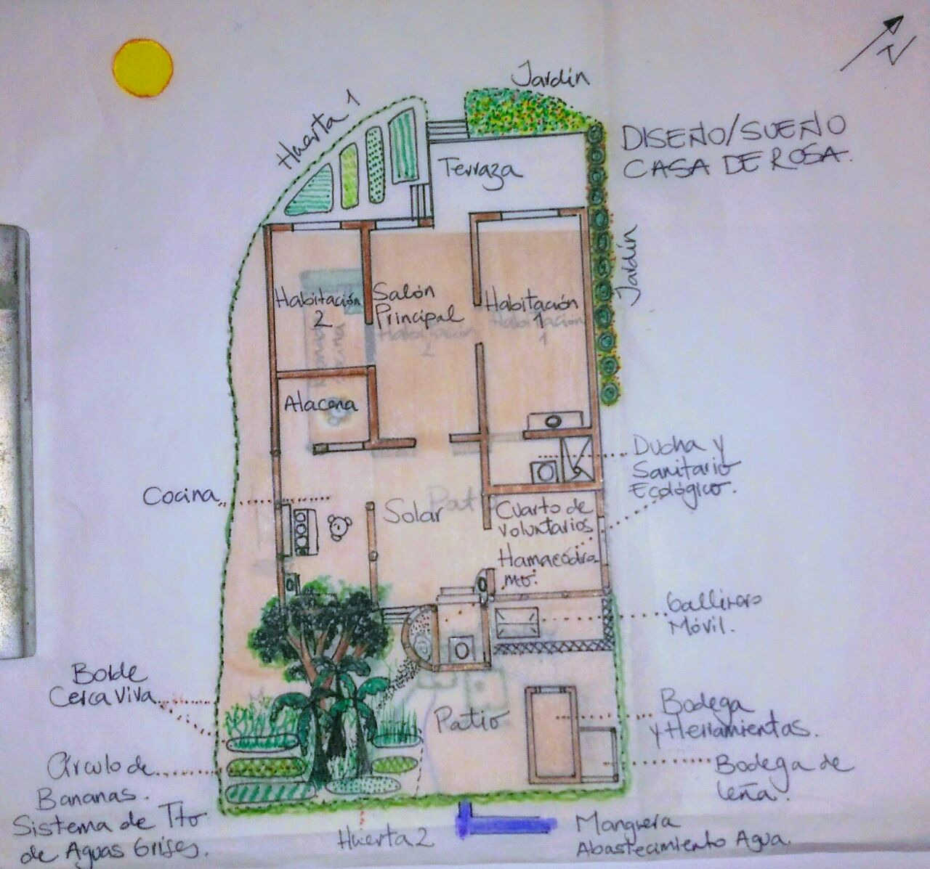

Permaculture refers to the development of agricultural ecosystems intended to be sustainable and self-sufficient.The above drawing illustrates the design of such a system for the house of Doña Rosa.

Who will participate in the Living Classroom workshops?

These workshops have been designed for the local community of Atánquez to address the specific challenges they are facing. However, there will also be participants from other communities and regions of Colombia. A characteristic of the Living Classroom methodology is the emphasis placed on promoting the diversity of participants. This means inviting local peasants, store owners, local municipal representatives, and encouraging the participation of women and youth.

Workshop dates, focus and number of expected participants

Workshop 1:
Date: 9 - 16 April, 2017
Focus: Awareness raising and introduction to permaculture
Number of participants 30 locals, 30 external

Workshop 2:
Date: 10 - 25 June, 2017
Focus: Practical workshop on Ecological design
Number of participants: 30 locals, 50 external + facilitators

Workshop 3:
Date: 2 - 18 November, 2017
Focus: Design of Transitional Town Atanquez
Number of Participants: 30 locals, 50 external + facilitators

Partners in the Project

The partners of this project are: CASA Colombia, Foundation Transitional Minds, Boavida, Kankuama Indigenous Organization, Valledupar Mayor's Office, National Indigenous Organization of Colombia, Bureau of Indigenous Affairs of the Ministry of Interior, La Pacha PEAT.

