Community in Action
Annual Report for September 2015 – August 2016

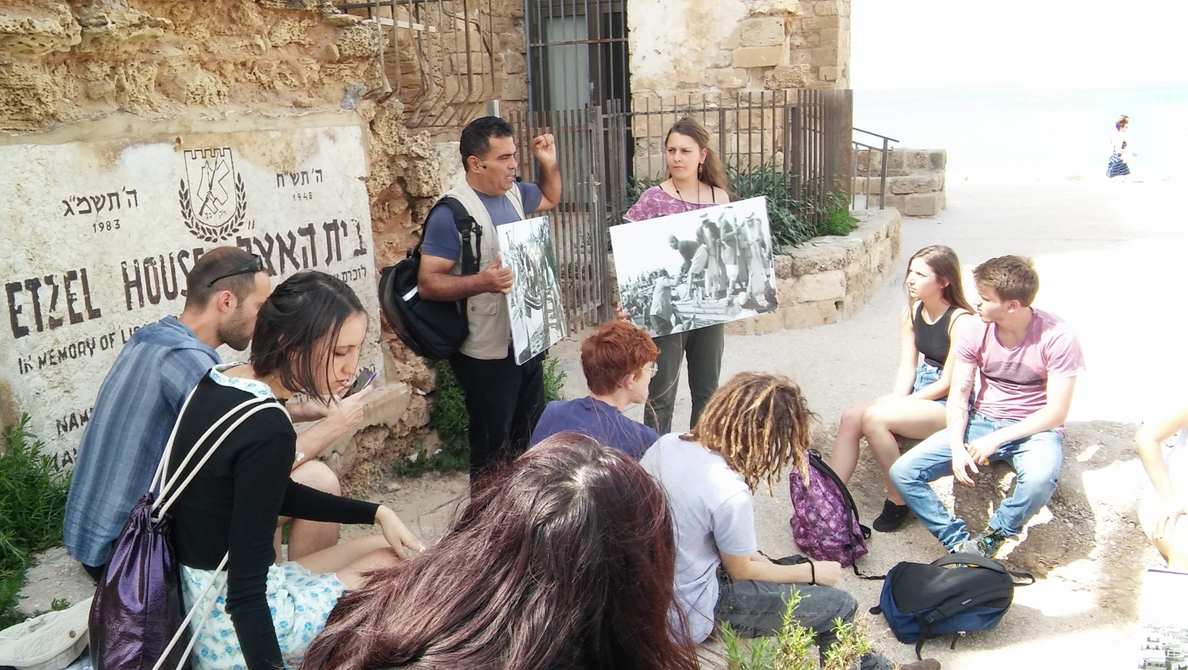

Submitted to:
Name of Project: Community in Action (CiA)
Reporting Period: September 2015 - August 2016
Contact Person: Becca Strober, Resource Development / Monitoring & Evaluation Coordinator
becca@reutsadaka.org

(Pictured: Participants on the Jaffa to Beirut tour)
CONTENTS

EXECUTIVE SUMMARY 3
CONTEXT 4
Changes within the organization 5
OVERVIEW OF ACHIEVEMENTS 6
Outputs 6
Outcomes 6
Impact 7
PARTICIPANTS AND ACTIVITIES 7
Project design and planning 7
Project Activities and Analysis 9
Community Centers Activities and Students 14
EVALUATION 16
LESSONS LEARNED 17

EXECUTIVE SUMMARY
Sadaka-Reut (SR), an Arab-Jewish Youth Partnership organization, educates and empowers Jewish and Palestinian-Israeli youth and university students to pursue social and political change through bi-national partnership. Our grassroots dialogue and leadership development programs seek to address the deep-seated injustices caused by the Israeli-Palestinian conflict, and to create a new generation of young activists promoting a shared society based on equality, solidarity, and justice. We seek to provide our participants with adequate knowledge on the conflict and its history along with the necessary tools and experiences needed to engage in joint social change initiatives and build alternative models for interaction between the two groups.
Community in Action (CiA) is a volunteering and leadership development project for young Palestinian and Jewish high school graduates and university students. The project creates a cadre of young committed, bi-national activists and leaders who have the tools, knowledge and capability to promote social political change and the vision of a just society.
The 2015-2016 activity cycle began in September 2015. The educational program included two full days per week plus two overnight seminars and four day-tours. During enrichment activities and leadership training, participants took part in lectures, workshops and tours led by activists, leading community members and NGOs, focusing on social injustices and on the structure and consequences of national oppression within Israel and the Occupied Palestinian Territories (OPT). Participants also underwent training in dialogue group facilitation, campaign building, advocacy and other social change skills designed to build their capacity as activists. As part of their action program, participants provided one-on-one or small group sessions twice a week to Palestinian and Jewish students from marginalized communities residing in Jaffa. The only bi-national group active in Jaffa, the participants volunteered for a total of 2468 hours during the year, reaching over 63 young people aged 6-17. They acted as role models for students, and provided them help with their studies.
During the education process, participants became more aware and knowledgeable about their own national history as well as the history if “the Other.” They developed a deeper understanding about systems of oppression and how they take form and affect the players within it. They learned, through dialogue, tours, and lectures, to view their own realities in a more critical manner. They were exposed to people's personal stories in order to connect the systematic perspective with real-life experiences of oppressed peoples. This enabled participants to develop empathy and a sense of responsibility to change their reality.
A central part of the program is moving from dialogue and learning to activism. Through workshops and trainings, participants were given tools and skills to initiate social campaigns. Having began a process of a social awareness, they were able to take issues important to them and to plan, develop and execute campaigns. In the first campaign of the year, they held a street photo exhibition. Then the group took photos reflecting their budding critical viewpoint on social issues in Jaffa such as housing shortage, gentrification, and inequality in education. Working together as a group, they hung the photos in a main street in Jaffa, together with the questions they were asking themselves. Weary to go out and face the public, they gradually found their place, and spoke to passersby, answering their questions and handing them postcards with photos from the exhibit. Working together, as a bi-national team, both with young people and on their campaigns, made them sensitive to each other’s needs, empowering themselves through supporting each other.
The project affected participants deeply, as most had undergone a personal empowerment process, coming to terms with their different identities and gaining self-belief and self-worth. Several participants are also planning to continue their social political activism. The project also had a wider impact in the Jaffa community where participants volunteered as the only bi-national group. It brought other organizations working in the locality to realize the challenges that working in bi-national environment brings and request SR's assistance in training their own staff.

CONTEXT
The Israeli-Palestinian conflict has been escalating regularly in the last decade without a political solution in sight. In the last two years we have seen a continuous decline also within Israel. On one level, following the last war on Gaza and recent individual attacks, potential Jewish participants, their parents and social circles present fear from Arabs and hatred towards them, which lead to unwillingness to take part in our programs - many conversations with potential Jewish participants and partners end soon after they hear our bi-lingual name and the mention of Arab-Jewish partnership. At the same time, our Palestinian participants and graduates share with us their experiences in recent months and tell us about extreme cases of violence, racism and discrimination. In January, Ahmad Amer, a Palestinian board member whose engagement with SR began as a participant in the Students' project, had his Tel-Aviv apartment broken into without a warrant by the Israeli police. As part of their search for a shooter in Tel Aviv, the police targeted and raided apartments occupied by young Arab students solely because they are Arabs.
On another level, discriminatory government legislation continues to contribute to the exclusion of Palestinian citizens from Israeli society through de-legitimization and denial of their equal citizenship rights. A bill allowing Knesset Members to suspend their peers, aimed at Arab KMs, was passed in late July. These trends are strengthened with racial discriminatory practices such as house demolitions and land confiscation. Notably, the Supreme Court recently legalized the destruction of Umm el-Hiran, a Bedouin village, in order to build a Jewish village instead. The Bedouin village of Al-Araqib was also recently destroyed for the 101st time.
On an organizational and personal levels, recent de-legitimization of left-wing and pro-partnership organisations are also taking effect. The much discussed 'NGO bill' sponsored by the extreme right-wing Justice Minister and Prime Minister is one example, as NGOs that receive funding from foreign governments will be branded as 'foreign entities' themselves, ousted from the Israeli society. Other examples include policies which prevent left-wing NGOs from receiving benefits such as national service volunteers and donor tax deduction, based on their political agenda. In the past weeks we've also seen campaigns by right-wing groups affiliated with the government targeting specific individual activists and groups, culminating in the arrests of three Ta'ayoush activists. This de-legitimization is felt by our activist staff, as well as organizationally as we work with educational partners, who now hesitate to be affiliated with the organization. This year, for the first time, partnering school staff had talked to us about their uncertainty of the consequences they will face by the reporting our joint activities to the ministry of education.

Changes within the organization
The reporting period included staff changes within the organization and project. Sadaka-Reut's Palestinain Co-Director, Hana Amoury, left Sadaka-Reut after many years with the organization to pursue new opportunities. She was replaced by Rawan Bisharat, previously worked for five years as the coordinator of “building a Culture of Peace” program.
Dina Gardeshkin joined as the new Jewish project Coordinator; she is a graduate of SR's students' project and a former facilitator with the “Building a Culture of Peace” program. Rula Khalaily, who stepped as the Palestinian co-coordinator last year while Fatma Hlewa was on maternity leave, continued in the position this year.

OVERVIEW OF ACHIEVEMENTS
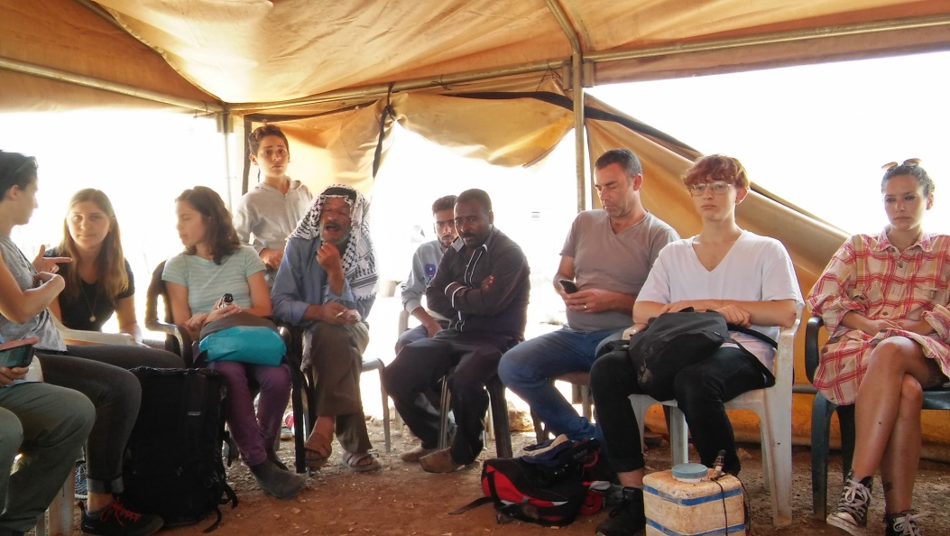
Participants sit with residents of the Jordan valley during a tour to the area.

Outputs
- 15 youth of both nationalities and gender completed the educational program, of them four Palestinians, 10 Jewish and one mixed (with a Palestinian parent and a Jewish parent); 10 females and five males.
- 11 participants completed the volunteer program; four participants were students and participated in at least one of the learning days and also in the seminars and tour days.
- 9-month long educational program was implemented, including enrichment and training sessions, public outreach campaigns’ development and execution, leadership skills development and dialogue sessions, through:
  - 76 activity days, two weekly (Monday and Thursday).
  - 4 day-tours in Jaffa, “From Jaffa to Beirut”, Lod/Lyd and the Jordan Valley (OPT).
  - 2 two-day seminars held in Haifa and the Negev/Naqab.
- 4 public outreach campaigns initiated, developed and executed by participants.
- Voluntary work was performed in 3 local community centers and after-school clubs:
  - 2468 volunteering hours in total;
  - With 63 Jewish and Palestinian 6-17 year-old students.

Outcomes
- Participants reported improving their ability to express themselves
- Participants changed perceptions and attitudes in relation to “the Other”
- Participants reported and demonstrated change in their perceptions of the collective “Other” and the heterogeneity of individuals them.
- A positive perception in participants in believing in their shared responsibility to change society
- Belief in bi-national partnership as a way to positively effect change

Impact
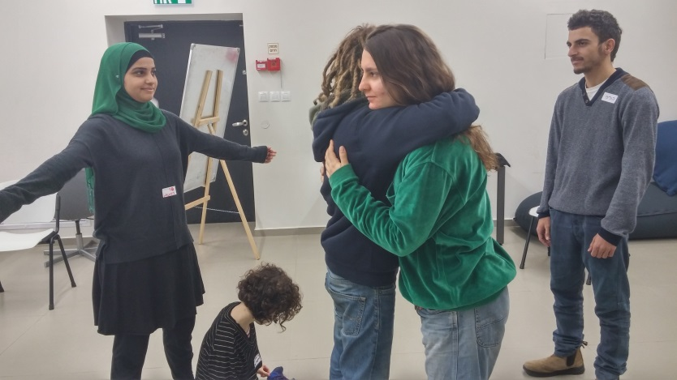
- Participants gained knowledge and experiences which led to changed attitudes and perceptions. In turn, these have led to a change in behavior for some participants, on a personal level as well as social change agents:
  - Three participants will continue volunteering with Sadaka-Reut's youth group in the next activity cycle (2016-17) or in similar frameworks.
Participants Duaa (PF), Anat (JF), Guys (JM), Naya (JF) and Yuval JM) during a ‘theater of the oppressed’ activity.

  - Participants left with a cohesive identity and recognition of the complexity of identities
  - Five participants completed a training this summer to continue with Sadaka-Reut as bi-national tour guides in Jaffa
- Sadaka-Reut partnered with the local representative of the Jabaliya neighborhood to demand that they municipality, who has largely ignored the neighborhood over the past many years, uphold its responsibility to collect trash. The action sparked interested from both parties to continue working together in the future for the neighborhood and the city.

PARTICIPANTS AND ACTIVITIES

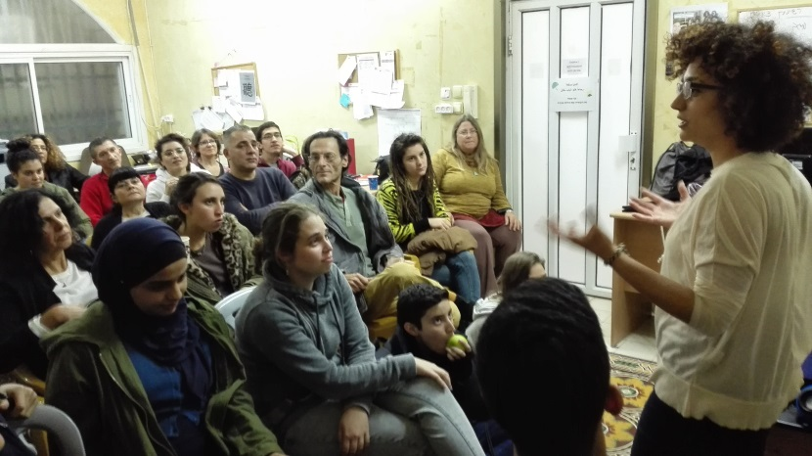
Project design and planning
This year, parents of participants gathered to hear more about the project and organization. January, 2016

During August 2015, Coordinators further developed the project's Theory of Change and wrote a new educational program. Community in Action (CiA) has been running since September 2011, replacing another project following a review process. Learning from the past 4 years was gained through internal evaluation processes and was used to inform the new educational program. The educational program sets out to explain the project's rationale, political and pedagogical context and activities model. It includes seven periods aimed at helping participants through a change process:
- Introduction – the period focuses on participants getting to know themselves, their group members and the program, Sadaka-Reut and its vision, the communities they will volunteer in.
- 'The personal is political' and human rights – in this period participants are encouraged to view themselves as political beings, reflect about their place in society, and learn about human rights.
- Racism and oppression – in this period participants share personal experiences and learn about institutional inequality, discrimination and racism in Israel, and connect between the personal and structural.
- Consciousness-forming mechanisms – the period focuses on mechanism such as the educational system, militarism, media, and asks participants to explore power relations in their society.
- The Israeli-Arab conflict – through this longer period participants engage with personal experiences, different narratives, critical views and non-hegemonic historical information to analyze and reflect on their and their national-group's place in the conflict, with 1948 as a pivotal point. They also get to know the 1967 occupation and the life-reality it still holds.
- Partnership, solutions and paths of action – this concluding period focuses on solutions and ways of action such as bi-national partnership, their challenges and the groups, organisations and movements currently in operation; and help direct participants to continue their engagement with social political activism following their graduation from the program.
- Reflection and summary – personal and group reflections and future plans.
2015-16 program Structure
Unit | Sub-unit | Aim | Activity type | Facilitation
Enrichment | On campus | Gain alternative knowledge and critical thinking in order to become politicized | Lectures, workshops | Project Coordinators, NGO representatives and other activists
 | In the field |  | 4 Day-tours, 2 seminars | Project Coordinators, NGO representatives and other activists
Leadership | Skills training | Gain practical campaigning tools | Workshops | Project Coordinators, external expert if required
 | Life skills | Gain personal empowerment | Lectures, workshops | Project Coordinators, SR staff and external experts
Action Program | Campaign development | Implementation of the knowledge, view and tools gained into practical experience | Team meetings | Project Coordinators and participants
 | Volunteering |  | Teaching, tutoring and mentoring sessions at afterschool clubs | Project Coordinators

Recruitment was in full swing during August and September. Recruitment efforts included marketing the project through contacts – SR’s network of project graduates, local youth groups, facilitators and partner organizations, as well as the local Coordinators’ contacts. 13 Participants started activities in September, and while recruitment continued until the next entry point, in November, three of them left. Six more entered the group in November, of them 3 students who participate only in one activity day per week instead of two.
At the end of the reporting period, the group had a stable with 16 participants: five Palestinians, 10 Jewish and one mixed (with Palestinian and Jewish parents); 10 Female and 5 male.

Project Activities and Analysis
Group activities began in September with the 11 participants accepted (6 Jews and 4 Palestinians and 1 mixed - with Palestinian and Jewish parents; 6 females and 5 males). During the reporting period, 2 participants left the group, while recruitment continued for the next entrance point in November. In November and December 6 participants joined the group, four of them students who join the group activities only one day each week. The group stabilized at 15 participants: 10 Jews, 4 Palestinians and 1 mixed; 10 females and 5 males.
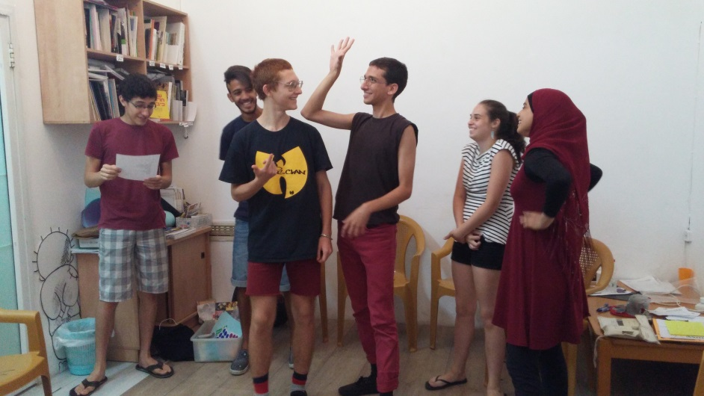
Group activities began at the beginning of September. The first introductory activities period took place in September and aimed to introduce participants to Sadaka-Reut, to other participants in the group, to the program, and to Jaffa. The educational program included a tour of Jaffa introducing the well-known Zionist narrative alongside the unfamiliar Palestinian narrative. Participants were excited to begin their journey with Community in Action and each other. They started off enthusiastically, participating fully in activities, weren't afraid to ask about things they didn't understand or know, and question others, sharing opinions and views, albeit sometime speaking in slogans. Participants began to understand the context in which they operate: they started to get to know Jaffa and the connections between political policies and daily life; they were exposed to the gaps between Palestinians and Jews within Israel and its effects on both groups' place in society.
Preparation for activism began with workshops on photography and theater of the oppressed – both technical, and as a tool for social change. As preparation for their voluntary work, participants learnt about the education system, also with Ruthie Lavie, a local Jewish educator and teacher who has been collaborating with the project for the past 3 years. Following the participants questions, they were already given tools to deal with setting boundaries and racism during their work with the young students.
Participants during their first activity of the year.
The lack of Palestinian participants is felt in the group. The existing Palestinian participants felt as a minority and as if their carrying responsibility of representing Palestine rather than expressing their own feelings and thoughts. Gender roles were also visible at the beginning of activities, with having a more dominant voice.
In October, the second period aimed to encourage participants to view themselves as political beings, reflect about their place in society, and learn about human rights. As part of the educational program, participants learned about the human rights convention, rights of Indigenous peoples and minorities, met with Amnesty International – Israel branch and the Association for Civil Rights in Israel (ACRI), and started to get to know deeper social issues and institutional challenges. On the occasion of the Memorial Day for the Kafr Qasim massacre, the group watched a film about it and discussed it in view of their newfound knowledge. They also had a discussion about children's right and SR's child protection policy, adopted with CAFOD’s support. The group began to come together. Participants talk and share more while listening, respecting and understanding their peers. Participants found issues of common interest, such as human rights, and voice multiple opinions about moral issues in social change struggles, the legitimacy of non-violent or violent struggles and others. Their mutual respect and care for each other made it possible to work together in their first initiative, at a very early stage. It also enables them to share personal feelings and experiences, which brings them closer together and allows deep and meaningful discussion around difficult issues. Jewish participants began to dismantle their prescribed identity, recognizing wrongs committed by Israel in the past and lately: "I feel shame when I see these kinds of acts by my people, who have suffered wrongs in the past." Guy (MJ).
The group had their first experience in campaign development as they worked together on producing a street exhibition of the photos they took in Jaffa, honing messages jointly about their attitudes towards the social gaps in Jaffa. Palestinian participants were supported closely with personal conversations with the Palestinian Coordinator, strengthening their place in the group and encouraged to voice their own thoughts and opinions, even if those might sound radical to Jewish participants.
In November, new participants entered the group and some introductory workshops were held. Three female Palestinian participants joined the group which brought stronger and more diverse Palestinian voices and strengthened the existing Palestinian participants, even though they only attended one day a week. The third period concentrated on racism and oppression. The group were introduced to different minority groups in the society in Israel such as Ethiopian and Mizrahi (with North African and Middle Eastern heritage) Jews, women, and members of the LGBT community. The group went on an overnight seminar in Haifa, where they met with activists from the different groups, shared personal oppression experiences and discussed their identities, the different groups, their connections and struggles in uni-national and bi-national settings. Discussions about gender power relations brought to the fore common experiences of Jewish and Palestinian female participants, who identified with each other, while male participants questioned the definitions of sexual harassment but also talked about the ill effects of patriarchy on men. Participants began their change process, as one said she "starts to put the pieces together and understand why there is inequality" (FJ), while another had "glimpses of how Jews become racist" (FP). Jewish participants were dealing with restructuring their Israeli identity as it is also the identity of the oppressor and occupier, while Palestinian participants were interested in understanding history and forming a Palestinian liberated identity.
Participants went out on two initiatives relating to Jaffa and their place in it. The first was a street photo exhibition that participants began working on in the previous period. Then the group took photos reflecting their budding critical viewpoint on social issues in Jaffa such as housing shortage, gentrification, inequality in education and more. Working together as a group, with each performing different duties, they hung the photos in a main street in Jaffa, together with the questions they were asking themselves. Weary to go out and face the public, they gradually found their place, spoke to people on the street while giving out phot-postcards and dealt with difficult questions ("why don't you show Palestinians throwing stones?", "why here and not in [wealthy] north Tel-Aviv?") as well as received encouragement and good words from the public. It was an exhilarating experience for the group, whose success gave them motivation and challenges made them think of lessons for future initiatives.

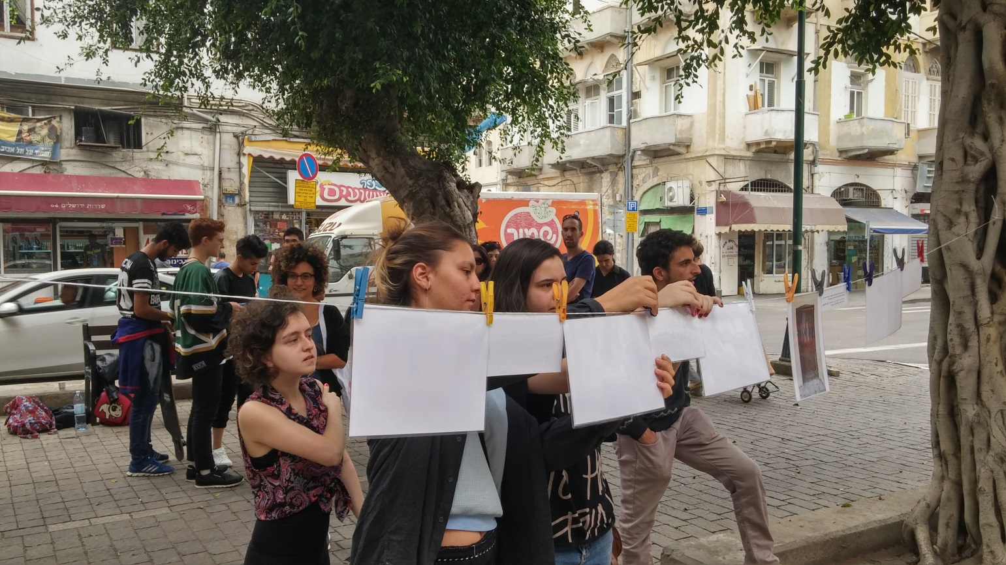
Community in Action participants setting up for the photo exhibit on the streets of Jaffa in November, 2015.

While working with community center partners, the group found out about municipal plans to build a light train connecting Jaffa and Tel-Aviv, and a local campaign calling the municipality for more involvement of residents in the planning process. It was important for them to take part in something organized locally and will affect daily life in Jaffa, and so they invited Michael Ro'ee, a former Tel-Aviv vice-mayor and now a member of the Green Party to give his view. the group decided to take part of the local campaign. They learned more about the issues, went out to the streets to hand out fliers and sign residents on a petition. Following their activities and initiatives in this period, the group continued to strengthen and build, and look at reality around them more critically: "I walk the streets looking around me, noticing what is going on and examining it from a more critical point of view, after the workshops." (FJ).
The fourth period spanned across December and January and concentrated on consciousness-forming mechanisms such as the educational system, militarism and media. Participants learnt through diverse methodologies including films, articles, academic papers, discussions with activists and their own experiences how these mechanism work and what alternatives are there. They met with a representative from Breaking the Silence, a group of former soldiers opposing the occupation, with Druze conscientious objectors of the group Ourfoud workers' rights activist and journalist and co-editor of alternative media blog Local Call and others. Following the suggestion of Guy (MJ), the group decided to go together to support his cousin, the conscientious objector Tair Kaminer. Around international Holocaust remembrance day, the group also discussed the politicization of the holocaust. Later Sapir (FJ) facilitated a workshop about veganism. Participants' knowledge deepened and they became more aware of oppression systems and societal gaps, as well as of their own privileges, especially to so with education. They were beginning to understand the erasure of Palestinian identity and the strengthening of Jewish nationalism. Another aspect the group is regularly approaching, following current events, is the legitimacy of violent struggle. Although the consensus in the group is against it, there are thoughts about its complexity, as by Anat (FJ): "it's contradictory that in the name of the military anything could be done, soldiers beat up civilians all the time, but coming from the other side it's called terror…".
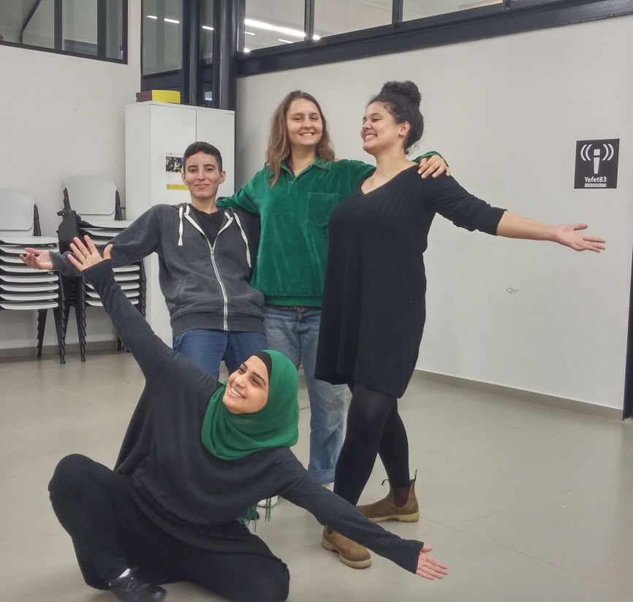
As part of their leadership training, participants learnt how to deal with racist remarks of their students, discussed democratic and dialogic education (Freire), and brought to the group situations in which they were challenged during their volunteering, and together tried tools to mitigate them. They also had a theatre workshop by an actor-activist, which aimed both as presenting them with another tool for social change and to facilitate emotional processing of the process they are going through so far. The workshop helped them start work on the group's next campaign, with participants learning and experiencing campaign building - how to choose an issue, how to focus messaging, how to choose methodology – in facilitated and independent sessions.
Sapir (J), Naya (J), Yaffa (P) and Do'aa (P), sitting, at a theatre workshop, January 2016
At the end of the period a Parents' evening was conducted. Almost all parents came, and heard from SR's Co-Directors about the organization and their personal transformation into activists. The Project Coordinators presented the project and its activities, while Do'aa (FP), Guy (MJ) and Naya (FJ) spoke about their experiences. Later, parents experienced the program themselves as they took part in a workshop where they, and the participants, talked about social political issues that they were and are interested in. Most participants and parents took an active part of the event, and said they enjoyed it.
February opened the fifth period – the conflict – which continued until the end of may. The educational program started with sessions focusing on participants' personal and familial stories, in which they shared stories and emotions. It continued to discuss the collective narratives in uni-national and bi-national settings. First the Palestinian narrative, with informational sessions about the Nakba through varied methodologies, and a presentation on the Jewish narrative, Zionism and Jewish immigration waves pre-1948. Researching and then sharing family stories, which were similar for the Palestinians but different for the Jews, made participants think critically about the one prevalent Zionist narrative that sometimes didn’t fit their stories. They also expressed anger, disappointment and shame about their families’ role in the conflict. When participants were asked to present their national narratives again the Palestinian group had one voice, while in the Jewish group it was important to most participants to explain that they do not identify with the Zionist narrative, although they acknowledged its effects: “I’m influenced by the ideology of the Jewish narrative, even if I object to it, it still affects me” (Gilad, MJ). They were heartened to see different branches of Zionism and Jewish thinking, which gave them some encouragement. While learning about the Nakba and the history of Jaffa, participants had meaningful discussions in which they brought their own knowledge as Jaffa natives or new information their learnt following program activities. Adam (MP), a native Jaffaite referred to the lack of knowledge of Palestinian history: “if the youth of Jaffa had known what was here before they would have walked around with heads held high, instead of being ashamed of who they are”. At this stage, it is easy for Jewish participants to get stuck on feelings of guilt and despair, however with this group participants managed to pass through these feelings with a desire to learn more and disseminate the new information to others. The discussions and the Jewish participants' reactions brought to more trust between the Palestinian and Jews in the group. Palestinian participants no longer weary of the Jews' reactions when they say difficult things. The discourse has become less theoretical and more personal, focused on feelings, creating a sound base for the continuation of the educational plan and the change process participants go through.
The group partook in the annual tour "From Jaffa to Beirut", whose overall goal is to deepen knowledge of the hidden history of the Nakba through personal accounts and to develop a political vision among the participants based on reconciliation and partnership. Bar (FJ) said that the tour "strengthened for me why are going through this process, and why learning about this history is important."
Many of the Jewish participants said that they are beginning to talk about the subject they are learning with friends and family, but that it is causing tension. Even so, most said they were unwilling to remain silent and preferred to have discussions. Throughout the reporting period, Project Coordinators conducted personal conversations with participants by phone and face-to-face, supporting them as they embark on this life changing process.
In the leadership program, the group heard about activism in art from Alina Yakirevitch, a former program graduate who is now an art student and activist.
Campaign development continued, with participants deciding to develop two campaign initiatives. In March, the participants created and implemented a in Jaffa in which they placed themselves in different areas around the city, including the port, the destroyed neighborhood of Ajami, and the Dolfinarium, and shared less known information about the local history of the Nakba and pre-1948 to passersby as it related to that location. While some passersby were upset by the content and its presentation, there were also local Palestinian Jaffaites that thanked them for making the public more aware of their history; some Jewish Israelis also positively engaged and asked questions. In April, the group created another campaign based on sexual assault, in which they put stickers against 'man-spreading' on buses; the stickers read "man, get off my leg." This was to combat the common occurrence of men overtly touching women by spreading out their legs while sitting on public transport. This issue is common in both Jewish and Palestinian societies.
Throughout April, the group also learned about and discussed forms of oppression (that are not directly linked to the conflict) affecting our societies, such as oppression against women, Mizrachim, and the Ethiopian minority in Israel. Connecting back to the conflict itself, the group focused on the 1967 war, Oslo, and the Intifadas and their effects on the societies.
In May, the group entered the sixth period, focusing on partnership, solutions and paths of action. As a part of the educational program, participants went on a political tour to the Jordan Valley in the West bank and met with locals residents in order to learn about their experiences and the oppression they face because of occupation. They also heard from Israelis from the group Ta'ayoush, who work in partnership with residents to end the Israeli occupation and to achieve full civil equality through daily non-violent direct-action. In addition to the political tour, they also began to meet with human rights groups, such as Physician for Human Rights- Israel, Gisha, and Coalition for Women of Peace in order to better what can be done to effect change on these matters.
As part of their leadership program, participants attended the second weekend seminar as a group. The Seminar was held in the Negev/Nakab region and focused on issues facing Bedouins residents, such as unrecognized villages and other aspects of inequality in this region. Participants met with local activist, who organized in previous years against home demolitions. After the seminar, they went on a trip to Lod, which is a mixed city within Israel, but is ethnically separated by area within the city. The city has segregated neighborhoods, and the group visited both 'sides' (Jewish and Palestinian) to understand the differences and the relative poverty of the Palestinian side, as well as the local fight against drugs occurring there.
After spending time in the Jordan Valley, Negev/Nakab, and Lod, where daily life is incredibly difficult for residents, participants were quick to critique the government. One participant said that "The role of the municipality and the state is not care for the residents like they teach us in civics class. The goal is to control civilians, abuse them and to take advantage of them; the only way to change effect change is through a social struggle." The mood of the group became more negative, and so the coordinators decided to step in and to-focus the conversation on action, so that the frustrations they were feeling would not turn into hopelessness. This helped the group transition into planning one last campaign in the community.
June was the last month of activities, and so the participants focused on wrapping up the year, sharing their experiences and discussing how to move forward with their newfound knowledge. Planning their final campaign helped to re-ignite the group, and allowed them to finish the year on a positive note. Therefore, the group decided to arrange, in partnership and under the leadership of the local neighborhood committee, a garbage disposal event with Jabalia's children and youth. The purpose of the act was not just to clean the streets, but to state that we do not except the municipality’s disregard of the Jabalia neighborhood and its population, and to use the cleaning act as a resistance to oppression. A participant said of the action that "we must actively support every struggle for the restoration [of a space or community]."

Community Centers Activities and Students
In October, the group visited the different community centers where they would be volunteering, met with staff there and heard about the roles they would occupy while discussing the role of the educator. Participants were assigned to volunteer in the different community centers based on their requests, their abilities and the centers’ needs, and began their voluntary work with a strong belief of education as a way for social change. They planned their schedule, were punctual and started to make connections with the children. On top of scheduled sessions, they shared with each other and with the Coordinators episodes, challenges and happy events. At this stage, their main challenges focused around educational methodologies and defining the scope of their roles.
As part of their volunteering, participants mapped the needs of the community centres and the children with who they work. As they try to find their roles boundaries, several sessions were dedicated to discussing their experiences and challenges while connecting between their voluntary work and what they learn in the rest of the program. Participants also began to develop personal relationships with students. At this point, participants viewed the volunteering as the most important component of the program, although some found the transition between the educational sessions and the voluntary work difficult. They began to develop personal ties with the children and engaged with their parents while trying to set boundaries. In Lev-Yaffo centre, participants started thinking about hoe to mitigate a conflict between Palestinians and Jewish children.
In November, the project ended its collaboration with the newly partnered Bnei Brith center. Participants and Coordinators felt extremely restricted there, with the center’s educational approach focused on competitiveness between the young students and strict discipline. Volunteers were given negative feedback repeatedly as they would not conform to the center strict approach and competitive educational methodology, while refusing to adhere to the center’s demand of children with different mother-tongues to speak only Hebrew. It was felt that with such a new collaboration, at that point there was no room for the project to try and make a difference from within. However, following the experience there two participants, Ifaf (FP) and Yaffa (FP), suggested to open an Arabic learning group for Palestinian children, who were not allowed to speak their mother-tongue at the community center. As the Arab educational system in Jaffa is lacking resources and considered very poor, many parents send their children to private church schools or to the Jewish educational system – where the teaching languages are French, English or Hebrew. An Arabic learning center opened at SR's office, and the volunteers began working on an educational plan with the help of both Coordinators, one of them an English teacher. The group had four students (one male, three female) throughout the year.
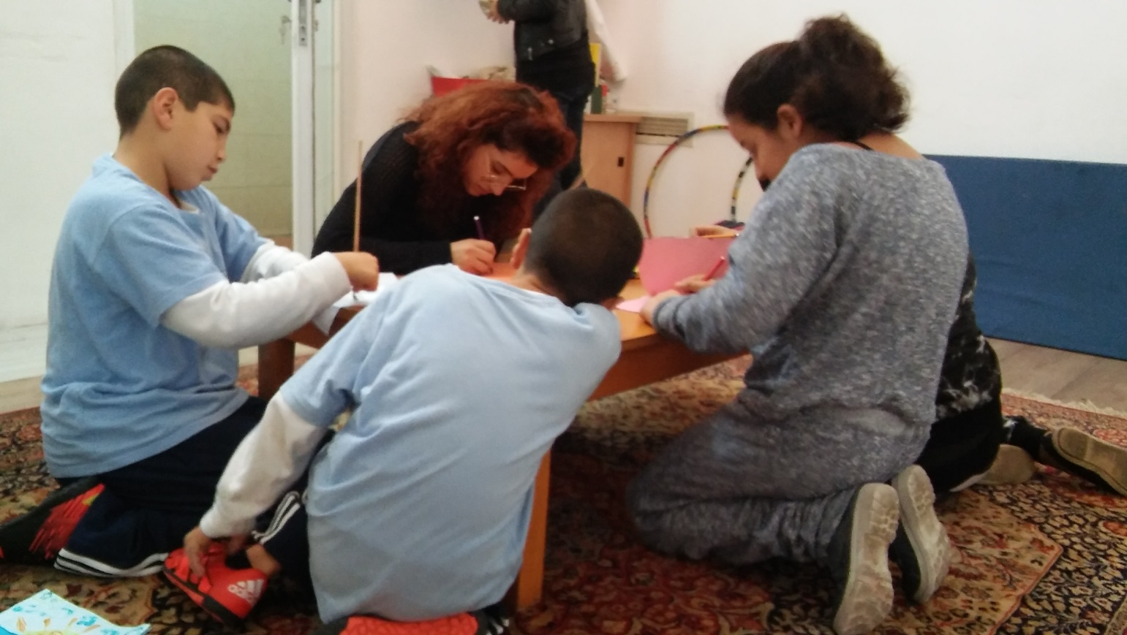
Yaffa (PF) Volunteering with three children at the Arabic Language center held at the Sadaka-Reut office.

At the same time, Key staff members in the community centers were very happy with the volunteers and this year's collaboration with the project. At Lev-Yaffo, participants who found homework help difficult began other types of regular activities with the children such as art workshops and football. Naya (FJ), a dancer who was finding it difficult to help students with homework, established a hip-hop dance group. Participants presented excellent dynamics with the children in an atmosphere of caring friendship. In the Mandel center the group was also dominant, with participants responsible for scheduling the children and lessons, reminding the children to arrive and finding replacements when necessary, including recruiting their Coordinators for support when volunteers from another group were away.
Participants shared issues they face in the community centres, such as the militarisation inputted into the Lev-Yaffo centre by the soldiers working there, the disconnect between Palestinian and Jewish children coming to the centres and gender issues. The partners continue to express their satisfaction of the work done by the volunteers. The children continue to come regularly to the Arabic language centre at SR once a week and enjoy their creative learning sessions. At Lev-Yaffo participants have developed strong individual connection with the children. At Mandel library, Doa'a (FP) and Yuval (MJ, Arabic speaker) opened a writing workshop to the Palestinian children, working on language and creative writing.
The Carnival Day at Lev-Yaffo community center, where some of the participants volunteered, did not happen of varying expectations between us and the management. Additionally, our volunteers did not generally do a group volunteering, but rather individual volunteering, making it difficult to find a time and way to do a concentrated event. The Carnival Day at Mandel was successful, and participant expressed feeling proud that they were able to do something special and out of the ordinary for the kids they are working with.
Throughout the year, participants expressed how meaningful the volunteering was for them. During the Passover break, one participant went to a student's house (with permission) to help him with his homework; others met during the break to plan the Carnival Day, even though they were also on break. In total, the participants volunteered 2468 with 63 Jewish and Palestinian 6-17 year-old students.

EVALUATION
During the reporting period, Community in Action participants have undergone a change process encompassing different aspects such as political awareness, leadership, activism and personal change.
Monitoring and evaluation (M&E) data was collected throughout the reporting period and included pre-test and post-test workshops and ongoing monitoring (attendance sheets, monthly self-reporting and reporting, activity viewing). Two evaluation meetings with project staff (Project Coordinators, M&E Coordinator and Co-Directors) were held during the reporting period –mid-term and end-term evaluations. In these, the accumulated information was analyzed, successes and challenges were reviewed and positive and negative lessons were extracted and learned.
Political awareness, knowledge and perspective
Participants gained political awareness of injustice, discrimination and the Israeli-Palestinian conflict:
"More and more I realize that the most important thing is to recognize the Palestinian history and identity, so that there will be people who will change the situation. Action is also important, even if it's small things, empowerment of youth for example."
They also changed their perceptions about ‘the other’. For most the project was the first meaningful encounter with the other nationality. The introduction to different communities within the Palestinian society has helped both Palestinian and Jewish participants to understand the heterogeneity of the other nationality.
Some, mostly Jews, gained a more critical view on their own communities:
"I went through a process in term of forming my identity and opinions about myself and others."

While all participants now recognized oppressive phenomena, make connections between different injustices and understand their institutional causes:
"When talking about conflict in Armenia and Chechnya, I kept thinking, I see these patterns in our own society."
Leadership and activism
Participants all gained a sense of responsibility to create social change:
"The group makes me more politically involve as I go through an emotional time right now."
"I am really proud of the campaign we did. Our audience was big and vbaried."
"Personally, I feel like I can have an influence [on a situation]."
They learned how to work as a group, and most believe in their ability to influence others. Some reported that taking part in the program strengthened their urge to act. The new gained feeling of responsibility also manifesting itself in future plans: 2-3 Jewish participants are planning to volunteer with Sadaka-Reut’s youth groups in the upcoming activity year. Another four participated in the Sadaka-Reut tours training program over the summer, so that they can lead bi-national tours throughout Jaffa in the coming year.
Volunteering
Participants felt volunteering was a meaningful experience for themselves as well as for the students they volunteered with. Many expressed interest in continuing to volunteer, and most mentioned that volunteering in local schools strengthened their connection to Jaffa and the activism they were doing.
“I felt like I can make difference. I'm sad to be leaving them at the end of this year, and I want to continue volunteering there if I can”.
Personal change
All participants reported that the project gave them dialogue skills such as listening, self-expression and the ability to contain another's opinion even if disagreed with. They acquired the ability to express themselves on political and social issues fluently while speaking to different circles. Some also mentioned an improved self-confidence, and the ability to work within a team. Participants also learnt to think about and understand their different identities.
“The program was very useful; it develops the personality and the person”.

LESSONS LEARNED
Educational program
- Continue the framework of the program for next year, which starts its focus on universal issues (not specific to our conflict), then takes an historical look at our conflict, and lastly focuses on current events.
- Keep the workshops that focus on struggles around the world, particularly identity based conflicts.
- The tours are helpful in gaining more knowledge and understanding, and in the coming year, at least one tour should focus on current events rather than just historical ones.
- In the upcoming year, there should be more of a focus early into the program on the difference between a group and an individual. Many times, the Jews turned to a Palestinian and asked "What do all Palestinians think?" or to the one queer participant and asked "what do all gay people think?" There needs to be a concerted effort on part of the staff to ensure that a participant who falls into any giving category is not representing it, and that the other participants understand that no group has a singular thought or outlook.
- There needs to more time during breaks in which the coordinators remove themselves from the group so that the participants can bond without them being present and so that the coordinators have an opportunity to rest as well.
Volunteerism
- The monthly meetings about volunteer placements, in which participants can discuss successes, hardships, and relationships was very helpful for the participants and should continue next year.
Recruitment
- The recruitment for Palestinian participants should begin already in May. Offering a higher stipend and a scholarship for school may help bring in participants who could otherwise not volunteer with us.

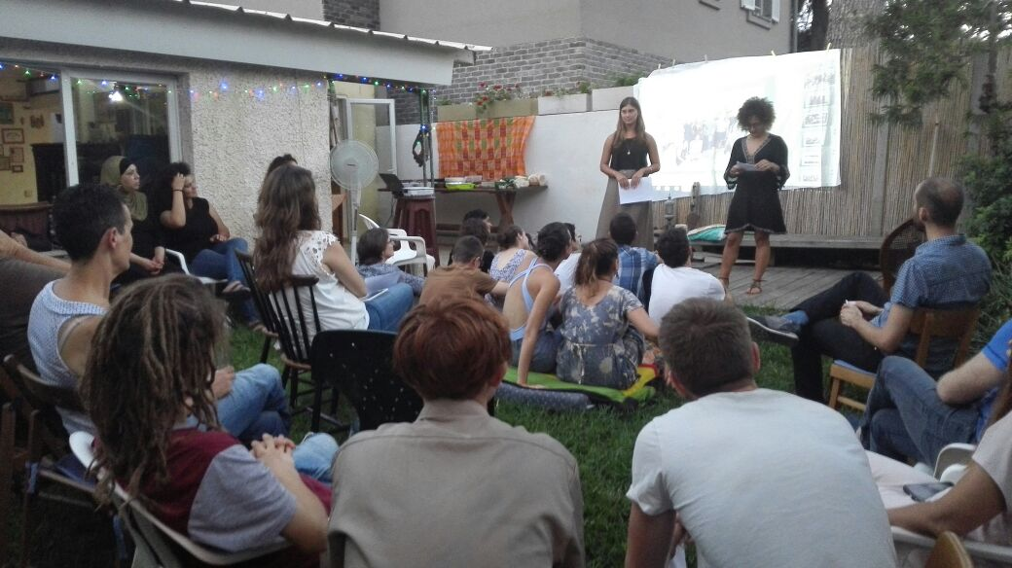
Participants during the year’s closing ceremony, July 2016.

See Adalah’s database of over 50 discriminatory laws. Examples include the 2010 Loyalty amendment [Haaretz.com, Cabinet approves loyalty oath, but only for non-Jewish new citizens, 10 October 2010]; The 2011 Nakba law, [972 Magazine, The new Nakba Law: Privatizing freedom of speech, 23 March 2011]; The 2013 Prawer-Begin bill, a legislation that will serve as the implementing arm of the Prawer-Begin Plan, the government’s overarching policy framework for the Arab Bedouin community. If implemented, the plan would forcibly displace tens of thousands of Arab Bedouin citizens of Israel living in the unrecognized villages in the Naqab (Negev) desert in the south of Israel. It would dispossess the Bedouin of their property and historical rights to the land, destroy the social fabric of their communities, and condemn thousands of families to lives of poverty and chronic unemployment. A public struggle by different Palestinian communities was held. Sadaka-Reut activists in Jaffa, Jews and Palestinian, have joined the ongoing protests and were taking leading roles also in organizing informational events and demonstrations in Jaffa and in the Naqab. The plan has been postponed indefinitely [Adalah, Prawer Plan: Demolition and Eviction of Bedouin Citizens of Israel in the Naqab (Negev)]; The annual renewal of the Citizenship Law correction, an addition to the law which determines that Palestinian non-citizens who marry Israeli citizens will not be eligible for Israeli residency or citizenship [Haaretz.com, Israel extends law restricting unification of citizens with spouses from 'enemy states', 14 April 2013; The Independent, Controversial citizenship law that bans Palestinians married to Israelis from living in Israel extended by the Knesset, 17 June 2015]; The 2014 Governability bill includes some far-reaching structural changes to the political system, in particular the raising of the electoral threshold for Knesset representation to 3.25% (approximately 4 seats), just above the usual votes obtained by the parties representing the Arab minority [Haaretz, Bill to raise Knesset's electoral threshold passes first reading, 31 August 2013; Ynet, http://www.ynetnews.com/articles/0,7340,L-4497586,00.html, 11 March 2014]. It forced the Arab partied to come together for the 2015 elections; The attempts to oppress the hunger strike of the Palestinian prisoners by force-feeding law [Haaretz, World Medical Association to Netanyahu: Reconsider force feeding law, 19 June 2014; Haaretz, Israeli government approves bill to force feed prisoners on hunger strike, 14 June 2015].
Haaretz, After Stormy Debate, Knesset Approves Law Allowing Ouster of Lawmakers, 20 July 2016.
Al-Arakib village has been destroyed regularly by the government since 2010, and completely destructed in 2014. See the Negev Coexistence Forum for Civil Rights, The destruction of the cemetery compound: Al-Arakib, 13 June 2014. Dahamesh is an unrecognized Arab neighbourhood in mixed Lod which legal struggle against house demolitions has beagn over a decade ago. In June new demolition orders were approved by the court. See HaOkets, Dahamesh ruined by bulldozers, 8 July 2014 (Hebrew); Haaretz, 700 Israelis whose home don’t exist, 20 March 2015. Residents of Ikrith and Biram villages in the Galilee were expulsed during the 1948 war, but were granted court approval in the 1950’s to return. They were prevented by the state from doing so since, until in recent years 3rd generation youth have returned, only to be expelled and their structures to be demolished once more in June 2014. The demolitions continue in the OPT and in Palestinian communities within Israel: YnetNews, Hundreds rioting in Tayibe over demolition of illegally built house, 24 January 2016; Haaretz, Israel to Step Up Demolitions of Illegal Structures in Arab Sector, 25 January 2016; YnetNews, Civil Administration demolishes dozens of illegal Palestinian structures, 12 February 2016. See Local Call, Wave of demolition orders and house destructions, 11 June 2014 (Hebrew) and 972 Magazine, Israel's housing policy for Arabs is designed to fail, 2 February 2016 (English).
972 Magazine, High Court okays plan to raze Arab village, build Jewish one in its place, 11 May 2015.
972 Magazine, There is no Green Line when it comes to home Demolitions, 11 May 2015.
The Jerusalem Post, US Jewish groups express concern over Israel's proposed NGO bill, 13 January 2016
Haaretz, Official Fog Shrouds Granting of Tax Deductions to Israeli NGOs, 23 December 2016
AlMonitor, How the Israeli government funds right-wing groups, 20 January 2016

