Anjali’s Clean Drinking Water Enterprise
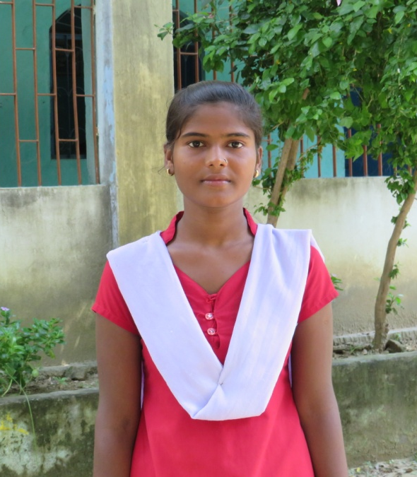
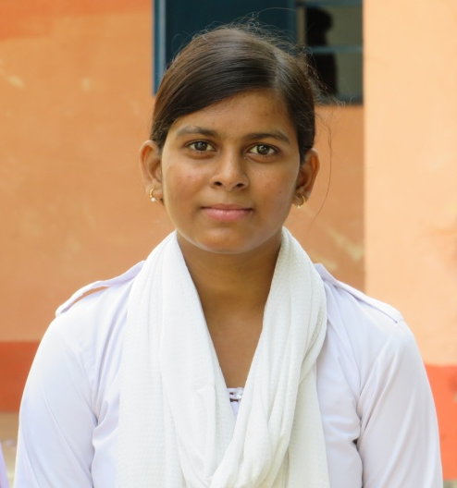
Anjali, age 14, wants to solve a big problem for everyone at her school: drinking water. Yes, it’s true, there is no clean drinking water at her school. She’s pitched her plan and done the research to understand how much it will cost to install a water filter, she’s even met a plumber who will install it. The ingenious part of Anjali’s plan is that it’s a match: she’s gotten all the kids in her school, teachers and principal to agree to match what she’s won in Pitch it to make it happen. Anjali thinks that way everyone will own it, they’ll know what it cost to get clean drinking water and they’ll maintain it. Anjali is looking forward to watching the plumber install it, so she can learn skills to maintain it.

Ankita’s Paper Pencil Home to School Campaign
Ankita, age 13, wants to get everyone back in school, but she knows she can’t do this from school, she has to go house to house. She’s got a plan. With an all-girl team they’ll go to each house where they know there are children who should be going to school and talk to their families to see how they can help children enroll and go to school. Ankita thinks it might be because there’s no easy way to get to school, especially for girls, so she thinks they may all have to walk together, in large groups. Her promotion mechanism is to leave a notepad and pencil, so when the children are ready to go to school, they’ll have what they need to succeed.

Newton’s Laboratory

Deepak, age 14, loves science. He wants to know everything he possibly can about the science of everything. What does sulphur smell like? How does a telescope work? Everything. But Deepak’s school doesn’t have a science lab. Only once a year does his science teacher take him to another school’s science lab. More than anything in the world Deepak would love to have a science lab in his school. He and his friends have made a list of equipment and costs. He tells us 400 children will be impacted, today, now, when the lab opens, and 400 children every year after that.

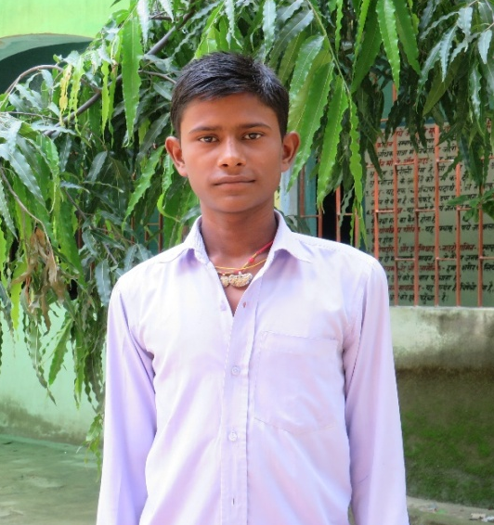
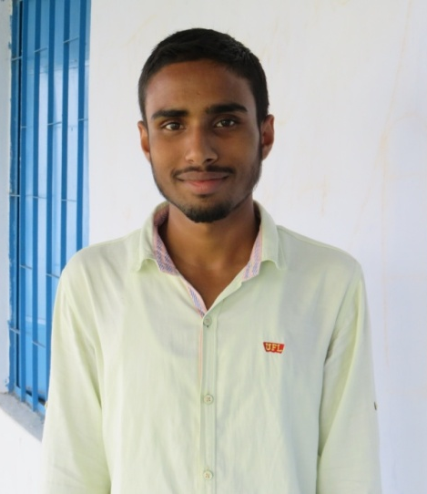
A school without stories
Inzmam, age 14, loves to read but there is no library in his school and that’s a problem when you love to read. He’s got a plan. There’s an unused room in his school that he’s already got permission from the principal to turn into a library. And he’s already asked his friends, teachers and families across the village to donate books. He’s pitching to everyone to fund a little bit for book cases and chairs. He tells us 350 children will be impacted right now, he’s made teams of children to run the library like a bank checking in books and out again. With a wonderful big smile he asks if we’ll match his investment. Yes, we will.

