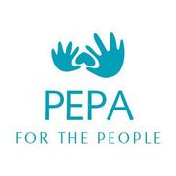

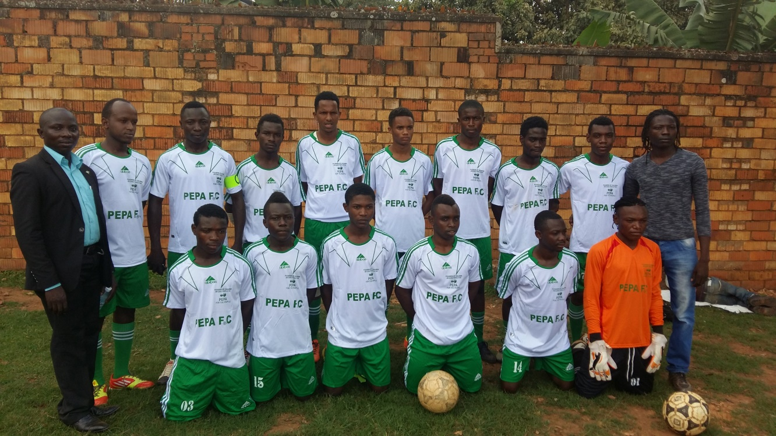
PEPA/ORGANIZATION (PLEADERS OF CHILDREN AND ELDERLY PEOPLE AT RISK)
DR.Congo AND uganda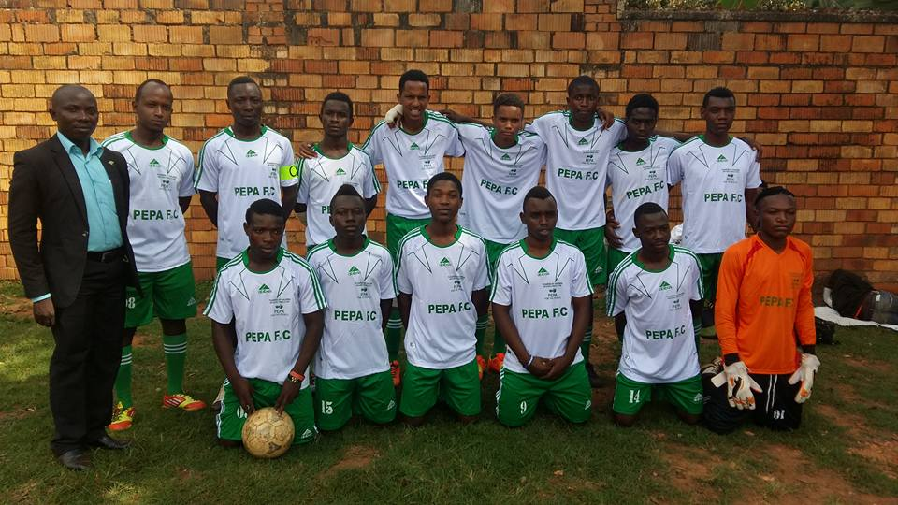
Welcome to PEPA FC/ Soccer teams
- PEPA is a Nonprofit Organization working at community level to respond to the need of the most vulnerable people in Africa, we work to promote and save the human dignity, for this PEPA/Organization initiated two soccer teams to empower refugees and local disadvantaged young people, youth within the communities by giving them hope to become champions in the Soccer and various areas in the world.
- I am happy to share with you the development of our Soccer team of refugees in Uganda, and the Democratic Republic of Congo with the aim of empowering young people, refugees from different countries in Africa; We initiated this teams in March 2016.
It is a brave and champion team due to its multicultural background, the team is made of refugees from 8 countries and Uganda makes the 9th nationality.
Many young people picked interest in the team in the way to be entertained in the football instead of surrounding in streets developing risky behaviors.
So far we have refugees from Congo DR, Burundi, Rwanda, Somalia, Sudan, Ugandan, Kenyans and the coach from Nigeria.
.
Why we need you?
- We are calling for you to join and support in raising the funds to enables us to sustain our refugee players, disadvantaged in assisting their basic needs such as food, clothing, buying soccer equipment, and supporting in emergency medical aid and getting some support when practicing with various football clubs.
How we got there
- We started this team in march 2016 in Kampala and the one in Congo, Goma in June 2016, the most interesting and challenging is when bringing youth who fled their home countries to seek for asylum and when not speaking the same language, it was not an easy task, but it turned to a success to bring together a young generation of youth from 6 countries together to share and decide on their destiny to become the global champions, it is surely exciting.
- Our teams are experiencing challenges, first of all raising the full equipment for both Congo and Uganda team, assisting their basic needs in terms of food, clothing, accommodation, medical assistance.
Recognition and Acknowledgement
- We first of all thank the Governments of DR.Congo, Uganda and the United States for allowing PEPA/Organization to empower the Young generation in sports, much thanks to the existing families of refugees that are encouraging them to join the team and to the PEPA staff for their devotion and determination to have and make strong the PEPA. FC team and to you who is reading and watching us.
- 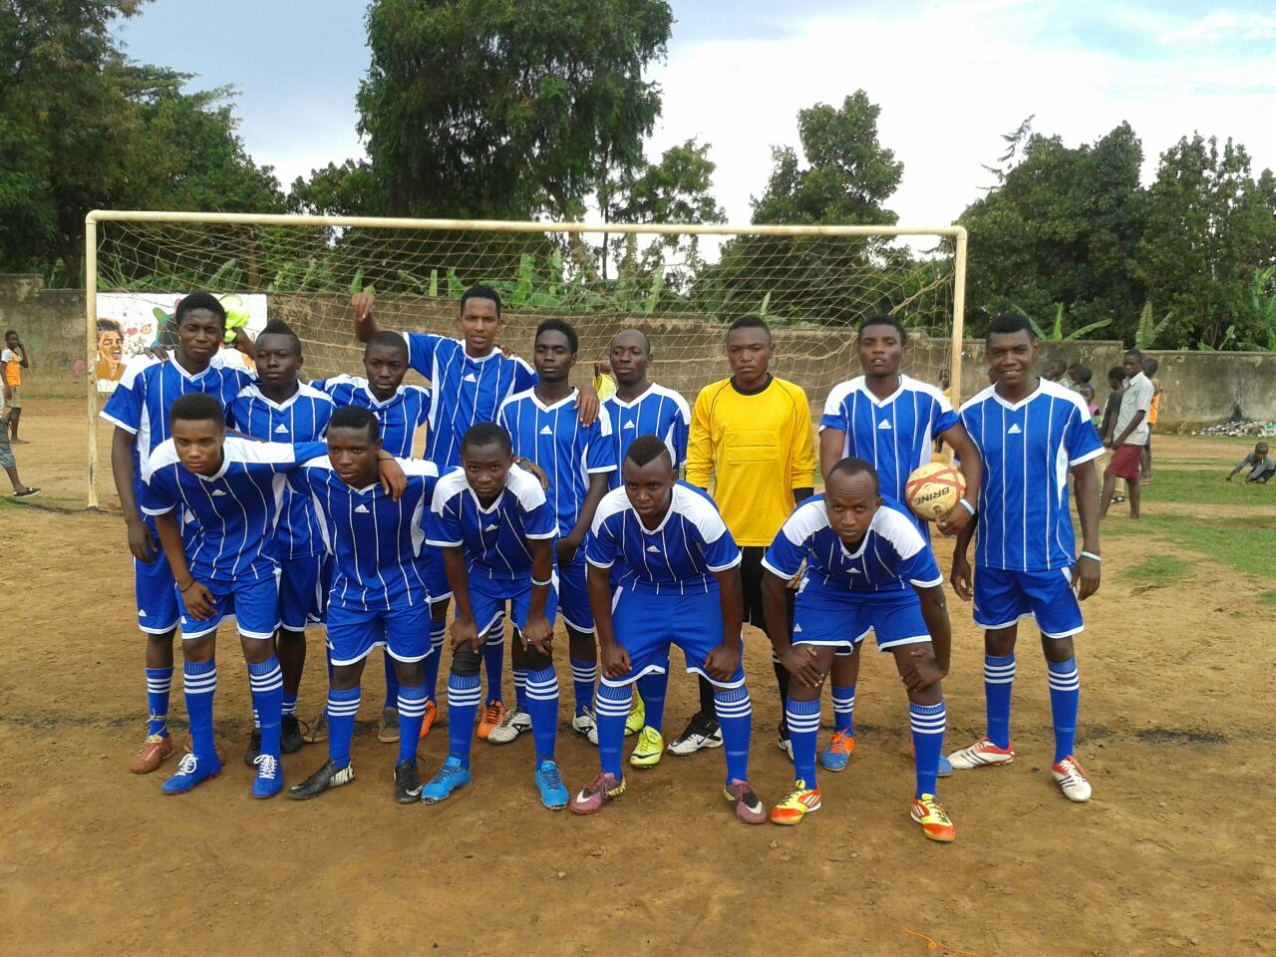
Join My Team and Spread the Word!
- Our thanks go to everyone for accepting and giving the opportunity to raise the voice for these community young teams and calling for support and involvement to our young team, for we believe together we can change the world and bring hope to the hopeless.
- Thank you to everyone reading us and accepting to support and joining PEPA/Organization to make strong this team.
- Follow our Soccer team facebook page at: https://www.facebook.com/PEPAFC1/
- Watch the player’s interviews: https://www.youtube.com/watch?v=APtCaSgFDUQ
- sports@pepahumandignity.org
How to join us:
You can join us by sending an email to: info.pepaorg@gmail.com, info@pepahumandignity.org
If you are in the United States, We are located at the address 538, Grace Street, Excelsior, Minnesota 55331, United States, or send an email to our US Chairperson Ms. Jennifer Valentine at: jennifervalentine@pepahumandignity.org or rebeccaJASPER@pepahumandignity.org
In case you are in Europe, you can mail our representation, Freibrechts 3, 87509 Immenstadt , Germany or email to zagabe@pepahumandignity.org
We thank you for your collaboration and support
PEPA/Organization
Communication Team
08 Walikale Avenue, Himbi2, Musee Road, Goma
DR.Congo.
Tel: +243 993100892
info@pepahumandignity.org

