MAP INTERNACIONAL ECUADOR - MAPEC

Promoting Comprehensive Early Childhood Development (CECD)
In Communities in Napo Province, Ecuador

Project Location: Province of Napo, Ecuador
Number of Beneficiaries: 2,400
Project Duration: 3 years
Total Budget: USD 286,950

- Background
MAP International has been working in Ecuador since 1975 as a nonprofit, non-governmental organization (NGO), inspired in Christian values through the creation of MAP Internacional Ecuador-MAPEC, with a national office in Quito and projects in different regions of the country. MAPEC is an affiliate of MAP International, with headquarters in Brunswick, Georgia in the United States of America.

During these 35 years of work and experience in community health projects and programs in Ecuador, MAPEC has developed the capacity to quickly respond to emergencies, in coordination with the Ministry of Health, local governments, cooperation/development agencies, private companies, communities, and diverse local and national stakeholders.

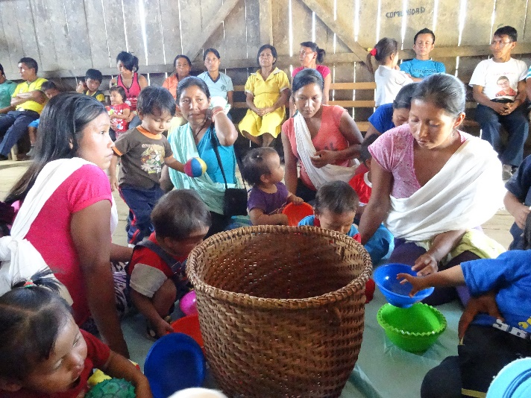
MAPEC has developed participatory methodologies to support community development processes in the following areas: community health, cholera, water, sanitation and hygiene, sexual integrity, children´s rights, and currently on early childhood development.

MAPEC has a team of trained professionals with ample experience for strengthening communities´ capacity to rebuild, through good sanitation and hygiene practices, as well as other actions, with a view to reducing the risk of the most common diseases and with the goal of reconstructing healthy community life.

This project will work with five communities in the Napo Province of Ecuador, located in the Amazon rainforest. These impoverished rural communities face serious health and development issues. With average household incomes at around USD 200-300 per month, economic conditions are difficult. These Kichwa and Spanish-speaking communities rely mainly on agriculture and manual labor for income; men tend to seek work in the city as masons or laborers, while women take responsibility for crops at home, and taking care of their children. Most families have between 5 and 7 children, and women often marry at a very young age, becoming mothers by the age of 15 or 16.
In general, this lack of knowledge, together with inadequate access to health care, has had long-term consequences on the health and development of children in the communities of the Napo region. As a result, there is an urgent need to strengthen the comprehensive project of maternal and child health that MAP began two years ago, with innovative community-focused activities in the following areas:

- Training parents in Comprehensive Early Childhood Development(CECD);
- Training parents on the priority of changing their understanding of the central role that their infants can play, as well as the overall dynamics of families and communities. By prioritizing investment in the comprehensive development of infants, it is possible to change histories of adversity in families and communities by working with parents in accompanying their infants with a new focus on cognitive, physical, and emotional nurturing, together with self-agency, based on respect for the autonomy and freedom of infants;
- Parents and mothers and other family members learn to support their infants in developing brain architecture, thus ensuring full lives, while contributing to the upbringing of future generations who are more productive and autonomous;
- Follow-up mentoring and guidance visits to parents on the promotion of comprehensive health and nutrition practices, by focusing on the priority of investing in the early years of of their infants;
- Training parents in Comprehensive Early Childhood Development, using key strategies based on educational processes of family togetherness, on motor-sensory development, and in developing infants´ social skills;
- Follow-up visits to families with pregnant women based on a comprehensive early childhood development approach, supporting parents who are involved in a comprehensive preparation to accompany the stages of pregnancy, childbirth and postpartum;
- Promote access to comprehensive prenatal and postnatal care.
- Promote access to comprehensive and professional care in a health center, both before and after childbirth;
- Emotional support to mothers throughout their pregnancy and postpartum period;
- Training health promoters, to accompany families in the development of comprehensive health focused on early childhood;
- Annual meetings with families, communities and health workers to measure the impact and evaluate the progress of the project.

- Justification
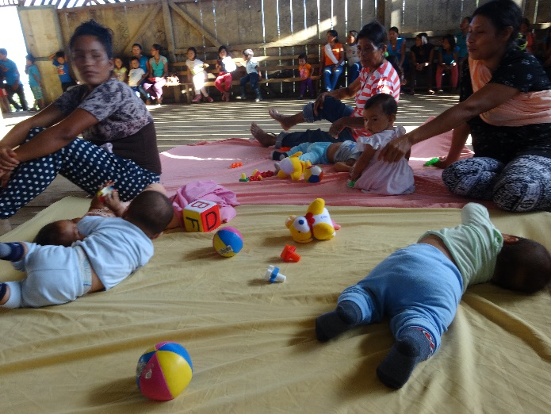
Since 2010 MAPEC has been working together with the communities of Napo Province to identify and address their comprehensive health needs. Over the past year, MAP has focused on the urgent need for communities to address the needs of maternal and child health within a comprehensive strategy. Through community health education and proper hygiene, MAP has been implementing the latest scientific research on brain development for a healthy early childhood, guided by the need to go beyond maternal and child health care based solely on a clinical approach. MAPEC favors a holistic approach that integrates best practices in comprehensive early childhood development with maternal and child health care needs. Families in the communities of Napo Province have begun using these strategies, and the significant impact that is already producing tangible benefits in the health of mothers and infants.

Access to maternal and child health care with a focus on equity, women´s rights, and in promoting infants as active members of the community who participate in a full life, enjoying optimal conditions for their welfare, is a complex issue in these five communities in Napo Province, as there is still very limited importance assigned to parents´ involvement in the conception of children, pregnancy, childbirth and postpartum. Maternal-infant health systems provide a basic service, which urgently required to be complemented by awareness-raising processes in parents about the paternal and maternal sense of conceiving children who can play a central role in families living in harmony and respect for all its members, prioritizing infants.

Parents also lack the knowledge and skills for creating conditions for the early development of children. Most communities in Ecuador experience high rates of domestic violence and child abuse, and most infants and children grow up in families and communities with chronic stress. Recent research has shown that this toxic stress in early childhood can damage the stress response systems of an infant´s developing brain and body, resulting in high economic and emotional costs for individuals, families and society. The vast majority of members of families and communities do not consider infants to be agents of transformative change.

- Objective
Promoting Comprehensive Early Childhood Development (CECD) in 5 communities in Napo Province, contributing to the growth of new generations with strengthened capacities in cognitive, physical, social and emotional nurturing, and self agency. Infants who contribute to the development of more productive, autonomous communities, thus contributing to the overall health of all members of the community.

- Participating Population
The project will be implemented in 5 of the most seriously affected and underserved rural communities in the Province of Napo. The estimated number of families per community is 60; taking into account that in rural areas families are made up of between five to seven members, the project will work with about 2,400 people.

- Outcomes
Through a comprehensive and integrated approach, this project can result in long-term changes with a great impact on the health of women and children in Napo Province, especially in the critical area of healthy brain development in infants.

Support in creating community spaces to promote the development of activities that facilitate learning, with a focus on early childhood
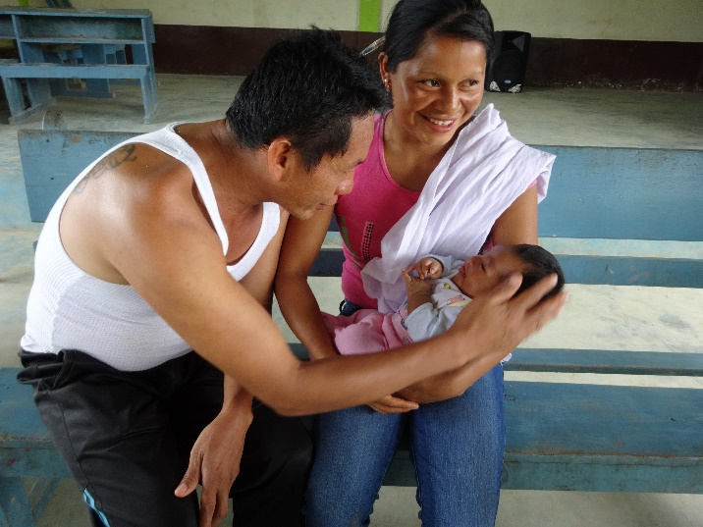
- Strengthen the knowledge and skills of health promoters in the development of maternal and child health, with a focus on the determinants of early childhood;
- Adaptation of early childhood materials to the context of Kichwa communities;
- Development of educational activities with the participation of parents, infants and other family members (grandparents, uncles, etc., together with other family members, taking into account the cultural and social context of their communities.

Fostering healthy environments for early childhood development
- Parents become more aware about creating improved family conditions that lead to healthy brain development in early childhood through: (1) cognitive nurturing, (2) physical nurturing (3) social nurturing, (4) self-agency (5) safe, enriching environments and (6) improvement in family relationships;
- Families practice healthy strategies for conflict resolution and the prevention of violence;
- Parents develop skills to communicate with their infants and to respond effectively to four types of needs: strengthening communication connections with their infants, their curiosity, their physical well-being and autonomy, and self-agency. Parents learn to create home environments that lead to healthy development of infants;
- Communities create environments that are favorable for the development of a healthy early childhood.

- Outputs

- Health workers and families trained in Comprehensive Early Childhood Development (CECD);
- Technical resources and content delivered to parents and health promoters;
- Coordination between the health system, MAP and families to improve medical check-ups, examining and measuring weight, size and nutrition in infants.

- Methodologies
MAP International Ecuador - MAPEC has developed relationships of respect and trust with impoverished and vulnerable communities, and has built a cordial inter-institutional relationship with Ministry of Health officials, based on accountability and efficiency. MAPEC serves as a facilitator for the coordination of activities that promote the welfare of these communities.

Throughout its years of work and presence in the most vulnerable communities of the country, MAPEC has developed extensive experience in community strategies and methodologies focused on health promotion, supporting communities to build their capacity to improve living conditions within a holistic approach. This allows empowered communities to take appropriate and timely measures to promote their own development and improve the living conditions of families.

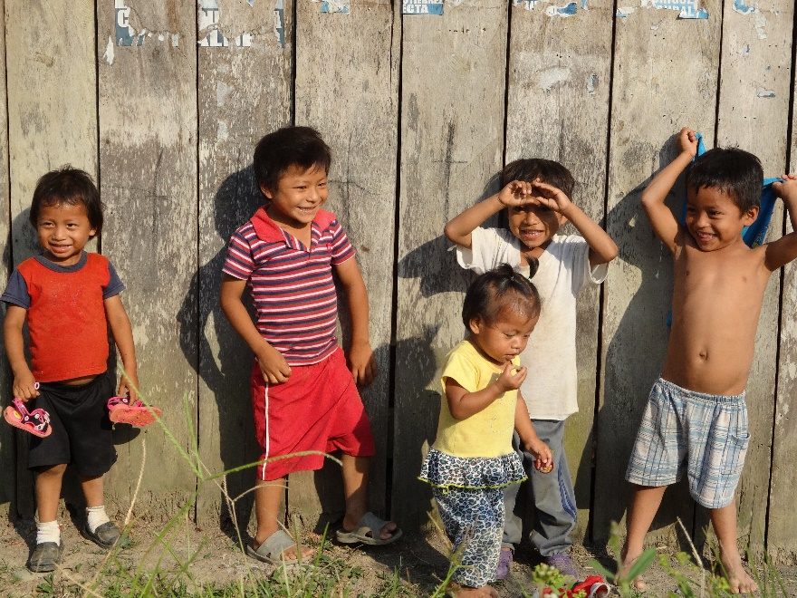
Promoting comprehensive health care, with a focus on Early Childhood, has allowed the MAPEC team to strengthen their capacities to work with families in rural and marginal urban communities, introducing new approaches to the role of infants in the development of their families and communities. The change in the understanding of how to best accompany and support the development of infants, based on respect for them as human beings who are not mere recipients of services, but rather are active participants, can only work if adults can open their minds to give them a chance to contribute in building new relationships within families and communities. This new generation will be much more self-critical, analytical, autonomous, free, secure, and productive, within the diversity of different socio- cultural contexts.

The methodology for working with families within an early childhood approach has allowed the MAPEC team to develop educational strategies based on local contexts, enabling adults to open themselves up way to receive affection, tenderness and mutual respect from infants as family members, compensating them though an optimal development of infants, strengthening cognitive, social and emotional development, self-agency, healthy spaces and family environments in harmonious relations. This results in infants with the freedom to decide for themselves step by step, confident in the support of adults based on trust, solidarity and respect.

The methodology focused on early childhood, has contributed to families and communities, and enhanced healthy relationships, with families realizing that fathers and mothers should generate healthy conditions to promote holistic lives of their infants. These changes have determined that other members of the family also enjoy healthier environments. Parents have begun to realize that if they promote the motor-sensory development of infants, and generate physical changes and improvements in their homes so that babies can move about freely, and that this contributes significantly to the cognitive development of their children. Parents will become convinced that these new contributions enrich the development of the architecture of the brain, which can influence the development of analytical skills of these infants, who will grow up to be the men and women who will be the new agents of change in their families and communities.

