UPDATE
WOMEN VOCATIONAL TRAINING PROGRAM DISTRICT DIAMER PAKISTAN
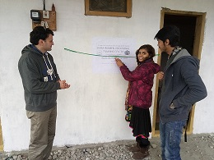
Summary
KIDF started its Vocational Training Program for the Women in District Diamer with donation of 738 US Dollars received in Global Giving platefarm in January 2017 by our worthy donor. We expect to enhance the scope of our work with your assistance in future.Here is an update about the project.
Introduction
KIDF started its pilot project of Women Economic empowerment through providing vocational trainings and connecting them to the local market a year ago in the remote villages of Gilgit-Baltistan with generous support from Australian Embassy in Pakistan. The Project helped 400 village women in district gilgit in making them skillful in cloth stitching, embriodery, netting and connecting them with market to sell their products locally.
After huge success of the first project, KIDF ventured into the more hinter lands of Gilgit-Baltistan with help from local organizations and peer-to-peer supporters taking up the cause of Women Economic Empowerment. District Diamer is one of such area with a conservative society, low literacy rates espacially in female education and tribal culture which hinders women empowerment. According to a survey, 52% children in District Diamer are out of school with 36% girls and 16% boys.(http://www.dardistantimes.com/gilgit-baltistan/news/2016/comparative-analysis-status-education-gilgit-baltistan-pakistan). NGO's face alot of risk while working in the area as the religious clerics have a strong hold on the society and issues related to women education and empowerment are labelled un-islamic and un-ethical.
In such a backdrop, KIDF started its Women Vocational Training Centers in two villages of District Diamer, namely Goharabad and Gais. The centers are equipped with sewing machines, material and staff for training. It has two trainers and a security staff in each center. Free of cost training is being provided to 20 Women in each training session in a cycle of 16 weeks. After the Completion of Training, The top five position holders are awarded with sewing machines to start their own home based business of sewing cloths in their community. A local Organization (Central Asia Institute Gilgit) is collaborating with us in supporting salaries of the staff and some of our volunteers from community and abroad also work in the project.
The Women Vocational Training Center in Goharabad Village has been named to our peer donor which was inaugurated by one of our volunteer staff member. The center will train 30 Women in Vocational skills of Cloth sewing, embriodery and netting in sixteen weeks in first phase. After induction of new machinery, the strength of students will be raised to 60 in the second batch. We could not take pictures of the students due to cultural ristrictions, however, they were greatful to the donors who cared for their situation while siting thousands of miles away in a free World.
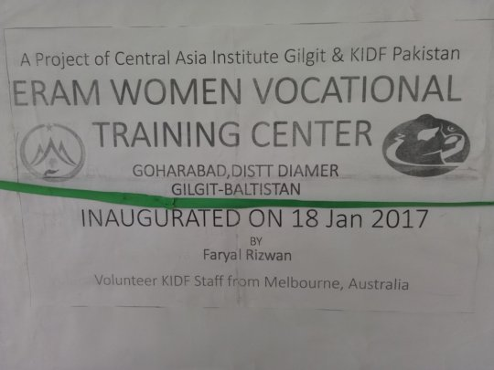
Dedicated to our first drop of rain on GG platform
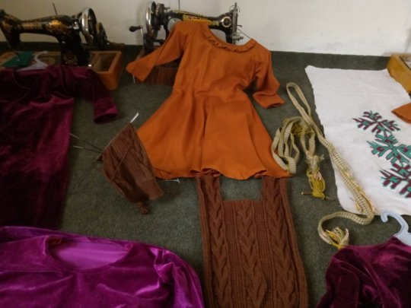
Few samples of works which students prepared
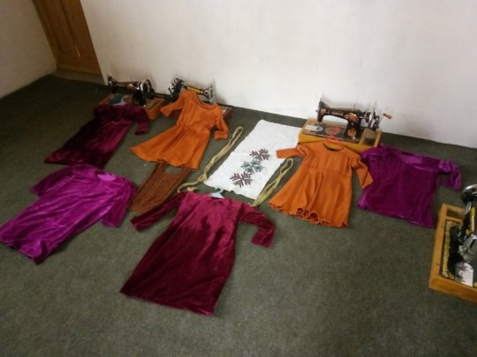
Trainee's work samples

