“I’m determined my great grandchildren will be able to go to Africa and find wild great apes.”

Dr Jane Goodall, DBE

You can help us achieve this vision…

About Chimpanzees
Only about 150,000 chimpanzees remain in the wild today, whereas one to two million lived in 1900. The main threats to their survival is the expansion of agricultural and living spaces for the human population, industrial logging, poaching for bush meat and the live capture of young chimpanzees for the pet trade.

The Jane Goodall Institute
We work to prevent the extinction of chimpanzees through conservation, research and education.

How we do this:

Conservation:
We work with local communities to facilitate sustainable agriculture and efficient use of resources, to avoid the need to encroach upon chimpanzee habitat.

Research:
We conduct non-invasive research to find out more about our closest relatives and other primates.

Education:
We work with local communities to ensure the well-being of chimpanzees, other primates and animal welfare activities in general.

Meet Vichika

Rescued in 2001, Vichika was taken to Tchimpounga in 2001 when she was found. Like most chimpanzees who are brought to the Sanctuary, Vichika probably witnessed her mother being killed. Then she was taken by poachers who tried to sell her on the black market. But Vichika was one of the lucky orphans – authorities spotted her and brought her to the safety of Tchimpounga. As sometimes happens, Vichika did not fit in well with the older chimpanzees in her group. Staff members decided to place her in an infant group, where she thrives as a “mother” to the younger ones.

The bush meant trade is illegal, unsustainable and cruel. Surprisingly, it is fuelled not by starving people but by greed. It is tightly linked to the logging industry - hunters follow the timber companies when they move into new patches of forest.

The wood is exported and the bushmeat is sent to city markets, where it is regarded as a luxury and fetches high prices. Because of the high demand, the bushmeat trade is considered perhaps the greatest threat to Africa's primates and other large animals.

Sadly there is also a demand for infant chimps, who can be sold on the black market. In Africa, chimps are used as gimmicks to attract customers to businesses, bought and sold as pets, or exported to wealthier countries for private zoos or family pets. Every year about 1,000 infant chimps are exported from Africa for the pet trade, entertainment industry and the medical testing trade.

Pioneering
Dr Goodall’s pioneering study of wild chimpanzees, which began nearly 50 years ago in Tanzania, revolutionised how we think about both chimpanzees and ourselves. Her research in Africa continues to this day and is the longest consecutive field study ever undertaken of any group of animals in the wild. The Jane Goodall Institute (JGI) was established to build on and develop her conservation work.

We work in four major areas in Africa:
Tanzania, Democratic Republic of the Congo (DRC), Uganda and Republic of Congo. Programmes range from chimpanzee behavioural research, working with local communities on conservation projects and sanctuaries for rescued chimpanzees. The main programmes are listed below:

Tchimpounga Sanctuary, Republic of Congo (one of our keepers with a pair of orphaned chimpanzees is shown below)
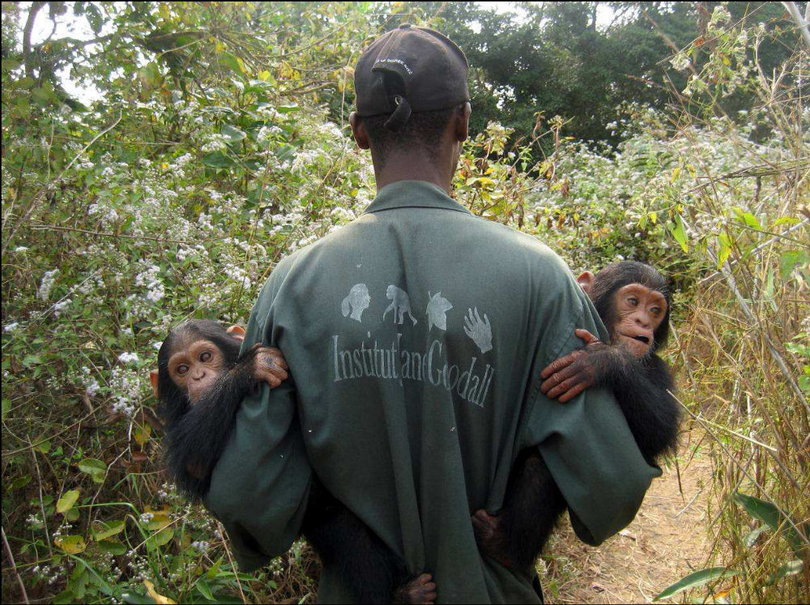
Tchimpounga is the largest chimpanzee Sanctuary on the African continent and is in the Kouilou region. Without the sanctuary, orphaned chimpanzees would be sold into the pet trade after their mothers have been brutally killed, or are smuggled abroad to be used in circuses. In most cases, the Congolese authorities deliver the chimpanzees to

the Sanctuary after confiscating them
from hunters trying to sell the young chimps into the pet or entertainment trades.

The Sanctuary is currently housing 140 orphaned chimpanzees – a number that is rapidly growing. Over the last two years, we have had 40 chimpanzees brought to our Sanctuary, and in the past year alone, we have seen more than a 20 percent increase in the chimpanzee population at the Sanctuary.

As with all JGI sanctuaries, Tchimpounga serves not only the chimpanzees which live there but also:
- Creates a centre for educating and engaging young people and communities in their environment;
- Works for the preservation of primate habitat and the protection of remaining chimpanzee populations and other threatened species in the wild;
- Brings tangible benefits to the local communities, by employing local staff and buying fruit and vegetables to feed the chimpanzees from the local markets
- Locates places where Sanctuary chimpanzees can be returned to the wild

The centre is being upgraded and expanded and is a major resource and focus for the fight against the bush meat trade.

Our plans include three rehabilitation sites on the Kouilou River islands. The islands offer a major advantage – a controlled and optimally secure environment which is ideal for chimpanzees and local communities alike. JGI is also working to re-introduce chimpanzees from the Sanctuary to the wild. The islands can better accommodate some of the older chimpanzees who will never be able to join a full release programme, whilst providing a pre-release space for some of the younger chimpanzees.

We have also developed a Community Centred Conservation Programme at Tchimpounga, based on the same principles as our hugely successful programme in Tanzania.

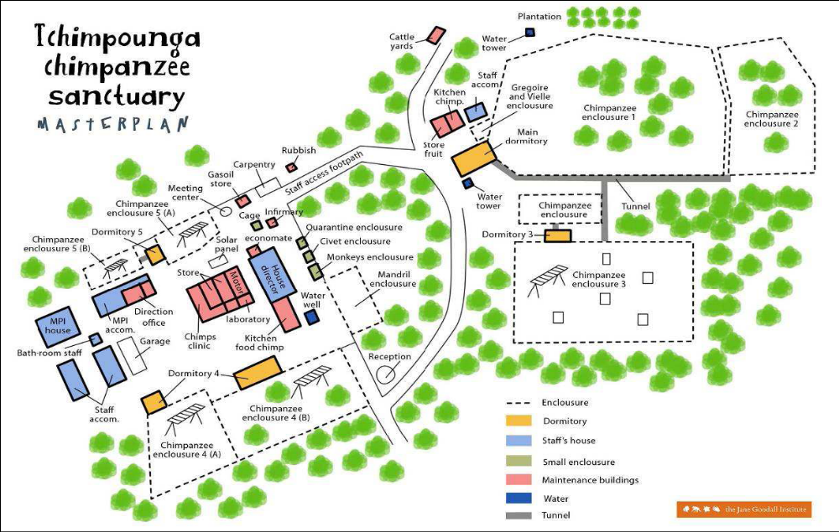

To ensure that these chimpanzees are well provided for the following needs to be met include:
- Salaries for all the staff who provide around the clock care and support to all the chimpanzees at Tchimpounga.
- Operational costs including equipment (computer and solar panel batteries), vehicle and solar panel maintenance, and internet connection.
- Adequate veterinary care for the chimps and includes medicine, laboratory equipment (microscopes), laboratory procedures (x-rays) and maintenance and improvements to the current housing facility.
- feeding the chimps and provide uniforms for sanctuary staff = US $1460 p/chimp
- A 22kva generator to ensure that the sanctuary remains operational.

For more information, please contact:

The Jane Goodall Institute

REGISTERED CHARITY NO. 802133 (England and Wales) SCO38057 (Scotland)

ADDRESS:
Suite 9 Orchard House, 51-67 Commercial Road, Southampton, Hampshire SO15 1GG

Contact Name:
Denise Bailey, Executive Director, Development

Tel: + 44 (0)7721 580604
Email:
denise@janegoodall.org.uk

Website Address:
www.janegoodall.org.uk

Thank you for considering our application for funding



