**Civil Uplifting and Renovation (CURE)**

**Deep Clean Project (DCP)**

CIVIL HOSPITAL, Karachi Uplifting and Cleaning

S.O.C.H, a non-profit REGISTERED NGO, is the brain child of students of Dow Medical College, Karachi. It aims to support and help patients attending Civil Hospital Karachi.​Civil Hospital, one of the most important public hospitals of a metropolis, Karachi is seen to be deprived of proper infrastructure, sanitation, waste management and proper cleanliness.​ Owing to the current hygiene conditions S.O.C.H. takes an initiative to spread public awareness regarding infection control. It also focuses on hospital’s uplifting and construction projects. National Health Forum is helping SOCH from its inception and promote medical students participation in volunteer work.

Can we imagine eating in the same plate as our pet? Can we think of lying on the bed utilized by patients with contagious diseases, without getting it cleaned properly? On the other hand would we be able to envision getting admitted in a facility as Civil Hospital Karachi? Clearly No. We detract all measures to keep ourselves from getting sick and if we get diseased our need is a private healing center. That is on account that this hospital is not up to our standards. yes, There is a critical need of uplifting the framework and maintenance of cleanliness of this hospital, SOCH began with this thought and our task CURE (Civil Uplifting and Renovation) began in 2013 with OPD square's painting and later proceeded as we got supported by National Health Forum (NHF) and Dr. Nasar Qureshi and we adopted wards for cleaning, this was the beginning of our 'deep clean project' and as of late with the assistance of our generous donors from NHF we were successfully executing it in 6 wards of CHK.

A team of 6 professional janitors equipped with state of the art equipment were hired to clean the ward thoroughly. The team was well equipped with mechanical scrubbers and potent chemicals for this purpose. This team was responsible for once weekly cleaning of 6 wards which includes everything from roof to floor and bed to bed. With the positive impact of Deep Clean Project, currently twice weekly cleaning is being done. For execution of his program in upcoming months funds will be needed for which we need financial assistance.

Current Annual Budget:

The Janitorial Salaries FULL TIME AND PART TIME

Anthony (Janitorial Head)

The equipment cost approximately Rs.12, 000/- per month which becomes Rs.170, 000 per year.

Work Plan:

The Janitors have been arranged by a private contractor under the order of director of the operations society.

The janitors follow the following time table:

* 9am to 12:30pm: All 6 janitors to be cleaning the ward assigned to them on the respective day
* 12:30pm to 1:30pm: LUNCH BREAK/ NAMAZ TIME
* 1:30pm to 5:00pm: 4 of the 6 janitors leave, 2 for each Paeds Unit 1 & 2 DAILY and remain there, whereas the other 2 shall go back to the same ward assigned for the day and continue with the Deep Clean

As for the Chemicals & plastic bags, we have our wholesale supplier at Joriya Bazar, from where we get our chemicals on a monthly basis.

You keep a strict check to make sure:

* That all janitors arrive and depart on time
* They wear the SOCH vests already provided to them
* Their work is efficient enough
* They empty the dustbins when they leave and place new plastic bags

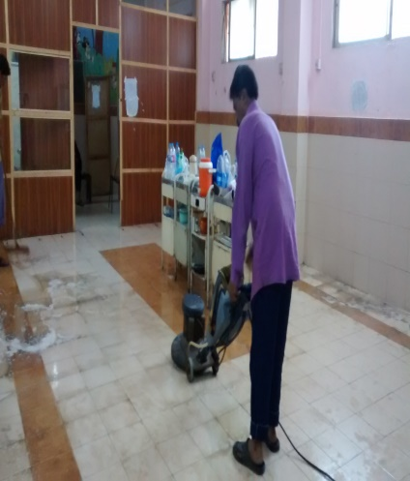 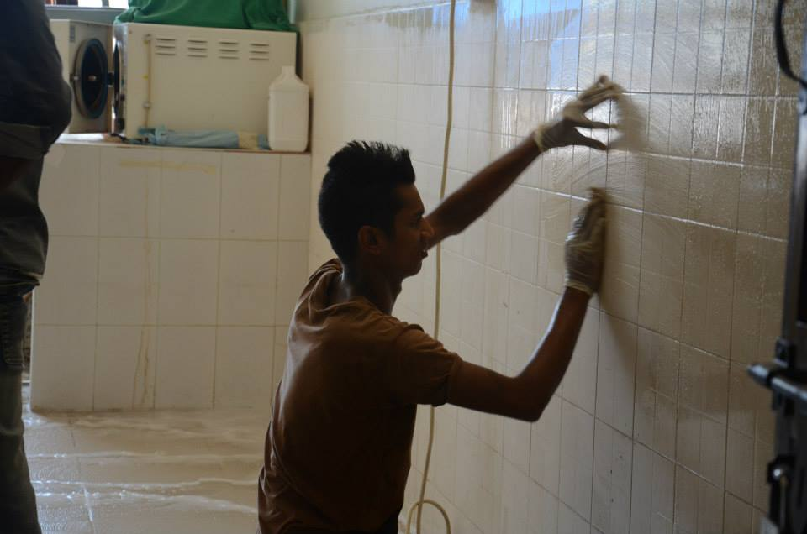

One of our janitor scrubbing the floor of Another one while cleaning the walls.

assigned ward.

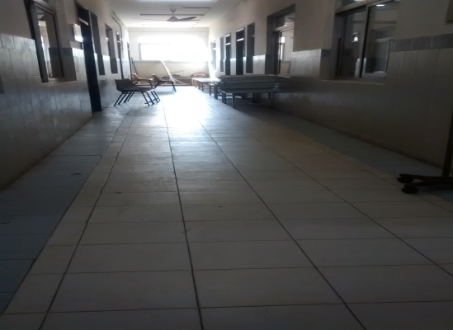 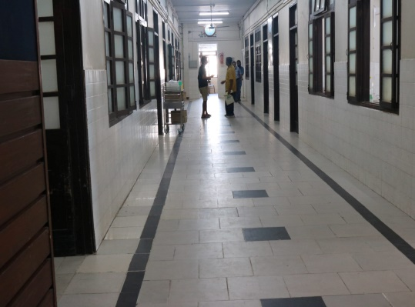

Corridor of Surgical Unit 5 post DCP Corridor of Surgical Unit 4 post DCP

The thought here is to enhance the state of CHK as much as could be done which is impractical without the assistance of our supporters.

The success of this project is the appreciation we get from the wards we have adopted.

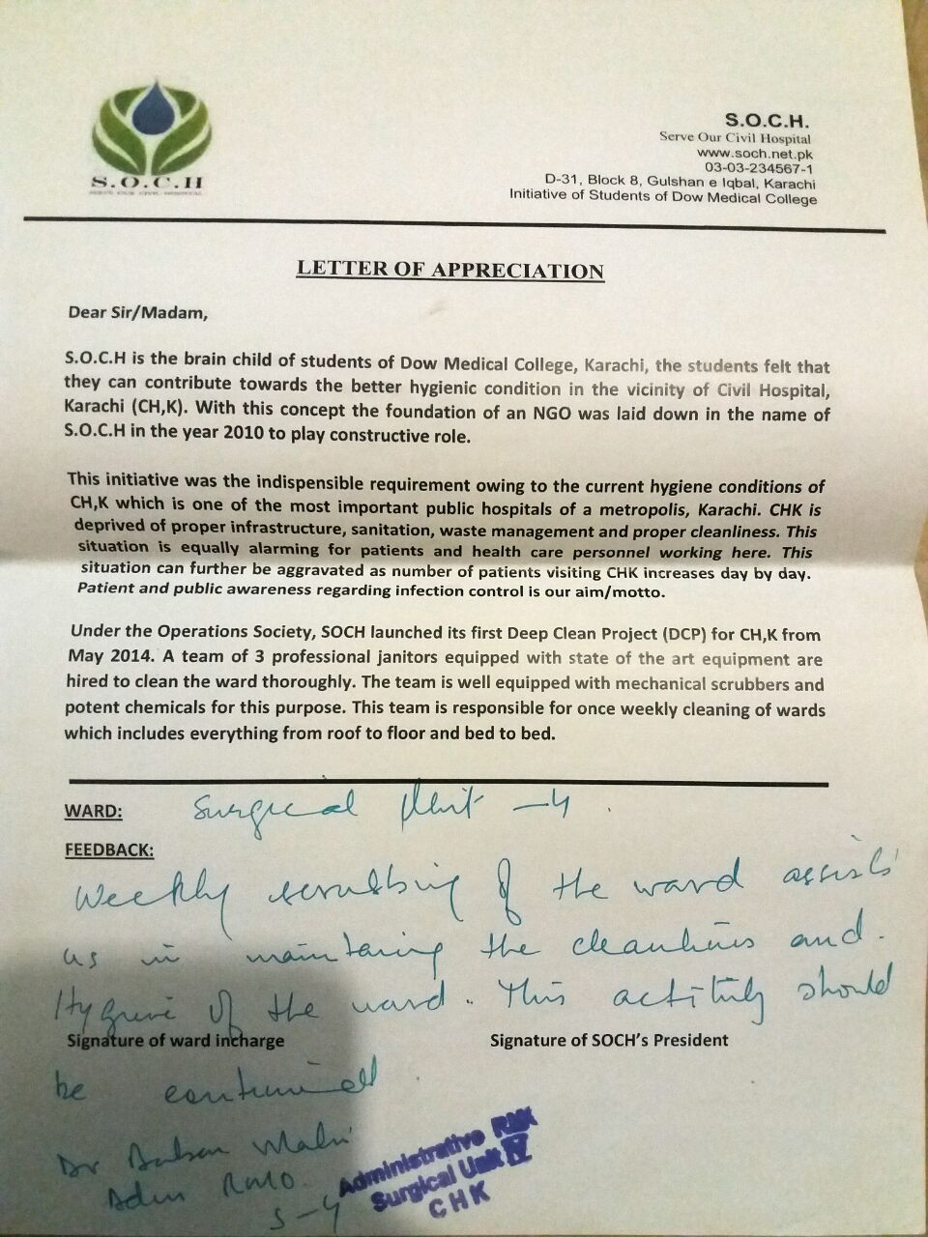 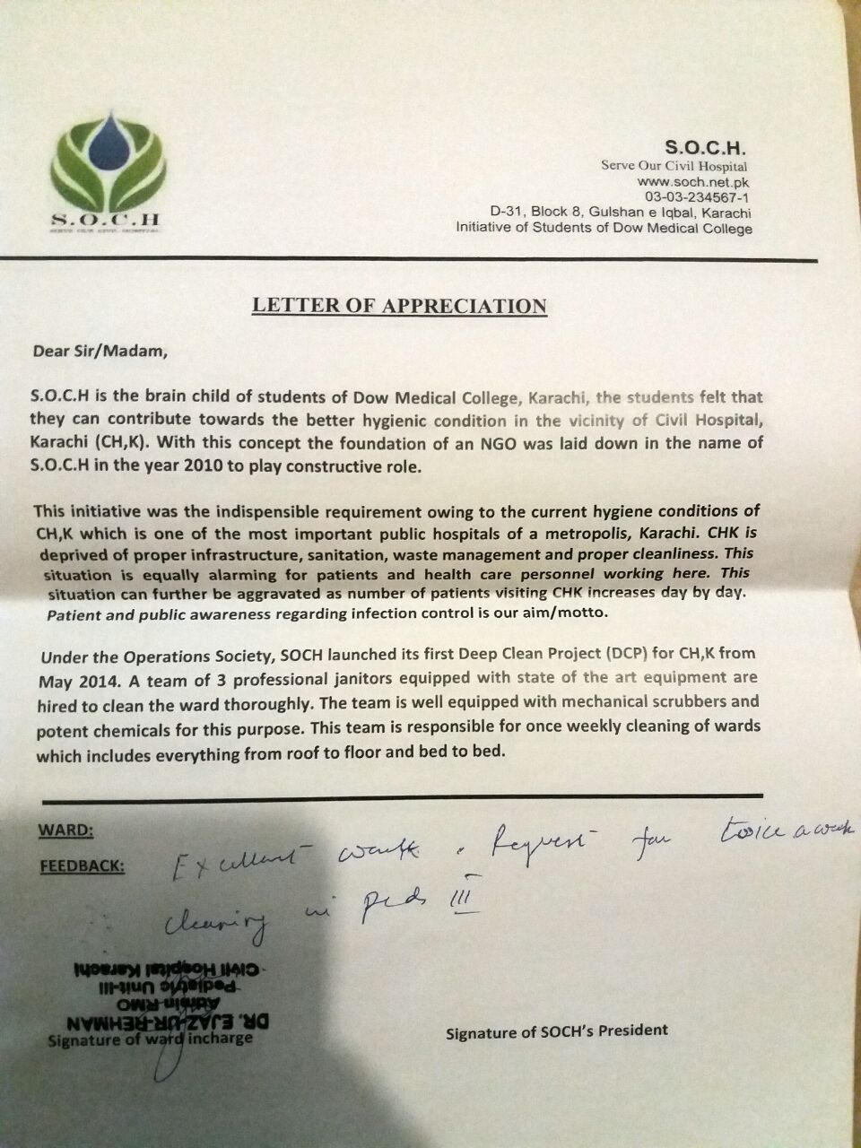

From Surgical Unit 4: “weekly scrubbing of the ward assists us From Paeds Unit 3: Excellent work,request for

in maintaining the cleanliness and hygiene of the ward. This twice a week cleaning in paeds 3.

activity should be continued”

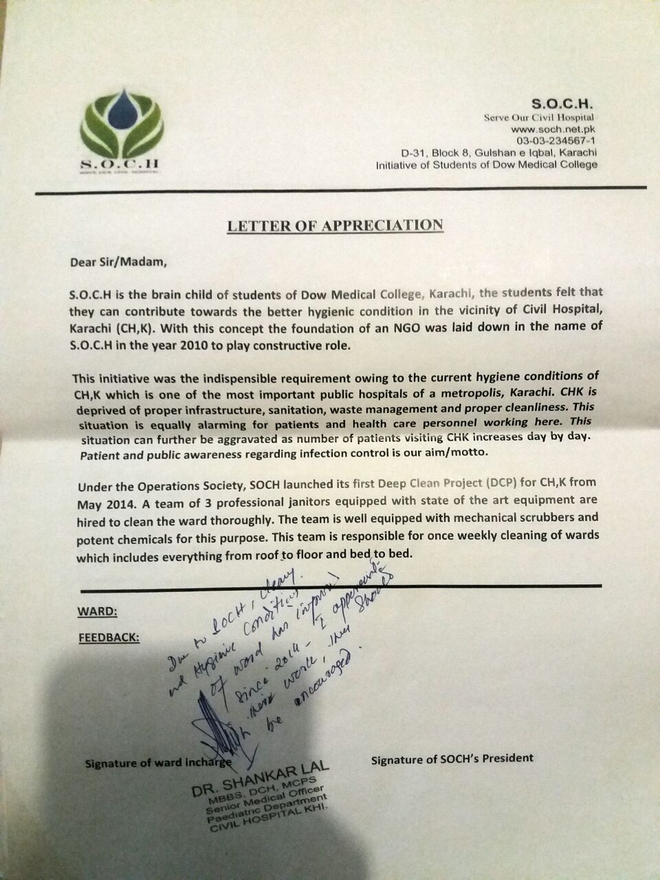

From Paeds Unit 1: “Due to SOCH, cleaning ad hygienic

condition of ward has improved since 2014. I appreciate

their work, they should be encouraged.