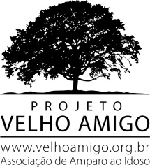

Heliopolis Elderly Center

Projeto Velho Amigo is a non-profit association that since 1999 has contributed to the inclusion of the elderly, ensuring their rights and valuing their participation in society. It works in the search of resources and partners to serve the 18 institutions supported, contributing financial and human resources to about 1500 elderly people in a situation of vulnerability, in several houses located in São Paulo. Only attend institutions that welcome the needy elderly, mostly without family.

With the significant increase in the number of elderly in the community of Heliópolis, as well as the identification of the marginalization and isolation of these elderly people, the ability to create a nucleus focused on this segment in the community was perceived in order to remove them from social isolation, Education for old age.

Target Audience
Aimed at people aged 60 years or over residing in the Heliopolis Community.
Today we have a total of 60 enrollees with 40 elderly frequenters.

Goal
The purpose of the Center is to compensate for the limitations arising from the aging process through the social inclusion of the elderly, thus presenting new possibilities of social life, physical activities, cultural assistance, social assistance, preventive health actions, thus becoming , A reference center for the elderly community and relatives of Heliópolis.
The function of the core activities is to enable the elderly and the family to have a greater intergenerational relationship, and the capacity to demand their rights and autonomy of thought, as useful members of society, thus redeeming their social role and autonomy in the community and in the family.
Education should be something that impresses on society a new culture of respect for the elderly, breaking myths and stereotypes present in the scenario of aging. We need to educate society to this new reality: Brazil is becoming an old country.

Operation
Monday to Friday from 9:00 a.m. to 5:00 p.m.

Offered Activities
All activities, projects and programs are developed in a continuous and planned manner. Among the actions developed as a tool to create links with our target audience, we have: crafts, literacy, art therapy, dance, computer science, gymnastics, memory workshop, yoga, lectures and cultural activities.

Need
Support for expenses.
US$ 50,000

Activity photos

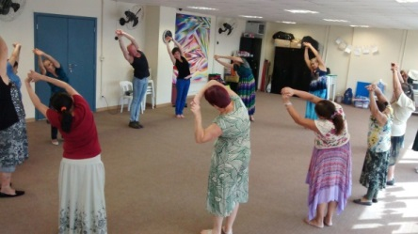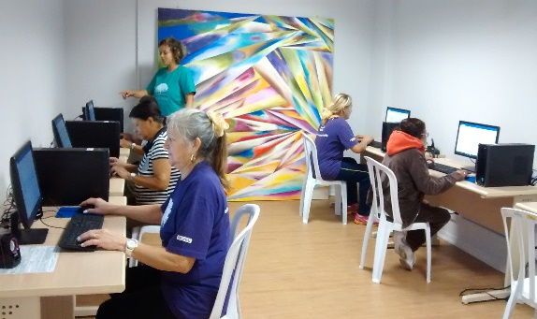
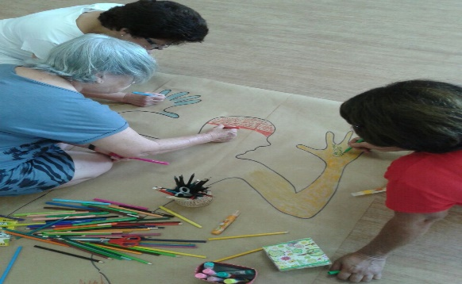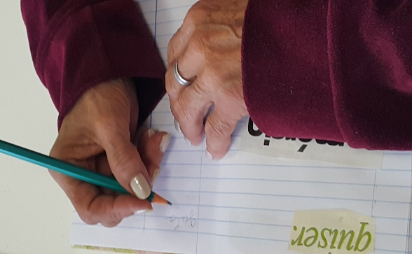

Marisa Simeão Pereira
Project Manager and Partnerships
11-3071-4040
marisapereira@velhoamigo.org.br

