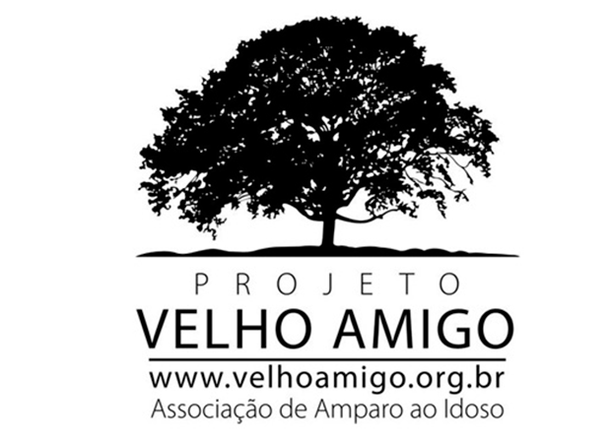Seminars:
February 10th: presentation of activities, information about The Velho Amigo Project objectives, what it is composed of, signing up for events, number of absences (allowed) in activities, among other information, 47 seniors attended;
February 23rd: "The importance of physical activity for older people" with professor Paulo Henrique Energy Institute, 36 seniors attended;
March 30th: International Women's Day celebration, messages exchanged among the senior women present, 37 seniors attended;
April 27th: movie session: Pixar: "How to live in a group and accept others", 20 seniors attended;
May 25th: movie session: "How to activate your memory - 10 tips on how to improve your brain", 22 seniors attended;
June 29th: we had planned to have a lecture on violence against older adults (but the speaker was confused about the time), so we had a dynamic group activity, 26 seniors attended;
July 27th: Lecture on "Preventing Falls in the Elderly” – Presented by professionals from Sesc Ipiranga, 28 seniors attended;
August 31st: Lecture on "Reusing Leftovers (food)" – Presented by professionals from Sesc Interlagos, 31 seniors attended;
September 21st: We had a Spider Web Team Building Activity (led by our volunteer Clear), then a Circular Dance, the aim was to teach the group how to dance, as well as educating them about the benefits that dancing provides, 40 older adults attended;
October 26th: In October we ended our monthly meetings for the year. The schedule for November and December 2017 was handed out. The community was introduced to d the new Social Worker who will give continuity to The Velho Amigo Project, 27 older adults attended;
Total: 314 visits to our monthly meetings.
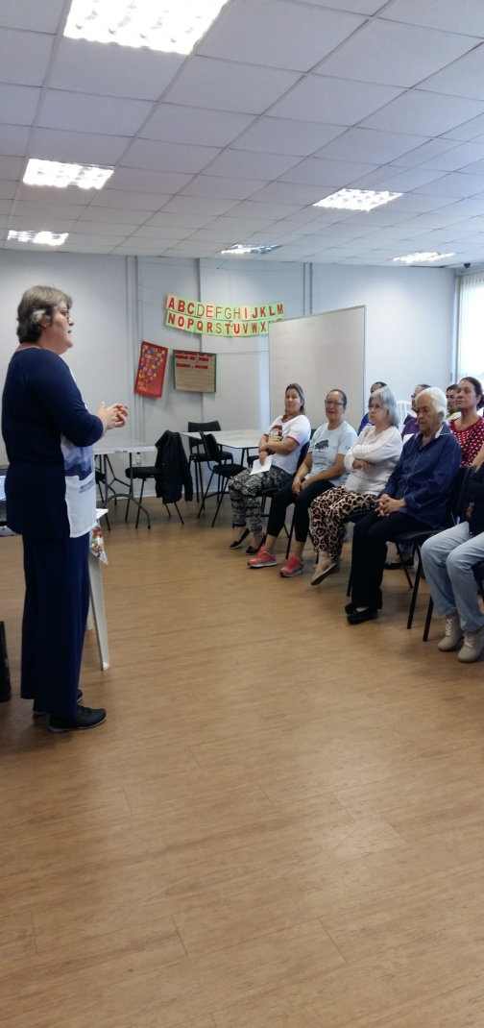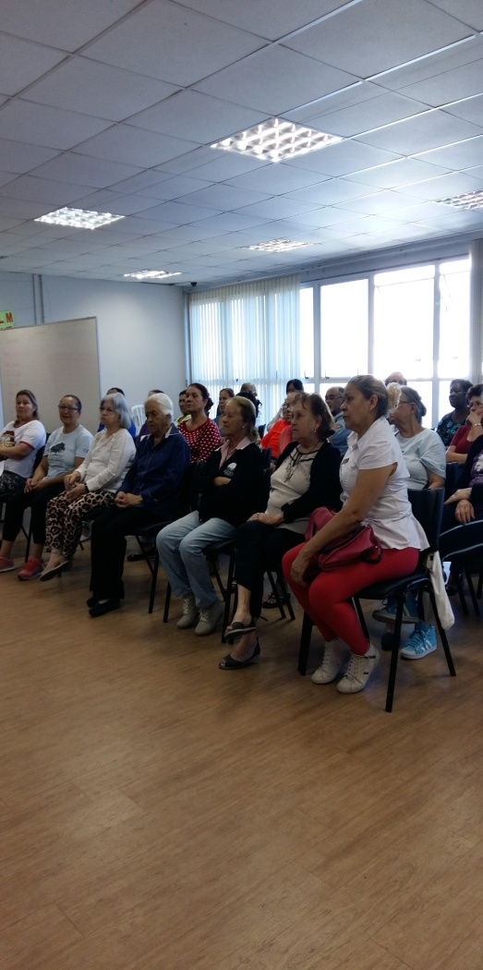

Photos 4 and 5 - Lecture on "Preventing Falls in the Elderly”

Chart 2 - Attendance at Monthly Meetings
The number of participants in each of the monthly meetings varied in accordance with: group interest in the topic being addressed, daily temperature/weather (mainly if it was cold), other activities that were being held by institutions outside The Velho Amigo Project, trips to the doctor (by group members), physical therapy and consultations previously scheduled in the public health system, and having to stay home to take grandchildren to school and/or nursery.

Voluntary activities carried out throughout the year:
April 6th, 2017: "How to Manage our Motivation to Live Healthier Lives" with Bia Manhas, number of participants: 15 Senior Citizens were present;
May 4th, 2017: Handicraft Workshop (topiary table centrepieces) – The art of sculpting plants and seeds, with volunteer Taiz Vincent, 12 Senior Citizens were present;
May 18th, 2017: Speaker and Director: Clair Vieira de Moraes - Theme: "The benefits of circle dancing in promoting health and well-being, quality of life and socialization", 13 Senior Citizens were present;
June 8th, 2017: "The Importance of Motivation in Life" - with Bia Manhas, number of participants: 10 Senior Citizens were present;
July 13th, 2017: Theme: Physical and Mental Health – How to Boost your Happiness, with Bia Manhas, number of participants: 05 Senior Citizens were present;
August 3rd and 17th, 2017: Circle Dance, with Clair Vieira, April 3rd: 07 Senior Citizens were present; on April 17th: 06 Senior Citizens were present. In total 13 Senior Citizens were present;
September 14th, 2017: Circle Dance, with Clair Vieira, number of participants: 06 Senior Citizens were present;
Group Psychologist Sessions - Days: June 2, 9, 23, and 30/ July 14, 21 and 28/ August 4, 11, 18 and 25/ September 1, 15 and 22; totaling 43 Senior Citizens: we offered group visits with the psychologist, Lizah Yumi with the aim of building self-esteem and dealing with emotional baggage (the participants are emotionally fragile people). The sessions began with ten people, and in the end, we only had two people. Sessions were held every Friday of the month, from 09:00 am to 10:30 am. The sessions began on June 2nd and ended on September 22nd, 2017. Unfortunately, in my opinion, the senior women did not regularly attend the sessions, because they did not like exposing their problems in front of the group (therefore decreasing attendance).
We have come to realize that sporadic activities which are carried out with volunteers (and are not part of the daily routine) have irregular attendance.
It is crucial to evaluate; how interested the group is, time availability and the focus of the activity. Since they have other activities outside of the center, in addition to their personal lives, because some of the elderly still work and take care of their grandchildren.
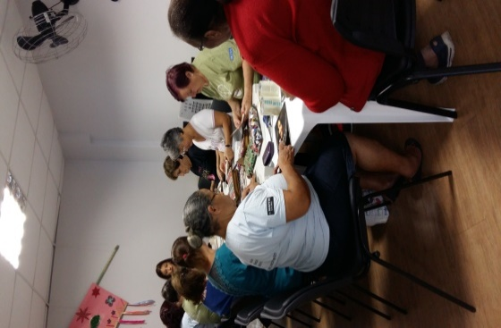

Photo 6: Workshop – Making Handbags out of Magazines.
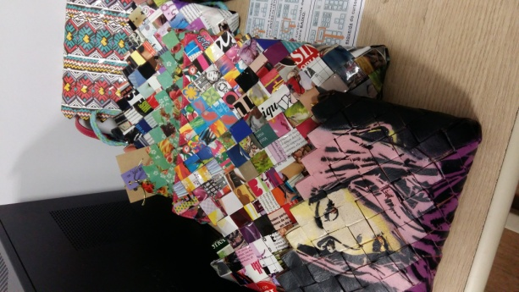

Photo 7: Bags made with Paper and Magazines

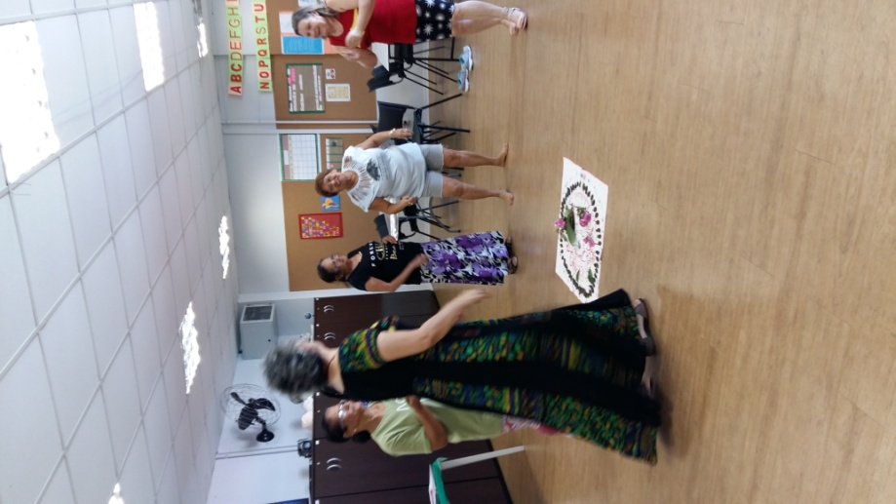
Photo 8 – Circle Dance

Other Events (that were carried out):
June 20th – A June Celebration (Festa Junina) held inside The Velho Amigo Project – Heliopolis. 30 Senior Citizens attended;
September 25th and 29th – Senior Citizens Week and the 3rd Movement for the Elderly, held at the Heliópolis CEU inside The Velho Amigo Project – Heliopolis. 135 people participated among them, Senior Citizens and adolescents;
October 3rd - The Board and partners of The Velho Amigo Project put on a celebration in honor of International Day of Older Persons. A total of 46 older adults from The Velho Amigo Project in Heliopolis were in attendance (due in part to the group meeting).
Penpal Letter Exchange: the aim of the penpal letter project was to strengthen bonds of friendship (amongst themselves) as well as forging new friendships with Apple company employees. Ten elderly women participated in the project. They had an opportunity to learn about Apple and visit the company store at Shopping Morumbi. Afterwards, Apple employees went to visit The Velho Amigo Project of Heliopolis where all of the activities are carried out.
Happiness Speech: "What is happiness, how does it work, what impact does it have and how it can be achieved" September 2nd, 2017. From: 09:00 to 12:30.
Envisioned by Eduarda Oliveira in 2014, the "International Happiness Forum" originated in Coimbra-Portugal. After Eduarda attended an open class at the University of Coimbra at the Faculty of Psychology and Educational Sciences on the “Neurochemistry of Happiness”. That was the pivotal moment which inspired the creation of an event that leads people to have a better understanding of "What is happiness, how does it work, what impact does it have and how it can be achieved". The elderly women participated in the following activities: Lecture "I with myself" - delivered by Patricia Gebrim - Flowing in the River of Life towards Love and a Workshop with Plinio Cutait - Reiki a path of healing.
Workshop: More Participative Games for the Elderly: Transparency and Open Data: Information about social control of public policies (municipality) for instance: Participation and Transparency, the law of access to information, social control, transparency portal, Cultural São Paulo, seeking better health, URSI – Unidade de Referência ao Idoso (Unit of Reference for the Elderly) in Ipiranga, Portal 156, SAMPA Plan, focusing on the city, purchasing and procurement, Live SAMPA, municipal budget, revenue, information systems for citizens, functionalism, waste, cleaning, citizenship, University for Senior Citizens, PAI - Programa de Acompanhamento do Idoso (Companionship Program for the Elderly), improvement of bus stops, better health programs, City Friend of the Elderly – Live Longer and Better. After the lecture, there was a group dynamic with interactive games.
Workshop: Making bags out of paper and magazines with Petrusca (the teacher) a total of three classes were administered for making the bags, with the objective of inspiring the elderly women who might be interested in making some extra income.
Distribution of Gifts - Donations:
- International Women's Day - compact powder and blush- 80;
- Winter jacket with the logo of The Velho Amigo Project - 47;
- During the monthly meetings, gifts offered by the volunteers were distributed to the elderly who participated in the meetings. The elderly themselves, also, made spontaneous donations of gifts (which they had at home) and which had never been used and were in perfect condition.
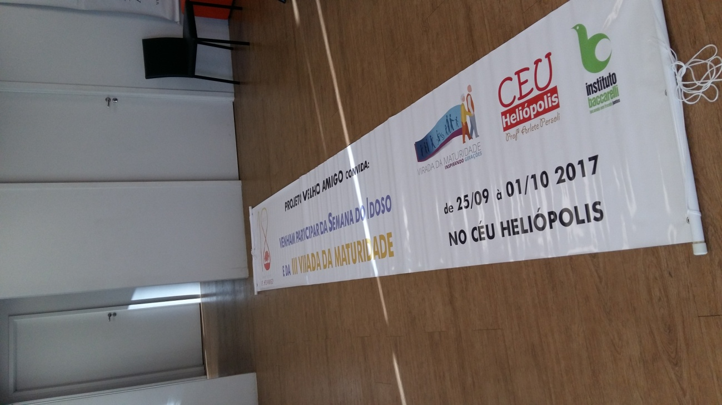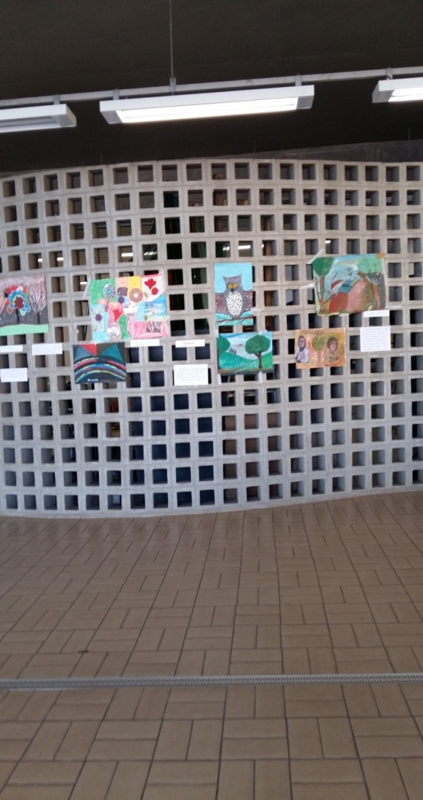

Photos 9 and 10 - Senior Citizens Week and the 3rd Movement for the Elderly
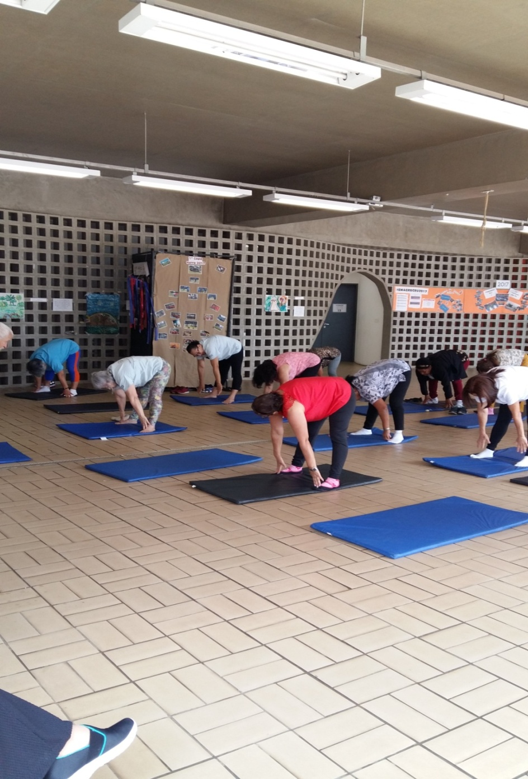

Photo 11 - Senior Citizens Week and the 3rd Movement for the Elderly - Yoga Class

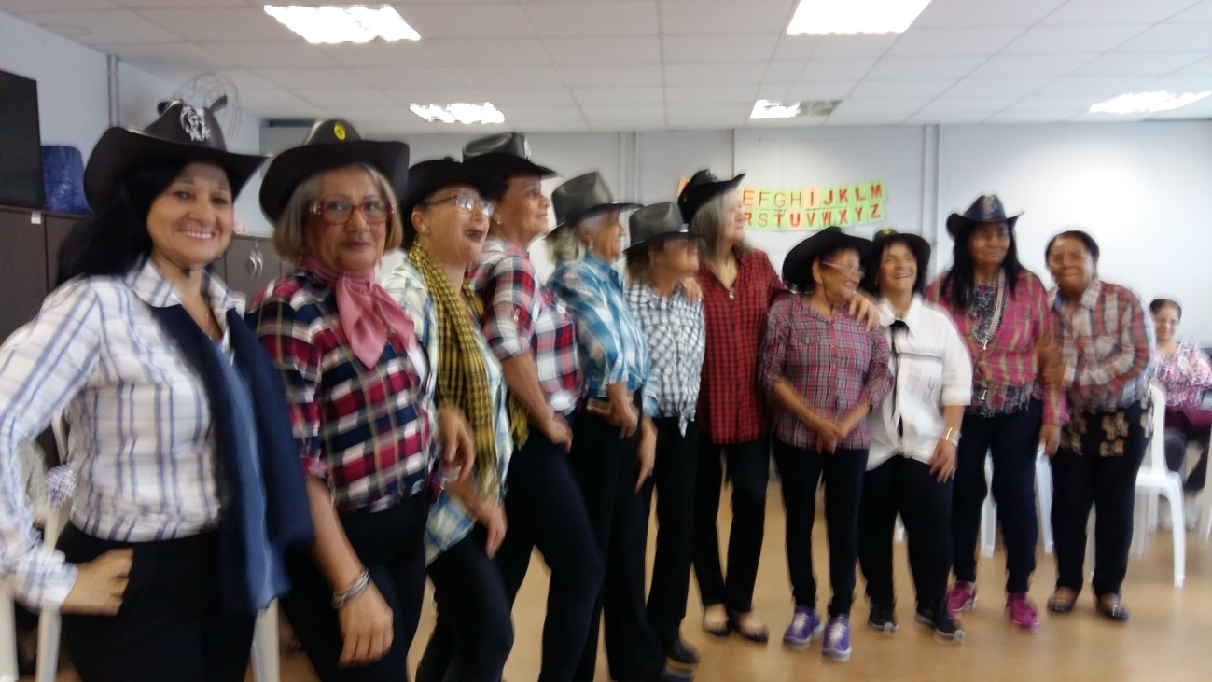

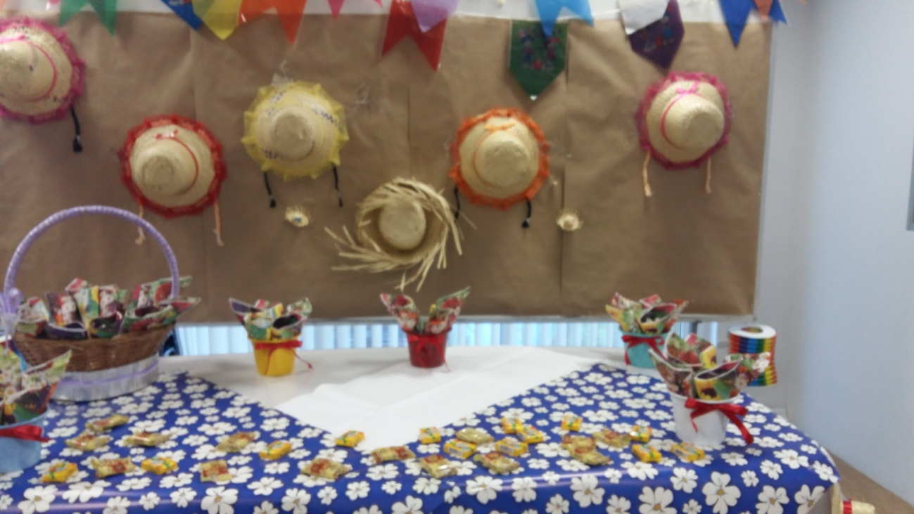

Photos 12 and 13 – June Celebration “Festa Junina”

