Campaigns:
No | Dentistry Campaign at  “Atelier Oral” | Number of people who benefited | Dates
1. | Alzenira, Cecíia, Edite, Franca, Guiomar, Neuza Dias, Nlvalda, Josefa Barbosa (Zefinha), Nadir, Zilda, Marieta, Daise and Coralia. | 13 people  There were several activities offered on location such as morning coffee, handicraft activities, Choral Singing, and Ballroom Dancing. | May 20th, 2017
2. | Cecilia, Daise, Elmira, Franca, Josefa Barbosa (Zefinha), Josefa Gonçalves (Zefa), Luzinete, Nadir, Maria Gorete, Marieta, Neusa, Neuzinete, NIvalda and Zilda | 14 people | July 15th, 2017
 | Ophthalmology Campaign | Number of people who benefited | Dates
2. | Maria de Lourdes Santos, Guiomar, Nadir, Marisa Roza da Conceição, Daise, Edit, Nivalda, Antonia Cavalcante, Franca, Luzinete, Maria Julia, Marieta and Elmira | 13 people  On location, various things were distributed such as snacks for everyone present. | July 6th, 2017
 | Penpals Letter Exchange - Apple Project | Number of people who benefited | Dates
3. | Ausenda, Daise, Edite, Maria do Socorro, Rosalita and Zilda | Ten people were invited, but only six people showed up at Shopping Morumbi | July 26th, 2017
 | Health Campaign - Berrini Medical Center | Number of people who benefited | Dates
4. | Dalva, Antônio da Cruz, Daise, Edite, Elmira, Francisquinha, Francisco Ferreira, Guiomar, Luzinete, Maria Goretti, Nadir, Marieta, Rosalita, Zilda | 14 people | September 23rd, 2017

The objective of these campaigns was to help the Senior Citizens (in need) within the community of Heliopolis who attend The Velho Amigo Project (with greater frequency and punctuality) it is a prize for anyone who participates.

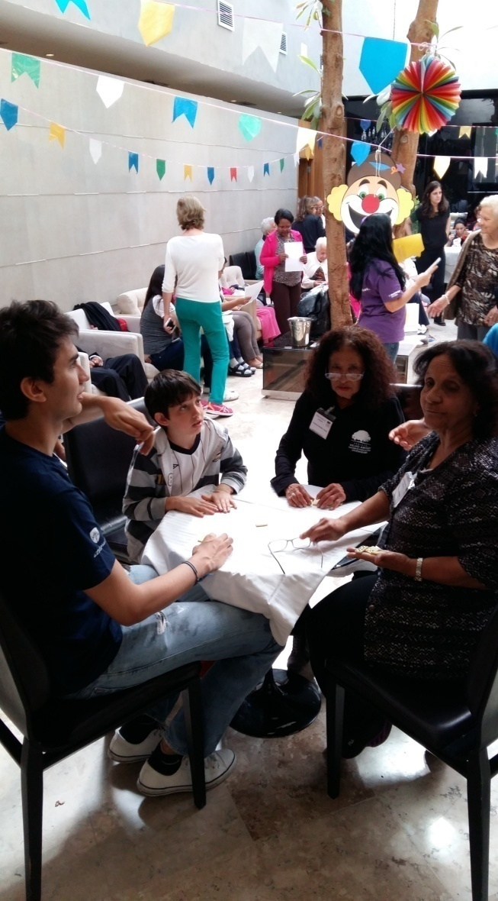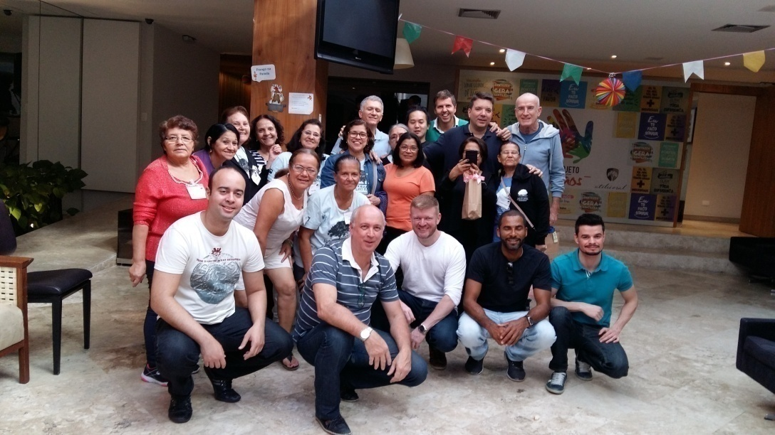

Photos 14 and 15 – Dentistry Campaign
Individualized care:
As soon as Senior Citizens are welcomed into the center (for enrollment or re-enrollment into the group), they receive individualized care. When the elders ask for help, they are already in a fragile state (especially in their relationships). The aim of The Velho Amigo Project is to promote the role of the elderly person within society by developing their potential and stimulating their participation in activities within the Community. The center gives them attention and affection, which are very important for their coexistence not only with the teachers within the center but also with the group and the community.

Positive points:
- Systematization, with dates and times of the monthly meetings;
- Systematization, of the distribution of the monthly schedule, with the objective of seeking greater interest from the members of the group for the activities offered;
- It was perceived by the board of the institution that the coordination of the Center of Heliopolis, should be done by a professional social worker (because of their knowledge in the area of ageing). This would help to further solidify the credibility and seriousness of the institution, within the social sector, in addition to giving greater visibility to the institution.
- To best suit the needs and interests of group members we realized that there was a need to substitute some of the instructors for new areas like; crafts, computer literacy, and dance.
-The handicraft workshop had very positive reviews because the senior women who attended the workshop were able to add these handmade products to their household income. Throughout the year they made a large and diverse amount of handmade products.

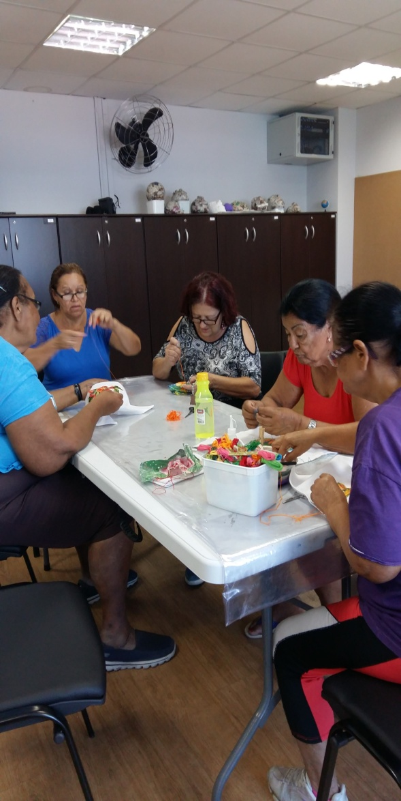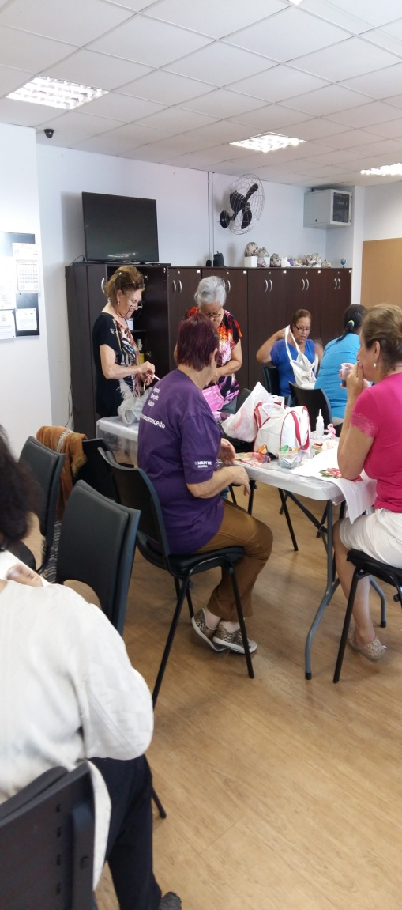

Photos 16 and 17 – Arts and Crafts Classes

Negatives:
- To be better prepared regarding lectures and activities, given by volunteers, so that the volunteer who is preparing to administer the event will not to disappointed by the number of participants that show up. And at the same time for the Seniors not to be disheartened by the activity offered by not creating expectations.

Professional participation in events:
As a way of perfecting this professional social workers participated in the following events:
- Day: 16 march/2017 - Talk About Volunteering: "The importance of the purpose of volunteering with the elderly";
Day: 25 May/2017 - MaturiTalks: "The intergenerational relations in the work environment";
Day: 25 May/2017 - Seminar: Wake of coexistence for the elderly: a possibility of social participation" - Sesc and CBCISS;
Day: 22 june/2017 - Multiple faces of veiled violence - Sesc and CBCISS;
Day: 25 august/2017 - the work of Social Workers in Education Policy - Sesc and CBCISS;
Day: 29 September/2017 - Relations between the generations in current society, Sesc and CBCISS.

