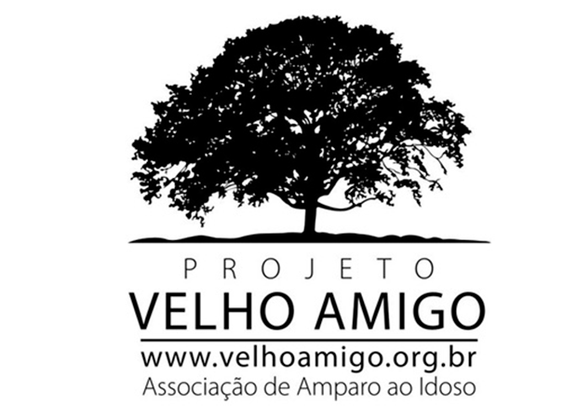Background Heliopolis Elderly Center

Photo 1 – Classrooms

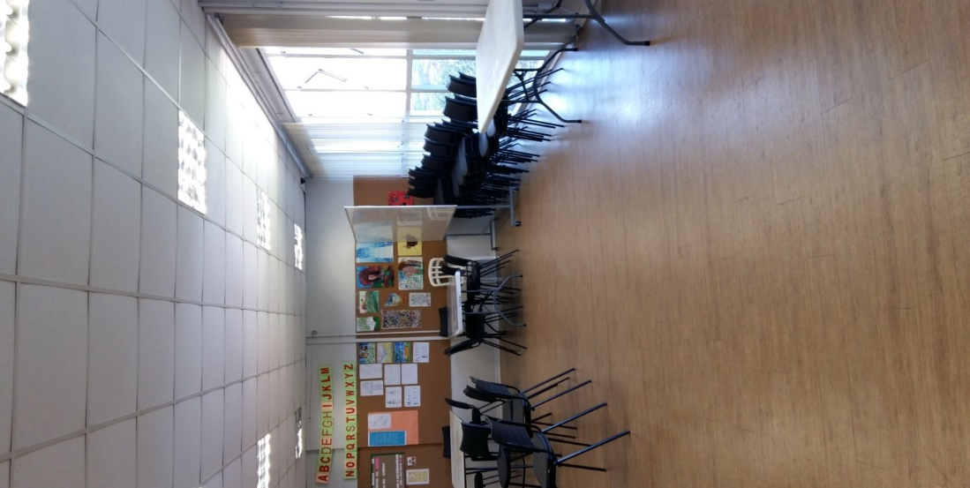

Photo 2 - Computer Room

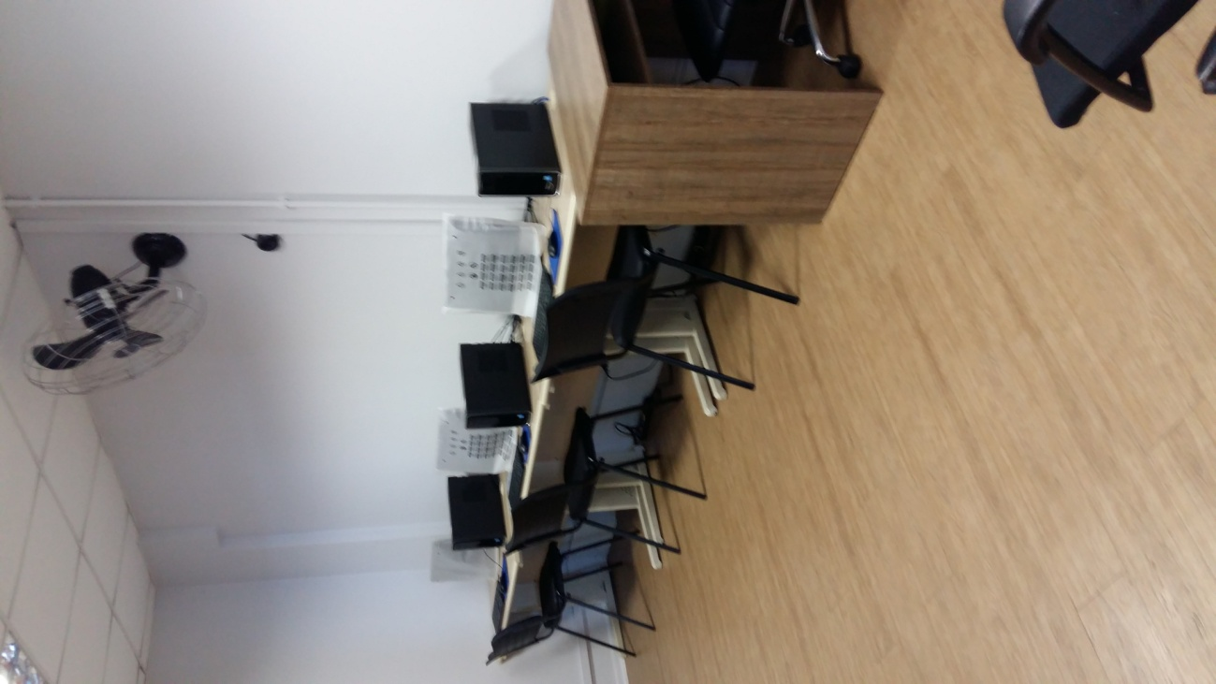

The Environment:
“There is a greater concentration of seniors in the Community of Heliopolis because it is the hub of the textile industries in that region and for that reason the community settled within the vicinity.” (Brazil, 2003)
The Group, Associação de Amparo ao Idoso – The Velho Amigo Project – Heliópolis was made up of 60 senior citizens when the project first began in January 2017, and throughout the course of one year, we were able to accommodate more people who sought the project – we now have 101 seniors enrolled in the project.
The group has a monthly income of one minimum wage on average, being that the vast majority of their relatives, sons, daughters, grandchildren and others survive on what they (the elderly) have to sustain themselves.

Chart 1. Percentage of the monthly income of group participants

S/M - Minimum Wage.
The table above shows that 90% of the members of the group receive a monthly income of up to one minimum wage, in general, retirement, pension or the Continuous Cash Benefit Program (REVAS-BPC-LOAS), while the remaining 10% receive two or more minimum wages, from (besides the incomes mentioned above) other extras, such as; domestic services (maid), selling beauty products and providing services to sewing companies.
Re-enrollment:
Enrollment for the year of 2017 was carried out from January 16th to February 9th – and on February 10th we had our first meeting with the newcomers. We had 47 people in attendance out of the 60 people that had enrolled. The aim of the meeting was to let people know the objectives of The Velho Amigo Project (Heliopolis) as well as how activities would be conducted.
Meetings:
There were ten monthly meetings (two of these were held in February) and once a month after that. The monthly meetings aimed to provide general reports of activities, allocate the monthly schedule, assess the activities that were planned and implemented the month before, setting of guidelines, watching educational films, group workshops, raffles and seminars.
On February 23rd we had a meeting with the entire group, which from then on would be held monthly, on the last Thursday of every month (on that day we had 36 older adults in attendance). The purpose of the meeting was to build rapport among the people in the group. We also wanted to make them more knowledgeable about the program. We distributed the monthly schedule and explained how they could sign up for activities, as well as the importance of good attendance (since activities are in high demand).

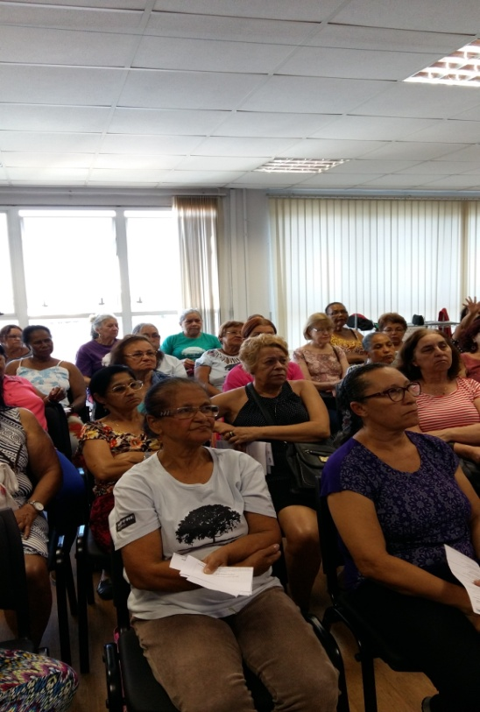
Photo 3 - Monthly group meeting.

