Overview & Conclusion 2017:
The Senior Citizens who attend The Velho Amigo Project – Heliópolis are ready and willing to learn. Under real learning conditions, the students begin to transform by constructing and reconstructing the knowledge taught, with every professional who works in The Velho Amigo Project – Heliopolis. The professionals are also subjected to the process, as the teachers learn from teaching and those who learn become teachers of what they have learnt. (Freire, 2006, p. 29).
We believe that we achieved our goal once attendance for each activity improved. The strong demand from the older adults within the community for the activities developed by The Velho Amigo Project – validated the need for the project designed within Heliopolis. Since the teachers are trained and dedicated to what they do the Senior Citizens are receptive and accepting. Everyone within the community is received with affection and dedication, and this helps in the dissemination of the project within the community.

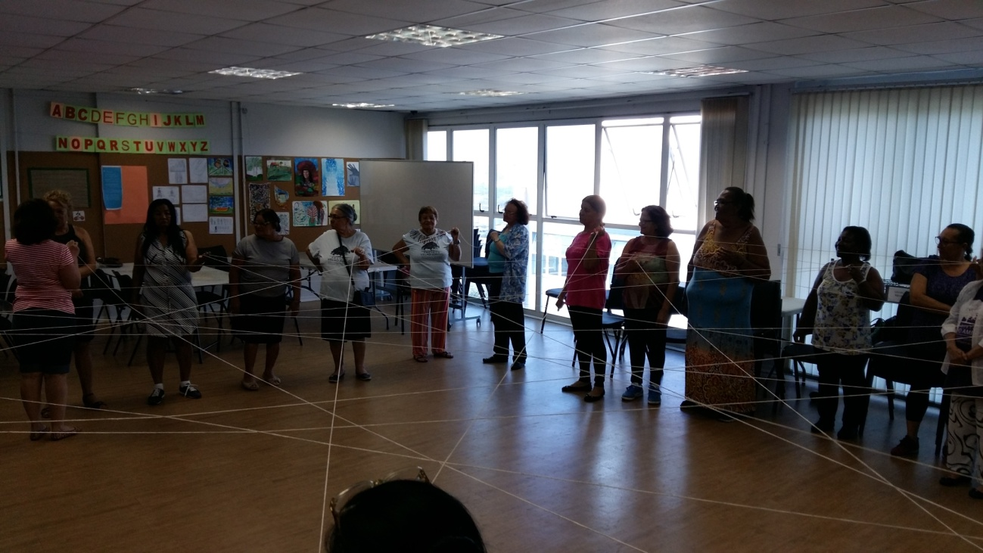

Photo 18 - Group Dynamics at the monthly meeting.
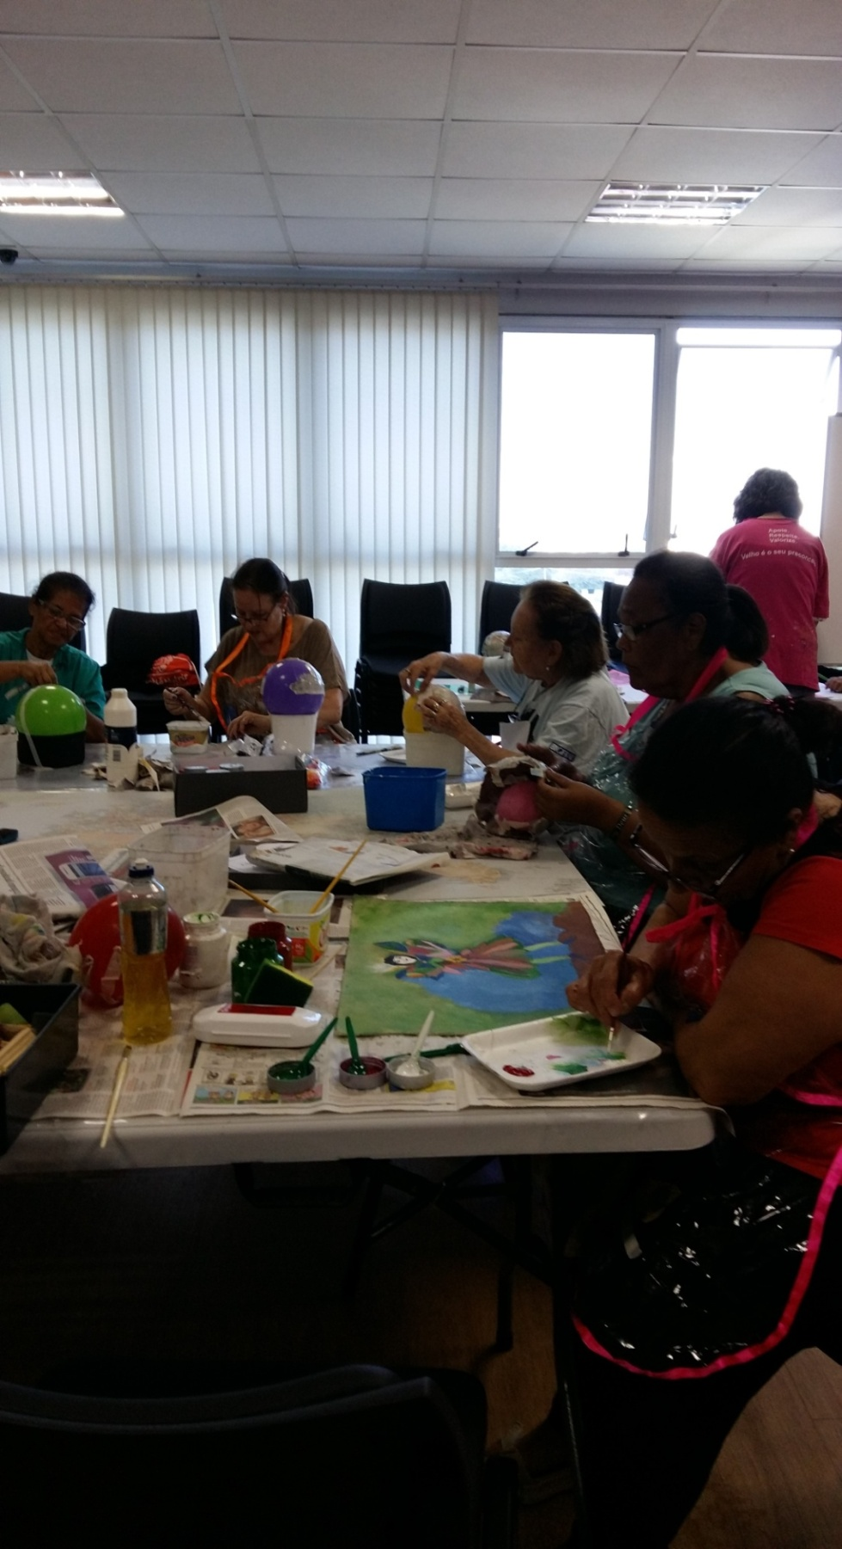

Photo 19 - Art Therapy Class
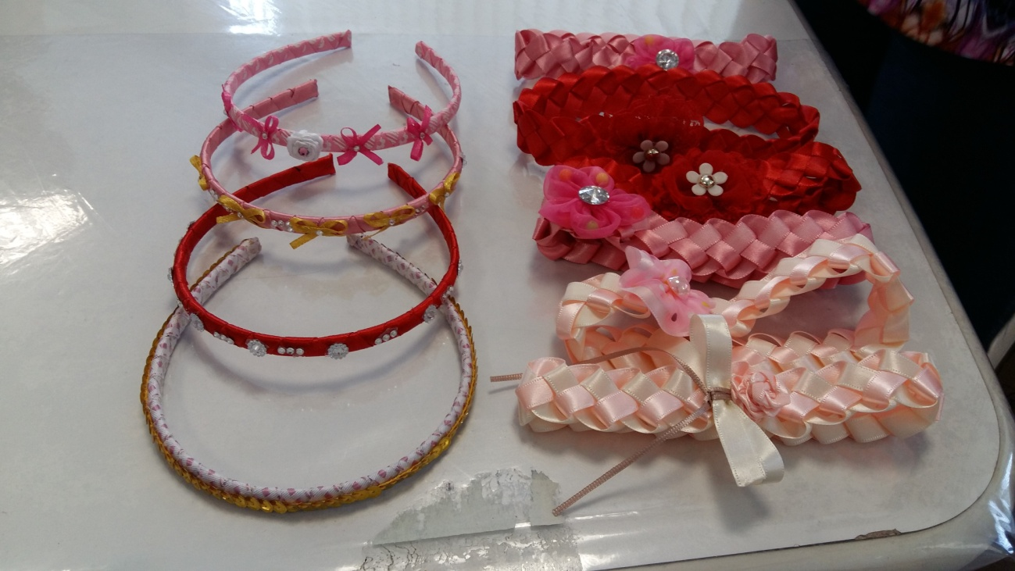

Photo 20 - Making tiaras for children and babies – Arts and Crafts Classes

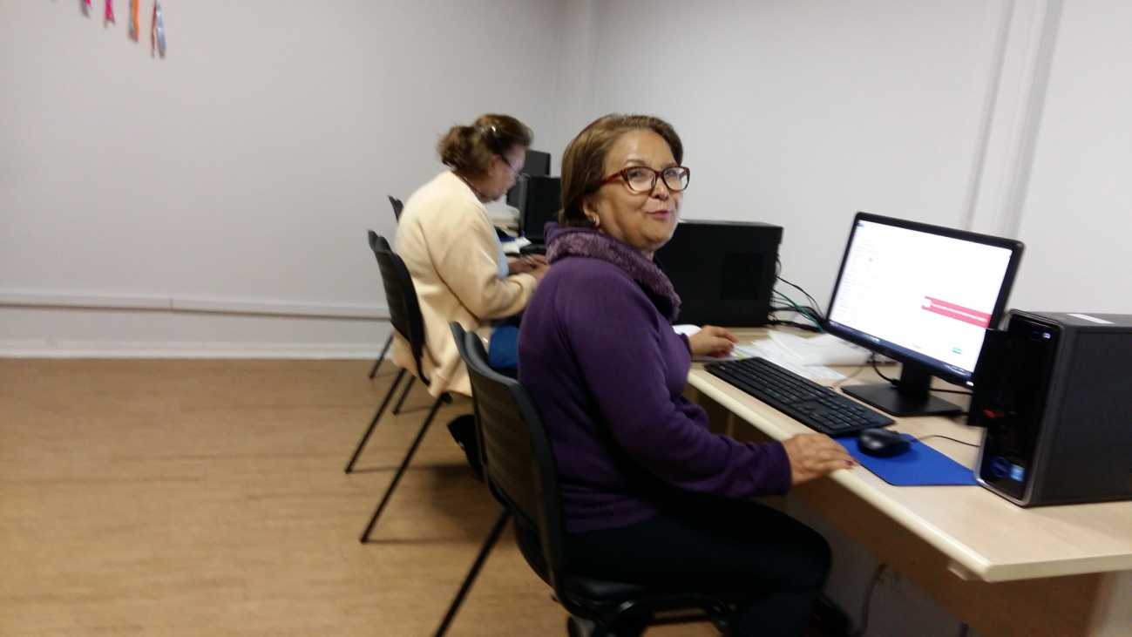

Photo 21 – Computer Technology Class

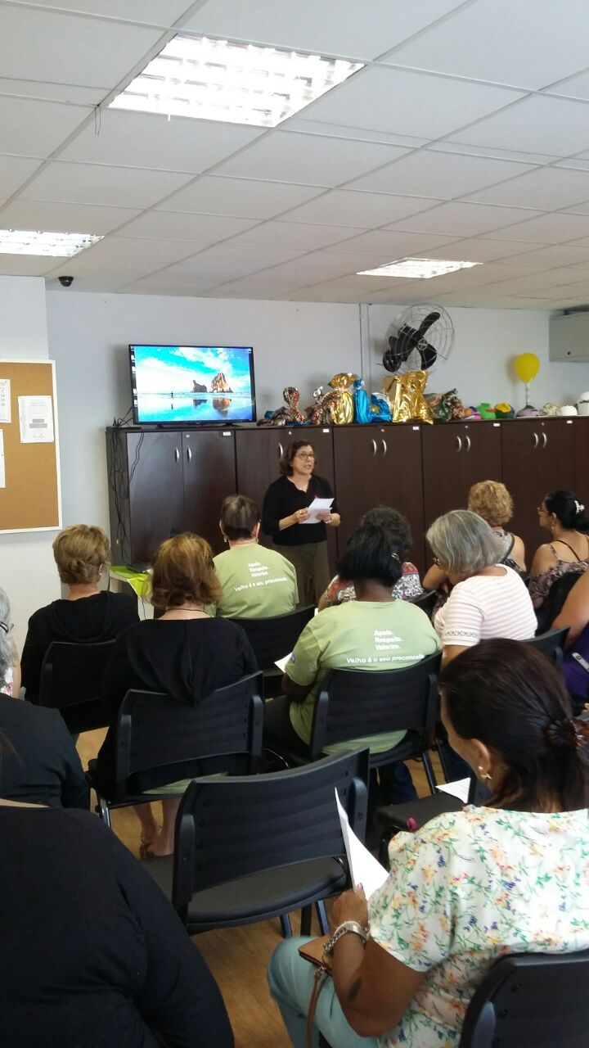
Photo 22: Monthly meeting October 26th, 2017
20. Bibliography
1. CENPEC/Fundação Itaú-Social/UNICEF - Many Places To Apender.São Paulo, 2003.
2. IBGE. 2010 - www.IBGE.gov.br;
3. Site www.velhoamigo.org.br

São Paulo, October 31st, 2017
Rita de Cássia Pereira da Silva de Miranda
Social Worker and Gerontologist

