Progress Report

Residential Centres

January-June 2020

Submitted by: Salaam Baalak Trust
Introduction-
Salaam Baalak Trust’s residential centres are 24*7 programmes which provide shelter (long- term and/ or short-term) and a package of childcare services based on continuum of care approachtochildrenrescuedfromthestreets.Theseservicesincludemedicalcare,foodand nutrition (three hot cooked meals and evening nutrition), psychological support, education, vocational training, job placement, restoration and rehabilitation. The centres also provide sports and latent talent development opportunities for all round development of children. These residential centres are recognized and licensed under the Integrated Child Protection Scheme(ICPS)andtheJuvenileJusticeAct,2015.Theadmissionandcareplanofeachchildis made under the guidance of respective Child Welfare Committees(CWCs).

SBT Residential Centres –
SBT has 7 residential centres for children from street and vulnerable situations. The centres have the basic infrastructure –classrooms, play area, computer lab and dormitories. Each centre has a team of trained and compassionate caregivers who work towards the holistic development of the children residing in these homes.

Brief overview of the centres-
Centre | Catering to Boys or  Girls | Brief Overview
Aasra | Boys | Aasra was the first shelter home started by SBT. With a capacity of 50 it caters to boys of five to 18 years. It is an inclusive set up where children with disabilities and typically developing children reside together.
Apna Ghar | Boys | Itis a short stay centre, where 40 children come and stay for short duration and then they are either restored or transferred in a long  stay home. The home was set under the JJ Act, 2000.
DMRC | Boys | DMRC Children’s Home was established as part of Delhi Metro Rail Corporation’s corporate social responsibility. The home  houses 125 boys from the age of five to below 18 years.
Old Delhi Railway Station (ODRS) Open Shelter | Boys | ODRS open shelter is an open centre catering to 30 boys. It is a short stay centre, where children come stay short duration and then they areeitherrestoredorpostedinalongstayhome.Thehomewas  set under the JJ Act, 2000.
Arushi | Girls | Arushi was first girls’ shelter home under SBT. It is an initiative to offer 24 hour shelter to 50 girls between the ages of five years to18 years living on the streets.
Udaan | Girls | Udaan was started in the year 2010. It started with eight girls and currently shelters 80 girls at a time.

Key Activities and Progress Update-

Residential Care –
A safe space is the most critical need for any child to realise his/her own full potential. Thus, we started residential programmes to provide safe child friendly shelter for children rescued from street situations and any other distress situations.Children residing in these homes have a sense of belonging and call it their own home.

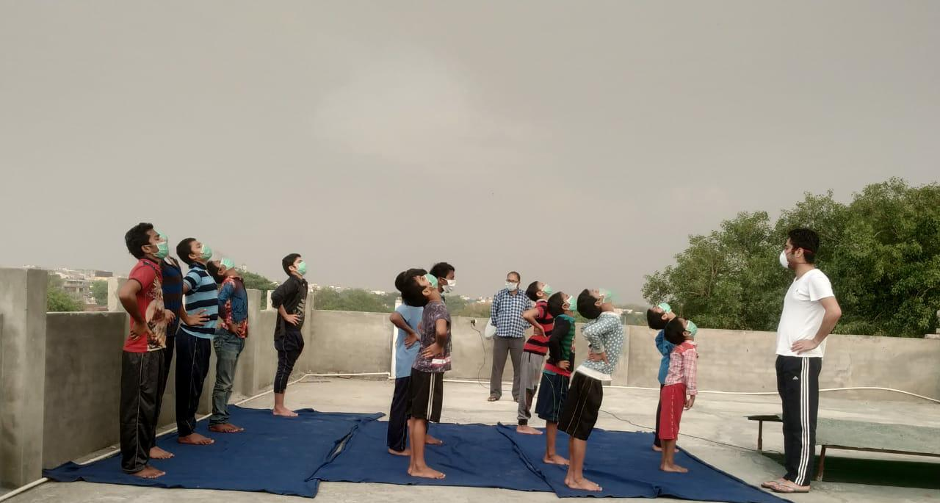

Nutrition
To meet the nutritional needs of children, nutritionally-balanced and hot-cooked meals are served at residential. The meals are prepared in the kitchen space provided at the centre under the supervision of staff members to ensure safe and hygienic practices. In some cases, children have special nutritional requirements due to illness such as tuberculosis and malnutrition. Such children are provided with special nutrition including protein supplements, additional servings of fruits and milk as prescribed by the doctor.

Education
Education is integral to any child’s development and hence all the children residing in the homes are connected with education either through formal, non-formal or open school of learning depending on the strength of the child. Each centre has an in-house teacher who helps the children with their home work and also teaches the children who are studying through open learning.

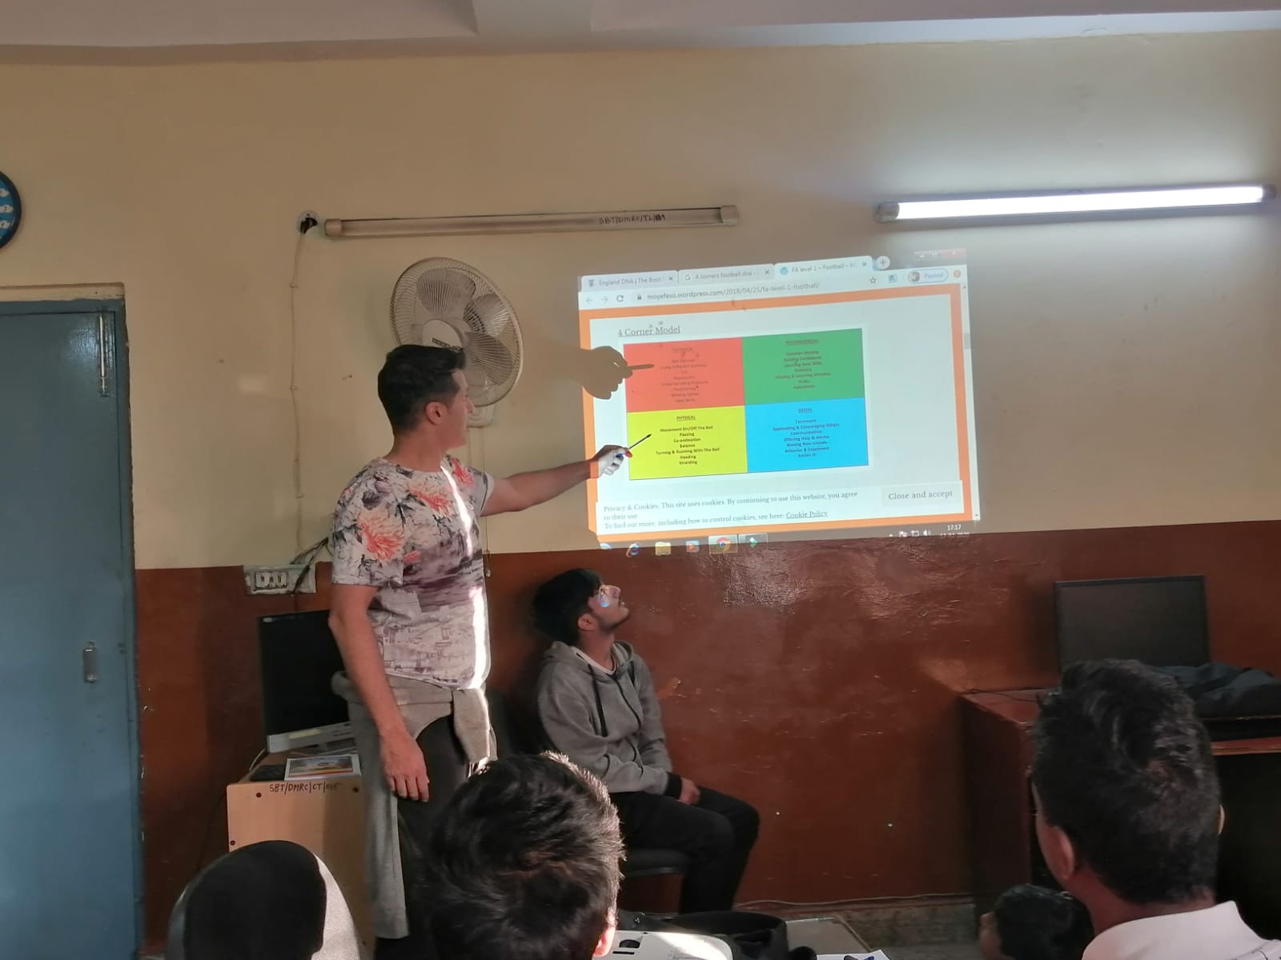

Medical Care
Children on the streets live in unsanitary conditions and are prone to various infections and diseases. Therefore, regular medical check-ups of the children are done at the full care residential centres. Individual health cards are maintained for each child. Whenever required, pathological tests are conducted as per the recommendation of the doctors. We have a full-time doctor employed with SBT solely for this purpose. Apart from that we also invite external doctors or get our children treated by specialists at hospitals.

Mental Health-

Full-time mental health professionals appointed in the centre provides psychological support and counseling to children. The mental health and psychological support helps children rescued from the streets get over their traumatic past. There are a team of 9 psychologists with a senior Psychiatrist who work towards the management plan of children having psychological difficulties.

Vocational Training and Job Placement -
Children who are above 16 and/or have completed Class10 are linked to a wide range of vocational training courses. A career counselor matches children’s skill sets and interest with suitable courses. Based on counselor’s recommendation children join vocational courses of their choice. Children at SBT centres often opt for computer, travel and tourism, fashion designing, beauty culture and hotel management courses. Upon completion of their vocational training courses children are also assisted in finding gainful employment. The centre teams help children in applying forjobs.

Restoration and Rehabilitation: Those children who are missing or run away from their homes often long for their families. The centre teams in conjunction with the CHILDLINE and police make efforts to find homes and families of these children and reunite them with their parents.

For those children who live in the residential centres till they turn 18, a proper rehabilitation plan is drawn. These young adults are not only linked to jobs butarealsosupportedinfindinganewaccommodationandareprovidedbasicnecessitiesto start a life such as bedding utensils and financial assistance for buying groceries and pay rent for up to three months. Rehabilitation is SBT’s carefully planned attempt to reintegrate the children back into societies as productive adults and responsiblecitizens.

A snapshot of services provided by the residential centres from January – June 2020 has been presented in the Table below.

S.No | Activities | Number of Children
1. | Shelter Provided | 809 children
2. | Restoration | 370 children
3. | Education (Formal Schooling) | 150 children
4. | Open Schooling | 28 children
5. | Non-Formal Education | 524 children
6. | Food and Nutrition | 809 children
7. | Health Check Up | 761 children
8. | Skill Development and Vocational Training | 25 children
9. | Job Placement | 11 children
10. | Rehabilitation | 05 children

Challenges –
Due to the Pandemic, there are limited opportunities for children to be constructively engaged There was a surge in mental health concerns of children and staff since the movement and the daily routine has been disturbed.

Initially, only few staff members could come to work and this led to classes being irregular. Younger children are particularly being affected due to the lockdowns as its difficult for them to comprehend the scenario.

Future Plan:
The effort is to keep all the children in the homes safe during the pandemic and at the same time to work towards their physical and mental health.

SBT is also working to upgrade the digital infrastructure at each home so that the children don’t miss out on the academic front.

Mental health team is working proactively with both the children and the staff and has increased the number of life skill sessions.

